**Title:-**

A Decade of Economic Trends: Analyzing Key Indicators from World Bank Data for Selected Countries

**Name:-**

Shazia Nasim

**Abstract:-**

This comprehensive analysis explored various indicators, including urban and rural population, inflation, GDP growth, fuel imports and trade for selected countries over a 10-year period. Line plots revealed trends and fluctuations while bar charts provided a clear visual of country-specific data. Correlation heatmaps unveiled interrelationships between indicators and statistical methods such as mean, skewness and kurtosis offered insights into data distribution characteristics. Results indicated notable variations in indicators among countries, highlighting patterns and potential factors influencing economic trends for example india and Canada has highest inflation while other side india has least urban population and its inflation did not impact on its GDP growth which is second highest.

**Github link:-**

A Decade of Economic Trends: Analyzing Key Indicators from World Bank Data for Selected Countries

This analysis focuses on countries from various continents, examining their data over a 10-year period to explore the interdependence key factors influencing the economy. The factors under investigation include rural and urban population, inflation, GDP growth, fuel imports and trade.

The presented visualization illustrates diverse analyses based on World Bank indicators across multiple countries.

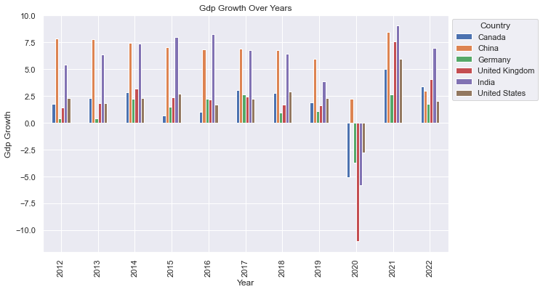

Figure 1

The bar graph represents the GDP growth trends of selected countries from 2010 to 2020. Overall, China and India showed higher GDP growth but in 2020, all other countries including India experienced a decline. Notably, China's GDP growth remained positive, distinguishing itself from the general trend of economic downturn among other nations.

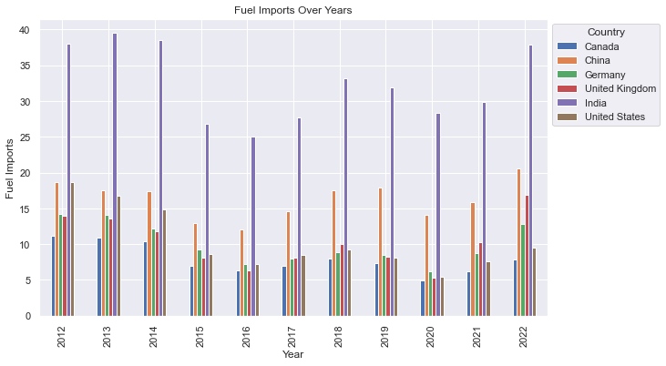

Figure 2

The bar graph (Figure 2) demonstrates the fuel imports of selected countries, with India and China being the highest importers. However, it's important to note that a direct comparison between India and China may not be suitable due to significant differences in their fuel import quantities.

In both (Figure 1 & Figure 2) fuel imports and GDP growth, India and China stand out as the top countries. Meanwhile, the UK and Germany show varying patterns in their GDP growth and fuel imports, experiencing both increases and decreases. The link between GDP growth and fuel import advocates that a growing economy may lead to an increased demand for fuel resources.

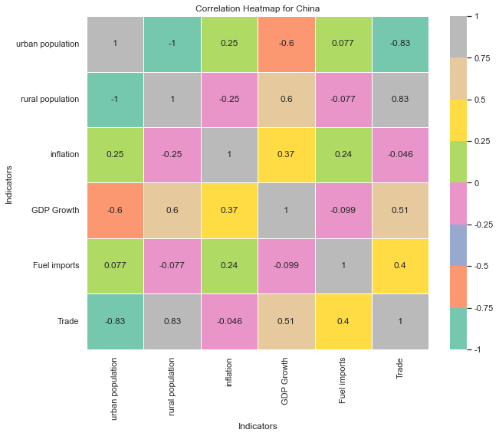

Figure 3

The correlation heatmap for China indicate that an increase in fuel imports is associated with growth in trade and a rise in trade corresponds to higher GDP growth. Typically, urban population, GDP growth, and trade tend to increase together, but in China, rural population positively influences both GDP growth and trade.

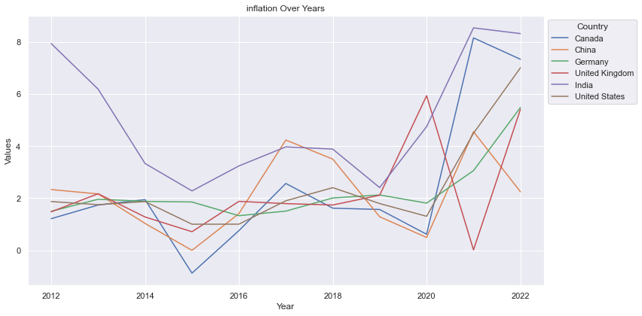

Figure 4

The figure 4 displays inflation over 10 years and India consistently has the highest inflation except for two years when China and the United Kingdom experienced higher inflation. However, the plot also reveals a sudden increase in inflation for Canada in 2021 and 2022, indicating challenges in controlling inflation during those years.

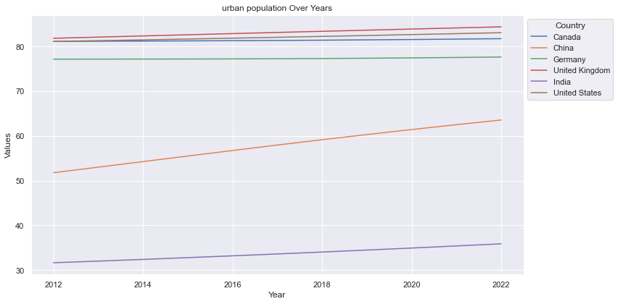

Figure 5

The line plot for urban population highlights that Canada, the United Kingdom and the United States have the highest urban populations. Notably, China stands out with a consistent increase in its urban population year after year, showcasing significant urbanization trends.

Looking at the 10-year trends in inflation and urban population, it appears that India experiences high inflation despite having a relatively low and stagnant urban population. In the case of China, although inflation fluctuates, its urban population consistently grows. This suggests a potential link between lower inflation and increased urban population.

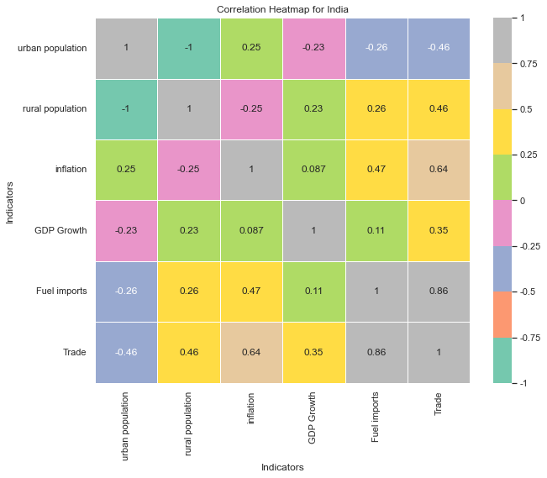

Figure 6

In this figure 6, GDP growth shows a positive correlation with both trade and fuel imports, indicating a potential connection between economic growth and international trade and fuel consumption. Inflation has a moderate positive correlation with urban population and trade. These correlations suggest that urbanization and increased trade activities might contribute to inflation, while the relationship with fuel imports is less pronounced.

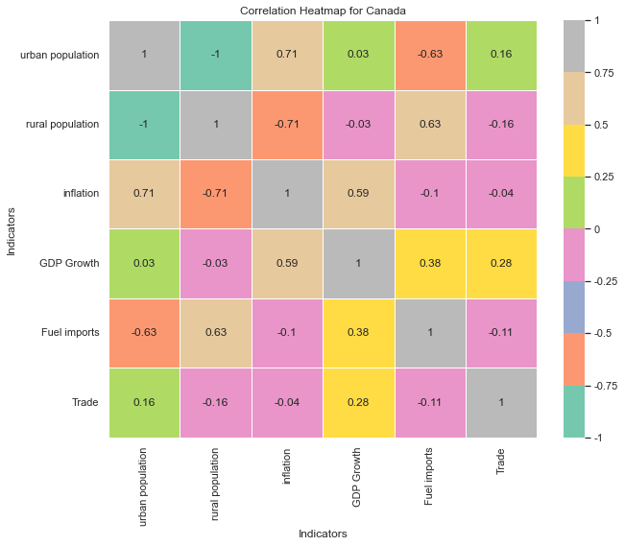

Figure 7

The correlation heatmap of Canada reveals interesting patterns. The trade and GDP growth have a strong positive correlation, conversely, there is a notable negative correlation between trade and fuel imports. Urban population has a slight positive correlation with inflation, but it is not a strong association.

The tables presented below are the outcome of employing various statistical methods to conduct a comparative analysis among countries and indicators. While 1,2,3,4,5,6 represent Urban Population, Rural Population, Inflation, GDP, Growth, Fuel imports, Trade.

|  |  |  |  |  |  |  |
| --- | --- | --- | --- | --- | --- | --- |
|  | Canada | China | Germany | UK | India | USA |
| 1 | 81.39 | 57.84 | 77.32 | 83.13 | 33.66 | 82.08 |
| 2 | 18.61 | 42.16 | 22.68 | 16.87 | 66.34 | 17.92 |
| 3 | 2.42 | 2.11 | 2.23 | 2.23 | 4.98 | 2.40 |
| 4 | 1.79 | 6.39 | 1.11 | 1.59 | 5.71 | 2.14 |
| 5 | 7.92 | 16.30 | 10.01 | 10.23 | 32.43 | 10.42 |
| 6 | 64.49 | 39.78 | 87.13 | 61.40 | 45.24 | 27.53 |

The table mentioned above displays the mean values of indicators over a span of 10 years. It indicates that the United Kingdom has the highest urban population, while India exhibits the highest inflation rate.

|  |  |  |  |  |  |  |
| --- | --- | --- | --- | --- | --- | --- |
|  | 1 | 2 | 3 | 4 | 5 | 6 |
| skewness | -18744.08 | 18744.08 | 4.47 | 0.02 | 55.17 | -8.10 |
| kurtosis | 4.99 | 4.99 | 7.59 | 0.95 | 232.61 | 16.68 |

India's urban population distribution is significantly left-skewed, going towards lower values, while rural population is highly right-skewed, favoring higher values. Inflation leaning towards higher values with a kurtosis suggesting occasional extreme values. Fuel imports exhibit a highly right-skewed distribution with an exceptionally high kurtosis, indicating concentration towards higher values and potential outliers.