**Line Plot**

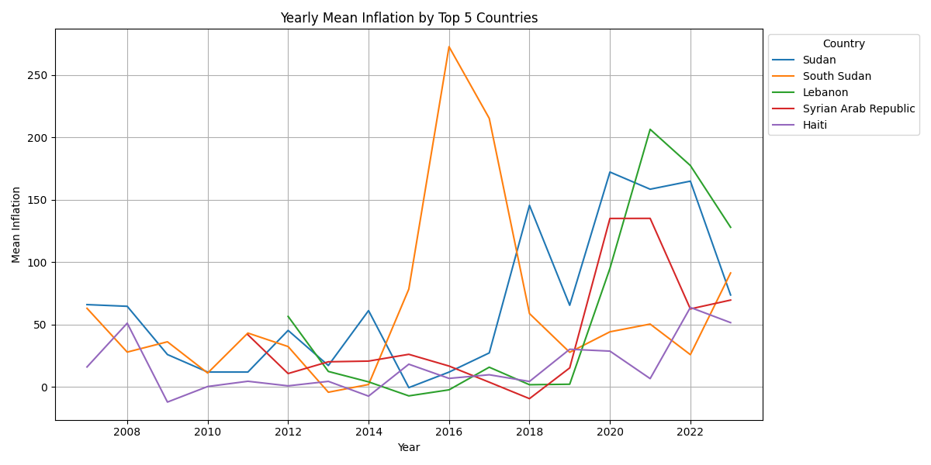

Figure Yearly mean Inflation of top five countries

The line chart from 2007 to 2022 illustrates mean inflation values for the top five countries, with the y-axis ranging from 0 to 250. Notably, South Sudan exhibited extreme economic fluctuations, reaching an inflation peak exceeding 250 in 2016 and a sharp decline to below 50 in 2019. In the same year, the remaining featured countries experienced a collective rise in inflation, except for Haiti and South Sudan, which maintained inflation rates below 50. This synchronized inflation increase in 2019 suggests common economic trends affecting multiple countries, while Haiti and South Sudan's sustained lower inflation levels indicate unique economic circumstances. The chart offers a compelling perspective on these nations' economic dynamics, enabling valuable insights into their economic trajectories and challenges.

**Box Plot**

A box plot is suitable for displaying the distribution of mean inflation for different countries, helping us understand the spread, central values and latent outliers in the data. This box plot provides a comprehensive visual representation of the mean inflation values for the top five countries, South Sudan, Lebanon, and Haiti, over a specified period. This box plot allows for a quick visual comparison of the mean inflation values for these three countries, emphasizing their distinct economic dynamics, as shown in Figure 1. South Sudan exhibits wider variability with numerous extreme inflation periods, Lebanon showcases more stability within a narrow range, and Haiti reflects consistent, albeit lower-level inflation. The presence of outliers in South Sudan and the absence of outliers in Lebanon provide valuable insights into these nations' economic trends and potential economic challenges.

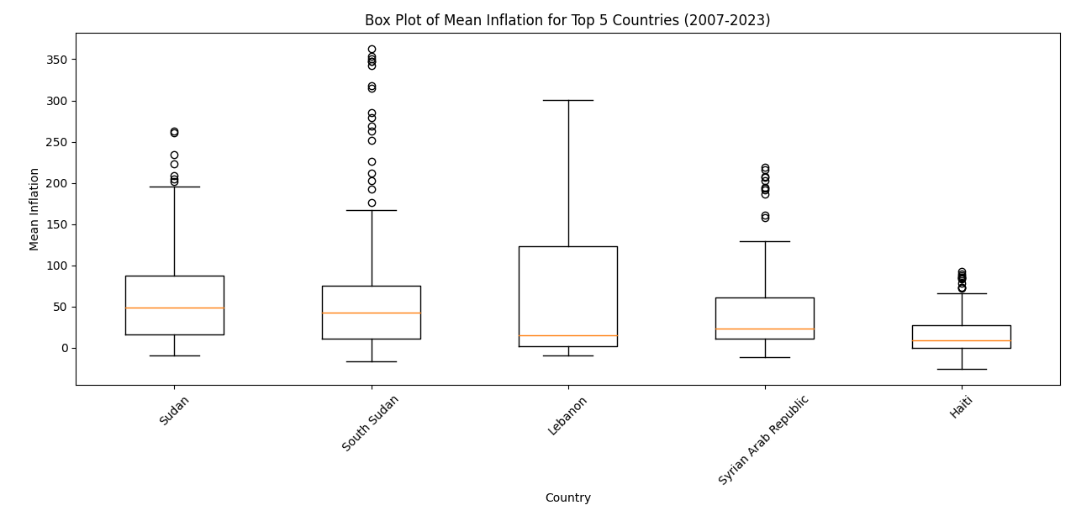

Figure Mean inflation of top five countries (2007-2023)

**Bar Chart**

As Bar charts are effective for comparing numerical data among different categories so this generated stacked bar plot offers a comprehensive analysis of mean values within four crucial categories, namely "Open," "High," "Low," "Close," and "Inflation," across five featured countries. It provides a visual lens through which to explore economic trends and stability. Remarkably, the mean values for "Open," "High," "Low," and "Close" consistently remain below 10 for all countries, reflecting a shared trend of economic steadiness in these aspects. In stark contrast, the "Inflation" category emerges as a standout, with mean values exceeding 60, as shown in Figure 3. Notably, Sudan leads the pack in this category, positioned at the top of the x-axis, signifying the highest inflation levels. Meanwhile, the Syrian Arab Republic maintains a more balanced range of mean values, falling between 15 and 40 for inflation, indicating moderate economic fluctuations. On the other hand, Haiti's "Inflation" values span from 0 to 15, emphasizing a notably lower level of economic volatility than the other countries. This compelling stacked bar plot offers a nuanced perspective on economic stability and fluctuations within these nations, particularly emphasizing the "Inflation" category, where Sudan, the Syrian Arab Republic, and Haiti each present unique economic dynamics worthy of in-depth investigation and analysis.

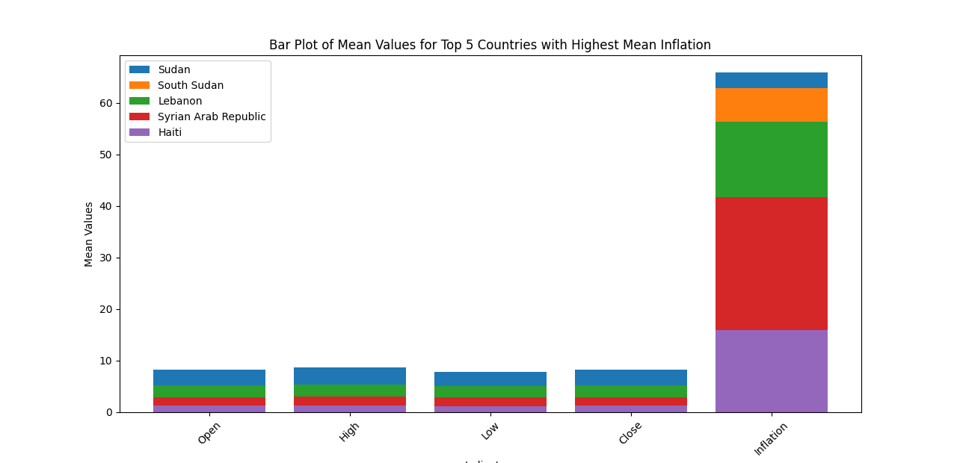

Figure bar chat shows the inflation, open, high, low, and close of the top five countries