# **DAY 5 - TESTING, ERROR**

# **HANDLING, AND BACKEND**

# **INTEGRATION REFINEMENT**

# **ECOMMERCE WEBSITE**

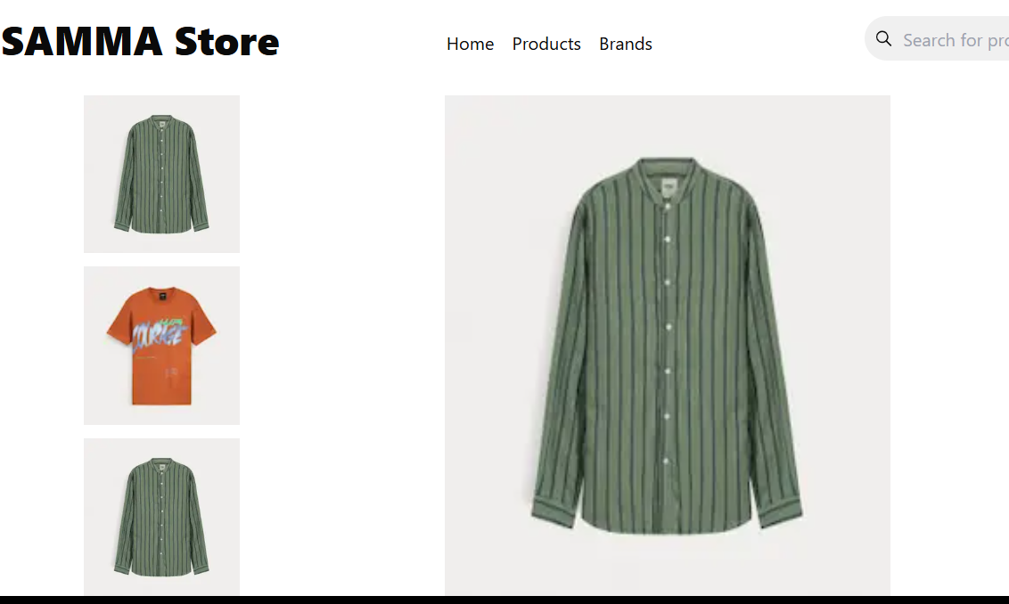

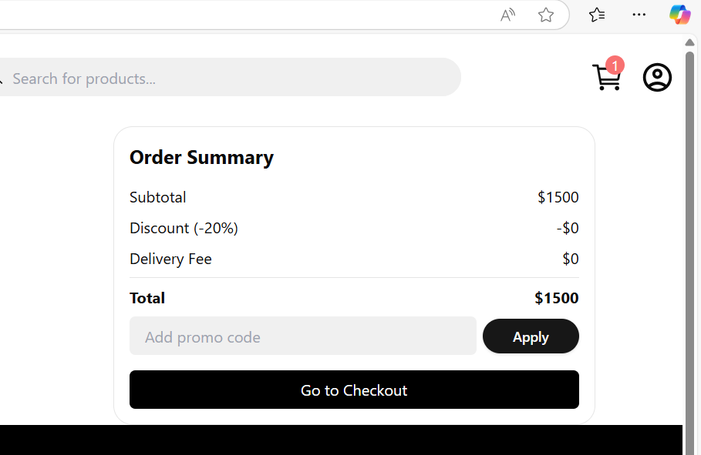

# **2. Integrating basic API responses to display dynamic data.**

# .components are responsive and accessible across devices and browsers

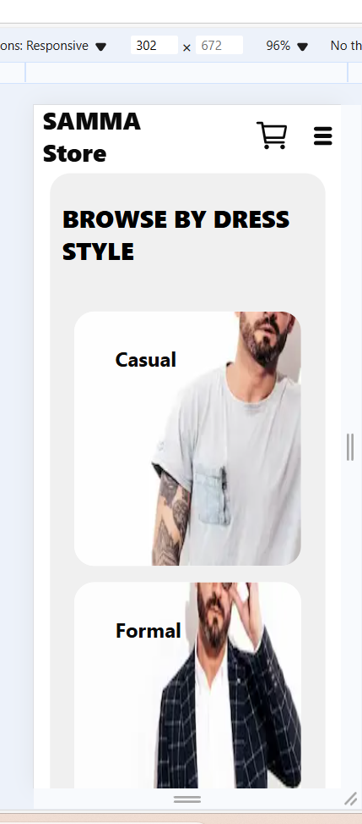

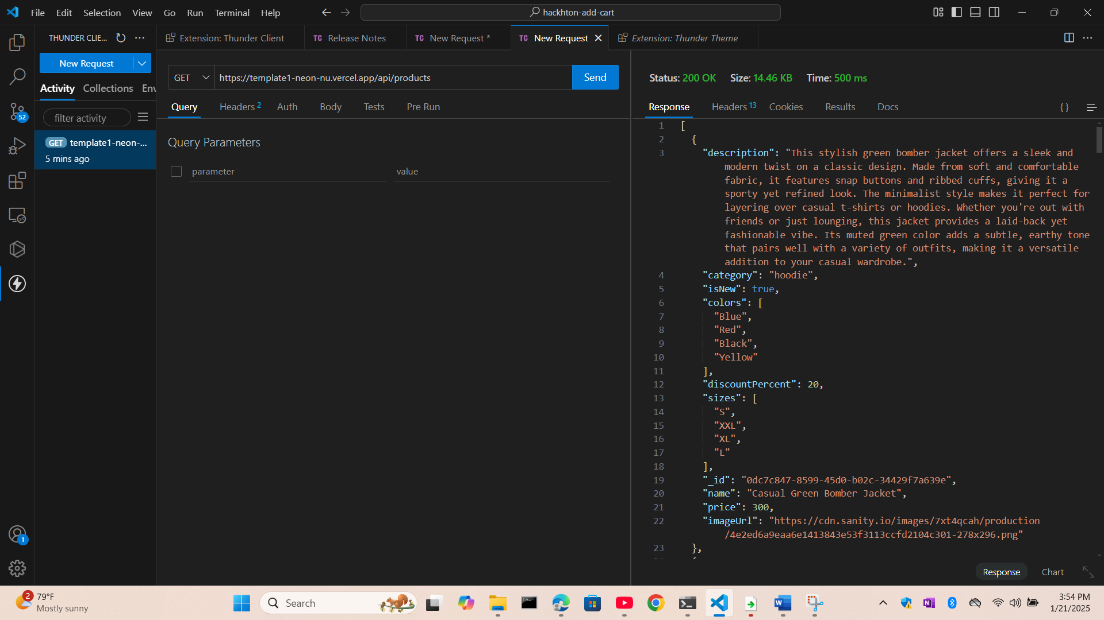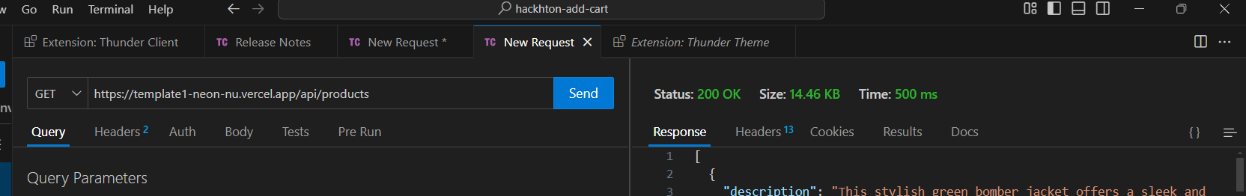

# Testing report sample

|  |  |  |
| --- | --- | --- |
|  | | |
| Test Case ID,Test Case Description,Test Steps,Expected Result,Actual Result,Status,Severity Level,Assigned To,Remarks | | |
|  | | |  | o issues found |
|  | | |  |  |
|  | | |  |  |
|  | | |  |  |
|  |
| TC001,Validate product listing page,Open product page > Verify products,Products displayed correctly,Products displayed correctly,Passed,Low,-,No issues found |
|  |  |  | | |
|  |  |  | | |
|  |  |  | | |

+

+

TC003,Check cart functionality, Add product to cart > Verify cart contents,Cart updates with added product,Cart updates as expected,Passed,High,-,Works as expected

+

TC004,responsiveness on mobile,Resize browser window > Check layout,Layout adjusts properly to screen size,Responsive layout working as intended,Passed,Medium,-,Test successful

