**NOTRE DAME UNIVERSITY BANGLADESH**



Software Engineering

Project Report

Submitted to:

Nafisa Tabassum (Lecturer NDUB)

Submitted by: CSE-19

Shazidul Alam - 0692220005101009

Anisur Rahman Naeem – 0692220005101015

Faisal Morshed Akash – 0692220005101007

**Image Compressor, Pdf encryptor, Complaint Management System**

**Introduction**

The Document Security, Image Compression & Complaint Tracking Suite is a comprehensive software project designed to address essential tasks in data management, including secure document encryption, efficient image compression, and organized complaint tracking. Built using Python, with tkinter for the graphical interface and MySQL for backend data storage, this suite combines robust functionality with a user-friendly design. Each application within the suite—the PDF Encryptor, Image Compressor, and Complaint Management System—serves a unique purpose to enhance data security, optimize storage, and streamline record-keeping. The PDF Encryptor allows users to password-protect PDF files, ensuring that sensitive documents remain secure and restricted to the originating device. The Image Compressor reduces image file sizes, saving storage space without sacrificing quality. The Complaint Management System provides a structured method for submitting and viewing complaints, enhancing organization and retrieval of feedback or records. Together, these applications create a cohesive solution that fulfills data security, storage efficiency, and management needs for both personal and professional use.

**Project Objective**

The primary objective of this project was to create three separate software applications:

**1. PDF Encryptor:** For secure PDF encryption with password protection and non-shareable restrictions.

**2. Image Compressor:** For efficient compression of image files to save storage space.

**3. Complaint Management System:** For recording and tracking user complaints in an organized manner.

**Motivation:**

The motivation behind the Document Security, Image Compression & Complaint Tracking Suite lies in the growing need for accessible, reliable tools that enhance data security, storage efficiency, and record management in everyday applications. As digital information management becomes essential for both individuals and organizations, this suite offers targeted solutions to protect sensitive documents, conserve storage resources, and maintain organized records of user feedback. By integrating these functionalities into one cohesive suite, the project aims to provide a practical tool that is simple to use yet powerful enough to address key data management needs. This report documents the development process, technical specifications, and functionality of each application, with the goal of showcasing how these tools contribute to a safer, more organized, and efficient digital environment.

**Literature Review:**

In recent years, the importance of data security, optimized digital storage, and efficient record-keeping has driven extensive research and development in digital information management. Numerous studies highlight the role of encryption software in protecting sensitive information. Encryption has become a standard for safeguarding documents, with password protection as one of the most accessible methods for individuals and small businesses (Garfinkel, 2015). PDF encryption, specifically, has grown in popularity due to its platform independence and widespread use in both personal and professional settings, underscoring the need for user-friendly encryption software that can integrate seamlessly with everyday workflows (Al-Suqri, 2017).

Alongside document security, image compression techniques are essential for reducing file sizes without significant quality loss, which conserves storage space and improves data transfer efficiency (Wallace, 1992). The development of algorithms such as JPEG compression has provided a foundation for tools that enable users to compress images quickly and effectively (Pennebaker & Mitchell, 1993). These advancements have proven particularly valuable as high-resolution images become increasingly common, necessitating solutions that allow users to manage storage space more effectively.

Moreover, complaint management systems have gained attention in research for their role in enhancing customer relations and organizational transparency (Davidow, 2003). Complaint management tools allow organizations to systematically capture, store, and respond to user feedback, which can lead to improvements in both customer satisfaction and operational processes (Homburg & Fürst, 2005). Studies have shown that organized complaint tracking contributes to better service quality and accountability, as these systems enable users to review and respond to issues in a structured way.

This project draws upon these foundational areas of research by combining encryption, compression, and complaint management into a single suite of applications. The Document Security, Image Compression & Complaint Tracking Suite is designed to integrate secure document handling, optimized storage, and systematic record-keeping in a single user-friendly package. In doing so, it seeks to provide a practical and efficient solution for the daily challenges of data security, storage management, and complaint tracking, offering users a versatile tool informed by advancements in data management technologies.

**Tools:**

Python, tkinter, MySQL, VS Code

**Implementation:**

**frontend**

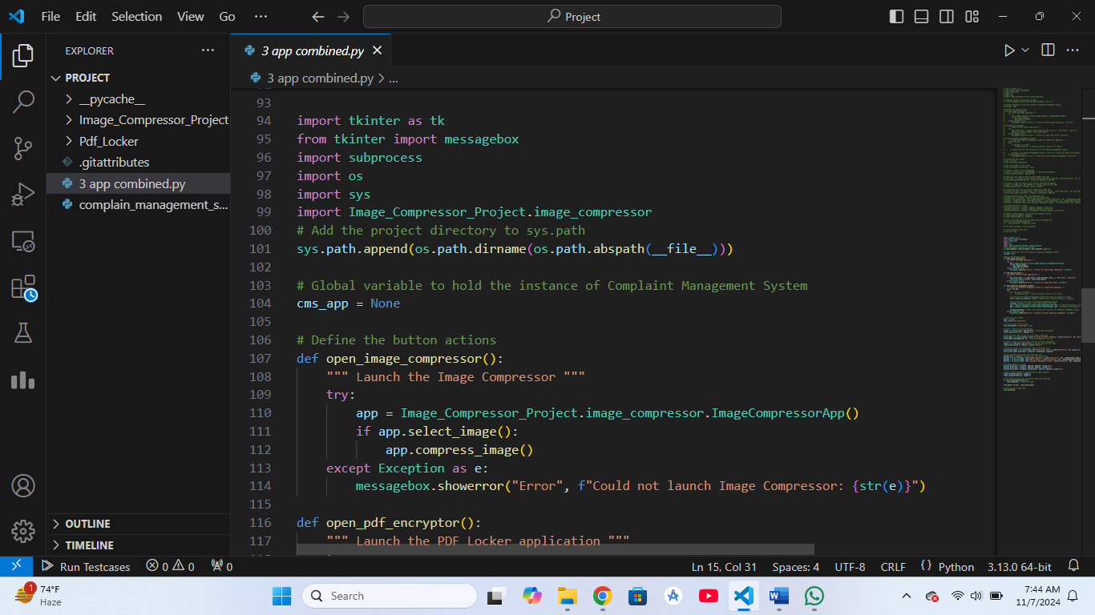

**Backend:**

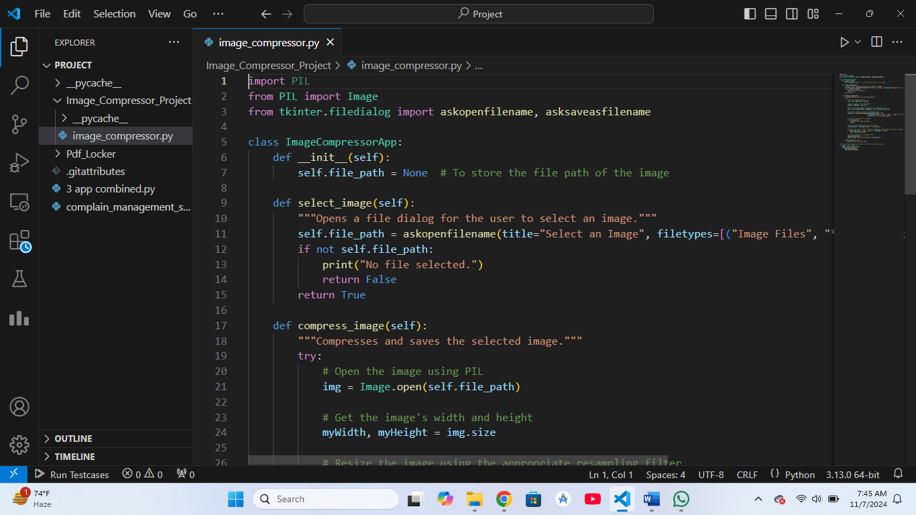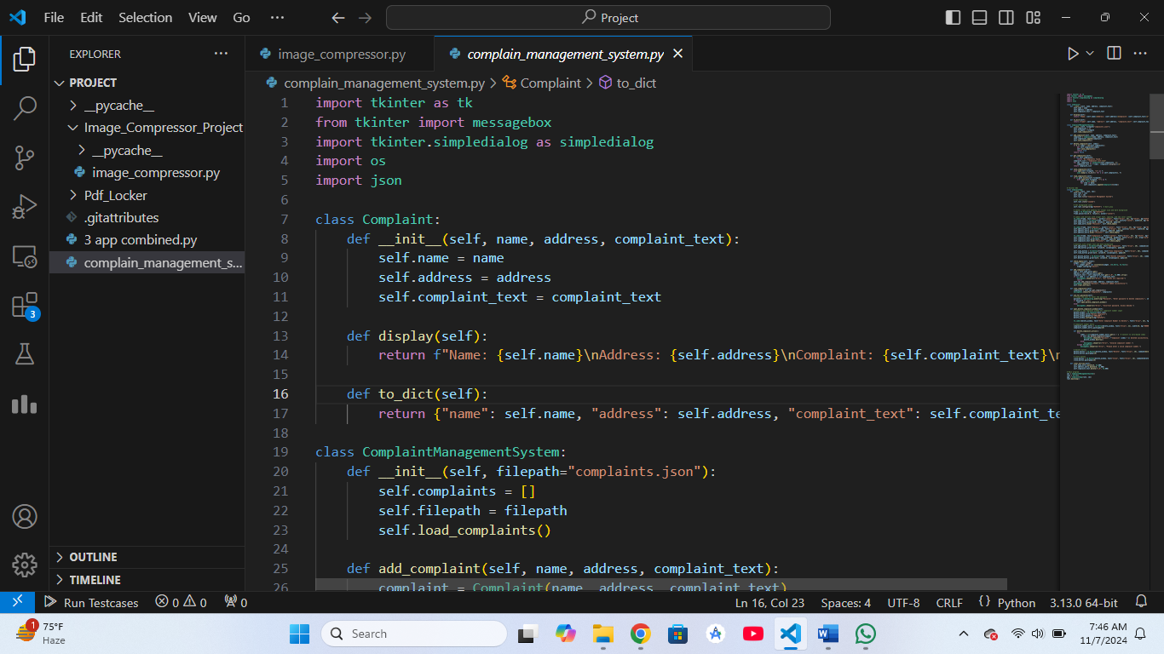

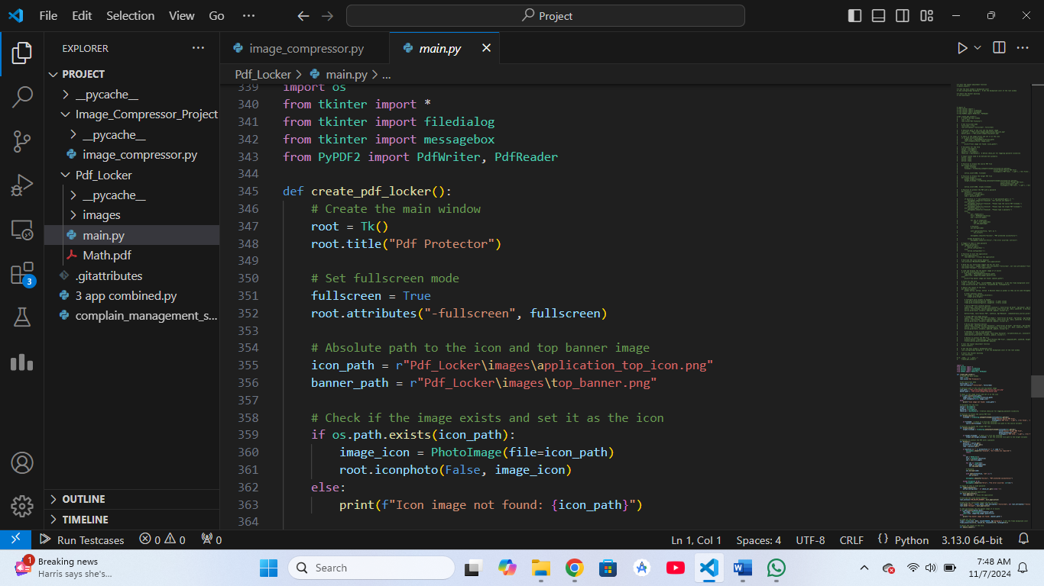

**Use Case Diagram**

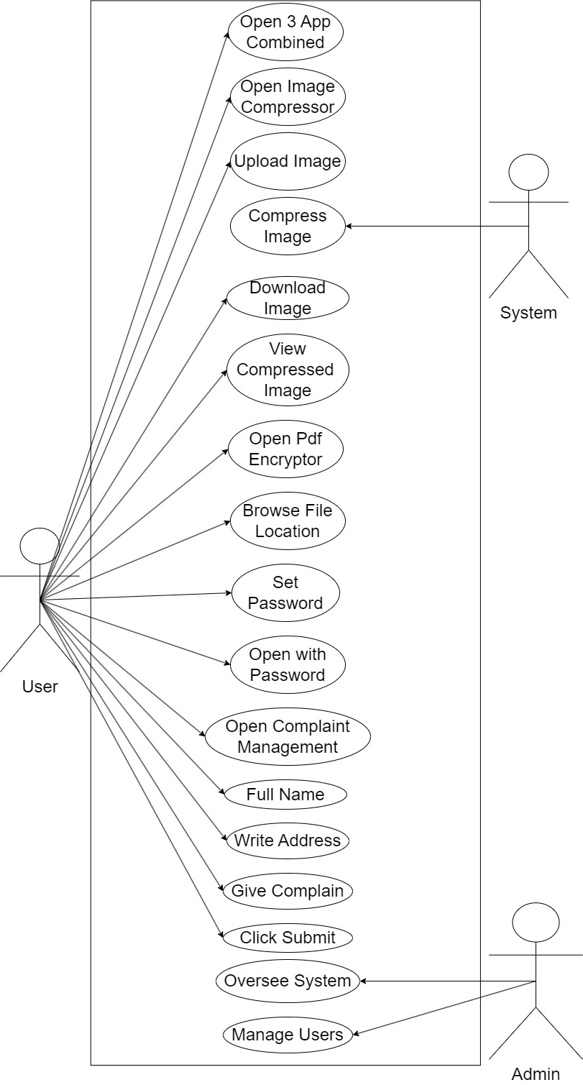

**Activity Diagram**

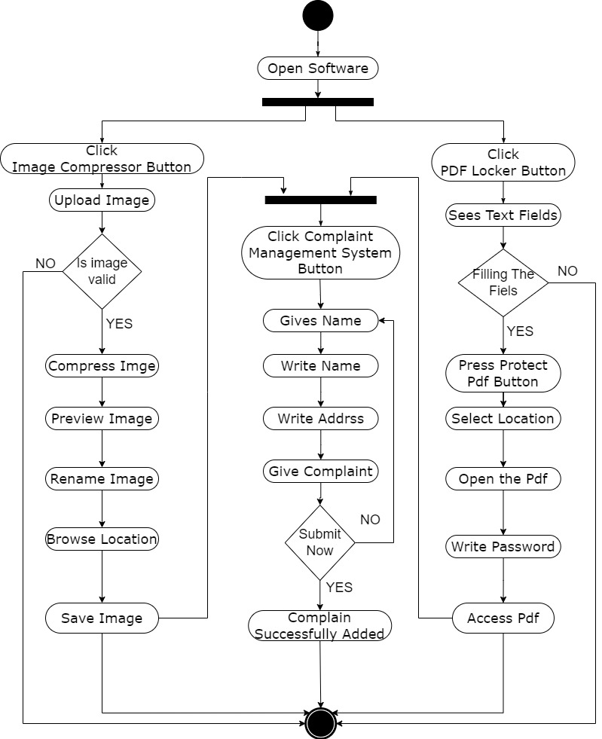

**Challenges Faced**

Throughout the development process, we encountered numerous challenges. One of the primary difficulties was debugging complex errors, particularly in ensuring PDF is encrypted and handling issues with the ui issues with complain management system. However, through persistent troubleshooting, we successfully completed the project.

**Future Scope:**

The **Document Security, Image Compression & Complaint Tracking Suite** is well-suited for users seeking a stable, offline tool for secure document handling, efficient storage, and organized complaint management. Its straightforward design and offline functionality make it an ideal solution for personal and small-scale professional use, particularly in environments with limited internet connectivity or where users prioritize local data storage. By maintaining its current scope, this suite provides a reliable, lightweight solution with long-term stability and minimal maintenance requirements.

**Conclusion**

The Pdf Encryptor & Complaint Management System is a robust solution for secure file handling, optimized storage, and complaint management. The successful development and integration of the PDF Encryptor, Image Compressor, and Complaint Management System demonstrate the power of Python, tkinter, and MySQL to create efficient and user-friendly applications. This System provides a reliable and practical solution for both personal and professional use, fulfilling the project’s objectives effectively.