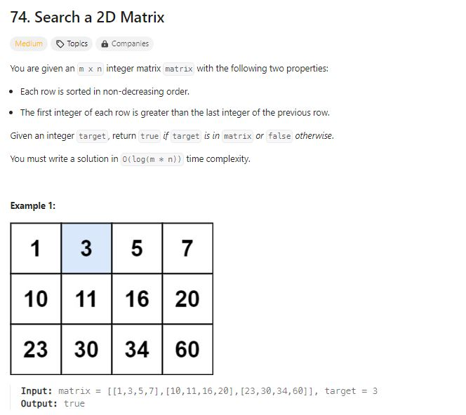**Problem Statement:**

This problem has easy brute force solution but it will take time complexity of T: O(n^2) but we have to optimize it into T: O (log n).

Some brute force solutions are:

**. Merging all the matrixes into a single list and then run binary search to find the element.**

**. Go through each row and doing binary search to find the element. O (N*log n)**

**Most optimal way here 🡪 T:O(log n)**

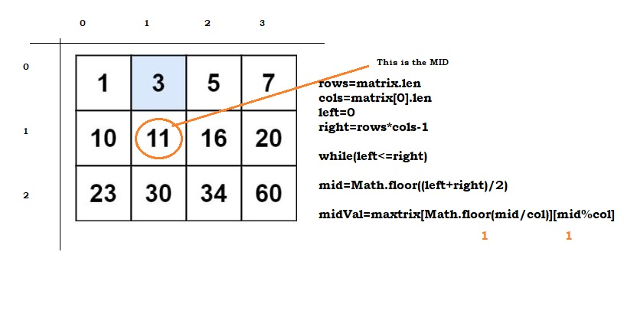

**Approach to find the mid inside the 2D Matrix**