

**Ahsanullah University of Science and Technology (AUST)**

Department of Computer Science and Engineering

## Assignment-3

Course No: CSE4238

Course Title: Soft Computing Lab

**Submitted to:**

Sanjana Karim Lora  
Lecturer  
Department of CSE,AUST

Nibir Chandra Mandal  
Lecturer  
Department of CSE, AUST

**Submitted by :**

**Name**: Shazid Morshedul Haque

**ID:**170104069

**Group**: B1

**Semester:**4.2

**Given Assignment:**

Last 3 digits of my id is 069.

* (069 % 3) = 0 which indicates that the experiment should be on Dataset 1.
* (069 + 1) %5 = 0 which indicates that model should be CNN with more than 2 convolutional layers.

**Overview of Given Dataset:**

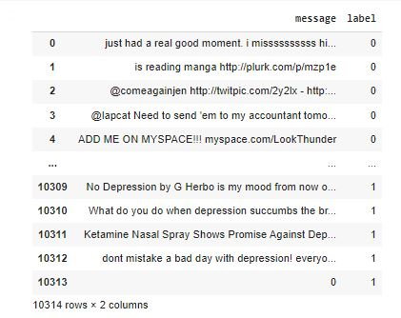

which has tweets and sentiment according to the tweets

Then the dataset was split into 3 parts -

1. Train
2. Validation
3. Test

The texts were filtered for special characters and then tokenized.

## A sequential model is initiated which is given below:

## 

## Parameters: Number of Epoch was 5.

## Epochs:

## 

## 

## Confusion Matrices:

## Train sequence

## 

**Validation Sequence**

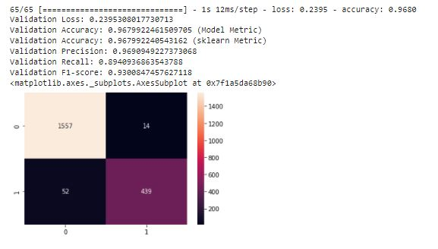

**Test Sequence**

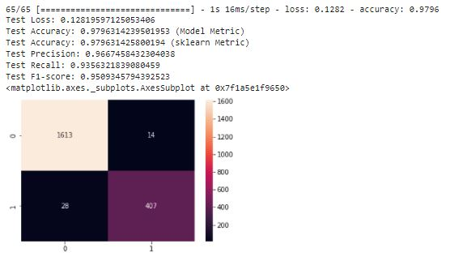

**Github Link of this course**

[**https://github.com/ShazidMorshed14/CNN-Model**](https://github.com/ShazidMorshed14/CNN-Model)