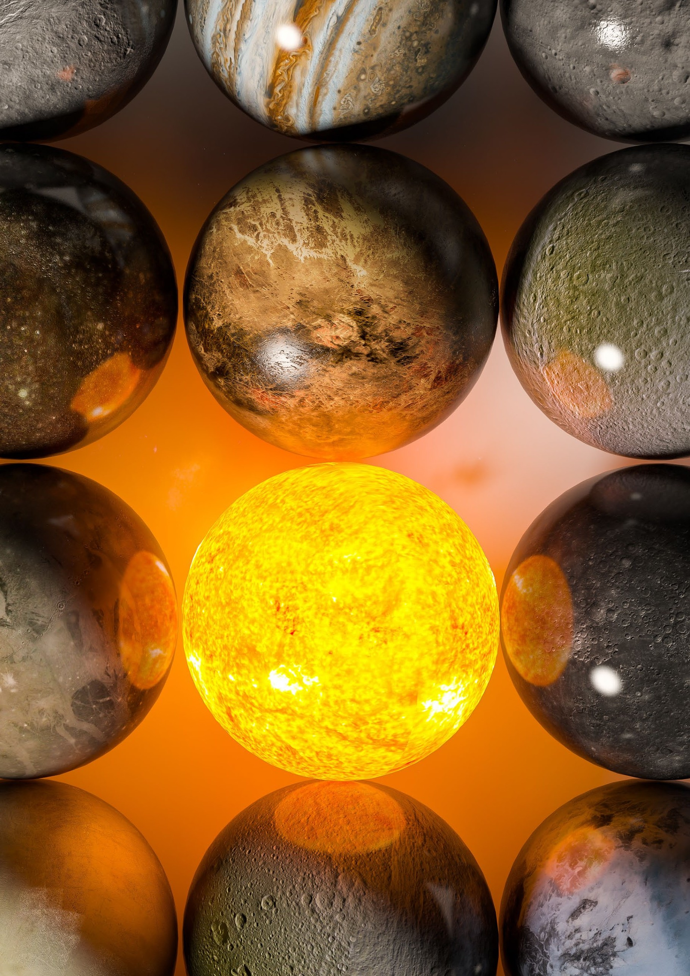

Planets

C#

Planets

Arrays are the traditional way of storing data while an application is running, and it works quite well. But arrays have, among other things, their limitations when it comes to dynamics – for example, it is both complicated and resource-intensive to insert a new element in the middle of an array. But fortunately, the framework contains modern and better alternatives – namely the so-called collection classes. There are a lot of classes related to collections, all under the System.Collections namespace

* but the most interesting can be found in System.Collections.Generic1

In order to use the different collections, you specify which data type should be represented in the collection. List<String>

In this task, you will work with Lister, and you will have to design your own generic class "Planet", which should have a number of properties / characteristics. You will find a list of properties for planets at the back of this task. Your list must contain "Planet" objects.

A list is also called a dynamic array. When allocating a list, you do not specify where you want items to accommodate. When a new item is added to the list, it is constantly placed at the back.

* 1. Design and create your "Planet" class with the associated properties.
  2. Create a list that you can call planets and add the following planets Mercury, Earth, Mars, Jupiter, Saturn, Uranus, Neptune, Pluto using the Add method. Remember that you must first instantiate the objects.
  3. Now print your list using the foreach loop.
  4. In the list of planets, Venus is missing. So, Venus must be inserted into the list. Since planets are sorted in order from the Sun, Venus must be inserted just after Mercury and just before Earth.
  5. Try printing your list again, is Venus in its place?
  6. In August 2006, the International Astronomical Union declared that Pluto was no longer considered a planet, instead the planet was given the status of a so-called dwarf planet. Therefore, Pluto must be removed from the list. It is a bit difficult to remove something from a list unless you have the correct object reference or you know the index in which the item is placed. There are good ways to remove items from a list. Remove – removes an item with the same obj. reference RemoveAt – removes an item at a given position RemoveAll – removes all items

It is far from always that you know the index number of the element you want to delete, therefore it will be smarter to loop through and find the element to delete - by using an if statement. Print the list and see if Pluto has disappeared.

* 1. Reinsert Pluto.
  2. There is a way to get the number of items in a list, find it, and print the number to the console
  3. Create a new list and insert all the items in the list that have a "mean temperature" below 0, print your new list – in this should be Mars, Jupiter, Saturn, Uranus, Neptune and Pluto. Tip: If you're not a shark for LINQ – you can use a foreach loop.
  4. Create a new list and add all the planets that have a diameter of more than 10000 km – but less than 50000 km
  5. Finally, try removing all planets from the list



**P**

|  |  |  |  |  |  |  |  |  |  |
| --- | --- | --- | --- | --- | --- | --- | --- | --- | --- |
| **Fakta-ark**  **laneter** |  |  |  |  |  |  |  |  |  |
| Mass (1024kg) | 0.330 | 4.87 | 5.97 | 0.642 | 1898 | 568 | 86.8 | 102 | 0.0146 |
| Diameter (km) | 4879 | 12,104 | 12,756 | 6792 | 142,984 | 120,536 | 51,118 | 49,528 | 2370 |
| Density (kg/m3) | 5427 | 5243 | 5514 | 3933 | 1326 | 687 | 1271 | 1638 | 2095 |
| Gravity (m/s2) | 3.7 | 8.9 | 9.8 | 3.7 | 23.1 | 9.0 | 8.7 | 11.0 | 0.7 |
| Rotation Period (hours) | 1407.6 | -5832.5 | 23.9 | 24.6 | 9.9 | 10.7 | -17.2 | 16.1 | -153.3 |
| Length of Day (hours) | 4222.6 | 2802.0 | 24.0 | 24.7 | 9.9 | 10.7 | 17.2 | 16.1 | 153.3 |
| Distance from Sun (106  km) | 57.9 | 108.2 | 149.6 | 227.9 | 778.6 | 1433.5 | 2872.5 | 4495.1 | 5906.4 |
| Orbital Period (days) | 88.0 | 224.7 | 365.2 | 687.0 | 4331 | 10,747 | 30,589 | 59,8 | 90,56 |
| Orbital Velocity (km/s) | 47.4 | 35.0 | 29.8 | 24.1 | 13.1 | 9.7 | 6.8 | 5.4 | 4.7 |
| Mean Temperature (C) | 167 | 464 | 15 | -65 | -110 | -140 | -195 | -200 | -225 |
| Number of Moons | 0 | 0 | 1 | 2 | 67 | 62 | 27 | 14 | 5 |
| Ring System? | No | No | No | No | Yes | Yes | Yes | Yes | No |

