**DAYANAND ACADEMY OF MANAGEMENT STUDIES**



**BACHELOR OF COMPUTER APPLICATION (B.C.A)**

**BATCH (2022 – 2025)**

**Project 1**

**Serverless Image Processing**

* **Submitted to:-** **Submitted by:-**
* **Mr. Abhinav Dwivedi Mohd shazim**
* **Trainer B.C.A 4-(B)**

***PROJECT-2***

**Deploy a Static Website on AWS**

|  |
| --- |
| ❖In this project, we will learn how to create a static website and deploy it using AWS services. A static website is a site that consists of HTML, CSS, and JavaScript files, and it doesn't require server-side processing or a database. |

∙ **LAB STEPS:-**

**Task 1: Sign in to AWS Management Console**

1. Click on the Open Console button, and you will get redirected to AWS Console in a new browser tab.

2. On the AWS sign-in page,

∙ Leave the Account ID as default. Never edit/remove the 12-digit Account ID present in the AWS Console. otherwise, you cannot proceed with the lab.

∙ Now copy your User Name and Password in the Lab Console to the IAM Username and Password in AWS Console and click on the Sign in button.

3. Once Signed In to the AWS Management Console, Make the default AWS Region as US East (N. Virginia) us-east-1.

**Task 2: Creating a S3 Bucket**

In this task, we are going to create a new S3 bucket in the US East (N. Virginia) region with a unique name disabling ACLs, and allowing public access for hosting the static website.

**1.** Navigate to S3 by clicking on the Services menu at the top, then click on S3 in the Storage section**.**

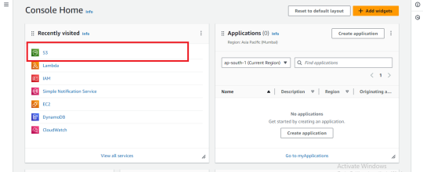

2. In the S3 dashboard, click on the **Create Bucket** button.

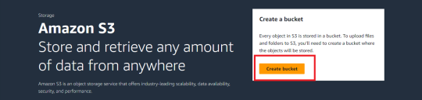3. In the General Configuration, **Bucket name**: Enter abcxyz

∙ **Note**: S3 Bucket names are globally unique, choose a name that is available. Maybe you can enter your name and create one.

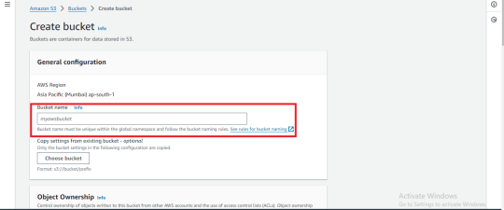4**.Object ownership**: Select **ACLs enabled** option.

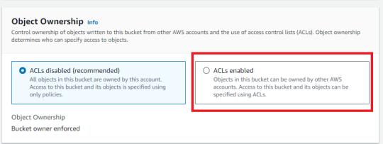

5. In the option of **Block Public Access** settings for this bucket, Uncheck the option of **Block all public access**.

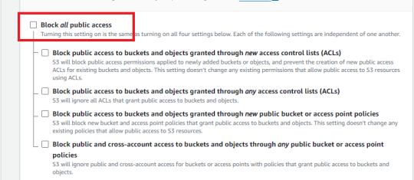

6. Check the I acknowledge that the current settings might result in this bucket and the objects within becoming public checkbox.

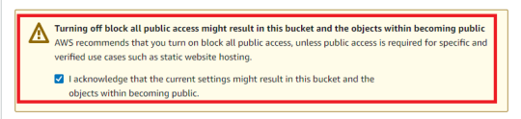7. Keep Everything default and click on **Create Bucket** button.

**Task 3: Uploading HTML File**

**1.** To proceed, go to the **S3 Bucket Name** that you created and click on it.

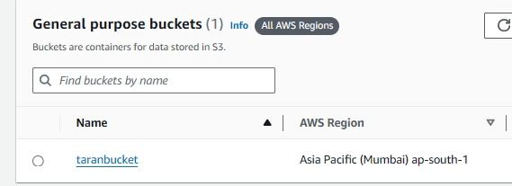2. After that click on **Upload**

Click on Add Files

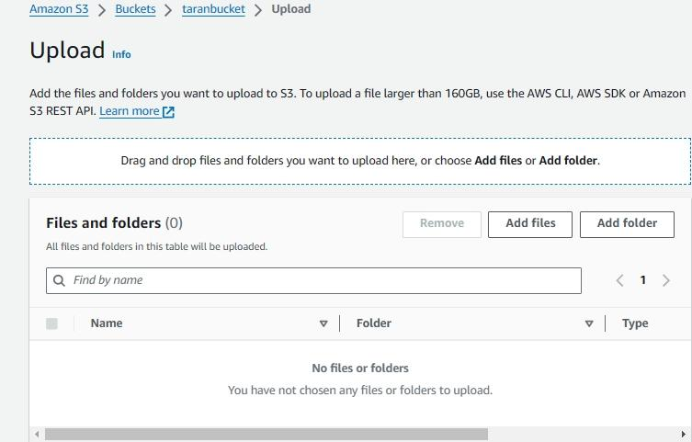3. Select your files and upload.

**Task 4: Enable Static Website Hosting settings**

In this task, we will enable static website hosting for our S3 bucket, configure it to use index.html and error.html.

1. To proceed, go to the S3 bucket name that you created and click on it. After that, navigate to the Properties tab which can be found at the top of the screen.

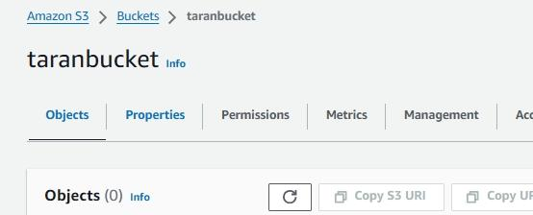

2. Scroll down to the **Static website hosting** section and click on **Edit** button.

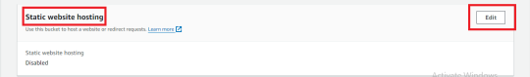

**3.** Static website hosting: Select **Enable**

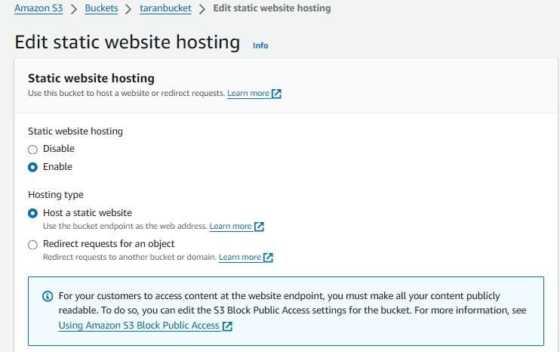

**4. Index document: Type index.html**

**Error document: Type error.html**

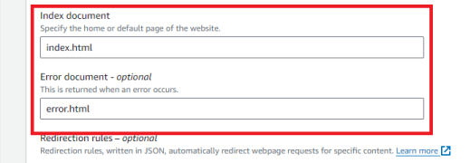**5.** Click on the **save Changes.**

**Task 5: Test the Website**

**1.** Select your **HTML** File

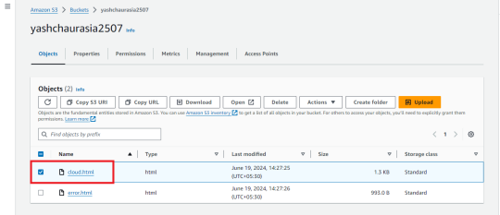**2.** Now copy the Static Website URL

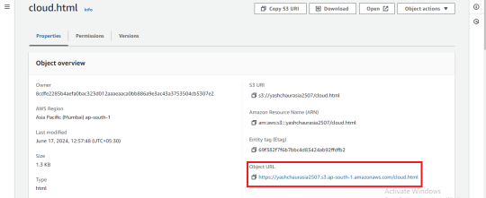**3.** Then, Run it in your Browser

