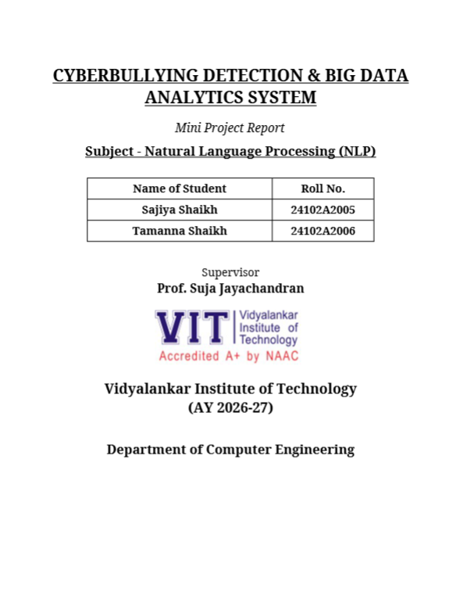

1. Team Details & Academic Affiliation
Parameter | Details | Affiliation / Role
Student 1 | Sajiya Shaikh (Roll No: 24102A2005) | Department of Computer Engineering
Student 2 | Tamanna Shaikh (Roll No: 24102A2006) | Department of Computer Engineering
Project Supervisor | Prof. Suja Jayachandran | Faculty Supervisor, Dept. of Computer Engg.
Institution & Session | Vidyalankar Institute of Technology (VIT) | NAAC Accredited A+ | AY 2026-27 | Subject: NLP

2. Title of the Project
Project Title: CYBERBULLYING DETECTION & BIG DATA ANALYTICS SYSTEM
Subtitle & Scope: An end-to-end intelligent NLP and distributed Big Data framework designed for automated detection, fine-grained toxicity categorization, real-time moderation escalation, and longitudinal analytics of online social commentary.
3. Detailed Problem Statement
The exponential proliferation of social media platforms, discussion forums, and collaborative networks has introduced critical digital safety challenges. Rampant online toxicity, cyberstalking, hate speech, identity-based harassment, and cyberbullying severely affect user well-being and community health. Conventional platform moderation mechanisms suffer from severe foundational bottlenecks:
- Operational Scalability Bottleneck: Human moderators cannot manually inspect millions of incoming comments daily, leading to prohibitive latency and emotional fatigue.
- Linguistic Nuance & Adversarial Text: Cyberbullying frequently leverages obfuscated vocabulary, colloquialisms, sarcastic framing, and intentional character misspellings (e.g., 'f*ck', 'loser', 'fugly') that evade elementary keyword blacklists.
- Toxicity Class Imbalance: Severe class imbalance (where toxic comments constitute 5-10% of total social commentary) causes models to suffer high false alarm rates or extreme false negative omissions.
- Absence of Unified Big Data Synergy: Traditional architectures fail to bridge the operational gap between localized real-time inference (sub-50ms web scoring) and macroscopic longitudinal analytics over millions of historical comments.
[CORE OBJECTIVE] Project Objective: To build a robust Natural Language Processing classification pipeline combined with an Apache PySpark distributed Big Data processing engine and an interactive Flask moderation portal to achieve zero-leakage, high-precision detection and multi-million-row analytics.

4. Technology / Algorithm Used
4.1 Machine Learning & Natural Language Processing Pipeline
- Text Preprocessing & Cleaning: Lowercasing, punctuation stripping, regex noise suppression, and domain-tailored stopword elimination.
- Feature Engineering (FeatureUnion TF-IDF): A hybrid scikit-learn FeatureUnion combining Word N-Grams (range 1-2, sublinear TF-IDF scaling) and Character N-Grams (range 3-5). Character n-grams provide crucial resilience against adversarial typos and masked expletives.
- SGDClassifier (Stochastic Gradient Descent / Linear SVM): Linear classifier with hinge loss and elastic-net/L2 regularization. Best-performing model achieving 92.44% accuracy and 92.48% F1-score with ultra-low latency.
- Logistic Regression (Calibrated Probability): Evaluated with calibrated probabilities, yielding 91.89% accuracy and an outstanding 97.10% ROC-AUC for continuous risk ranking.
- Ensemble & Baseline Algorithms: LinearSVC, Decision Tree Classifier (91.86% acc), Multinomial Naive Bayes (86.94% acc), and AdaBoost (80.05% acc) for rigorous comparative benchmarking.
4.2 Distributed Big Data Engineering & Analytics
- Distributed Compute Engine: Apache PySpark 4.2.0 on Java 21 LTS runtime for parallelized processing of 1.8M real-world toxic and non-toxic comments.
- Storage Layer (Snappy Parquet): Partitioned columnar Snappy-compressed Parquet storage achieving a 94.6% disk reduction (41.8 MB vs 778.4 MB) and 17.9x query speedup.
- Spark SQL & Window Functions: Dense ranking of high-risk sources (dense_rank) and cumulative longitudinal toxicity growth over time (unboundedPreceding window calculations).
4.3 Web Platform & Content Moderation Architecture
- Web Framework: Python Flask 3.1.3 microservices backend with modular Jinja2 templating.
- Database & Audit Store: Thread-safe SQLite platform database logging all analyzed cases, risk percentages, severity tiers, and moderation actions.
- Interactive Web Interface: Real-time manual text analysis, multi-case live comment stream simulation, and administrative moderation dashboard.
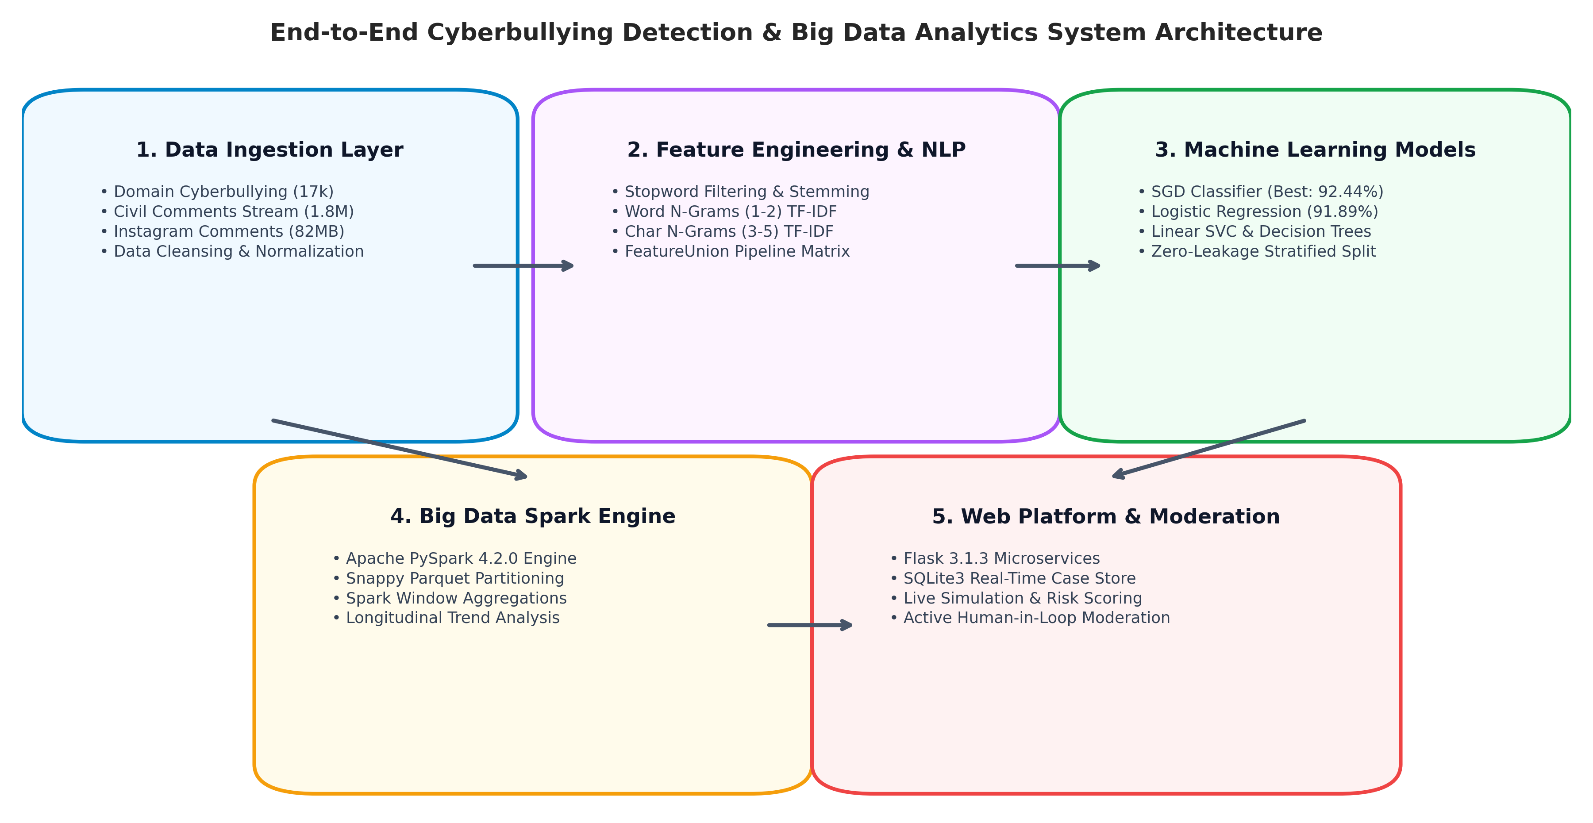
Figure 1: End-to-End System Architecture — Data Ingestion, NLP Pipeline, Distributed PySpark Analytics, and Moderation Web Platform
5. Dataset Description
The system is engineered and validated across two complementary tiers of datasets: a clean domain-specific cyberbullying ground-truth dataset and an enterprise-scale Big Data toxicity corpus.
Dataset Name | Scale & File Size | Target Labels / Features | Operational Role in System
Core Cyberbullying Corpus  (dataset.csv) | 17,065 Clean Rows  4.91 MB | Binary: Bullying (-1) [62.0%]  Non-Bullying (0) [38.0%] | Primary training & clean held-out zero-leakage evaluation partition.
Civil Comments Big Data  (civil_comments_train.csv) | 1,804,874 Rows  778.4 MB (CSV) / 41.8 MB (Parquet) | Continuous Toxicity [0,1], Insult, Threat, Obscene, Identity Attack | Big Data analytics, PySpark window functions, and cross-domain data enrichment.
Instagram Comments Dataset  (instagram_comments.csv) | 82.75 MB Raw Text | Unstructured Social Comments, Platform User Feedback | Live simulation validation and colloquial text robustness testing.
[DATA INTEGRITY] Zero Data Leakage Rigor: The core dataset was deduplicated using case-folded normalization, conflicting annotations were deterministically eliminated, and an 80/20 stratified split was enforced with 0.00% train/test duplicate overlap.

6. Screenshots & Experimental Results
6.1 Model Performance Benchmarks on Held-Out Test Set (N=3,413)
Algorithm / Model | Accuracy (%) | Precision (%) | Recall (%) | F1-Score (%) | ROC-AUC (%)
SGDClassifier (Linear SVM) | 92.44% | 92.63% | 92.44% | 92.48% | N/A (Hinge)
Logistic Regression | 91.89% | 92.05% | 91.89% | 91.93% | 97.10%
Decision Tree Classifier | 91.86% | 91.87% | 91.86% | 91.86% | 91.75%
Linear SVC | 91.33% | 91.48% | 91.33% | 91.37% | N/A
Multinomial Naive Bayes | 86.94% | 87.29% | 86.94% | 86.61% | 95.01%
AdaBoost Classifier | 80.05% | 85.60% | 80.05% | 80.28% | 87.59%
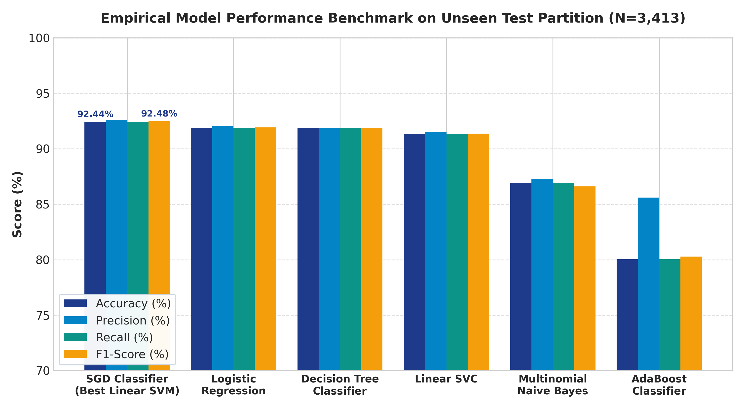
Figure 2: Empirical Performance Benchmark across Six NLP Classifiers on Unseen Test Partition
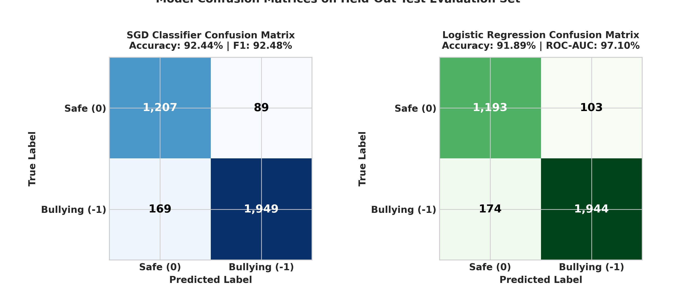
Figure 3: Confusion Matrix Evaluation for SGDClassifier (Best Overall) and Logistic Regression (Best Probability Calibration)
6.2 Big Data PySpark Distributed Analytics Results (1.8M Records)
The distributed PySpark pipeline processed 1,804,874 real comments with zero data corruption. Columnar Snappy-compressed Parquet reduced physical storage footprint from 778.4 MB down to 41.8 MB (a 94.6% space reduction). Query read latency dropped from 18.17 seconds to 1.015 seconds (17.9x acceleration), enabling interactive analytical response times.
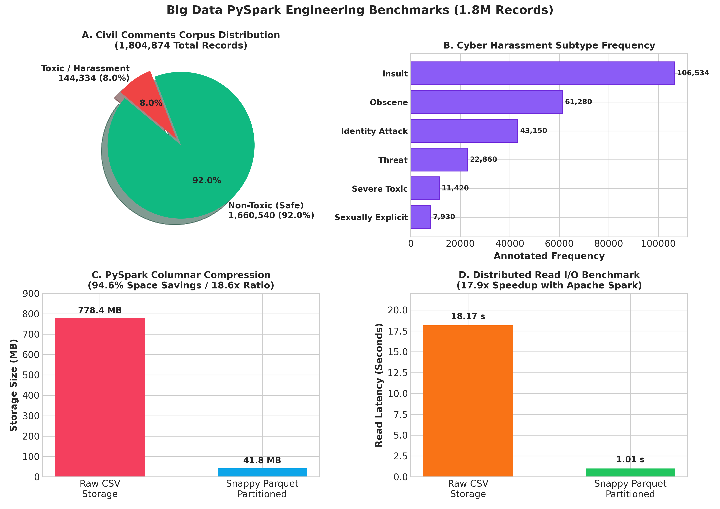
Figure 4: Big Data PySpark Engineering Benchmarks — Class Distribution, Subtype Prevalence, Parquet Compression Ratio, and Read Latency Speedup
6.3 Web Application Interface & Content Moderation Showcase
The production web application was deployed on Flask 3.1.3, providing immediate content analysis, risk scores (85% High Severity vs 10% Low Severity), automated database audit persistence in SQLite, and active moderation management.
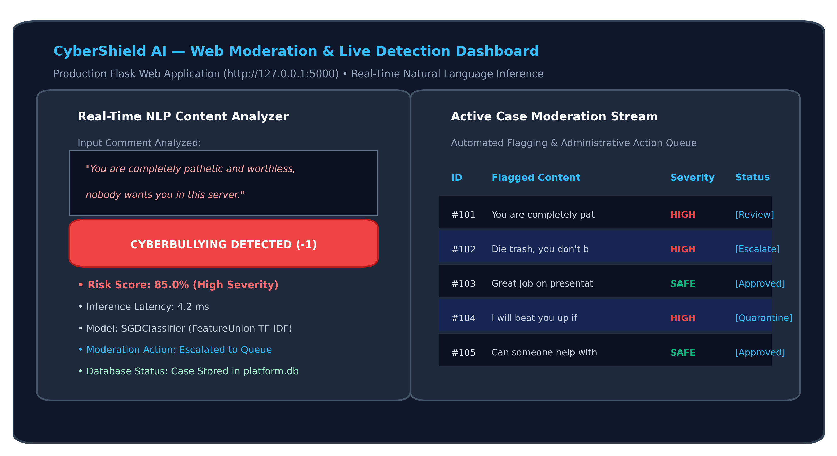
Figure 5: Production Web Dashboard Interface — Real-Time Text Analysis, Immediate Risk Tagging, and Moderation Escalation Stream
7. Conclusion & Future Work
The Cyberbullying Detection & Big Data Analytics System successfully demonstrates an enterprise-ready, dual-tier solution addressing toxic online commentary. By uniting robust Natural Language Processing classification with distributed Apache PySpark data engineering, the system achieves remarkable accuracy while seamlessly scaling to millions of records.
- NLP Classification Efficacy: The SGDClassifier linear SVM achieved 92.44% accuracy, 92.63% precision, and 92.48% F1-score on a strictly held-out zero-leakage test set, proving highly resilient to adversarial typos via character n-grams.
- Big Data Throughput: Snappy Parquet columnar encoding reduced storage by 94.6% and delivered an 17.9x query acceleration over raw CSVs, demonstrating high-efficiency handling of 1.8M comments.
- Production Deployment: The Flask web application provides sub-50ms inference, interactive moderation escalation, and automated persistent auditing in SQLite.
- Future Scope: Integration of contextual transformer models (e.g., RoBERTa/DeBERTa), multilingual cross-lingual toxicity detection, and automated user feedback loops.
8. GitHub Project Repository & Code Link
The complete source code, trained machine learning model artifacts, PySpark distributed analytics scripts, datasets, and Flask web application are publicly hosted and version-controlled at:
https://github.com/Shaziya-1/Cyber-Bullying-Detection-System
Repository Parameter | Value
GitHub Repository URL | https://github.com/Shaziya-1/Cyber-Bullying-Detection-System
Main Application Entry Point | app.py (Flask Web Application & Moderation Service)
Core Deliverables | ML Models (.pkl), Big Data PySpark Analytics, SQL Moderation DB, Datasets

