Table 1: AL376_UserOrderDetails:
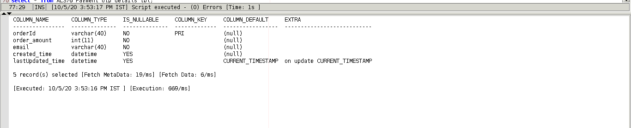

Table 2:AL376_UserCardDetails:
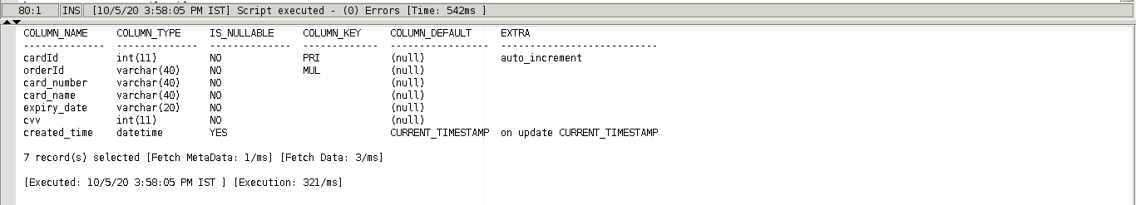

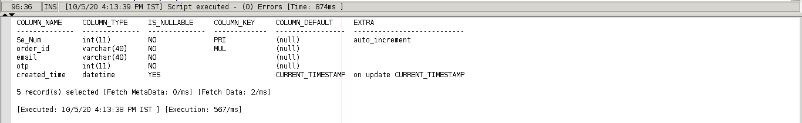
Table 3:AL376_Payment_Otp_Details_tbl:

