

**Subject:** Mobile-Application-Development

**Section:** 03

**Submitted By:** Shazma Rana(22SW15) & Zoya Zahid(22SW109)

**Submitted to:** Mam Mariam

**Date:** 27-Oct-2025

Working Project GitHub Link:

https://github.com/ShazmaRana/MAD_6thSemester_Project-Country_Explorer_App-.git

1.Real-World-Problem-Identification:

This app identifies the problem of user’s experiencing problem when exploring countries through we browsers and searching for them multiple time or everytime. It facilitates users explore countries at one place.

2.Proposed-Solution:

Country Explorer come’s here for providing Solution by offering users to view Countries around the world,Search them and add them to their favorites locally so they can see them even they are offline.

3.Responsive User Interfaces:

Screens:

1.Splash Screen:

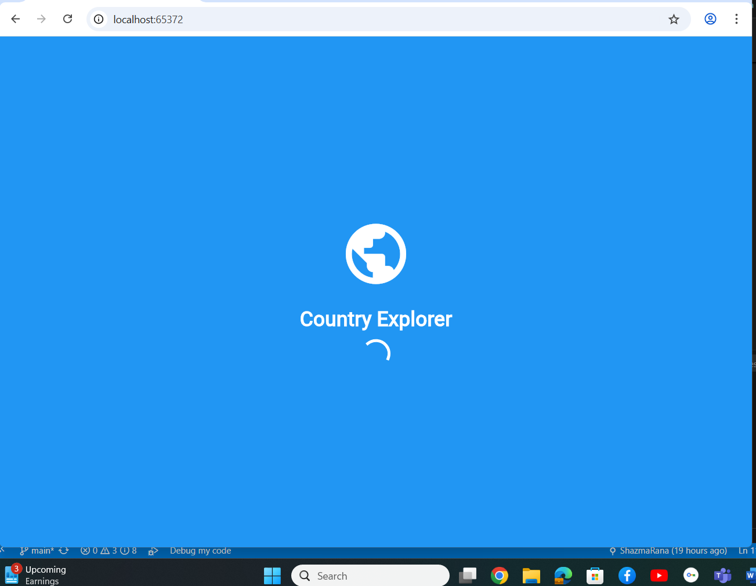

Home-Screen: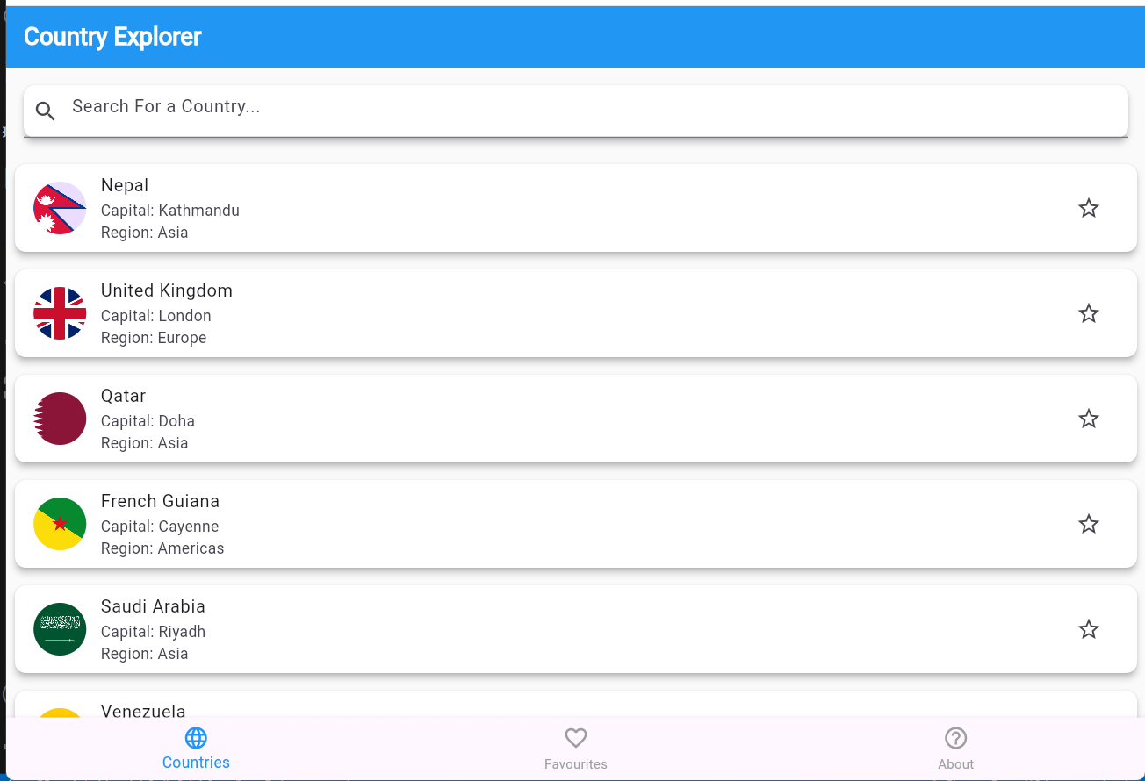

Detail-Screen: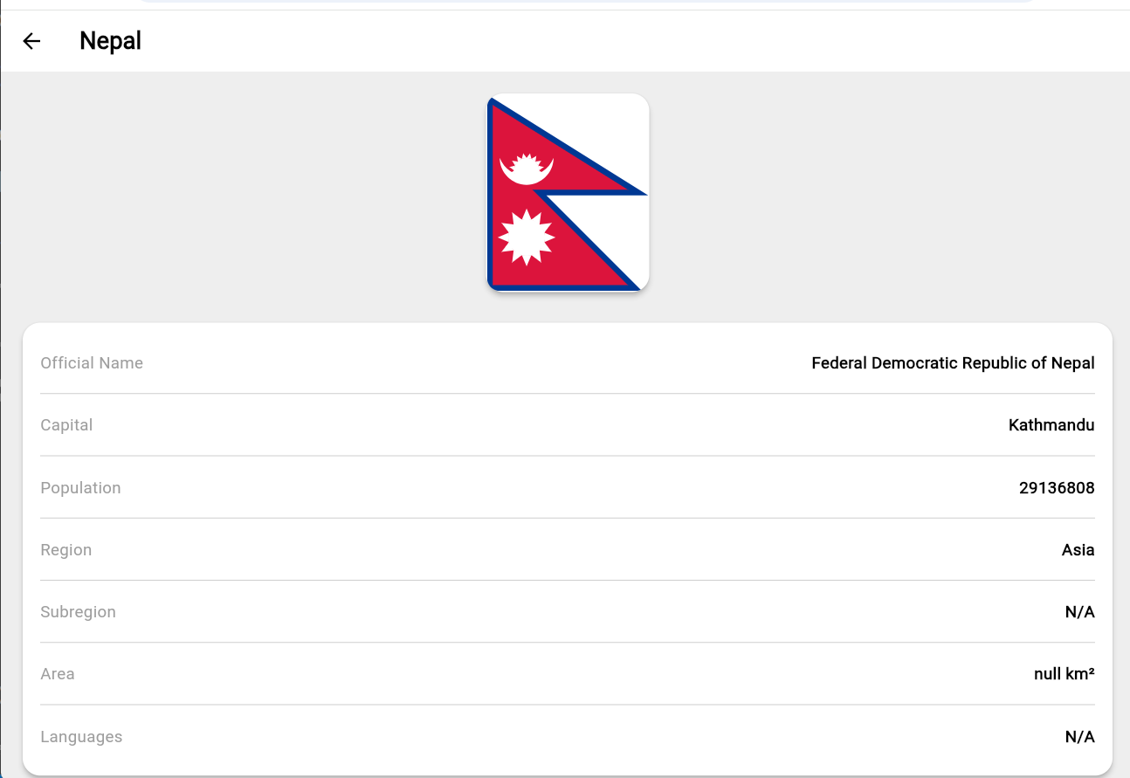

Adding countries to Favorite’s:

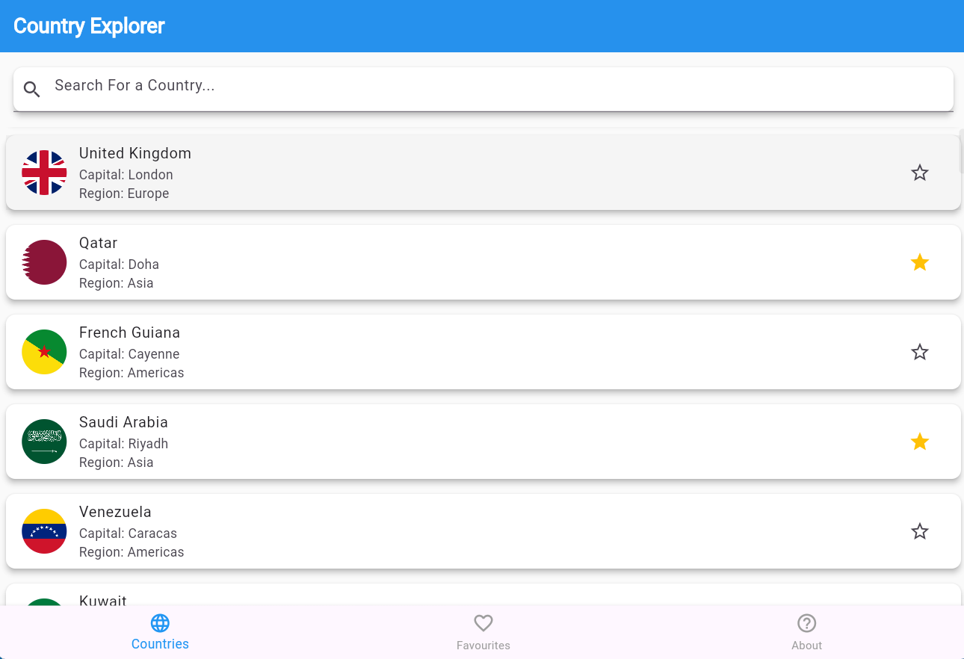

Favorite’s-Screen:

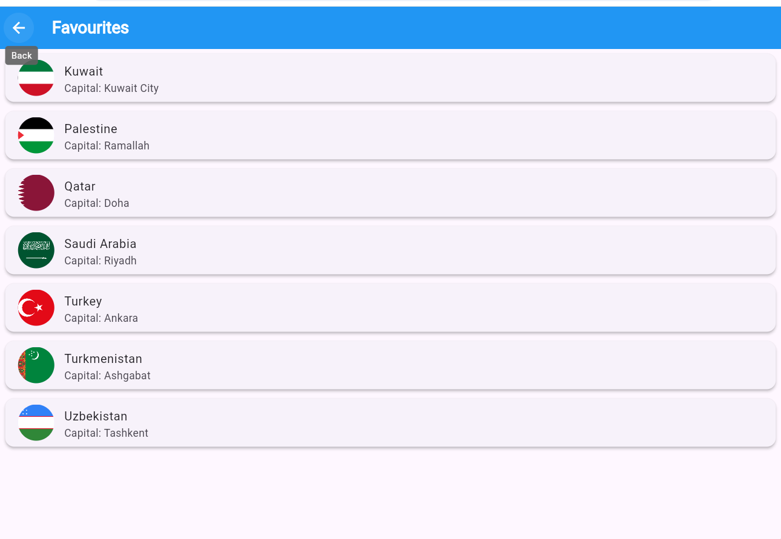

About-Screen: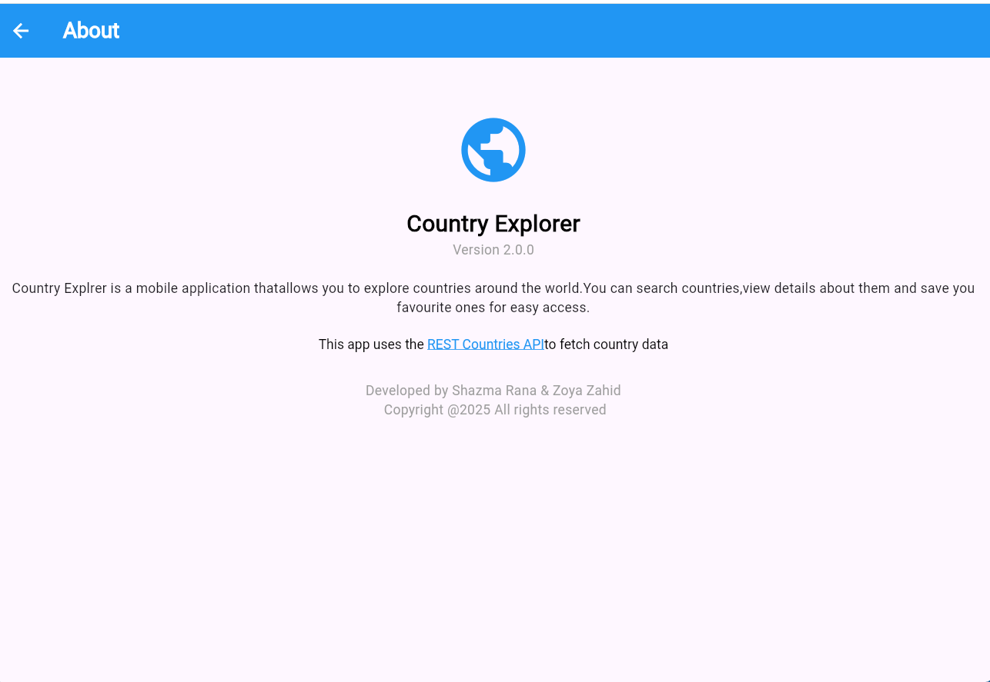

4.Data-Storage Justification:

We used Hive for data storage in our app. Since Hive is a lightweight(No Sql)

Database written in pure Dart and stores data locally which means we can read/write data even offline without an internet connection.

We wanted store very small data only the data of favorite countries i.e(their flag, name , capital, region etc.) so the user can see them even when the app restarts or the internet is off that’s why we opted Hive for storing this small structured data.

5.API’s/Packages:

Api: we used restcountries Api to fetch data of countries around the world or global countries.

Packages:

We used

http: To make Api calls(Fetching Json data from rest countries Api).

hive: to store data locally on device(used for storing favorite countries).

hive-flutter: Provides flutter integration for hive(used to initialize and access Hive boxes easily).

6.Isuues and Bugs we encountered During Development:

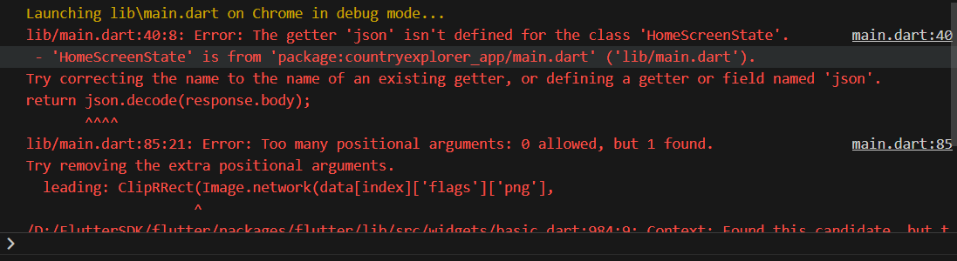

1. Error1 : Json getter error because of json.decode() :

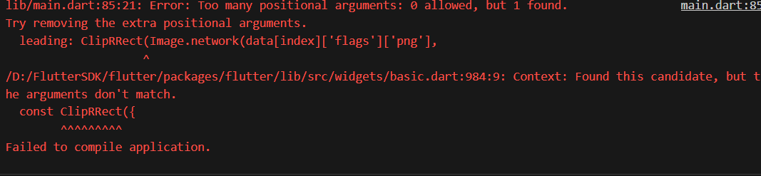

Solution:

Imported ‘dart:convert’ library that has methods json.encode() and json.decode()

import ‘dart:convert’;

Error 2:

Placed wrong arguments in ClipRRect()



Solution : since it doesn’t take Image.netwrok() positional argument

And takes named parametehr like border radius and child:

So replaced parameter with

leading: ClipRRect(

borderRadius: BorderRadius.circular(8.0), // optional, for rounded corners

child: Image.network(

data[index][‘flag’][‘png’],

fit: BoxFit.cover,

),

),

Error 3:

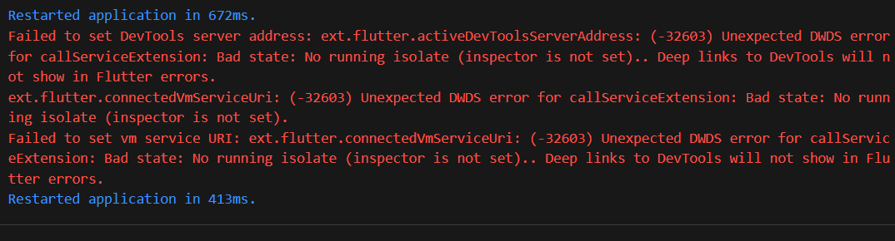Flutter dev tools error:

Solution: Restarted the application and error resolved

Error 4:

FavouritesScreen() constructor wasn’t recognized by flutter due to wrong naming convetion or writing FavouritesScreen like Favouritescreen

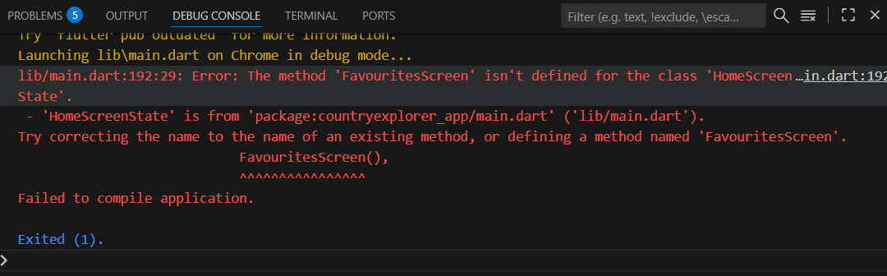

Solution: Corrected the name from Favouritescreen to FavouritesScreen

Error 5: App crashed because of Hive

Opened a wrong spelled HiveBox which was not there:

