Software Requirements Analysis.

for

Online Payroll Management System

Sri Lanka Institute of Information Technology

Software Engineering IT220 | Assignment Two

Prepared by

Rajapaksha R.P.D.S. IT14118982

M.F. Shazna IT14118432

Batch Two

|  |  |
| --- | --- |
|  |  |
|  |  |

Contents

1 Introduction 4

1.1 Introduction 4

2 Context Diagram 5

3 Level One 6

4 Level Two 7

5 Data Dictionaries 9

5.1 Data Dictionary 9

5.2 Data Dictionary for balancing 9

6 Member Contribution 10

# Introduction

## Introduction

An organization is divided in to many vital roles within. Amongst those vital departments Payroll is one of the most fragile yet important part of the whole process. Payroll as we know it today came about during the industrial revolution as the businesses bloomed rapidly, People began to move in to the cities searching for employment and within a short period of time factories were unable to cope up with managing the high number of employees. With the beginning of that mass employment, the need arose to keep accurate records of workers and their pay. Without financial documentation it would have been impossible to keep up with the capacity but later it was also not good enough as organizations began to expect much more than a manual system could provide.

In any business that employs staff needs a fluent and effective payroll system, for a larger organization, the need is much more complex and vital. As an organization becomes larger, various types of posts and departments are added, for those posts, different types of salary schemes will be implemented and their entitled allowances for different types of posts and allowed loans and various other additions to the salary will only make it unable to be managed by a manual system even with a whole department working. Having a software solution which will make the whole process effortless enables to fulfil the employer employee relationship by keeping out of the hassle of paying incorrect amounts and less allowances. It also helps in obeying to legal obligations by keeping the track of the records which helps when paying taxes.

An implementation of the payroll system as a software would result in automating most of the process done in a manual system. It will allow to calculate salary for different types of posts having different salary schemes and other related information, loan information and advances. Also if there are any issues in the salary, an employee would be able to report that from the software itself. Also an employee will be able to request any additional entitlements and information within the system itself.

An online solution goes beyond the norm and provide the access to the system from anywhere and on any device where responsible personnel can manage and do their work without being limited by any hardware or software interruption and customers.

# Context Diagram

# Level One

# Level Two

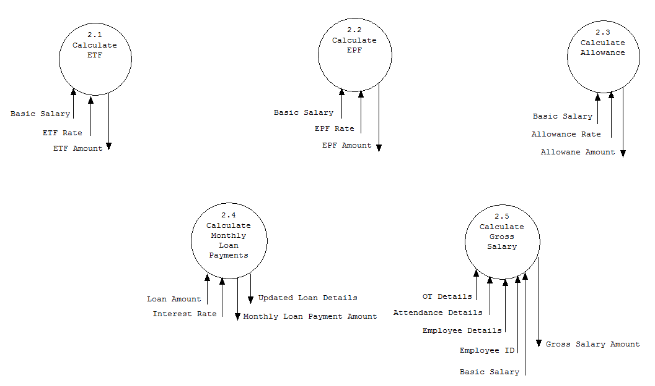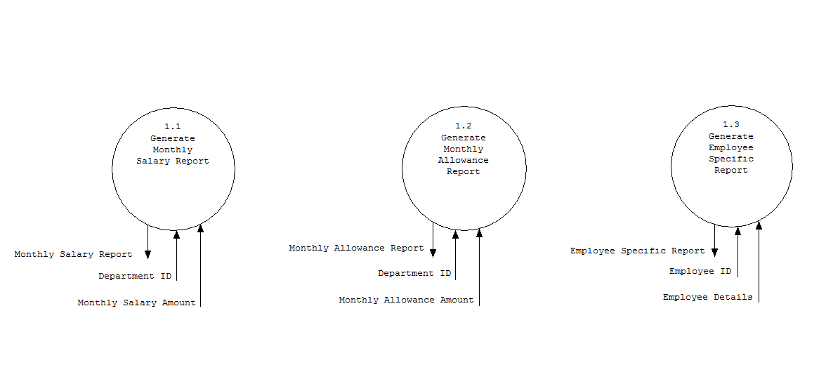

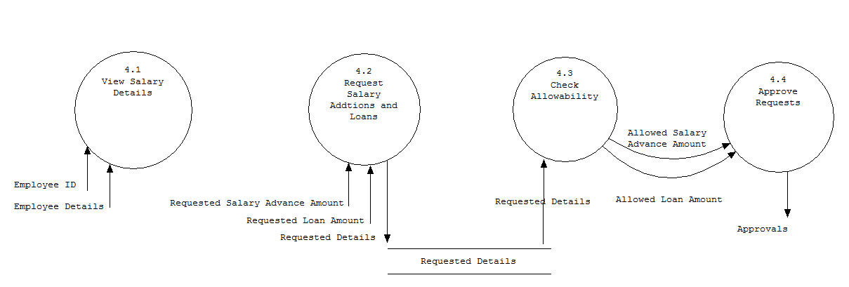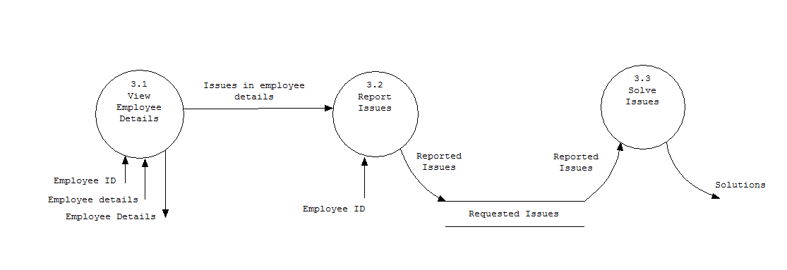

# Data Dictionaries

## Data Dictionary

Employee Details = Employee ID + name + post

Approvals = Salary advance request approval + Loan request approval.

Reports = Monthly salary report + Monthly allowance report + Employee Specific report.

Requests = Salary advance request + Loan request.

## Data Dictionary for balancing

Salary details = [Specific employee monthly salary amount | Department monthly salary amount | Department Monthly Allowance amount ]

Loan details = Loan rate + Loan Interest + Loan amount

Employee Details = Employee name + post + ETF rate + EPF rate

Attendance Details = Employee number of attendance + OverTime

Requested Details = [Requested loan details | Requested Advance amount]



# Member Contribution

Member Contribution

• Faced challenges in identifying main functions and their sub functions.

• Found difficulties in separating the processes for level one and level two in classifying inner processes & outer processes.

• It was complicated to identify the specific data stores to add in the level one or to the level two.

• When creating structure charts, found difficulties in organizing processes to be in transform or the transaction structure format.

• Found difficulties in data balancing when giving data couples from stores to modules in between both levels.