1. **Mobile OS vulnerability**

**Collection:**

Data is obtained by querying 5 English forums (Hackhound, elitehack, icode,anon and vctool) available in HackerWeb. We have retrieved 12 columns by using below SQL query and search string ‘%iOS%’ have been replaced with ‘%android%’ and ‘%windows phone%’ to get appropriate details for respective mobile operating systems.

*select eht.title, ehp.flatContent, ehp.postDate, ehp.subforum, ehp.postrank from elitehackthread eht,elitehackposts ehp where eht.threadID = ehp.threadID and ehp.flatContent like '%ios%' union*

*select at.title,ap.flatContent, ap.postDate, ap.subforum, ap.postrank from anonthread at,anonposts ap where at.threadID = ap.threadID and ap.flatContent like '%ios%' union*

*select it.title,ip.flatContent, ip.postDate, ip.subforum, ip.postrank from icodethread it, icodeposts ip where it.threadID = ip.threadID and ip.flatContent like '%ios%' union*

*select vctt.title,vctp.flatContent, vctp.postDate, vctp.subforum, vctp.postrank from vctoolthread vctt,vctoolposts vctp where vctt.threadID = vctp.threadID and vctp.flatContent like '%ios%';*

**Finding and Discussions:**

We have used analytics tools such as Tableau to analyze the most vulnerable mobile OS.

* We have analyzed on total posts for each mobile OS across timeline.

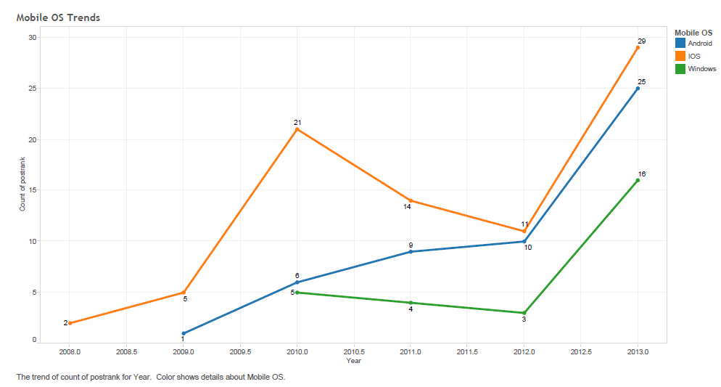

Referring to the above graph, we found that the no. of posts related to iOS are high when compared to other mobile OS. Thus, iOS is the most discussed topic among the hackers in these forums.

* Analysis on ranking of each subforum related to mobile OS on the basis of number of relevant posts

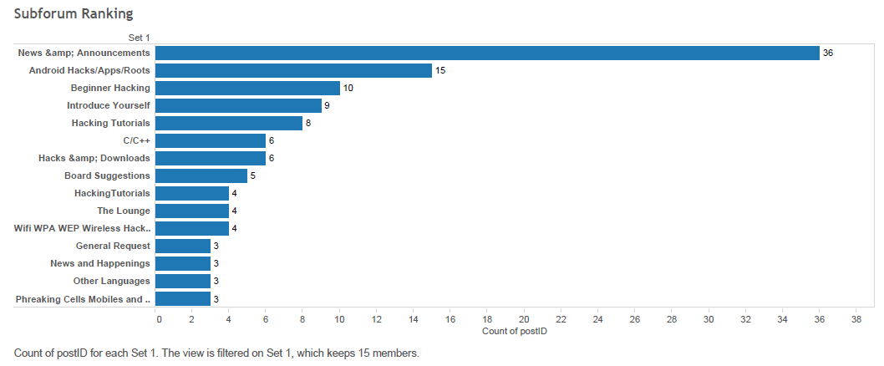

Above graph indicates that **‘News & Announcements’** is the most active sub-forum regarding the number of relevant Mobile OS hacking posts.

1. **Router hacking**

**Collection:**

Python API is used to fetch data relevant to open routers from Shodan. Substantial information related to 10,000 routers existing in different geographic location has been obtained. We have used Regular Expressions to clean and preprocess data and to apply further analysis, we have used excel to store data.

**Finding and Discussions:**

We did three step analysis to convert data into information. Two steps are as follows.

* 1. We have analyzed no. of open routers across countries.

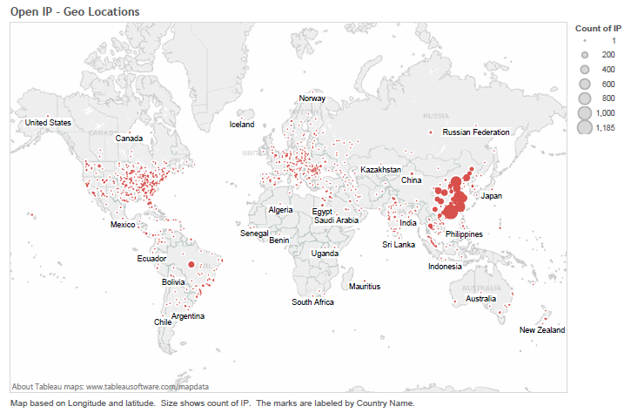

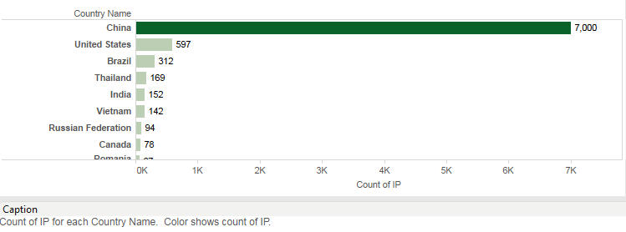

* 1. Further, we drilled down to the country with maximum no. of open routers i.e. China and then found the ISP that provides services for each router (IP). Also, further analysis enabled us to gather insight on which organization in a particular ISP is responsible for the downfall of the ISP.

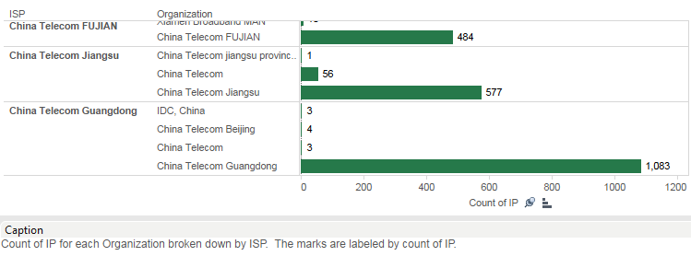

Thus, from the above analysis we came to a conclusion that China has maximum no. of open routers in the world. Also, China Telecom Guangdong – ISP is the most vulnerable ISP in china.

1. **Vulnerability/exploits in Raspberry PI**

**Collection:**

Python API is used to fetch data relevant to devices equipped with Raspberry Pi from Shodan. Substantial information related to these devices in different geographic location has been obtained. We have used Regular Expressions to clean and preprocess data and to apply further analysis, we have used excel to store data.

**Finding and Discussions:**

Tableau has been used to analyze the obtained data. We found that Germany has 22.35% vulnerable devices made of Raspberry Pi.

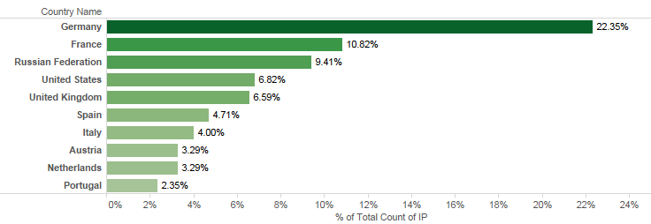

1. **IOT**

**Collection:**

Python API is used to find details on five IOT (Internet of Things) devices from Shodan. Substantial information related to these devices i.e. 32,091 installed in different geographic location has been obtained. We have used Regular Expressions to clean and preprocess data and to apply further analysis, we have used excel to store data.

**Finding and Discussions:**

We did three level analysis on the data obtained and following are the details on each level.

* 1. Analysis is done to find which country has maximum vulnerable Internet of Things. We have used Tableau and found that United States of America is top in combined category(Web Camera, Toasters, Refrigerators, TVs and BeamBox).

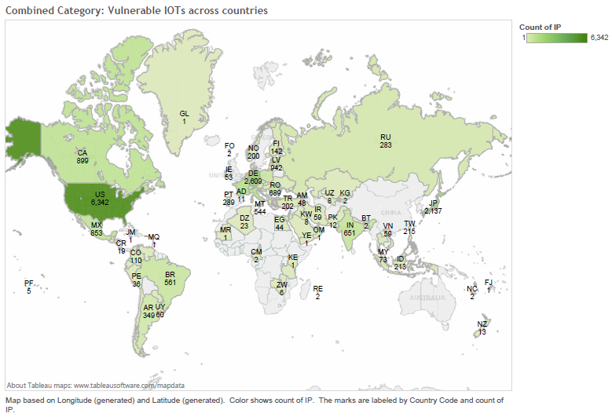

* 1. Also, analysis is done across equipments and we found that DreamBox has maximum no. of vulnerable IPs

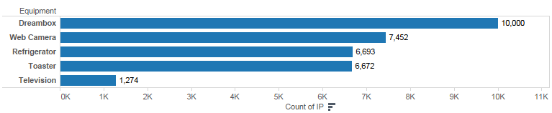

* 1. We also did further analysis on top 3 countries in each category and results are as below.

