**Token** being returned for user: gigi

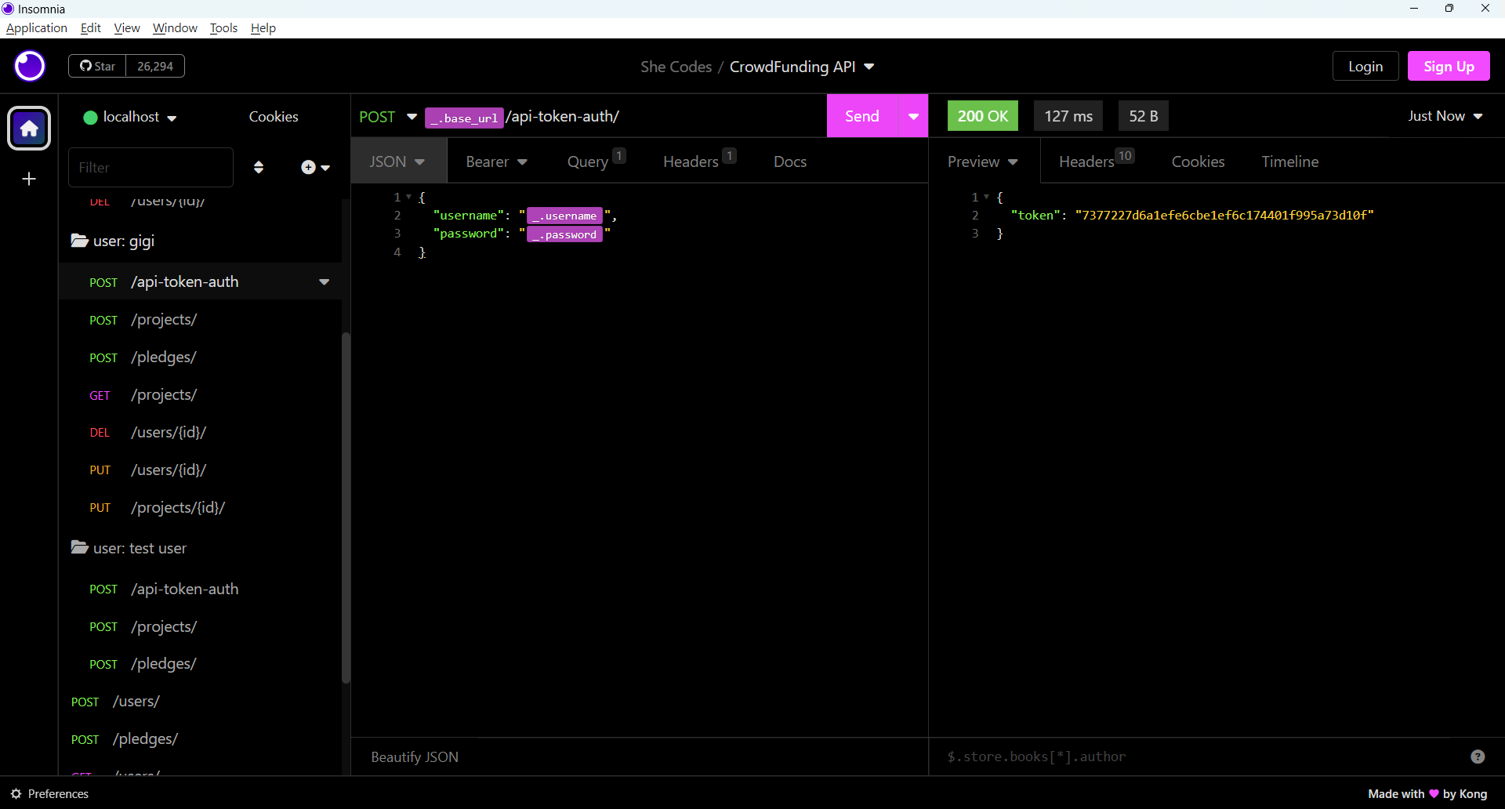

**POST** method:

User: gigi

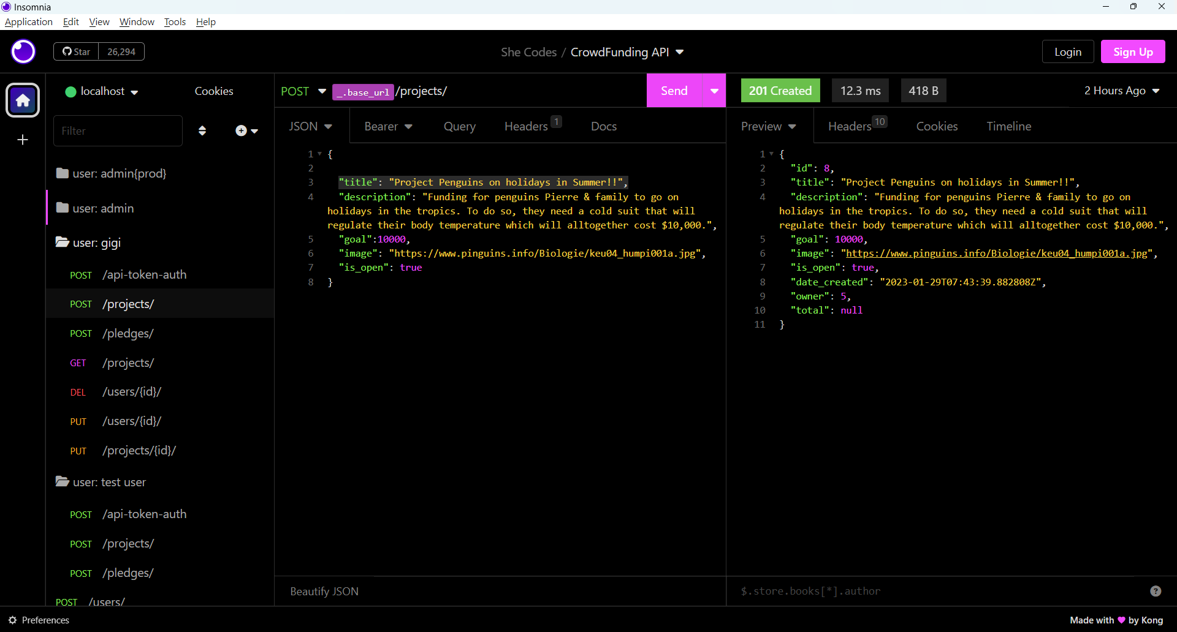

**GET** method:

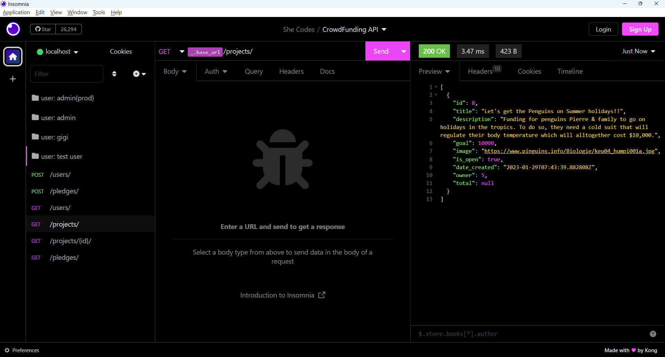

**DELETE** method + **Permissions**:

A user is allowed to delete their own account or an admin is allowed to delete a user account.

User: test user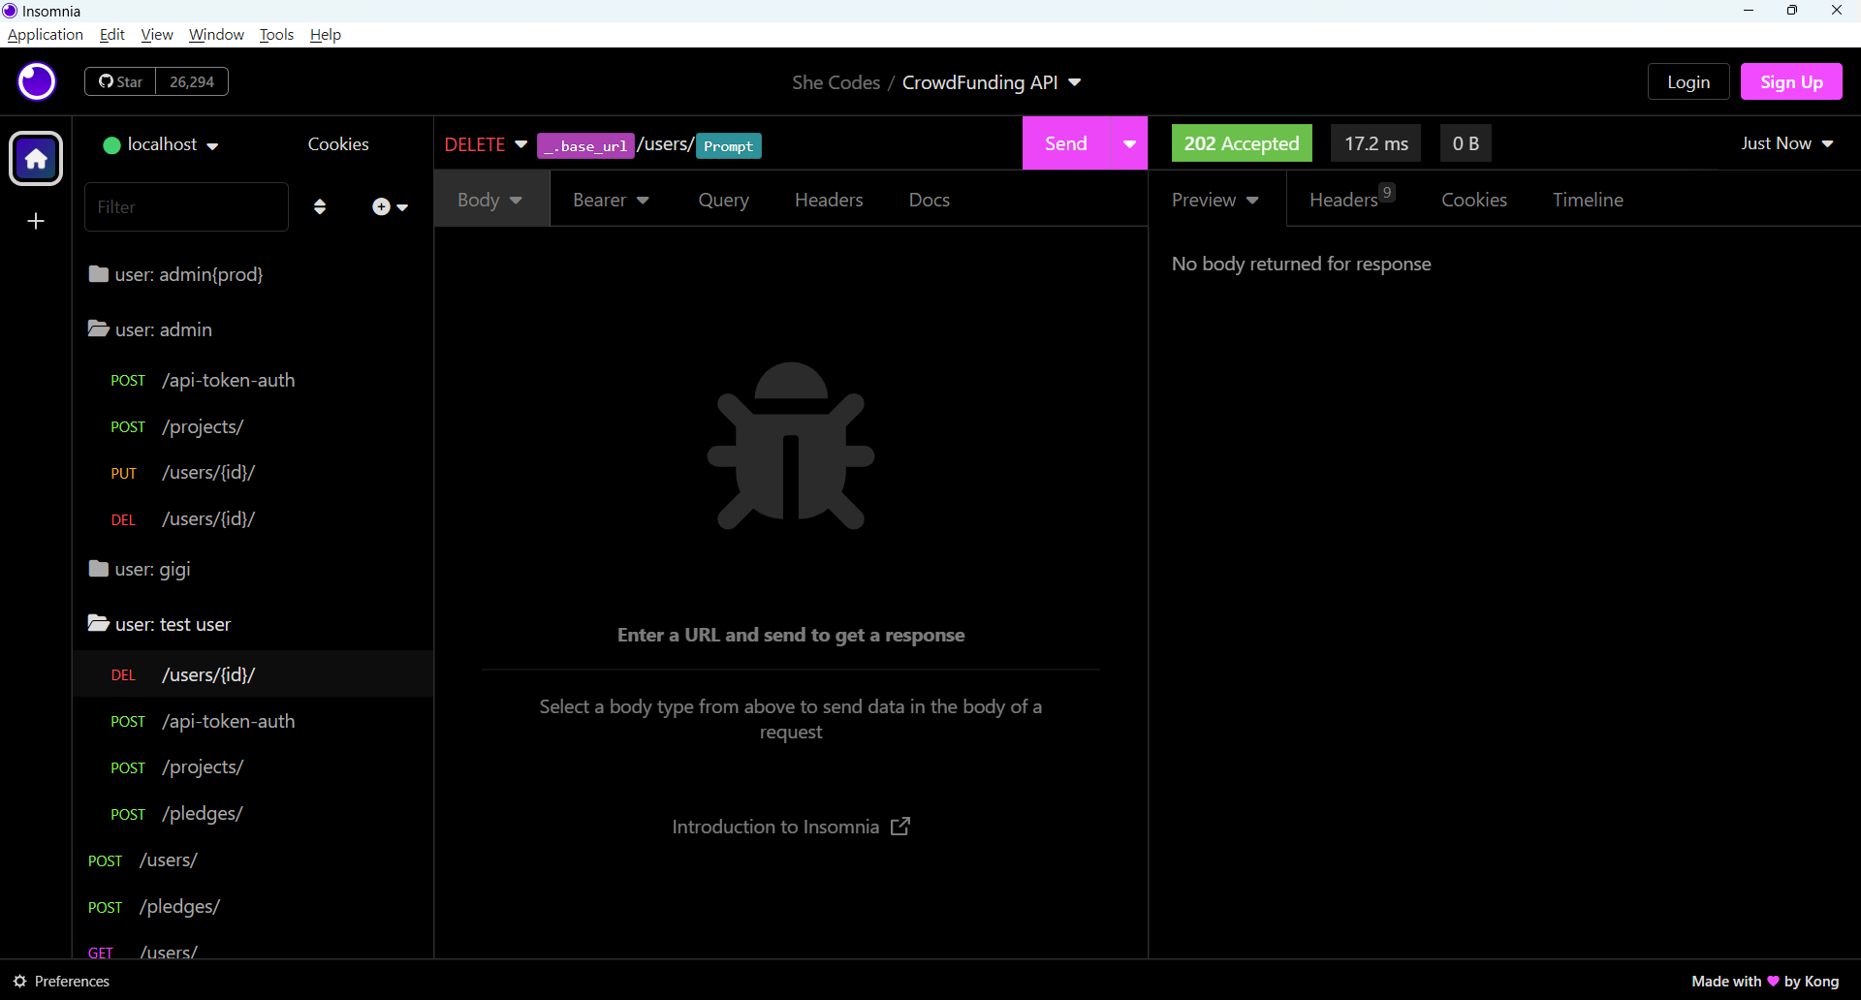

Admin:

**PUT** method:

User: seb

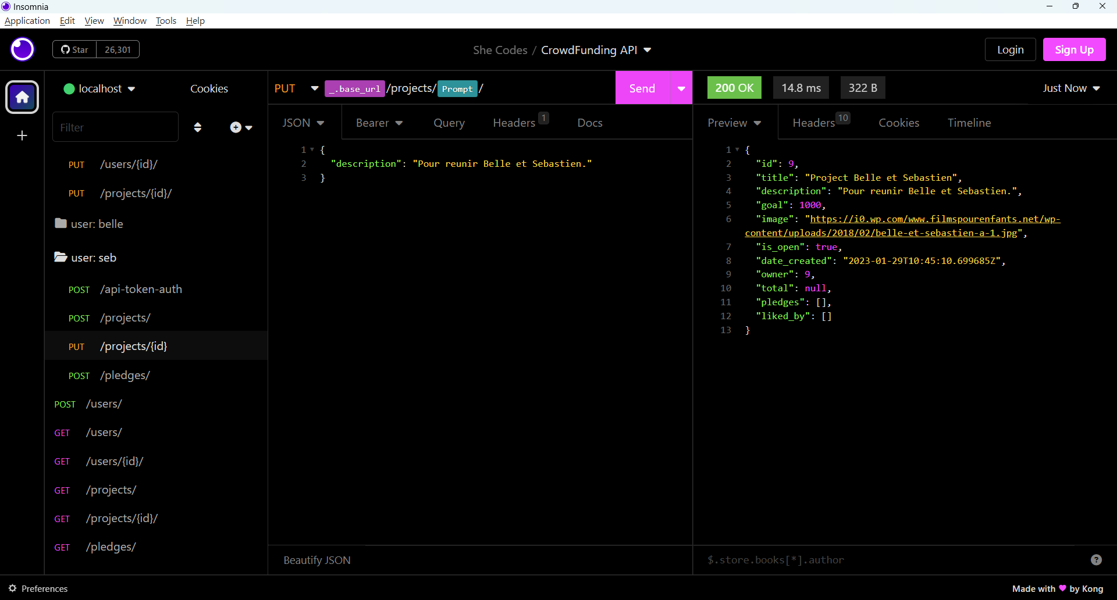

**Handling 404 gracefully**

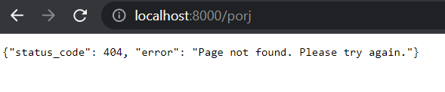

API specifications:

|  |  |  |  |  |  |
| --- | --- | --- | --- | --- | --- |
| HTTP Method | URL | Purpose | Request Body | Successful Response Code | Authentication/Authorization |
| POST | /api-token-auth | Create token for user. | User object. | 200 OK | Must be logged in. |
|  |  |  |  |  |  |
| POST | /users/ | Create a new user. | User object. | 201 Created | N/A |
| GET | /users/ | Returns all users. | N/A | 200 | N/A |
| GET | /users/1 | Returns the user with ID of “1” | N/A | 200 | N/A |
| PUT | /users/1 | Updates the user with ID of “1” | User object. | 200 | Must be logged in.  Must be the user. |
| DELETE | /users/1 | Delete the user with ID of “1” | N/A | 202 Accepted | Must be logged in. Must be admin or the user. |
|  |  |  |  |  |  |
| GET | /projects/ | Returns all projects. | N/A | 200 | N/A |
| POST | /projects/ | Create a new project. | Project object. | 201 | Must be logged in. |
| GET | /projects/1/ | Returns the project with ID of “1”. | N/A | 200 | N/A |
| PUT | /projects/1/ | Updates the project with ID of “1”. | Project object. | 200 | Must be logged in. Must be the project owner. |
| DELETE | /projects/1 | Delete the project with ID of “1” |  |  |  |
|  |  |  |  |  |  |
| POST | /pledges/ | Create a new pledge. | Pledge object. | 201 | Must be logged in. |
| GET | /pledges/1/ | Get the pledge with ID of “1”. | N/A | 200 | N/A |
|  |  |  |  |  |  |
| POST | /project-updates/ | Create an update about the project. | Projectupdates object. | 201 | Must be logged in. |
| GET | /project-updates/1/ | Get the project-update with ID of “1”. | N/A | 200 | N/A |
|  |  |  |  |  |  |

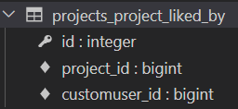

FK

FK

FK

FK

FK

FK