Insomnia GET, POST and TOKEN RETURNED

Database schema

Flowchart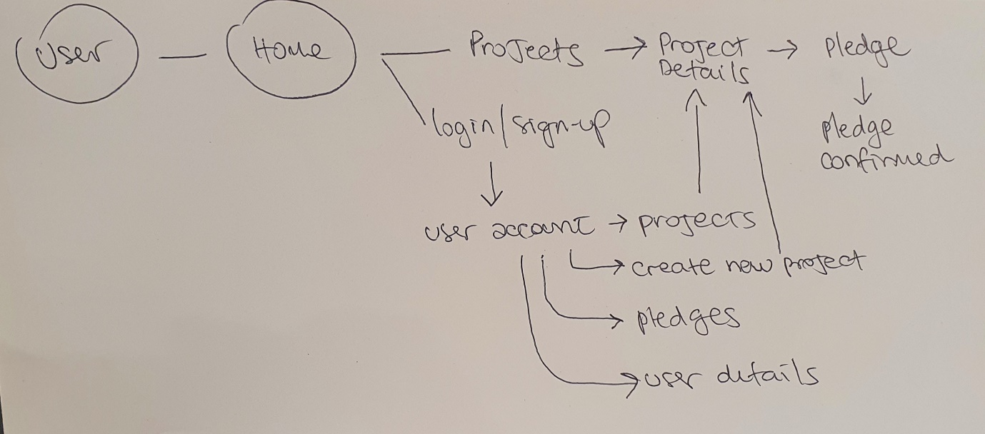

Endpoints

|  |  |  |  |  |
| --- | --- | --- | --- | --- |
| **Function** | **Endpoint** | **Method** | **Body** | **Authorisation** |
| **User Authentication** | [/api-token-auth/](http://localhost:8000/api-token-auth/) | POST | {  “username”: “username”,  “password”: “password”  } | **Token** |
| **Register New User** | [/users/](http://127./users/register/) | POST | {  "username": "username",  "email": "email",  "password": "password",  } | **Token** |
| **Users list** | [/users/](http://127.0.0.1:8000/users/profile/1/) | GET | {  "username": "username",  "email": "email",  "password": "password",  } | **none** |
| **Post Project** | /projects/ | POST | {  "id": 4,  "title": "Donate a dog",  "description": "Please help, we need a dog for she codes plus, our class lacks barks.",  "goal": 1,  "image": "https://upload.wikimedia.org/wikipedia/commons/c/c1/Dollar_bill_and_small_change.jpg",  "is_open": true,  "date_created": "2023-01-29T14:34:09.660758Z",  "owner": 1,  "total": null  } | **Token** |
| **Find Project id** | /project/1 | GET | {  "id": 1,  "title": "Donate 2 dog",  "description": "Please help, we need a dog for she codes plus, our class lacks barks.",  "goal": 1,  "image": "https://upload.wikimedia.org/wikipedia/commons/c/c1/Dollar_bill_and_small_change.jpg",  "is_open": true,  "date_created": "2023-01-17T12:06:15.959003Z",  "owner": 1,  "total": 3,  "pledges": [  {  "id": 1,  "amount": 1,  "comment": "have a dog",  "anonymous": false,  "project": 1,  "supporter": 1  },  {  "id": 2,  "amount": 2,  "comment": "have 2 dogs",  "anonymous": false,  "project": 1,  "supporter": 1  }  ],  "liked_by": []  } | **Token** |
| **Project List Page** | [/projects](http://127.0.0.1:8000/projects)/ | GET |  | **None** |
| **Post to Pledge** | [/pledges/](http://127.0.0.1:8000/pledges/) | POST | {  "id": 3,  "amount": 100,  "comment": "have a good trip",  "anonymous": false,  "project": 1,  "supporter": 1  } | **Token per User** |
| **Pledges list** | /pledges/ | GET | [  {  "id": 1,  "amount": 1,  "comment": "have a dog",  "anonymous": false,  "project": 1,  "supporter": 1  },  {  "id": 2,  "amount": 2,  "comment": "have 2 dogs",  "anonymous": false,  "project": 1,  "supporter": 1  },  {  "id": 3,  "amount": 100,  "comment": "have a good trip",  "anonymous": false,  "project": 1,  "supporter": 1  }  ] | **Token** |