NvM Concept
Concept:
The following describe that how to implement NvM between the ASW and BSW.
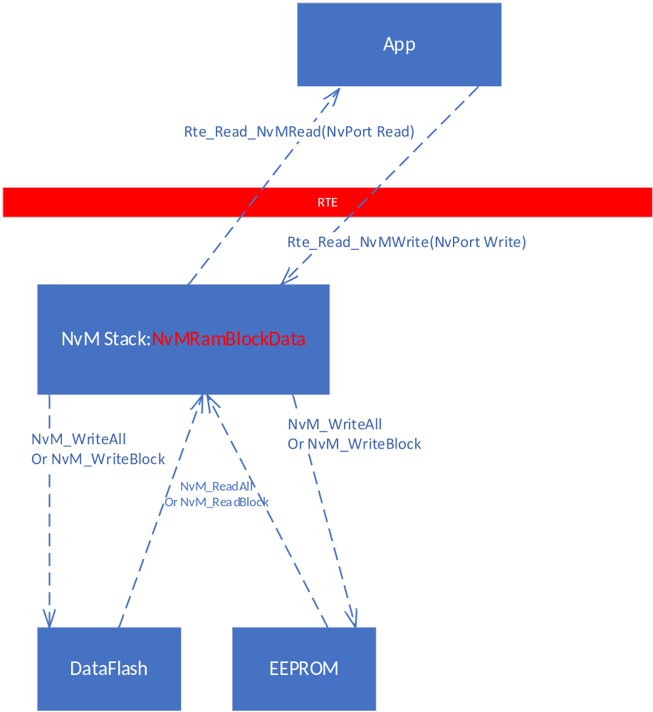
1. Between Application module and NvM Stack, we can use Nv port to implement it;
2. Regarding writing data to NvM, we can use Nv port to write data to NvM stack, when to write to data, we can configure it in Davinci; we can configure it to write immediately or write at shutdown;
3. Regarding reading data, we can read the data on startup by calling “NvM_ReadAll()”; during norm operation, we can using Nv port to read data from NvM ram mirror.
The following flow chart describe the logic to implement reading/writing data to NvM.
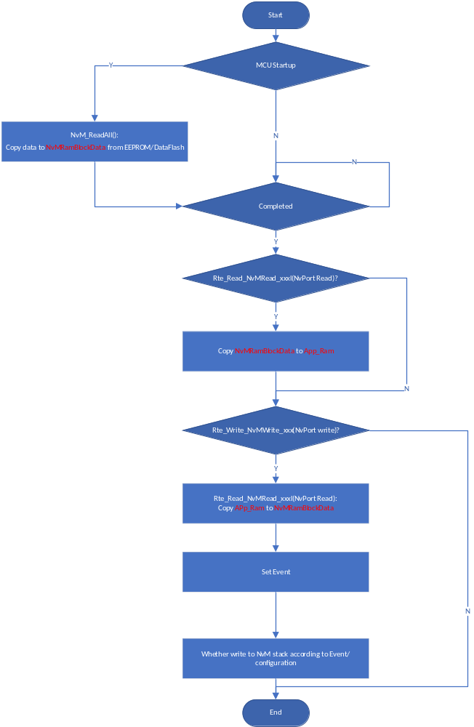
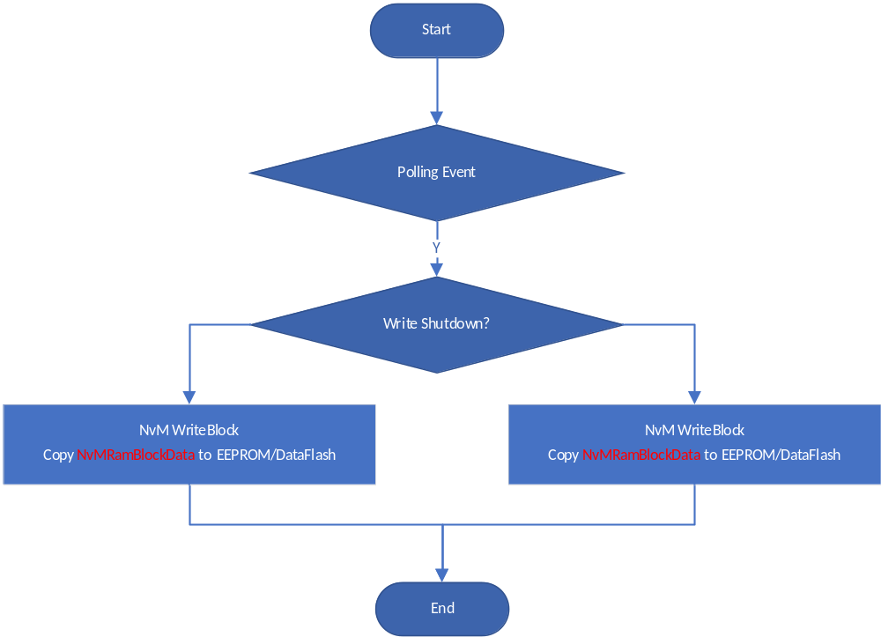
Manual:
1. Create a SWC using the type of “Non-Volatitle Memory Block” as the following figure shown;

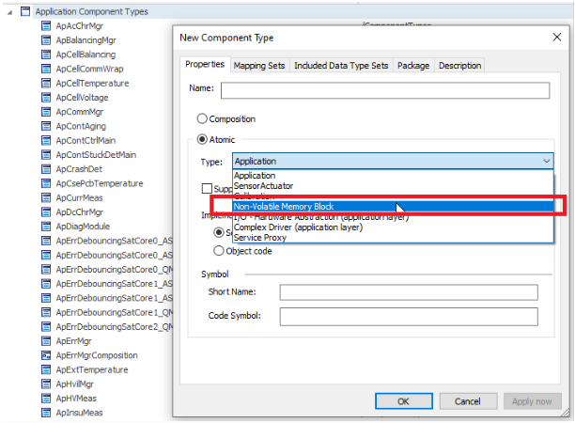
2. In the component, create the NV Block Descriptors as the following figure shown, using prefix “ NVBlockDescriptor_” naming the block;
3. Configure Properties,
a. Configure Ram Block:
Data type for the block
Support Dirty Flag
Init Value
b. Rom Block:
Data type
Init Value
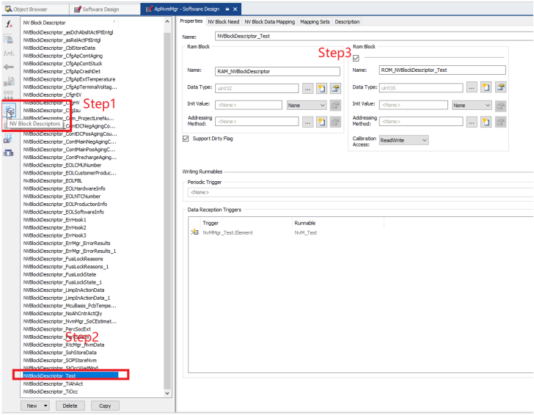
4. Configure attribute for the the Nv block in the “NV Block Need” as the following figure shown.
You can configure when to write/read the information.
a. Restore at Startup: Read data from NvM on startup by calling “NvM_ReadAll()”
b. Store At shutdown: Write data to NvM on shutdown by calling “NvM_WriteBlock()”
c. Store Immediately: Write data to NvM immediately by calling “NvM_ReadBlock()”
d. Calculate RAM Block CRC: If CRC required, the configuration need added
e. Use CRC Compare Mechanism: If CRC required, the configuration need added
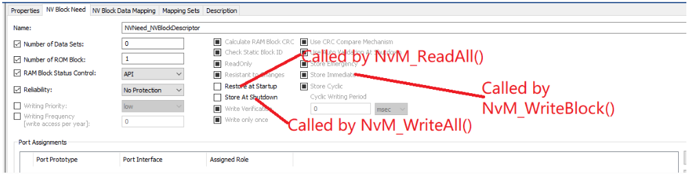
5. Create “Nv Data Port Interface” as the following figure shown.
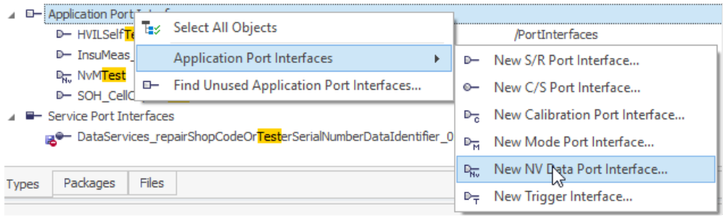
6. Create a Nv port in the SWC
7. Map “RAM Block Element” to “Nv Port” in the “NV Block Data Mapping” in the following figure
8. Create the runnable, the runnable can be used to write data to NvM. Also, set trigger condition.
9. Map the runnable to the task
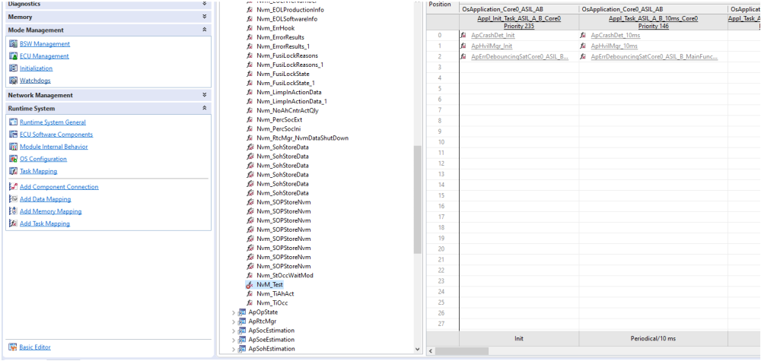
11. Configure the block attribute in the Davinci Configurator as the following picture shown.
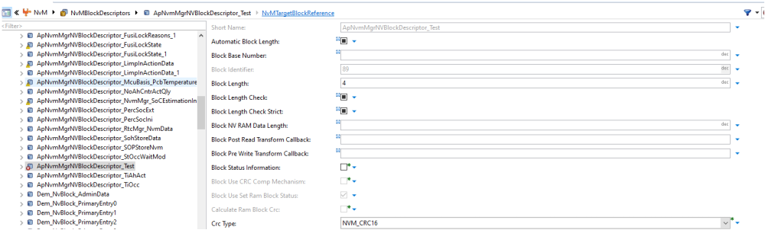

Example:
1. Coding for Rte write Nv port (Generated automatically)
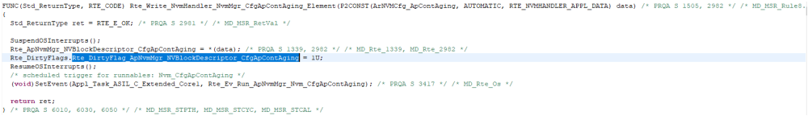
2. Runnable implementation(Generated automatically)
