Answers:

1. Variables and Datatypes

1.1)
1.integers 2.floating point numbers
3.unicode characters 4. truth values

1.2)

  - int number13e = 90213;
A: True

  - String return = "Hello";
A: False because return must not be used as variable name

  - String _variable = "Hello again!";
A: True, because the _ may always be used when creating a variable

  - double comma number;
A: True, because the var comma number is not given a value, but this can be done later.

  - int numberInEuro= 99.99
A: False, because firstly, a ";" is missing and secondly, comma numbers must be created with double

  - int 3Danzahl = 10150;
A: False because numbers are not allowed at the beginning of a variable name.

  - String black#tee = 20;
A: True

  - boolean $__$$4D = true;
A: True

  - int Double = 22;
A: True because Double is not double and therefore not a keyword.

1.3)

1. double
2. char
3. int
4. char
5. char
6. char
7. boolean
8. char
9. char

1.4)

 | Declaration | Initialisation
boolean | boolean d3; | d3 = true;
char | char zt3; | zt3 = ‘A‘;
byte | byte rs4; | rs4 = 4568;
short | short uj5; | uj5 = 7000;
int | int x; | x = 5;
long | long oo; | oo = 10000000;
float | float z; | z = 3.4;
double | double k; | k = 5.5;

1.7)

1. A: Constants cannot be changed after they have been initialized once, as is the case with variables. Final means that they are final.

2. A: For example, 9.81 N/kg Weight force

1.9)

A: Parsing is necessary when you for example want the value of a string to be an integer.

2. Case discrimination with the If-Else statement

Important information:

+ Addition int answer = 40 + 2;
- Subtraction int answer = 48 - 6;
* Multiplication int answer = 2 * 21;
/ Division int answer = 84 / 2;
% Divisor remainder, modulo operation, calculates the remainder of a division int answer = 99 % 57;
+ positive sign, usually superfluous int j = +3;
- negative sign int minusJ = -j;

++ post increment, adds 1 to a numeric variable x++;
++ Pre-increment, Adds 1 to a numeric variable ++x;
-- post decrement, subtracts 1 from a numeric variable x--;
-- pre-decrement, subtracts 1 from a numeric variable --x;

== equals 3 == 3
!= not equal to 4 != 3
> greater than 4 > 3
< less than -4 < -3
>= greater than or equal to 3 >= 3
<= less than or equal to -4 <= 4

4. Loops

4.1)

A: while and for-loop are head-controlled
do-while loop is foot-controlled

4.2)

A: Loops are used in programming when certain statements or operations are to be repeated any number of times.

For loop:

1.) Initialization:

for (initialization; target value; step size) {
// statements
}
for (int i=0; i<10; i++)
{
System.out.println("Hello World " + i);
}

While loop:

1.) Initialization:
The While loop is run through until the condition results in a False. The condition is at the beginning, so if it is already "false" before that, the loop is not executed once, but skipped.

boolean var=true;
while(var)
{
var=false;
System.out.println("Hello World");
}

Executed once, as var is set to false after the first pass.

Do-While loop:

1.) Initialization:

If you know that the loop should be executed at least once in any case, then you can use a do-while loop instead of a while loop. A do-while loop is basically nothing other than a while loop where the loop condition is at the end of the loop and not at the beginning.

boolean var=false;
do
{
System.out.println("Hello World");
}
while(var);

Execution once, because at the end because the condition gets false.

For-Each loop:

For-Each loops work very similarly to ordinary For loops and are effectively an evolution. Unlike the normal For-Each loops, however, For-Each loops do not use an externally visible run variable or iterator object, but always return the value directly in each iteration. This also means, however, that the loop must always iterate over a corresponding data structure (arrays and collection) that makes this possible. Let's look at an example:

1.) Initialization:

for (type var : array)
{
statements using var;
}

5. Methods Theoretical

1.) A: The methods help to implement our task easier. It saves a lot of time in case of several operations and several tasks. The methods help in data security.

2.) A:
Modifier + (static) + void or data type + name of the method + (parameter) +{}

3.) A: There are methods with and without a return value:
public void printName(){
System.our.println(„Name“)
} // without return value

public static double getAddition(double a, double b){
double ergA = a + b;
return ergA; } // with return value

6. Memory Management

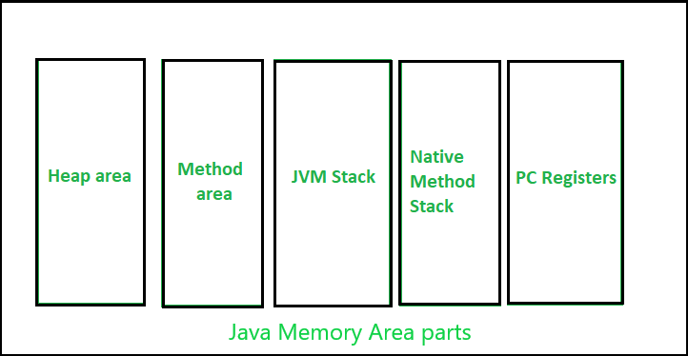
Heap :

- It is a shared runtime data area and stores the actual object in memory. It is instantiated during the virtual machine startup.
- This memory is allocated for all class instances and arrays. The heap can have a fixed or dynamic size depending on the system configuration.
- JVM provides the user with the ability to initialize or vary the size of the heap memory according to requirements. When a new keyword is used, a space is assigned to the object in the heap, but the reference of the same is present on the stack.
- There is only one heap for a running JVM (Java Virtual Machine) process.

Scanner sc = new Scanner(System.in);

The above statement creates the object of the scanner class, which is assigned to the heap while the reference "sc" is moved to the stack.

Note: The garbage collection in the heap area is mandatory.
Method Area:

- It is a logical part of the heap area and is created when the virtual machine is statup.
- This memory is allocated for class structures, method data and constructor field data, as well as interfaces or special methods used in the class. The heap can have a fixed or dynamic size depending on the system configuration.
- Can have a fixed size or be extended depending on the calculation. Does not have to be contiguous.

Note: Although the method area is logically a part of the heap memory, it cannot and does not become garbage collected even though garbage collection is mandatory in the heap area.
JVM stacks:

- A stack is created at the same time as a thread is created and used to store data and partial results that are needed while returning the value for the method and performing dynamic linking.
- Stacks can have either a fixed size or a dynamic size. The size of a stack can be selected independently when it is created.
- The memory for the stack does not have to be contiguous.

Native method stacks:
Are also referred to as C stacks and are not written in Java language. This memory is allocated to each thread when it is created. And it can be fixed or dynamic in nature.

Program counter (PC) registers:
A PC register is allocated to each JVM thread that executes the task of a particular method. The non-native method has a PC that stores the address of the available JVM instruction, while in a native method the value of the PCś is undefined. The PC register can store the return address or a native pointer on a specific platform.

7. CallByValue / CallByReference

1.) A:
Call-by-Value:
A copy of the passed value is assigned to the formal parameter.

Call-by-Reference:
Refers to original value.

2.) A:
https://feu.mpaap.de/cms/1618FAQ-CbvCbr

Call-by-value is used with primitive data types and with objects.
In Java, parameters are always passed "by value", i.e., a copy of the passed value is assigned to the formal parameter.
In Java, objects can only be accessed via references. Variables contain and methods never deliver objects, but only references. So, when a method is "passed an object as a parameter", in reality a reference is passed.
If the value passed is a reference, a copy of the reference is created and assigned to the formal parameter! Of course, this copy refers to the same object as the original reference.

9. Classes, Attributes and Functions

1.) A: The class defines the object in which all attributes and methods are defined. The object is only an instance of a class.
2.) A: They describe the properties of an object.
3.) A: Constructors provide an interface for creating objects and help to assign initial states to objects.

4.)

//Constructor in the class Pupil
Pupil(String n,int a,int c){
name = n;
age = a;
class = c;
}
//Instantiation of a pupil object
Pupil pupil = new Pupil(“Thomas Zeller“, 14, 8);

5.)

Setter:
Method that enables the modification of an object variable.

public class Customer{
// Attributes
private double accountStatus;
//method
public void setAccountStatus (double newAccountStatus ){
this.accountStatus = newAccountStatus; }
// ...
}

Getter:
Method that retrieves an object variable.

public class Customer{
// Attributes private
double accountStatus = 130;
// ...
// methods
public double getAccountStatus(){
return this.accountStatus ;
}
}

Customer customerSchmitt = new Customer();
double schmittsAccountStatus = customerSchmitt.getAccountStatus();
System.out.println("Mr Schmitt has " + schmittsAccountStatus + " Euro in the account.");

6.) A: If attributes or methods are private, you only have access via getter and setter.

7.) A: They are used in the declaration of classes, variables or methods to influence/restrict that access.

8.)
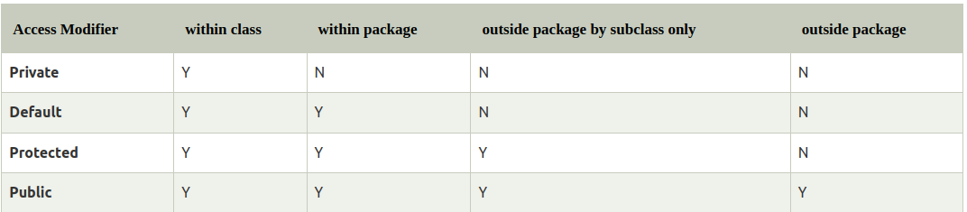
10.) Inheritance

10.1) A: The classes often have the same variables. The variables repeat themselves from class to class.

10.2)
A: Same code can be used more than once. So we avoid duplicated code.
The class vehicle, because all classes represent a vehicle and so there is commonality between the classes, thus we can inherit a lot.

11. Interfaces

1. Structure:

//Example Interface: Transportable
public interface Transportable {
// all methods in interfaces are implicitly public and abstract
// all four method declarations are permitted
float weight();
abstract float length();
public float width();
public abstract float height();
boolean breakable();
String caption();
}

2. A: Implements

3. Methods are included and then implemented in the class that refers to the interface.

4. Compiler throws an error because all methods of the interface must first be implemented in the class.

5. The same method is given and can be used and individualized in different classes. Standardization and control is given by an interface.

12. Collections

Important information:

List:
- contains references to objects in a specific order
- adjusts dynamically in size
- new elements can be added, in which case the existing elements, starting from position 2, move down by one
- old elements can be removed, in which case all elements below them move down by one
- also starts at position 0

LinkedList: Important methods

public boolean isEmpty()
public E get(int index)
public boolean add(E e)
public boolean removeLast()
public boolean removeFirst()

Faster to add and remove but slower to check because it has to go through all the lists as they are linked together.

ArrayList: Important methods

ArrayList<String> liste = new ArrayList<String>();

liste.get(13)
liste.add(0, "Heinrich")
liste.set(0, "Heini")
list.remove(1)
list.size();

Faster to read, slower to add or remove

Map:
- contains objects in a structured form, which is described in the interface java.util.Map and implemented in a single Map class
- is structured like a dictionary
- Each entry consists of a key and its value and any object can be added or removed.
- Each key/value pair is unique, but can be replaced

HashMap: Implements the map interface
- is used to store key and value pairs. In short, the mapping of key and value is maintained. This is how you can represent HashMap elements if they have an integer key and a string type value: e.g. {1 -> "Hello", 2 -> "Hello", 3 -> "Bye", 4 -> "Run"}
- does not allow duplicate keys, but duplicate values.

TreeMap:
- sorts the inputs automatically, according to the respective keys, unless you specify a custom sorting.
- Does not use an array to store the inputs.

Set:
HashSet:
The elements are stored in a hash table, which allows quick access.
- Does not allow duplicate elements, which means you cannot store duplicate values in HashSet.
- Allows a single null value.

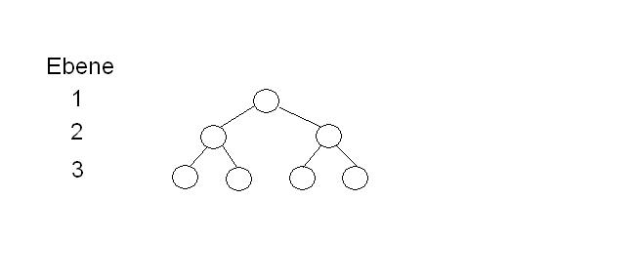
TreeSet:
The tree structure shown above has three levels. The node in the first level is the root. The nodes in the second level are called branches because they still have successors. The nodes on the third level are called leaves.
→ Binary tree, as only max 2 successors.
Classes that are to be inserted into a TreeSet must implement the interface Comparable & the method compareTo. It is also necessary that the objects have the same data type in order to be compared and with compareTo they are compared.

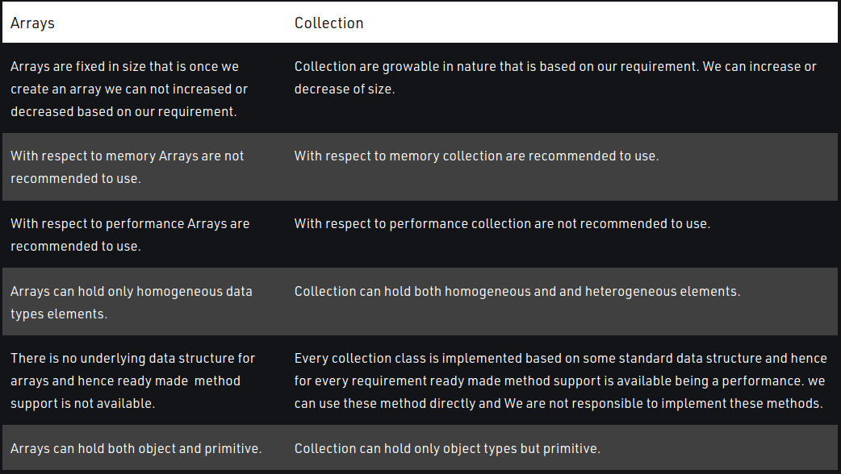
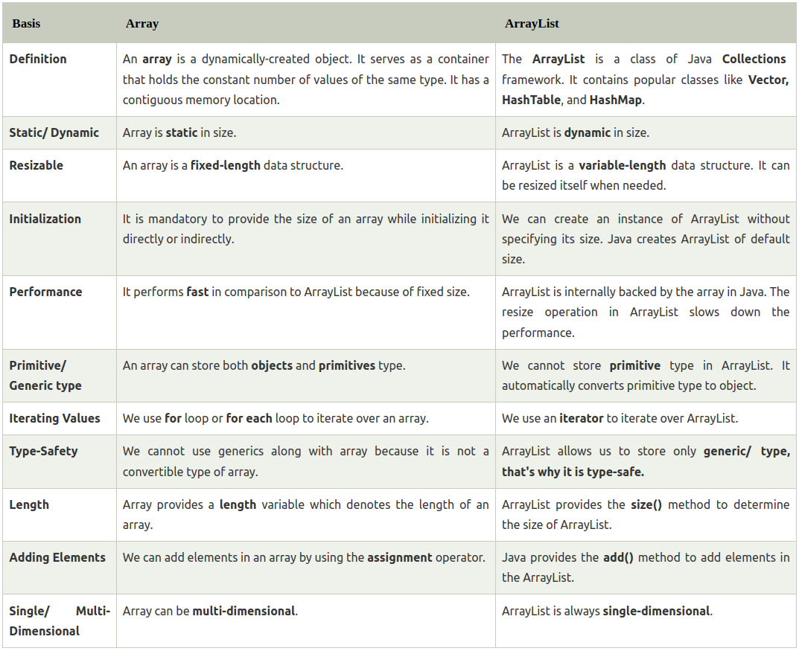
12.4)

13. Exception

1. A: An exception is a serious error that, if not handled, leads to crashes or undesired program states. Exceptions always occur at runtime, i.e. only during execution. This happens, for example, with arithmetic operations, violation of array limits, type conversion or access to objects that have not yet been created.

2. A: Error in Java is a runtime error that cannot be repaired or a hardware problem that causes the program to crash. Exceptions are usually not actual errors, but unexpected cases to which the program must react.

3. 3 Categories:
- Checked: Are the exceptions that are checked at compile time. If a code in a method throws a checked exception, the method must either handle the exception or specify the exception with the keyword throw.
- Unchecked: Are the exceptions that are not checked during compilation. E.g. RuntimeExceptions are unchecked exceptions.
- Error: Unrepairable errors.

4. How do you catch an exception?

public class ExceptionTest
{
public static void main (String [ ] args)
{
try
{
/* Here we convert the passing parameters into integer values */
int dividend = Integer.parseInt(args[0]);
int divisor = Integer.parseInt(args[1]);

/* Creation of an object of our exception */
double result = divide(dividend,divisor);

/* Statements after a throw statement in a block are no longer executed */
System.out.println("The result of the division is: "+result);
}
/* Here we catch our thrown exception */
catch(DivisionByZeroException e)
{
/* Here we ONLY print our error message */
System.out.println(e.getMessage());

/* Here we output the caller list */
e.printStackTrace();
}
}

public static double divide (int dividend, int divisor) throws DivisionByZeroException
{
double result=0;

if(divisor != 0)
{
result = dividend/divisor;
}
else
{
/* Here our exception is thrown */
throw new DivisionByZeroException();

/* Statements after a throw statement in a block are no longer executed */
}
return result;
}
}

class DivisionByZeroException extends Exception
{
DivisionByZeroException()
{
super("The divisor is 0!");
}
}

In this example, two integer values are expected at the start. The first is the divisor and the second is the dividend. If the dividend is 0, the exception is caught and thrown, if not, the result is thrown.

5. Create an exception yourself?

class MyException extends Exception
{
// Constructor of our own exception
MyException()
{
// Call the parent constructor with the error text to be
// appearing error text
super("An error has occurred");
}
}

You access the super class "Exception" and use the constructor to access the constructor from the super class. This passes our error text, in reality
a more appropriate error code should be displayed.

14. Nullpointer

1. A: A nullpointer is a variable that refers to an empty object.
e. g. : When...
- Calling a method of a null object
- Accessing an attribute of a null object
- Querying the length of an array that is equal to null
- Accessing an element of an array equal to null
- Throw an exception equal to null
- When accessing the element of an array, where the element has no value.

2. A: Unchecked Exception and it is only thrown when the code is executed, not during compilation.

3. See answer of the second task before

4.
- Sometimes with a try/catch block
- Check line by line with the debugger

5.. A: If the final value or object is still unclear when declaring.

15. Enums

1. A: Java enums are variable types with fixed value possibilities.

2. A: It is especially useful when a variable has only a small number of nameable states (enums). They serve the readability and logical structure of your code.
3. Public enum Weekday {Monay, Tuesday, Wednesday, Thursday, Friday. Saturday, Sunday}
Constructor or methods can also be declared here.

4. e.g.: Enum.Object.toString

5. Three Examples:

1. when calculating change, in which case you could put the coins into an enum.
2. when issuing vehicles, in which case you could put them and their parameters into an enum.
3. for card types

