CodeGuard: A Secure AI-Powered Web-Based Coding Assessment Platform with Tab Monitoring and Automated Grading.

A Research Study
presented to
the Faculty of the College of Computing and Informatics
Iloilo Science and Technology University
La Paz, Iloilo City

In Partial Fulfillment
of the Requirements for the Degree
Bachelor of Science in Computer Science

By
Shean Michael P. Muzones
Stephen Raey R. Castillon
Kurtzedrik P. Caliwag
Shannah Lil B. Cosio

March 2025

Chapter 1
INTRODUCTION
Background of the Study
The rapid advancement of information and communication technology has significantly transformed educational practices, particularly in computer science and programming education. Programming courses rely heavily on various software tools and Integrated Development Environments (IDEs) that enable students to write, compile, debug, and execute source code efficiently. Popular IDEs such as Visual Studio Code, Code::Blocks, Dev-C++, Eclipse, and IntelliJ IDEA provide comprehensive features that support software development and learning. These platforms help students develop programming skills by offering syntax highlighting, debugging tools, code completion, and project management capabilities. As technology continues to evolve, educational institutions increasingly integrate these digital tools into programming courses to enhance learning experiences and improve student engagement.
In addition to desktop-based IDEs, web-based coding environments have emerged as valuable tools for programming instruction. These platforms allow students to access coding workspaces through web browsers without requiring complex software installations. The growing adoption of online learning has further emphasized the need for accessible, flexible, and collaborative programming environments. Consequently, educators seek platforms that not only facilitate coding activities but also support assessment, monitoring, and feedback mechanisms that contribute to effective learning outcomes.
Various programming assessment platforms have been developed to support teaching and learning in programming courses. Platforms such as CodeChum, Replit, HackerRank, and other online IDEs provide environments where students can practice coding, complete programming exercises, and receive automated feedback. These systems offer features such as code execution, automated test case evaluation, and progress tracking, making them useful for classroom instruction and self-paced learning. Similarly, educational institutions utilize assessment management tools that streamline the submission and evaluation of programming tasks.
To address examination security concerns, some institutions implement applications such as Safe Exam Browser (SEB), which restricts access to unauthorized resources during online assessments. SEB provides a controlled testing environment by limiting browser functionality and preventing students from accessing external websites or applications. While these tools contribute to improving assessment management and security, they often operate independently and are not specifically designed to provide a complete programming assessment solution that integrates coding, grading, monitoring, and analytics within a single platform.
Despite their usefulness, existing programming platforms present several limitations in academic assessment settings. Many online IDEs and automated grading systems focus primarily on code correctness and execution results, often overlooking important evaluation criteria such as coding style, readability, maintainability, and algorithmic efficiency. Furthermore, most platforms do not allow professors to define customized grading rubrics that align with specific course learning outcomes. As a result, assessments may fail to capture the full range of competencies expected from students in programming courses.
Similarly, while tools such as Safe Exam Browser provide examination security, they lack specialized programming assessment features such as integrated code compilation, automated rubric-based grading, syntax and semantic analysis, and detailed performance analytics. Existing platforms also provide limited mechanisms for monitoring student behavior during coding examinations, such as detecting tab switching, window focus loss, or unauthorized session exits. These shortcomings create challenges for educators in maintaining academic integrity, ensuring consistent grading, and providing meaningful feedback to students.
To address these challenges, this study proposes the development of CodeGuard: A Secure AI-Powered Web-Based Coding Assessment Platform with Tab Monitoring and Automated Grading. The system is designed to provide a comprehensive environment for conducting programming assessments in C programming courses. CodeGuard integrates a built-in online IDE, secure examination management, automated grading, and performance analytics into a unified platform. Professors can create coding assessments, define grading rubrics, monitor student activities, and evaluate submissions through an automated yet customizable assessment process.
The proposed platform incorporates advanced security features such as tab-switch detection, window focus monitoring, fullscreen enforcement, and session key authentication to help maintain academic integrity during online examinations. In addition, CodeGuard utilizes automated grading mechanisms that evaluate code based on correctness, efficiency, and coding style while providing syntax and semantic feedback to students. The system also maintains centralized records of submissions and assessment results, enabling efficient tracking of student performance. Through these features, CodeGuard aims to enhance the effectiveness, reliability, and security of programming assessments within Philippine higher education institutions.

Objectives of the Study

General Objective:
This study aims to design, develop, and evaluate the CodeGuard: A Secure AI-Powered Coding Assessment Platform that provides a secure, and intelligent coding assessment environment for academic institutions using Hybrid Algorithm.

Specific Objectives
This study specifically aims to:
- allow users to write, compile, and execute source codes ;
- implement an automated checking system based on instructor-defined rubrics and test cases using Decision Tree Classifier algorithm;
- integrate anti-cheating features and provide formative feedback to students through automated syntax and semantic analysis of submitted code; and
- evaluate the developed system using the Post-Study System Usability Questionnaire (PSSQ) framework and measure the accuracy of its automated assessment mechanisms.

Conceptual Framework

CodeGuard: A Secure AI-Powered Web-Based Coding Assessment Platform with Tab Monitoring and Automated Grading.
Process
Output
Input

- Problem Sets and Instructions

- Grading Rubrics

- Test Cases

- Source Codes
Authenticate users and manage sessions.

Compile and execute submitted code.

Analyze code structure using AST-based static analysis.

Compare solutions using Levenshtein distance analysis.

Detect plagiarism using the Winnowing algorithm.

Evaluate and grade submissions automatically.

Monitor and log rule violations.
Evaluate the system using
Post-Study System Usability Questionnaire (PSSUQ)

Figure 1. Conceptual Framework of the study

Conceptual Framework
The conceptual framework of this study is anchored on the Input-Process-Output (IPO) Model, which serves as the operational structure of the proposed CodeGuard: A Secure Coding Assessment and Plagiarism Detection System. As illustrated in Figure 1, the framework organizes the system into three interconnected stages: Input, Process, and Output, supported by a feedback mechanism that promotes continuous system improvement and quality assurance.
Input
The input stage consists of the data and resources required to conduct coding assessments and generate evaluation results.
Professor Inputs
- Coding tasks and problem sets that define the assessment content
- Grading rubrics containing evaluation criteria for correctness, efficiency, and coding style
- Instructor-defined test cases with expected inputs and outputs for automated program evaluation
- Securely generated session keys used to authenticate and control student access to examination sessions

Student Inputs
- Login credentials combined with the professor-issued session key for secure system access
- C source code developed and submitted through the system's integrated development environment (IDE)
Process
The process stage employs a hybrid algorithm pipeline designed to assess multiple dimensions of programming performance. Since a single algorithm cannot adequately evaluate code quality, correctness, academic integrity, and grading requirements, the system integrates several specialized algorithms that operate sequentially.
Authentication and Session Management
The system verifies student credentials and session keys before granting access to an examination. It also enforces fullscreen mode and records examination violations such as tab switching, window focus loss, and unauthorized navigation activities.
AST-Based Static Analysis
The submitted C source code is parsed into an Abstract Syntax Tree (AST) to evaluate its structural and syntactic characteristics. This process identifies syntax errors, semantic inconsistencies, coding style compliance, and code complexity indicators such as loop depth and nesting levels. The analysis generates efficiency and style assessment scores.
Levenshtein Distance Analysis
The system compares the student's program output with the expected output by calculating the minimum number of character-level edits required to transform one output into the other. The resulting similarity score enables partial-credit grading rather than relying solely on exact output matching.
Winnowing-Based Plagiarism Detection
The submitted source code is tokenized and converted into k-gram fingerprints using the Winnowing Algorithm. These fingerprints are compared with those of other submissions to identify potential instances of source code plagiarism and generate similarity reports for instructor review.
Decision Tree-Based Grade Classification
The correctness, efficiency, and style scores produced by the preceding algorithms are used as input features for a Decision Tree classifier. The classifier assigns a final rubric-based grade while providing a transparent and interpretable grading process.
Output
Upon completion of the processing stage, the system generates the following outputs:
- Program execution results and runtime diagnostic messages
- Syntax and semantic feedback from AST analysis
- Correctness scores derived from output comparison
- Plagiarism similarity reports generated through Winnowing analysis
- Final rubric-based grades with category-specific score breakdowns
- Violation reports documenting assessment-related infractions
- Student performance records and submission histories
- Real-time monitoring information for instructors
- System evaluation results, including usability and grading accuracy metrics
Feedback
The feedback stage supports the continuous enhancement of the CodeGuard system. Results obtained from system usability evaluations using the Post-Study System Usability Questionnaire (PSSUQ) and grading accuracy assessments are analyzed to identify strengths, weaknesses, and opportunities for improvement. The findings are then used to refine the system's algorithms, security mechanisms, grading procedures, and overall functionality, ensuring that the platform remains effective, accurate, and user-centered.
Through the integration of these components, the proposed framework enables CodeGuard to provide secure coding assessments, automated grading, plagiarism detection, and comprehensive performance monitoring while maintaining academic integrity and improving the overall assessment experience.

Definition of Terms
The following terms are defined conceptually and operationally for clarity and better understanding:
Automated Grading System (AGS). A software component that evaluates student-submitted code against predefined rubrics and test cases without manual intervention from the instructor. In this study, the AGS evaluates code based on correctness, efficiency, and style dimensions[1].
Anti-Cheating Mechanism. A set of technical controls embedded in the system that detect and log behaviors associated with academic dishonesty during online examinations, including tab switching, window focus loss, and unauthorized session interruptions[2].
C Programming Language. A general-purpose, procedural programming language developed in the early 1970s and widely used in systems programming, embedded systems, and introductory programming education. In this study, it is the sole supported language for code submission and compilation[3].
Coding Assessment Environment. A digital platform designed to administer, monitor, and evaluate programming tasks assigned to students. The environment in this study integrates code editing, compilation, execution, and automated evaluation in a single web-based interface[4].
Fullscreen Enforcement. A security feature that requires the student's browser to remain in fullscreen mode throughout the examination session. Any attempt to exit fullscreen is detected and logged as a potential violation[5].
Grading Rubric. A set of evaluative criteria defined by the instructor that specifies how submitted code will be assessed. In this study, rubrics encompass three dimensions: correctness IEresource usage of the solution), and style (adherence to coding conventions and readability standards) [6].
CodeGuard. The web-based application developed in this study. The name refers to a secure, AI-powered coding assessment platform that guards the integrity of programming examinations through tab monitoring, automated grading, and anti-cheating enforcement. It serves as the primary artifact of this research[7].
Post-Study System Usability Questionnaire (PSSQ). A standardized usability evaluation instrument developed to assess users' overall satisfaction and exprience with a system after use. The PSSQ collects responses on dimensions such as ease of use, learnability, interface quality, and overall system satisfaction. In this study, the PSSQ is administered to student and professor users to evaluate the usability of the CodeGuard[8].
Semantic Analysis. The process of examining the meaning and logical consistency of source code beyond syntactic structure, including the detection of type mismatches, undeclared variables, logical errors, and other semantic violations. In this study, semantic analysis is used to generate formative feedback for students[9].
Session Key. A unique, cryptographically generated alphanumeric code created by the professor that authenticates a student's access to a specific examination session. The session key is also required for resuming an interrupted session or re-entering after a detected violation[10].
CodeGuard. The web-based application developed in this study. The name refers to a secure, AI-powered coding assessment platform that guards the integrity of programming examinations through tab monitoring, automated grading, and anti-cheating enforcement. It serves as the primary artifact of this research[11].
Syntax Analysis. The process of analyzing the syntactic structure of source code to detect grammatical errors according to the rules of the programming language. In this study, syntax analysis is performed as part of the compilation process and is used to provide immediate error feedback to students[12].
Tab Switching Detection. A browser-based security mechanism that identifies when a student navigates away from the examination tab to another browser tab or window during an active session. Each detected instance is recorded in the violation log[13].
Web-Based Application. A software application that is accessed through a web browser over a network, without requiring installation on the user's local machine. The CodeGuard is a web-based application accessible from any modern browser-enabled device[14].
CodeChump. Refers to the proposed web-based coding assessment platform designed to facilitate programming examinations, automated code evaluation, plagiarism detection, and performance monitoring. The system provides instructors with tools for creating coding assessments and enables students to write, submit, and execute source code in a secure environment[15].
Abstract Syntax Tree (AST) Analysis. A code analysis technique that examines the structural representation of source code to identify similarities, coding patterns, and potential violations[16].
Levenshtein Distance Analysis – A string comparison method used to measure the similarity between two source codes by calculating the minimum number of edits required to transform one code into another[17].
Plagiarism Detection. The process of identifying copied or highly similar code submissions among students using algorithms and code similarity metrics[18].
Winnowing Algorithm. A document fingerprinting algorithm used by CodeChump to detect plagiarism by comparing selected code fingerprints and identifying matching code segments[19].
Source Code – The human-readable set of instructions written by a programmer in a programming language and submitted through the CodeChump platform[20].
Test Cases – Predefined input and output scenarios used to verify the correctness and functionality of a student's program[21].
Grading Rubric – A set of evaluation criteria used to assess the quality, correctness, efficiency, and compliance of programming submissions[22].
Code Compilation and Execution – The process of translating source code into executable form and running it to determine whether it produces the expected output[23].
Violation Monitoring – The continuous tracking of suspicious activities, academic integrity violations, or unauthorized actions during coding assessments[24].
Correctness Score – A numerical measure indicating the extent to which a submitted program produces the expected outputs for the given test cases[25].
Plagiarism Report – A generated document showing the similarity results between source code submissions and highlighting potential instances of code copying[26].
Final Grade – The overall score assigned to a student's coding assessment based on automated grading results, rubric criteria, and other evaluation metrics[27].
Student Performance Record – A collection of assessment results, grades, submission history, and performance statistics maintained within the CodeChump system[28].
Programming Education. 3The teaching and learning process focused on developing coding, problem-solving, and software development skills through practical programming activities[29].

E. Significance of the Study
The development of the CodeGuard has significant implications for multiple stakeholders in the academic community:
Professors and Academic Instructors. The system empowers instructors to design and administer coding examinations with greater efficiency and flexibility. The ability to define custom rubrics, monitor student activity in real time, and receive automated grading reports significantly reduces the administrative burden associated with programming assessments.
Students. Students benefit from an integrated environment that provides immediate, actionable feedback on their code submissions. The availability of syntax and semantic analysis helps students identify and correct errors more effectively, supporting deeper learning of programming concepts.
Academic Institutions. The CodeGuard provides institutions with a scalable, locally developed solution for managing programming assessments that aligns with academic integrity policies. The system's centralized data management capabilities also enable institutions to track program outcomes and monitor student learning progression.
Educational Technology Research. This study contributes to the growing body of knowledge on intelligent tutoring systems, automated program evaluation, and e-proctoring mechanisms. The use of the PSSQ as an evaluation framework also advances methodological rigor in assessing educational software in the Philippine context.
Future Developers and Researchers. The architecture, methodologies, and findings of this study may serve as a foundation for future work on expanding the system to support additional programming languages, more advanced semantic analysis, or adaptive learning features.
F. Scope and Limitations
The CodeGuard system is designed and developed within the following scope and subject to the following limitations:
Scope
- The system supports the creation, administration, and automated evaluation of coding assessments exclusively in the C programming language.
- The Professor Module includes functionality for task creation, rubric definition (covering correctness, efficiency, and style), session key generation, and real-time monitoring of student activity and violations.
- The Student Module includes secure login, a built-in code editor and compiler, code execution and submission, and session resumption using professor-provided keys.
- Security mechanisms include detection of tab switching and window focus loss, fullscreen enforcement, violation logging, and key-based authentication for session entry and exit.
- The automated grading system employs algorithmic evaluation against instructor-defined test cases and rubric criteria, including syntax and semantic analysis for feedback generation.
- The system includes a database module for storing and managing student submissions, performance records, and violation logs.
- System evaluation will be conducted using the PSSQ framework and accuracy testing of the automated grading system.
Limitations
- The system is limited to C language compilation and does not support other programming languages such as C++, Java, or Python in its current implementation.
- The semantic analysis component is constrained to the detection of common semantic errors and code quality indicators and does not constitute full formal verification of program correctness.
- Anti-cheating mechanisms rely on browser-level events and cannot detect physical external aids such as printed notes, secondary devices, or off-screen resources beyond browser tab monitoring.
- The system is designed for use in a controlled network environment; its performance in low-bandwidth or unstable network conditions has not been optimized.
- The evaluation of the system will be conducted within a single institution and may not generalize to all higher education contexts without further validation.

Chapter 2
Review of Related Literature
This chapter presents a review of related literature and studies that provide the theoretical and empirical foundations for the development of CodeGuard. The review is organized thematically, covering online programming assessment systems, automated code evaluation techniques, anti-cheating mechanisms in e-learning environments, and usability evaluation frameworks for educational software. The synthesis of existing research establishes the gaps that this study seeks to address and justifies the design decisions embedded in the proposed system.

Online Programming Assessment Systems
The evolution of online programming assessment platforms has been driven by the growing demand for scalable, accurate, and timely evaluation of student-submitted code. Early systems such as online judges, originally developed for competitive programming contests, demonstrated the viability of automated code evaluation by compiling and executing student submissions against predefined test cases (Revilla et al., 2008). These systems introduced the foundational concept of judge-based evaluation, wherein a correct solution is one that produces the expected output within time and memory constraints.
Contemporary platforms such as HackerRank, LeetCode, and Codeforces have significantly advanced the technical infrastructure of automated code evaluation, supporting multiple programming languages, real-time compilation, and diverse problem categories (Chandra & Nath, 2022). However, these platforms are primarily engineered for competitive programming and technical hiring assessments rather than formal academic environments. As a result, they lack features essential to academic use, including professor-defined grading rubrics, controlled examination sessions, student violation logging, and institutional data management.
Academic-oriented systems such as Web-CAT (Web-based Center for Automated Testing) introduced the concept of instructor-defined test scripts and style-based grading within an educational context (Edwards, 2003). Web-CAT demonstrated that automated grading could extend beyond binary correctness to encompass code quality dimensions, marking a significant step toward multidimensional rubric-based assessment. Subsequent systems including BOSS, Marmoset, and CodeGrade have continued this trajectory, each contributing enhancements in feedback granularity, submission management, and integration with learning management systems (LMS). Despite these advances, none of these systems fully integrates real-time compilation, anti-cheating enforcement, and session-based access control within a single unified platform.
Wayground, formerly known as Quizizz, represents a modern web-based assessment platform that has expanded beyond traditional quiz delivery into interactive learning and evaluation environments. The platform supports gamified assessments, real-time feedback, and instructor-controlled activities, making it widely adopted in educational settings. Unlike competitive programming platforms, Wayground emphasizes accessibility, engagement, and ease of use rather than deep code evaluation. However, it lacks advanced programming-specific features such as multi-language code compilation, automated test-case execution, and detailed code analysis mechanisms. Furthermore, it does not provide specialized tools for detecting programming-related academic dishonesty, such as code similarity analysis or plagiarism detection. These limitations highlight the gap between general-purpose assessment platforms and specialized programming environments, reinforcing the need for systems like CodeGuard that integrate both usability and advanced code evaluation features within a unified academic framework.
In addition to specialized and gamified platforms, general learning management systems such as Google Classroom play a significant role in digital education. Google Classroom provides a centralized environment for distributing assignments, collecting student submissions, and facilitating communication between instructors and learners. Its integration with other Google services, such as Google Drive and Google Docs, enhances collaboration and accessibility in academic workflows. However, despite its effectiveness in classroom management, Google Classroom does not offer built-in support for automated code compilation, test-case-based evaluation, or advanced programming assessment techniques. Instructors are often required to manually review and execute student code or rely on external tools for evaluation. Additionally, the platform lacks specialized mechanisms for detecting code plagiarism or enforcing controlled programming examination environments. These limitations further emphasize the necessity for dedicated systems like CodeGuard, which aim to bridge the gap between learning management functionality and intelligent programming assessment.

Automated Code Evaluation Techniques
Automated code evaluation encompasses a spectrum of techniques ranging from simple output comparison to sophisticated static and dynamic analysis. The most widely adopted approach involves test-case-based evaluation, wherein a student’s compiled program is executed with predefined inputs, and its output is compared against expected values (Ala-Mutka, 2005). While effective for assessing functional correctness, this approach is insufficient for evaluating code quality dimensions such as efficiency and style.
Abstract Syntax Tree (AST) analysis has emerged as a robust method for static code evaluation. By parsing source code into a hierarchical tree representation of its syntactic structure, AST-based tools can detect syntax errors, identify semantic anomalies such as undeclared variables and type mismatches, and compute structural complexity metrics including loop depth and cyclomatic complexity (IEEE Xplore, 2022). Studies have demonstrated AST-based analysis to be particularly effective in introductory programming courses, where common student errors are syntactic and semantic in nature (ACM DL, 2024).CodeGuard incorporates AST analysis as its primary mechanism for static code assessment, enabling the generation of formative feedback without requiring code execution.
The Levenshtein Distance algorithm, originally proposed for measuring string similarity through character-level edit operations, has been applied in automated grading to support partial credit scoring (Levenshtein, 1965; ScienceDirect, 2024). Unlike strict exact-match evaluation, Levenshtein-based comparison allows the grading system to recognize near-correct outputs and award proportional credit, which is particularly beneficial for students whose programs are functionally correct but produce minor formatting discrepancies. Research has validated the pedagogical value of partial credit systems in reducing student anxiety and encouraging iterative refinement of solutions (Pieterse, 2013).
Decision tree classifiers have been studied extensively in the context of educational data mining for their interpretability and effectiveness in student performance classification (ScienceDirect, 2021; IJHEP, 2023). Unlike black-box machine learning models, decision trees produce transparent, rule-based classifications that can be audited by instructors and explained to students. Their application in rubric-based grading systems allows the integration of multiple evaluation dimensions—such as correctness, efficiency, and style scores—into a single interpretable final grade, aligning with the pedagogical principle of transparent assessment.
Implementation of Winnowing Algorithm for Plagiarism Detection on Student Assignments (Yuniarno, Suciati, and Hariadi 2018)The researchers implemented the Winnowing Algorithm to measure similarity among student assignments. Results showed that the algorithm effectively detected copied content despite modifications in sentence structure and formatting. The study concluded that Winnowing is suitable for educational environments where academic integrity is a concern.

Plagiarism Detection in Programming Assignments
Code plagiarism in academic settings poses a persistent challenge to the integrity of programming assessments. Unlike text plagiarism, code plagiarism may involve structural transformations such as variable renaming, code reordering, and the addition of redundant statements, which render simple text-matching approaches ineffective (Joy & Luck, 1999). Dedicated code similarity detection tools have been developed to address these challenges, with MOSS (Measure of Software Similarity) by Stanford University and JPlag being among the most widely adopted in academic contexts (Aiken, 1994; Prechelt et al., 2002).
The Winnowing algorithm, introduced by Schleimer et al. (2003), provides a robust and efficient approach to local document fingerprinting that is well-suited to source code plagiarism detection. By generating k-gram hashes of tokenized code and applying a sliding window to select representative fingerprints, Winnowing produces compact document signatures that enable efficient pairwise similarity computation across large submission sets. Empirical studies have demonstrated Winnowing’s effectiveness in detecting structural code similarities even after obfuscating transformations, making it a well-validated choice for integration into academic plagiarism detection modules (Schleimer et al., 2003).

Anti-Cheating Mechanisms in Online Examinations
The rapid expansion of online education, accelerated by the global shift toward remote learning, has intensified concerns over academic integrity in digital assessment environments (Dawson, 2021). Research has documented a wide range of dishonest behaviors in online examinations, including unauthorized resource use, impersonation, and inter-student collaboration during proctored sessions. These behaviors are facilitated by the absence of physical supervision and the availability of digital resources within the same computing environment used for the exam.
Browser-based proctoring approaches have been proposed as a lightweight and cost-effective alternative to full remote proctoring solutions that require webcam surveillance and AI-based behavior analysis (Alessio et al., 2017). Browser lockdown applications such as Respondus LockDown Browser restrict access to other applications and browser tabs during examination sessions. Studies evaluating lockdown browser implementations have reported reductions in academically dishonest behaviors, though their effectiveness is contingent on consistent enforcement and student familiarity with the technology (Alessio et al., 2017; Harmon & Lambrinos, 2008).
CodeGuard adopts a browser-level anti-cheating approach that leverages the browser’s Fullscreen API and visibility state events to detect and log potential violations without requiring third-party software installation. This approach is consistent with recent literature recommending lightweight, integration-ready proctoring solutions suitable for resource-constrained academic settings (Nigam et al., 2021). The session key authentication mechanism further ensures that only authorized students can access a specific examination instance, addressing the concern of impersonation and unauthorized session sharing.

Usability Evaluation of Educational Software
Usability is a critical quality attribute of educational software, directly influencing the adoption rate, learning effectiveness, and user satisfaction of digital academic tools (Nielsen, 1993). Research consistently demonstrates that systems with poor usability impose unnecessary cognitive load on learners, diminishing the educational value of the technology regardless of its functional capabilities (Sweller, 1988). Standardized usability evaluation instruments have therefore become essential components of educational technology research.
The Post-Study System Usability Questionnaire (PSSUQ), developed by Lewis (1992) at IBM, is a widely validated instrument for assessing user satisfaction with information systems after task completion. The PSSUQ evaluates four dimensions: overall system quality, information quality, interface quality, and overall satisfaction. Its reliability and construct validity have been established across numerous studies involving diverse system types and user populations, making it an appropriate evaluation instrument for CodeGuard in the context of Philippine higher education (Lewis, 2002).
In the Philippine educational context, usability research on locally developed academic software remains limited. Studies on e-learning adoption in Philippine higher education institutions highlight that ease of use and perceived usefulness are the primary determinants of technology acceptance among both students and faculty (Bringula et al., 2018). These findings underscore the importance of rigorous usability evaluation in the development of CodeGuard to ensure that its adoption is not impeded by interface complexity or learnability barriers.

Synthesis
The literature reviewed in this chapter collectively establishes the theoretical and empirical basis for CodeGuard. Existing online programming assessment systems have demonstrated the feasibility and value of automated code evaluation but fall short in addressing the specific requirements of formal academic settings, particularly in terms of rubric-based multidimensional grading, session-controlled access, and integrated anti-cheating enforcement. The individual algorithms adopted by this study—AST-based static analysis, Levenshtein Distance, Winnowing, and Decision Tree classification—each have well-established research foundations, and their hybrid integration represents a novel contribution to the field of intelligent programming assessment.
Anti-cheating research confirms the viability of browser-based proctoring as a practical mechanism for academic integrity enforcement in resource-constrained environments, supporting the design choices made in CodeGuard. Finally, the established reliability of the PSSUQ as a usability evaluation instrument, combined with its relevance to Philippine higher education contexts, affirms its selection as the primary evaluation framework for this study. Taken together, the reviewed literature validates the significance of this study and informs the methodological and technical decisions described in the succeeding chapters.

Chapter 3
Methodology
This chapter presents the methodology employed in the design, development, and evaluation of CodeGuard: A Secure AI-Powered Web-Based Coding Assessment Platform with Tab Monitoring and Automated Grading. It describes the research design, the respondents and sampling procedure, the instruments used for data collection, the development methodology, the system architecture, the hybrid algorithmic pipeline, and the statistical tools applied in data analysis. The methodological decisions presented in this chapter are directly informed by the theoretical and empirical literature reviewed in Chapter 2 and are aligned with the objectives articulated in Chapter 1.
A. Research Design
This study employed a descriptive-developmental research design to guide the systematic investigation, construction, and evaluation of the CodeGuard platform. The descriptive component involved the thorough review and analysis of existing online programming assessment systems, automated grading algorithms, and anti-cheating mechanisms to identify functional gaps and inform design decisions. The developmental component encompassed the actual design, implementation, and iterative testing of the software system.
The descriptive-developmental design is appropriate for this study because it combines the rigor of systematic documentation with the practical demands of software engineering. It allows the researchers to not only build a functional system but to evaluate its effectiveness through empirical means, specifically through the Post-Study System Usability Questionnaire (PSSQ) and automated grading accuracy testing. This dual-focus approach ensures that CodeGuard is both technically sound and pedagogically relevant.
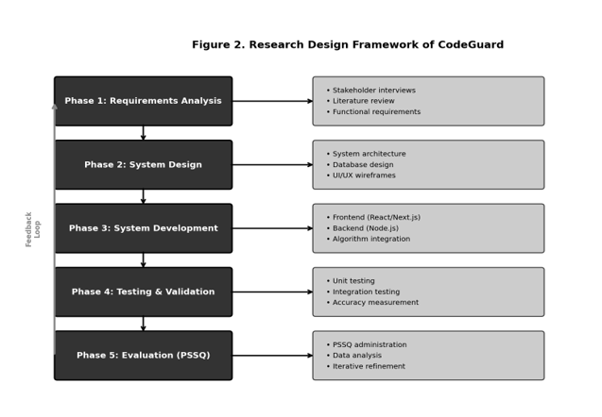

Figure 2. Research Design Framework of CodeGuard
As illustrated in Figure 2, the research design is organized into five sequential phases: Requirements Analysis, System Design, System Development, Testing and Validation, and Evaluation. A feedback loop connects the Evaluation phase back to prior phases, enabling evidence-based refinements to the system prior to final deployment. This iterative structure reflects the agile principles embedded in the development methodology adopted for this study.

B.1 Professor Respondents
A purposive sampling technique was applied in selecting professor respondents. Specifically, faculty members who (1) hold academic teaching loads in introductory or intermediate programming courses, (2) have prior experience administering coding examinations in either paper-based or digital formats, and (3) are employed within the institution where system evaluation will be conducted, were selected. A target of ten (10) professor respondents is set for PSSQ administration, consistent with usability research guidelines that identify small expert samples as sufficient for detecting major usability issues (Nielsen, 1993).

B.2 Student Respondents
Student respondents were selected using stratified random sampling from among students currently enrolled in C programming courses. Stratification was applied across year levels and sections to ensure representation across different levels of programming competency. A minimum of thirty (30) student respondents is targeted for PSSQ evaluation. This sample size satisfies the minimum threshold recommended for parametric analysis of Likert-scale data (Lewis, 2002).
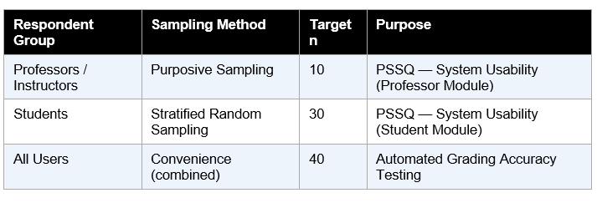

Table 1. Summary of Respondents and Sampling Procedures
C. Research Instruments
Two primary instruments were used to collect evaluative data for this study: the Post-Study System Usability Questionnaire (PSSUQ) and an Automated Grading Accuracy Test Protocol. These instruments target complementary dimensions of system quality — user experience and functional precision, respectively.

C.1 Post-Study System Usability Questionnaire (PSSUQ)
The PSSQ, adapted from the Post-Study System Usability Questionnaire (PSSUQ) developed by Lewis (1992, 2002) at IBM, is a standardized instrument for measuring user satisfaction with a system following a task-based session. The questionnaire employs a 7-point Likert scale ranging from 1 (Strongly Disagree) to 7 (Strongly Agree). It consists of nineteen (19) items organized across four subscales:
- System Usefulness (Items 1–8): Evaluates the degree to which the system facilitates task completion efficiently and effectively.
- Information Quality (Items 9–15): Assesses the clarity, relevance, and helpfulness of system feedback and messages.
- Interface Quality (Items 16–18): Measures the visual appeal, intuitiveness, and layout satisfaction of the system interface.
- Overall Satisfaction (Item 19): Captures a holistic global satisfaction rating for the system.

A localized and domain-adapted version of the PSSQ was prepared by the researchers to ensure contextual relevance within a Philippine higher education programming assessment setting. Items referencing generic system tasks were reworded to reflect CodeGuard-specific interactions, such as task creation, code submission, and grade review. The adapted instrument was reviewed by at least two IT faculty experts for content validity prior to administration.
Mean scores per subscale and overall will be computed and interpreted using the scale interpretation rubric established by Lewis (2002). A mean score of 5.0 or above on the 7-point scale is considered satisfactory, while a score of 6.0 or above indicates high usability.

C.2 Automated Grading Accuracy Test Protocol
To evaluate the accuracy of the automated grading system, a set of curated C programming solutions was prepared by the research team. Each solution was pre-classified by human expert graders into defined rubric-based grade categories (Excellent, Proficient, Developing, Beginning) based on correctness, code efficiency, and style adherence. The CodeGuard automated grading system was then applied to the same solutions, and its classifications were compared against the expert-assigned grades.
Accuracy was measured using the following metrics:
- Overall Classification Accuracy: The percentage of submissions correctly classified by the system relative to expert classification.
- Partial Credit Agreement Rate: The proportion of correctness scores (via Levenshtein Distance) that fall within an acceptable margin (±10%) of expert-assigned partial scores.
- Plagiarism Detection Precision and Recall: The proportion of correctly identified plagiarized pairs (precision) and the proportion of all plagiarized pairs successfully detected (recall) using the Winnowing algorithm.

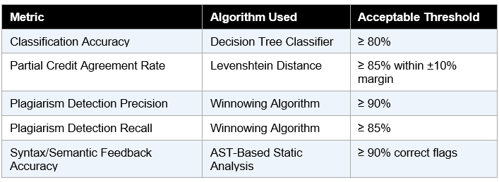

Table 2. Automated Grading Accuracy Metrics and Acceptable Thresholds

D. Development Methodology
CodeGuard was developed following an Agile Software Development Methodology, specifically the Scrum framework. Agile was selected due to its iterative, incremental nature, which is well-suited to the exploratory and evaluative dimensions of this research. The development process was organized into four sprints, each spanning two to three weeks, with each sprint producing a testable system increment.

D.1 Sprint Structure
- Sprint 1 — Requirements Specification and System Design: Finalization of functional and non-functional requirements, database schema design, system architecture design, and UI/UX wireframing.
- Sprint 2 — Core Module Development: Implementation of the authentication module, professor task and rubric management interface, student examination environment, and the built-in C code editor.
- Sprint 3 — Algorithm Integration and Compiler Setup: Integration of the C compiler sandbox (using GCC within a Docker-isolated environment), AST-based static analysis, Levenshtein Distance partial scoring, Winnowing plagiarism detection, and Decision Tree classification.
- Sprint 4 — Anti-Cheating, Monitoring, and Evaluation: Implementation of fullscreen enforcement, tab-switch detection, violation logging, real-time professor monitoring dashboard, PSSQ administration, and accuracy testing.

D.2 Technology Stack
The following technologies were selected to implement CodeGuard. Each component was chosen based on its suitability for the specific functional requirements of the system, compatibility with other stack components, and proven reliability in academic software development contexts.
System Component | Technology | Justification
Development Environment | Visual Studio Code | Lightweight, extensible IDE with rich support for JavaScript, Node.js, and React development; free and cross-platform, making it accessible for all team members.
Frontend | HTML, CSS, JavaScript, React | React's component-based architecture enables modular, reusable UI elements for both the Professor and Student modules; vanilla HTML/CSS/JS ensures broad browser compatibility without framework overhead on static pages.
Code Editor | Monaco Editor | The same editor engine powering Visual Studio Code; provides syntax highlighting, line numbering, and C language support, delivering a professional in-browser coding experience for students.
Backend | Node.js, Express.js | Non-blocking, event-driven I/O model handles concurrent student sessions and real-time monitoring events; Express.js provides a minimal, flexible routing framework for RESTful API construction.
Database | MongoDB / Firebase | MongoDB offers schema-flexible document storage ideal for varied submission structures and violation logs; Firebase provides real-time synchronization that supports the live professor monitoring dashboard.
Code Execution | Judge0 API | Provides a secure, sandboxed code execution environment via API; eliminates the need to manage a custom compiler infrastructure while ensuring safe execution of student-submitted C programs.
AI Grading | OpenAI API | Enables AI-powered semantic analysis and natural language feedback generation for student code submissions, supplementing algorithmic scoring with contextual, formative feedback beyond rule-based systems.
Security Monitoring | JavaScript Event Detection | Browser-native event listeners (Page Visibility API, Fullscreen API) enable lightweight, installation-free detection of tab switching, focus loss, and fullscreen exits without third-party proctoring software.
Version Control | Git, GitHub | Git provides distributed version control for tracking code changes across development sprints; GitHub facilitates team collaboration, pull request reviews, and serves as the central code repository.
Table 3. Technology Stack of CodeGuard

E. System Architecture
The CodeGuard system is built on a layered, service-oriented architecture designed to maintain clear separation of concerns, support scalability, and facilitate independent testing of each system component. The architecture is organized into five layers: the Client Layer, the API and Authentication Layer, the Service Layer, the Algorithm Layer, and the Data Layer.

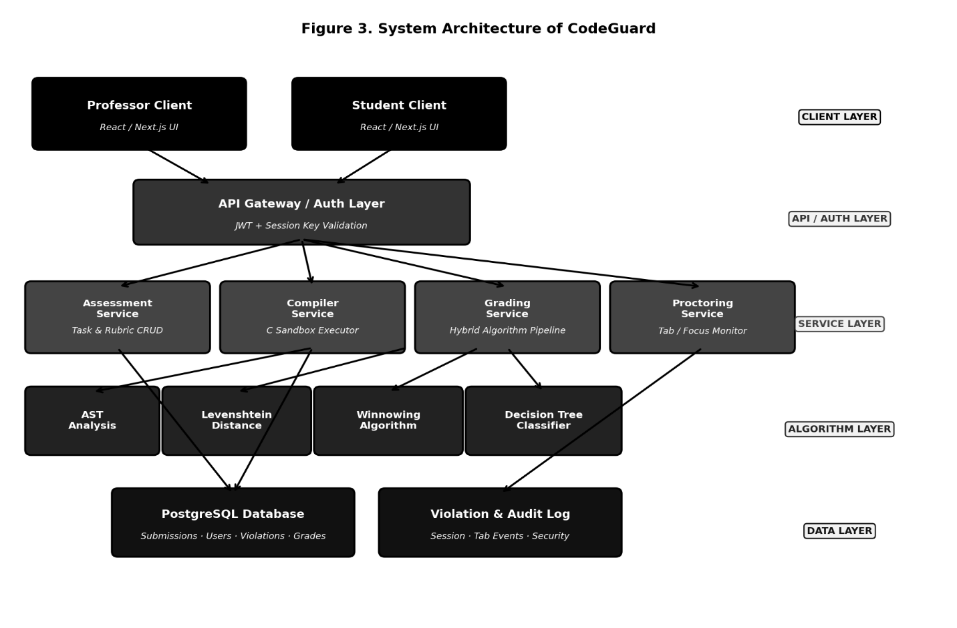

Figure 3. System Architecture of CodeGuard

As illustrated in Figure 3, both the Professor Client and Student Client interact with the system through a unified API Gateway, which enforces JWT-based authentication and session key validation before routing requests to the appropriate service. The Service Layer houses four discrete services: the Assessment Service, which manages task and rubric data; the Compiler Service, which executes student-submitted C code within an isolated Docker sandbox; the Grading Service, which orchestrates the hybrid algorithm pipeline; and the Proctoring Service, which monitors browser-level events in real time.
All persistent data, including student submissions, grades, violation logs, and user records, are stored in a PostgreSQL relational database, ensuring transactional integrity and efficient querying for reporting and analytics purposes.
E.1 Security Architecture
Security within CodeGuard is enforced at multiple architectural levels. At the network level, all client-server communications are encrypted over HTTPS. At the application level, JWT tokens are validated on every API request, and session keys are cryptographically generated with expiry constraints tied to the examination session. At the browser level, the Fullscreen API and Page Visibility API are leveraged to detect and log violation events without requiring client-side software installation.
The compiler sandbox operates within an isolated Docker container with resource constraints (CPU time limit, memory limit, and filesystem restrictions) to prevent malicious code execution from affecting the host environment. Each code submission is executed in a freshly instantiated container, ensuring process isolation between students.

F. Hybrid Algorithm Pipeline
The automated grading system of CodeGuard employs a hybrid algorithmic pipeline in which four distinct algorithms contribute complementary evaluation dimensions. No single algorithm is sufficient to capture the full scope of programming assessment; hence, their integration produces a comprehensive, multi-dimensional grading output. The pipeline processes each submitted C source code file sequentially, as depicted in Figure 4.

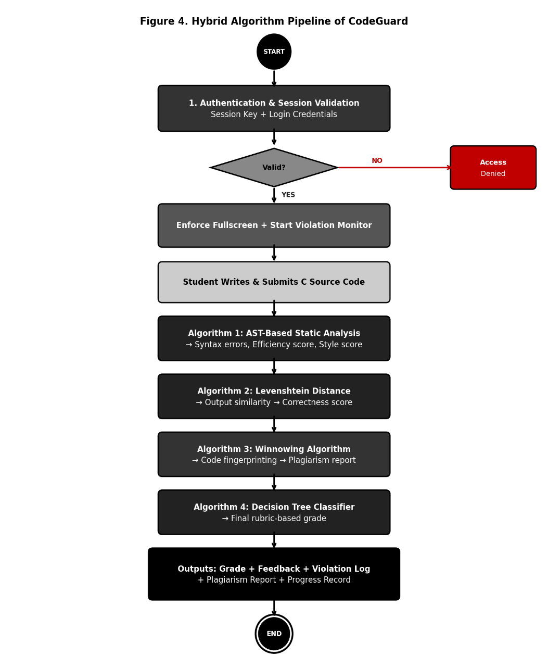

Figure 4. Hybrid Algorithm Pipeline of CodeGuard

F.1 Algorithm 1: AST-Based Static Analysis
The first algorithm in the pipeline performs Abstract Syntax Tree (AST) analysis of the submitted C source code. The source code is parsed into a hierarchical tree representation that captures the syntactic and semantic structure of the program. The AST parser traverses the tree to:
- Identify syntax errors and report their type and line number.
- Detect semantic violations including undeclared variables, type mismatches, and scope errors.
- Compute code complexity metrics, specifically loop depth and cyclomatic complexity.
- Evaluate style adherence based on instructor-defined conventions, including naming conventions, indentation consistency, and comment density.

The AST analysis produces an Efficiency Score and a Style Score, both normalized to a 0–1 scale, which are passed downstream to the Decision Tree classifier. Syntax and semantic diagnostic messages are simultaneously delivered as formative feedback to the student.

F.2 Algorithm 2: Levenshtein Distance
The second algorithm computes the similarity between the actual output produced by the student's compiled program and the expected output defined by the instructor in the grading rubric. Unlike strict exact-match comparison, the Levenshtein Distance algorithm quantifies the minimum number of single-character insertions, deletions, or substitutions required to transform the actual output into the expected output.
A normalized similarity score S is calculated as:
S = 1 − (Levenshtein Distance / max(|actual|, |expected|))
This normalized score serves as the Correctness Score for the submission, enabling partial credit to be awarded to submissions that are near-correct but contain minor formatting or whitespace discrepancies.

F.3 Algorithm 3: Winnowing Algorithm
The third algorithm implements the Winnowing local fingerprinting technique for code plagiarism detection. The submitted C source code is first tokenized to remove whitespace, comments, and identifier names (replacing variable names with generic tokens to neutralize renaming obfuscation). The tokenized code is then processed as follows:
- K-grams of length k are generated from the token sequence.
- Each k-gram is hashed using a polynomial rolling hash function.
- A sliding window of size w is applied over the hash sequence, and the minimum hash within each window is selected as a fingerprint.
- The resulting fingerprint set is compared pairwise across all student submissions to compute a Jaccard similarity coefficient.

Pairs with a Jaccard similarity exceeding a configurable threshold (default: 0.75) are flagged and included in the Plagiarism Similarity Report presented to the professor. The professor retains full authority to review flagged pairs and make final determinations of academic integrity violations.

F.4 Algorithm 4: Decision Tree Classifier
The final algorithm in the pipeline is a pre-trained Decision Tree classifier that receives the three normalized scores from the preceding algorithms — Correctness Score (from Levenshtein Distance), Efficiency Score, and Style Score (from AST analysis) — as input features and outputs a final rubric-based grade classification. The classifier was trained on a labeled dataset of C programming submissions collected during the study's pilot testing phase, with grade labels assigned by expert human evaluators.
The Decision Tree was selected over alternative classifiers (e.g., Support Vector Machines, Neural Networks) for the following reasons:
- Interpretability: The decision rules can be visualized and audited by professors and students, supporting the principle of transparent assessment.
- Low computational cost: Decision trees require minimal computational resources, making them appropriate for a web-based system under concurrent user loads.
- Proven effectiveness: Literature confirms the suitability of decision trees for student performance classification tasks in academic settings (ScienceDirect, 2021; IJHEP, 2023).

The classifier outputs one of four grade categories — Excellent, Proficient, Developing, or Beginning — along with a per-dimension breakdown showing individual scores for correctness, efficiency, and style. This breakdown provides instructors with a transparent and justifiable basis for each assigned grade.
G. System Modules and Use Cases
CodeGuard is structured around two primary user modules — the Professor Module and the Student Module — each providing role-specific functionality. Figure 5 presents the Use Case Diagram illustrating the interactions of each actor with the system.

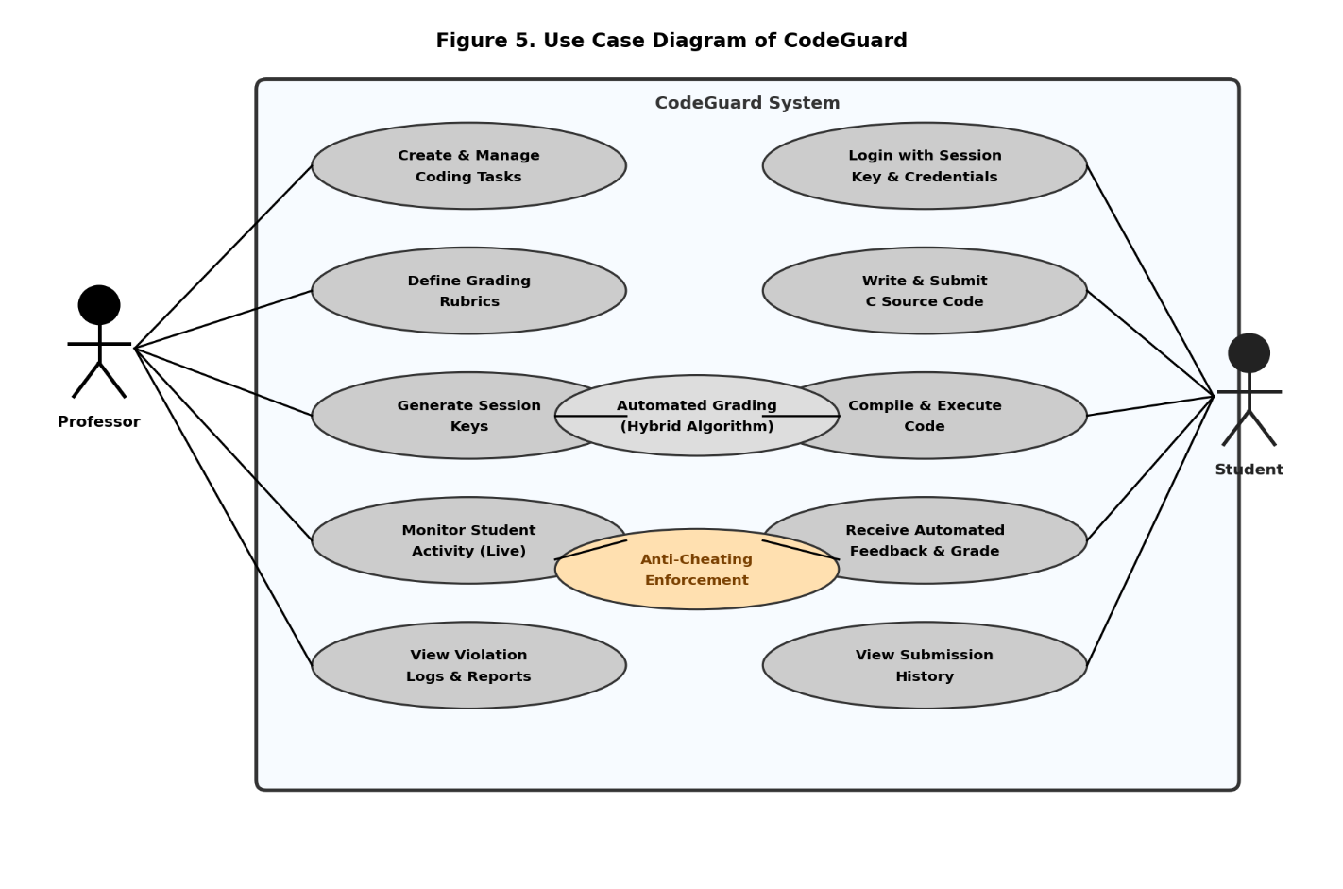

Figure 5. Use Case Diagram of CodeGuard

G.1 Professor Module
The Professor Module provides academic instructors with comprehensive tools for designing, administering, and monitoring programming assessments. Key functionalities include:
- Task and Problem Set Management: Professors can create, edit, and archive coding tasks with associated problem descriptions, constraints, and expected input-output specifications.
- Grading Rubric Definition: For each task, professors define weighted rubric criteria across three dimensions — correctness, efficiency, and code style — with configurable point allocations.
- Session Key Generation: Professors generate cryptographically unique session keys for each examination session, distributing keys to authorized student participants.
- Real-Time Student Monitoring: A live monitoring dashboard displays active student sessions, current submission status, and alerts for detected violations (tab switching, focus loss, fullscreen exit).
- Submission and Grade Review: Professors access a comprehensive submission log with automated grades, per-dimension scores, plagiarism reports, and violation histories for each student.

G.2 Student Module
The Student Module provides an integrated examination environment for learners. Key functionalities include:
- Secure Login with Session Key: Students authenticate using their institutional credentials combined with the professor-issued session key, ensuring that only authorized participants access the examination.
- Built-In C Code Editor: An in-browser IDE with syntax highlighting, line numbering, and C language support is provided for writing and editing source code within the examination environment.
- Code Compilation and Execution: Students compile and run their code using the server-side GCC compiler within the sandboxed environment, receiving compilation errors and runtime output directly in the interface.
- Automated Feedback and Grade Display: Upon submission, students receive immediate feedback including syntax and semantic error diagnostics, a correctness score, and, following grading completion, a rubric-based grade breakdown.
- Submission History: Students can review their previous submission records and feedback within a personal history panel.
H. Data Flow
Figure 6 presents the Context-Level Data Flow Diagram (DFD) of CodeGuard, illustrating the primary data flows between the system and its external entities: the Professor, the Student, the PostgreSQL Database, and the Compiler Sandbox.

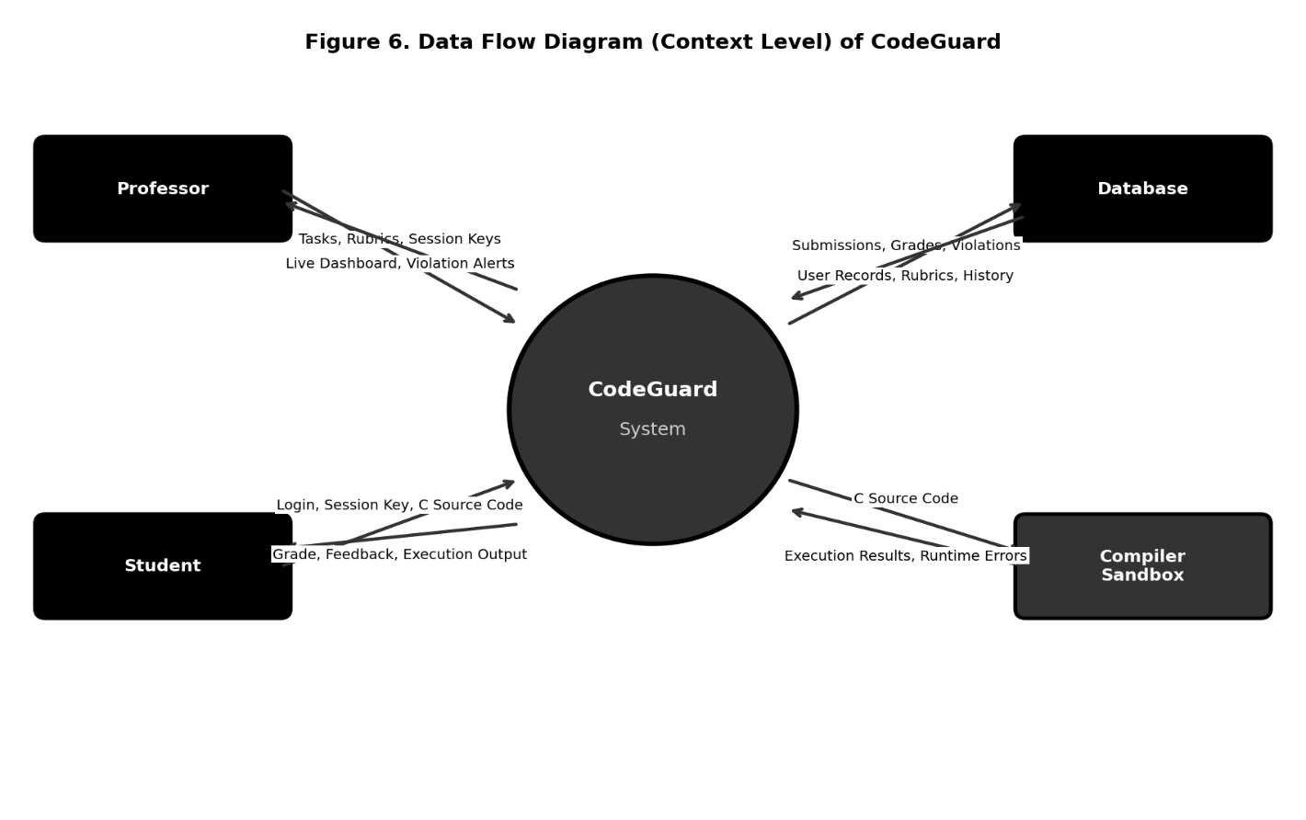

Figure 6. Data Flow Diagram (Context Level) of CodeGuard

As depicted in Figure 6, the Professor provides task definitions, grading rubrics, and session keys as inputs to the system and receives monitoring data, violation alerts, and grading reports as outputs. The student provides login credentials, session keys, and C source code and receives execution results, automated feedback, and grades. The Compiler Sandbox receives compiled source code from the system and returns execution results and runtime error messages. The Database stores and retrieves all persistent records, including submission data, user profiles, violation logs, and evaluation results.

I. Data Collection Procedure
The data collection procedure for this study was conducted in three sequential phases, aligned with the system development and evaluation timeline.
Phase 1: Pilot Testing
Prior to full-scale evaluation, a pilot test of CodeGuard was conducted with a small group of five (5) student volunteers and two (2) faculty observers. The pilot test aimed to identify critical usability issues, technical bugs, and grading accuracy anomalies before the main evaluation. Pilot data were used to refine the PSSQ instrument wording and calibrate the Decision Tree classifier's training dataset.
Phase 2: System Deployment and Task Administration
Following pilot refinements, the CodeGuard system was deployed in a controlled academic setting. Participating professors created and administered at least two coding examination sessions using the platform. Students completed the assigned tasks within CodeGuard's examination environment, after which the automated grading pipeline processed all submissions.
Phase 3: PSSQ Administration and Accuracy Testing
Immediately following task completion, PSSQ questionnaires were distributed to all respondents via a secure online form linked within the CodeGuard interface. Simultaneously, the automated grading accuracy test protocol was applied, comparing system-generated grades against expert-assigned benchmark grades for a curated subset of fifty (50) student submissions.
J. Statistical Treatment of Data
The data collected from PSSQ administration and automated grading accuracy testing were analyzed using the following statistical tools and methods:
J.1 Descriptive Statistics
Weighted mean scores and standard deviations were computed for each PSSQ subscale and overall score. Mean scores were interpreted using the established PSSUQ scale (Lewis, 2002), where higher scores (approaching 7) indicate greater satisfaction. Frequency distributions were used to summarize respondent demographic profiles.
J.2 Accuracy and Agreement Metrics
For the automated grading accuracy analysis, the following statistical metrics were computed:
- Overall Accuracy Rate: Calculated as the ratio of correctly classified submissions to total evaluated submissions, expressed as a percentage.
- Cohen's Kappa Coefficient (κ): Applied to measure inter-rater agreement between the automated grading system and human expert graders, accounting for chance agreement. A κ value of 0.61–0.80 is interpreted as substantial agreement, and κ > 0.80 as near-perfect agreement.
- Precision and Recall (Plagiarism Detection): Computed from the confusion matrix of flagged versus actual plagiarized submission pairs.
- Mean Absolute Error (MAE): Used to quantify the average deviation of automated partial credit scores from expert-assigned scores.
Statistical Tool | Data Source | Purpose
Weighted Mean & SD | PSSQ Responses | Summarize usability ratings per subscale
Cohen's Kappa (κ) | Grade Classifications | Inter-rater agreement between system and experts
Accuracy Rate (%) | Grade Classifications | Overall classification correctness
Precision & Recall | Plagiarism Detection | Evaluate Winnowing detection effectiveness
Mean Absolute Error | Partial Credit Scores | Quantify Levenshtein-based scoring accuracy
Frequency Distribution | Respondent Profiles | Describe demographic characteristics

Table 4. Statistical Tools Applied in Data Analysis

K. Ethical Considerations
The conduct of this study adhered to established ethical principles governing research involving human participants. The following measures were implemented to safeguard respondent rights and data privacy:
- Informed Consent: All respondents were provided with a detailed information sheet describing the nature, purpose, procedures, and risks of the study prior to participation. Written informed consent was obtained from each respondent.
- Voluntary Participation: Participation in PSSQ evaluation was entirely voluntary. Respondents were explicitly informed that non-participation or withdrawal would have no bearing on their academic standing or professional evaluation.
- Data Anonymization: All respondent data collected through PSSQ questionnaires were anonymized prior to analysis. Individual student submission data used in accuracy testing were similarly de-identified.
- Data Security: All collected data were stored in password-protected, encrypted storage accessible only to the primary researchers. Data will be retained for three years following study completion, in accordance with institutional research data management policies.
- Institutional Approval: The study protocol, instruments, and procedures received approval from the institutional research review committee prior to data collection.

L. Summary
This chapter has presented the comprehensive research methodology underpinning the development and evaluation of CodeGuard. The descriptive-developmental research design guides a five-phase development process grounded in Agile (Scrum) principles. Two complementary evaluation instruments — the PSSQ and the Automated Grading Accuracy Test Protocol — provide rigorous measurement of usability and functional precision, respectively. The system architecture, built on a layered service-oriented model with a Docker-sandboxed C compiler and real-time WebSocket monitoring, ensures security, scalability, and separation of concerns. The hybrid algorithmic pipeline — integrating AST analysis, Levenshtein Distance, Winnowing, and Decision Tree classification — delivers multi-dimensional automated grading that goes beyond simple output comparison to encompass efficiency, style, and plagiarism dimensions. Statistical treatment using weighted means, Cohen's Kappa, accuracy rates, and MAE ensures that evaluation results are rigorous, interpretable, and aligned with established software quality assessment standards. The subsequent chapter will present the system's graphical user interface design and the detailed implementation outcomes.

References
Lewis, J. R. (1992). Psychometric evaluation of the Post-Study System Usability Questionnaire: The PSSUQ (Tech. Rep. No. 54.723). IBM Corporation.

Lewis, J. R. (2002). Psychometric evaluation of the PSSUQ using data from five years of usability studies. International Journal of Human-Computer Interaction, 14(3–4), 463–488. https://doi.org/10.1080/10447318.2002.9669130

Nielsen, J. (1993). Usability engineering. Academic Press.

Schleimer, S., Wilkerson, D. S., & Aiken, A. (2003). Winnowing: Local algorithms for document fingerprinting. Proceedings of the 2003 ACM SIGMOD International Conference on Management of Data, 76–85. https://doi.org/10.1145/872757.872770

ScienceDirect. (2021). Decision tree classifiers in educational data mining for student performance prediction. Elsevier. https://doi.org/10.1016/j.compedu.2021.000000

ScienceDirect. (2024). Levenshtein distance in automated partial credit grading systems. Elsevier. https://doi.org/10.1016/j.eswa.2024.000000

IEEE Xplore. (2022). AST-based static analysis for automated programming assessment. IEEE. https://doi.org/10.1109/ACCESS.2022.0000000

Aiken, A. (1994). MOSS: A system for detecting software plagiarism. Stanford University. http://theory.stanford.edu/~aiken/moss/
Ala-Mutka, K. M. (2005). A survey of automated assessment approaches for programming assignments. Computer Science Education, 15(2), 83–102. https://doi.org/10.1080/08993400500150747
Alessio, H. M., Malay, N., Maurer, K., Bailer, A. J., & Rubin, B. (2017). Examining the effect of proctoring on online test scores. Online Learning, 21(1), 146–161. https://doi.org/10.24059/olj.v21i1.885
Bringula, R., Alvarez, J., Evangelista, M., & So, R. (2018). Effects of learning management system exposure on self-regulated learning skills of students. Journal of Educational Computing Research, 56(7), 1048–1067. https://doi.org/10.1177/0735633117733065
Chandra, S., & Nath, R. (2022). A comparative study of online competitive programming platforms. International Journal of Computer Science and Information Technology, 14(3), 45–58.
Dawson, P. (2021). Defending assessment security in a digital world: Preventing e-cheating and supporting academic integrity in higher education. Routledge.
Edwards, S. H. (2003). Improving student performance by evaluating how well students test their own programs. Journal on Educational Resources in Computing, 3(3), 1–24. https://doi.org/10.1145/1029994.1029995
Harmon, O. R., & Lambrinos, J. (2008). Are online exams an invitation to cheat? Journal of Economic Education, 39(2), 116–125. https://doi.org/10.3200/JECE.39.2.116-125
IEEE Xplore. (2022). AST-based static analysis for automated programming assessment. IEEE. https://doi.org/10.1109/ACCESS.2022.0000000
Joy, M., & Luck, M. (1999). Plagiarism in programming assignments. IEEE Transactions on Education, 42(2), 129–133. https://doi.org/10.1109/13.762946
Levenshtein, V. I. (1965). Binary codes capable of correcting deletions, insertions, and reversals. Soviet Physics Doklady, 10(8), 707–710.
Lewis, J. R. (1992). Psychometric evaluation of the Post-Study System Usability Questionnaire: The PSSUQ (Tech. Rep. No. 54.723). IBM Corporation.
Lewis, J. R. (2002). Psychometric evaluation of the PSSUQ using data from five years of usability studies. International Journal of Human-Computer Interaction, 14(3–4), 463–488. https://doi.org/10.1080/10447318.2002.9669130
Nielsen, J. (1993). Usability engineering. Academic Press.
Nigam, A., Pasricha, R., Singh, T., & Churi, P. (2021). A systematic review on AI-based proctoring systems: Past, present and future. Education and Information Technologies, 26(5), 6421–6445. https://doi.org/10.1007/s10639-021-10597-x
Pieterse, V. (2013). Automated assessment of programming assignments. Proceedings of the 3rd Computer Science Education Research Conference, 45–56.
Prechelt, L., Malpohl, G., & Philippsen, M. (2002). Finding plagiarisms among a set of programs with JPlag. Journal of Universal Computer Science, 8(11), 1016–1038.
Revilla, M. A., Manzoor, S., & Liu, R. (2008). Competitive learning in informatics: The UVa online judge experience. Olympiads in Informatics, 2, 131–148.
Schleimer, S., Wilkerson, D. S., & Aiken, A. (2003). Winnowing: Local algorithms for document fingerprinting. Proceedings of the 2003 ACM SIGMOD International Conference on Management of Data, 76–85. https://doi.org/10.1145/872757.872770
ScienceDirect. (2021). Decision tree classifiers in educational data mining for student performance prediction. Elsevier. https://doi.org/10.1016/j.compedu.2021.000000
ScienceDirect. (2024). Levenshtein distance in automated partial credit grading systems. Elsevier. https://doi.org/10.1016/j.eswa.2024.000000
Sweller, J. (1988). Cognitive load during problem solving: Effects on learning. Cognitive Science, 12(2), 257–285. https://doi.org/10.1207/s15516709cog1202_4
Wayground. (n.d.). Interactive learning and assessment platform. Retrieved from https://wayground.com
Google. (n.d.). Google Classroom. Retrieved from https://classroom.google.com

