CSIS 4495 -- 071 Progress Report 1
Team Name: Dream Team
Project Name: SoulBound Ascent
Team Members: Guillermo Tellez (300391317), Samuel Kagimbi (300389976), Steven Anderson (300414292)
Instructor: Michael Ma
1. Project Update
Since the proposal, the project has moved from a concept-focused planning stage into a more concrete visual and production-planning stage for the SoulBound Ascent prototype. The team has continued following the original Unity-based direction for a single-player dungeon auto-battler strategy game with a town preparation layer, an automated battle layer, and a semester-scale vertical slice goal.
Tasks completed since the proposal
Several tasks have been completed since the proposal stage:
- A game logo for SoulBound Ascent and team logo was generated to establish a stronger visual identity and help define the overall tone of the project.

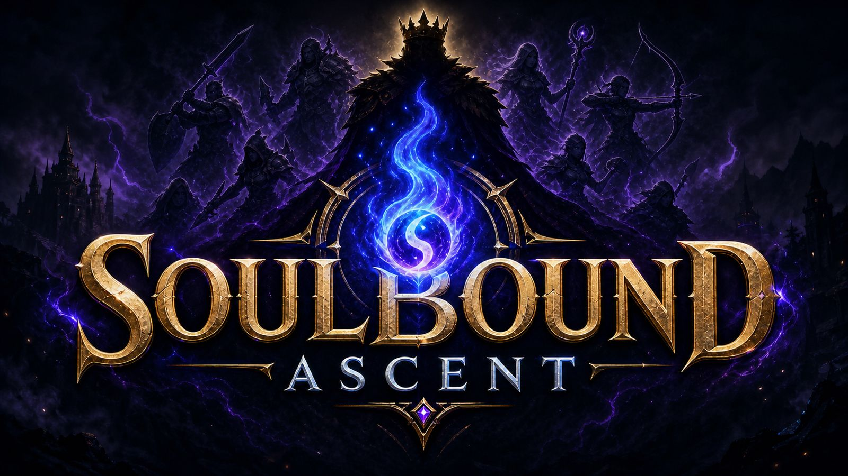
- Multiple Unity Asset resources were researched and shortlisted to support early prototyping in animation, character design, environments, and dungeon presentation.
- The team explored how to use Unity Hub and made a small demo.
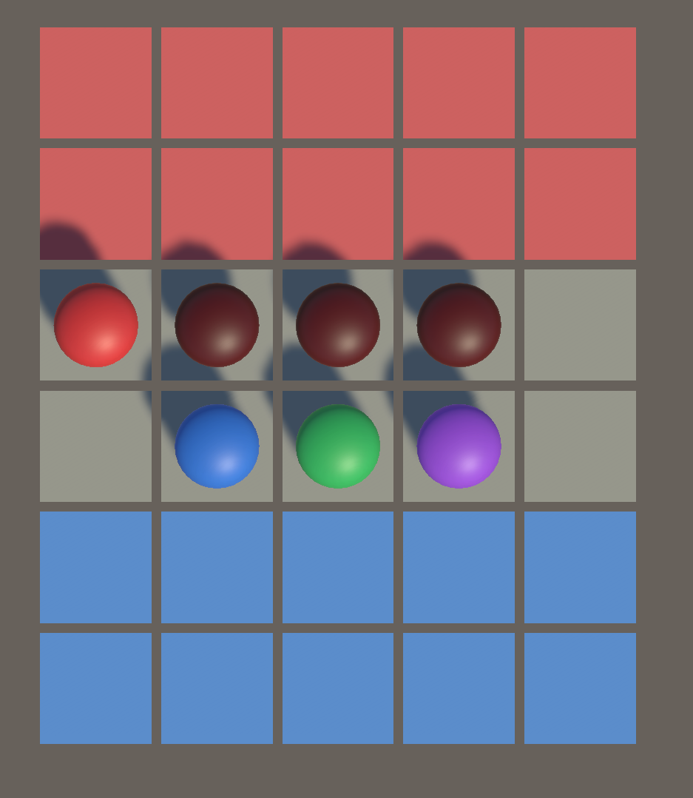
- The team reviewed which assets to use free or AI generated assets.
- The team refined presentation materials to communicate project updates and get feedback.
These tasks support the original proposal goal of building a playable, readable, and scoped semester prototype rather than attempting a full commercial game.
Current implementation status
The project is currently in an early implementation and visual-direction phase. The technical direction remains Unity with C# as the main development stack, with a 2D UI-based town layer and a 3D battle layer still serving as the intended architecture.
At this stage, the team has not only kept the original technical plan but has also added stronger visual planning. The most important status items are:
- The project identity and branding direction are now clearer through the completed game logo.
- Asset research has been carried out to reduce setup time and help the team choose practical resources for prototyping.
- The team is currently working on creating 2D assets for the game UI in Unity.
- The project continues to follow the demo-first approach defined in the proposal, where readability, combat clarity, and scoped implementation remain the priority.
Challenges or issues encountered
One major challenge remains the same as identified in the proposal: scope control. SoulBound Ascent includes many appealing systems such as summoning, training, hero progression, equipment, revival, synergies, invasion pressure, and town management, but these features can easily exceed what a three-person semester team can safely complete.
Another challenge is selecting assets and visual styles that fit the project tone. The team must balance speed, cost, asset compatibility, and consistency across UI, character, environment, and battle presentation. There is also the need to ensure that visual improvements do not distract from the core gameplay objective of making automated combat readable and understandable.
Planned tasks for the next stage
The next stage of the project will focus on converting the current planning and visual-direction work into prototype implementation tasks. Planned work includes:
- Continuing the creation of 2D UI assets in Unity for menus, player feedback, and interface consistency.
- Selecting and integrating the most suitable prototype assets from the researched assets options.
- Building or refining early battle presentation elements such as character placement, readable states, and combat feedback.
- Advancing the town preparation interface so the player can inspect heroes, prepare for battle, and understand progression systems.
- Preserving the original milestone priority of proving the combat loop first, then expanding supporting systems after the core loop is stable.
- Balancing difficulty design for each floors.
Changes to the original timeline or project scope
There is no full change to the project’s core direction, but the recent work suggests a practical refinement in emphasis rather than a redesign. The original proposal already prioritized a demo-first vertical slice, Unity implementation, and strict scope limits. That direction remains unchanged.
The main adjustment is that more attention is now being given to visual direction, branding, and asset selection earlier in the process than was emphasized in the original proposal. This is not a scope expansion by itself; instead, it is a support step intended to make implementation faster and the prototype more coherent. The team is still working within the same broad timeline of establishing setup, proving the combat core, building the preparation loop, and then polishing readability and supporting systems.
References
Technologies, U. (2026). ScriptableObject. Unity 6.1 Manual. https://docs.unity3d.com/6000.1/Documentation/Manual/class-ScriptableObject.html
Technologies, U. (2026). JsonUtility.ToJson. Unity Manual. https://docs.unity3d.com/ScriptReference/JsonUtility.ToJson.html
Technologies, U. (2026). Test Framework. Unity Manual. https://docs.unity3d.com/6000.0/Manual/com.unity.test-framework.html
Project, G. L. (2026). Git Large File Storage. https://git-lfs.com/
Unity Asset Store. Human Basic Motions FREE. https://assetstore.unity.com/packages/3d/animations/human-basic-motions-free-154271
Unity Asset Store. RPG Animations Pack Free. https://assetstore.unity.com/packages/3d/animations/rpg-animations-pack-free-288783
Unity Asset Store. Free Low Poly Nature Forest. https://assetstore.unity.com/packages/3d/environments/landscapes/free-low-poly-nature-forest-205742
Unity Asset Store. Stylized Low Poly Skeleton. https://assetstore.unity.com/packages/3d/characters/humanoids/fantasy/stylized-low-poly-skeleton-306857
Unity Asset Store. PB Frontier Settlement. https://assetstore.unity.com/packages/3d/environments/fantasy/pb-frontier-settlement-166680
Unity Asset Store. RPG Poly Pack Lite. https://assetstore.unity.com/packages/3d/environments/landscapes/rpg-poly-pack-lite-148410
Unity Asset Store. Brawler Animations Free. https://assetstore.unity.com/packages/3d/animations/brawler-animations-free-305932
Unity Asset Store. RPG Tiny Fantasy Forest PBR. https://assetstore.unity.com/packages/3d/environments/fantasy/rpg-tiny-fantasy-forest-pbr-309458
Unity Asset Store. Low Poly Dungeons Lite. https://assetstore.unity.com/packages/3d/environments/dungeons/low-poly-dungeons-lite-177937
Unity Asset Store. Lowpoly Universal Character Modular. https://assetstore.unity.com/packages/3d/characters/lowpoly-universal-character-modular-199781
Appendix: AI Usage Report and Documentation
AI tools were used as support tools during proposal preparation and progress-report preparation, but final design choices, project direction, and submitted content remain the responsibility of the team. The project proposal already documented that AI assistance was used for brainstorming, proposal drafting, slideshow creation, prototype discussion, and planning support.
Major AI-supported activities
- Brainstorming and refining the game concept.
- Comparing gameplay structures and narrowing the project to a manageable semester scope.
- Drafting and revising proposal language.
- Creating and revising presentation materials.
- Assisting with visual concept generation such as team or game logo ideas.
- Supporting organization of project updates into a formal progress report format.
Human verification and revision
The team reviewed AI-generated suggestions before using them. AI output was treated as draft material, not as final authority. Technical directions still require testing in Unity, and written materials must still be checked for accuracy, clarity, course alignment, and consistency with the actual state of the project.
Representative record
A representative example from earlier project documentation is the use of AI to help plan gameplay-loop visuals, proposal structure, and technical scoping decisions, followed by human revision to improve terminology, reduce ambiguity, and align the materials with the intended game direction. AI was also used to support image generation related to the team logo and game logo, with human review guiding which results were kept or revised.

