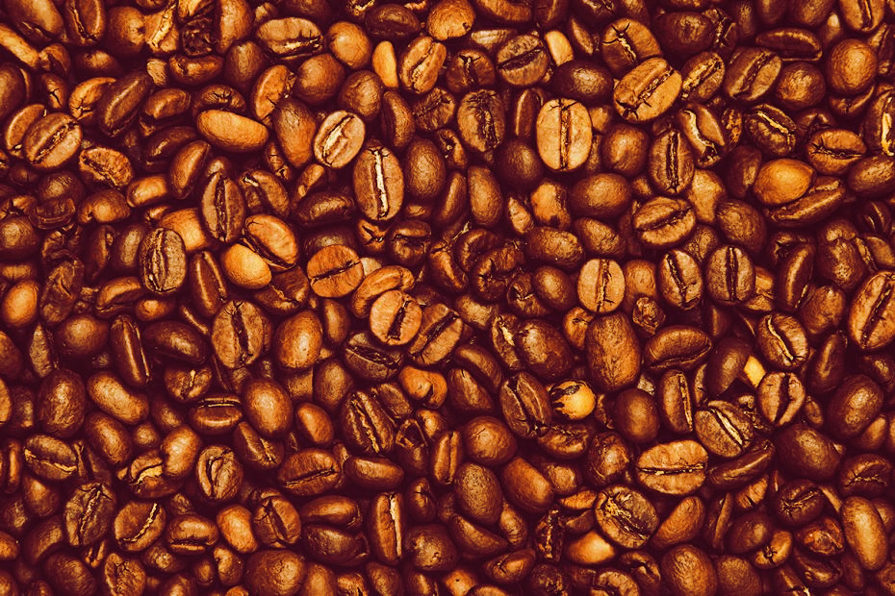Supercharged: A study of caffeine and how it affects short term memory & decision making

# Question: does caffeine affect short-term memory & decision making?

# Introduction

Caffeine has been a common household ingredient enjoyed throughout the ages and still today is the world's most ingested pharmacologic and psychoactive substance (Sökmen et al., 2008). Scientifically the consensus in relation to simple cognitive functions is that the ingestion of caffeine increases basic cognitive performance such as attention, vigilance and reaction time (McLellan, Caldwell and Lieberman, 2016). The focus of this paper will also be of cognition, but specifically due to the gaps in research the effect caffeine may have on short term memory & decision making, since the findings are limited regarding “higher” cognition & caffeine use. This is due perhaps to fewer published studies on higher-order cognitive function and a great variance between methods employed (McLellan, Caldwell and Lieberman, 2016).

Multiple research techniques have been done to test these findings but the approach that this paper will take is slightly varied with the assistance of a technological artefact. The artefact utilizes Augmented Reality to conduct a memory testing experiment while under the effects of caffeine and without to compare the results.

Augmented reality otherwise known as AR, allows users to see the real world, with virtual components fixed upon that world. Therefore, AR enhances reality and ideally lets the virtual objects appear as if coexisting within that reality (Azuma, 2006). Effectively creating a perfect environment for easily replicated tests without wasted resources.

# Proposal

Firstly, this paper will be taking a closer look at caffeine, not only its physiological effects but also its origins. Analysing varying ways society today ingests caffeine in its different forms, pinpointing different statistics within the population in terms of regular consumption and its involvement within the human species.

The second phase will be focused on short term memory & the differing states that may hinder or help the effectiveness of caffeine within the human body. Not necessarily only physical in terms of effects but looking at more holistic answers, for example considering mood or personality traits of the subject.

The third phase of this paper will be discussing the research method that the artefact will follow and the reasoning behind it. Finally, upon completion of testing, presenting the results and the conclusions attached to those findings.

# Origins of caffeine and its consumption today

Even though Caffeine containing plants have been used for their pharmacological effects since before recorded history, it was the growing interest within plant chemistry in Europe in the early nineteenth century that caffeine was first isolated & named by the physicist Friedlieb Ferdinand Runge (Bealer, 2004).

Today caffeine is perhaps mostly identifiable with coffee but is also commonly known to be found naturally in tea leaves, cacao beans, kola nuts and many other known plant species (Roehrs and Roth, 2008). When considering the rate of consumption you must understand that it is present daily in perhaps most of our lives for example the information gathered from the National Health and Nutrition Examination Survey found close to eighty-nine percent of all US adults consume caffeine daily (Fulgoni, Keast and Harris R, 2015) which can also give a clear indication of how prevalent caffeine has become.

# Variables to be considered when analysing the effects of caffeine

Many states of the human body should be considered when analysing the effectiveness of caffeine. For example a study has shown that the subject’s stress levels combined with caffeine directly created undesirable blood pressure levels two to four hours after ingestion(Hartley et al., 2001), while another study has found that impulsive subjects improved their throughput where unimpulsive were impaired when taking complex cognitive tests in the morning while under the effects of caffeine. Therefore, to create the most accurate results from testing, taking note of the subject’s personality and mood as well as physiological states and results are indeed also required.

## Short-term Memory

Short term memory is the process of holding certain information for short periods of time. Some examples may be remembering a phone number or street address so that it can be stored long enough to be written down or processed (Jones and Macken, 2015).

## Decision Making

Effectively we are all decision makers, but for the purpose of this experiment we aim to observe the decision made to be correct or incorrect.  Defining a correct decision as the collection of all information regarding the circumstances in order to develop the best solution for that situation (Saaty, 2008).

# Artefact Wireframes

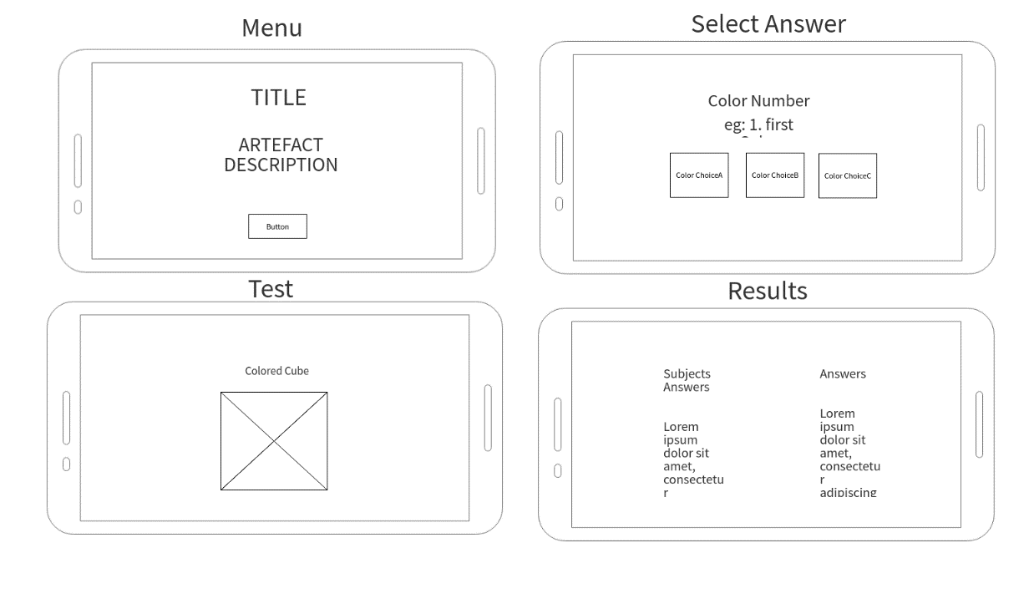

# Artefact Flowchart

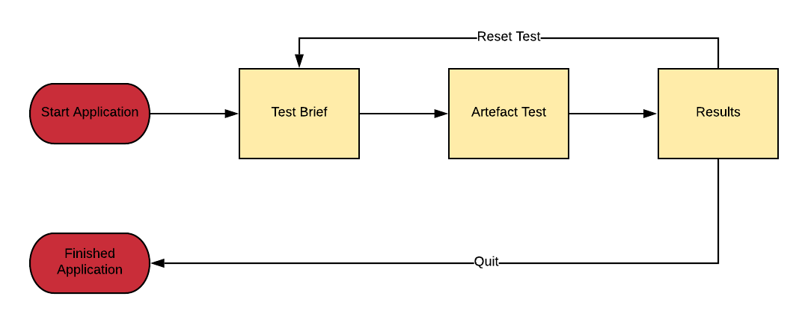

# Research Method

## Candidate Selection

The candidates must be of over the age of 18 and have given consent to these tests to be conducted. Aside from age restriction all other variables will be considered during testing but not integral for selection purposes. Below is the form provided for each subject to fill in after testing.

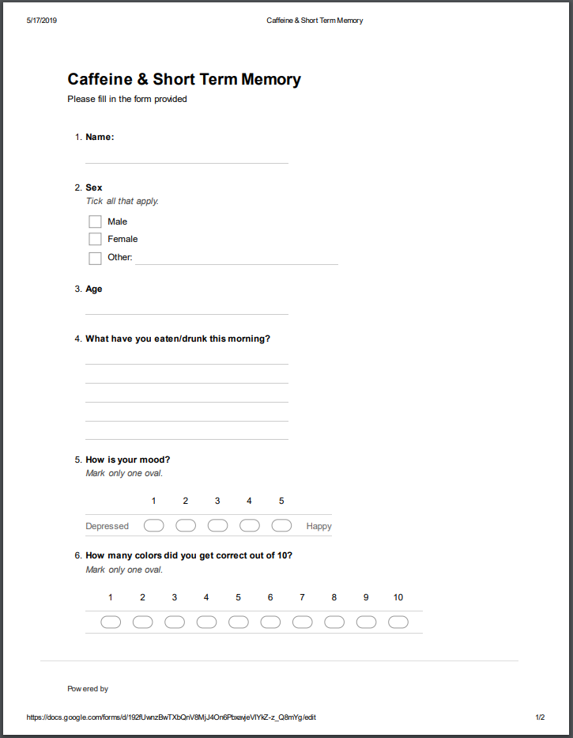

(*Test Subject Form*)

## Selecting the appropriate caffeine contained product for testing

Before the tests are to take place, a set of certain guidelines and observations must be made. First is selecting which form of caffeine the subjects will ingest.  Because most test subjects will be adults, the stimulant chosen will be coffee, to be exact one fluid ounce(30g) of espresso which on average contains 60-70 mg of caffeine (Jed’s espresso blend: strength 4). This choice is due to studies having been found that the primary dietary caffeine intake for adults all over the world was indeed coffee (Mahoney et al., 2019).

## Testing Environment

Perhaps the most important aspect of testing is creating a consistent environment and circumstances for that testing. Due to the fact the tests will be done on human subjects these points are to be taken note of and to be done repeatedly in the most similar fashion as possible.

#### Location:

Creating a relaxed environment with minimal distractions.

#### Time Frame/Participants:

The test will span five minutes. four tests to be conducted on each subject, two tests with the ingestion of caffeine and two tests without. With five participants in total.

#### Abstaining of caffeine:

As part of the test subjects are to abstain from any form of caffeine unless instructed otherwise.

#### Food Diary:

Each subject will also be asked within the form given as to what they have ingested.

# The Prototype Artefact

The artefact will be prepared in advance to ensure that minimal errors could occur. The test subject will receive an image target upon greeting and once the test has begun it will be recorded throughout using a mobile device to capture as much information as possible.

The subject will begin with using a mobile device provided.  The application will begin with the brief of the experiment, then followed by the user directing their device toward the image provided. Upon the image a simple cube will be sat within the centre. The user will be instructed to press the cube to begin the experiment.

The cube will begin to change colours and the subject must attempt to remember the sequence of colours that has occurred. Three buttons will appear once all colours have been shown. Prompting the user in choosing the correct colour among the choices directing you through each step until complete. The Answers will be accessible once completed (please refer to Image below) and footage of the experiment will then be reviewed and concluded once testing has been completed.

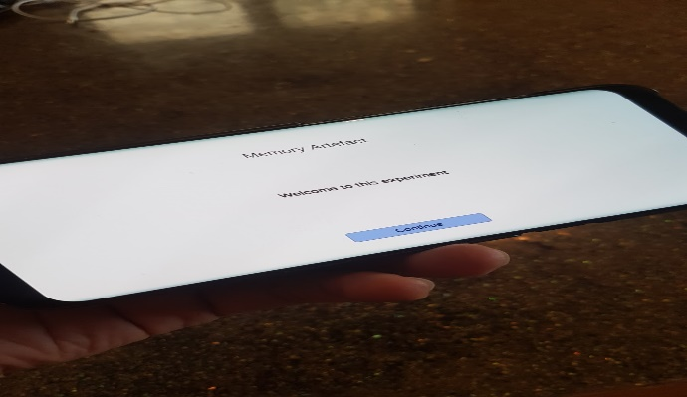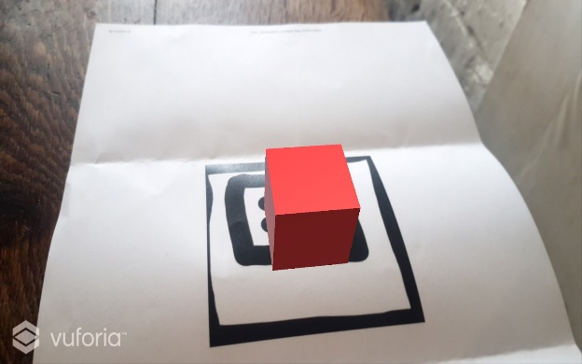

(*Image from AR prototype*) (*Entry Screen from prototype*)

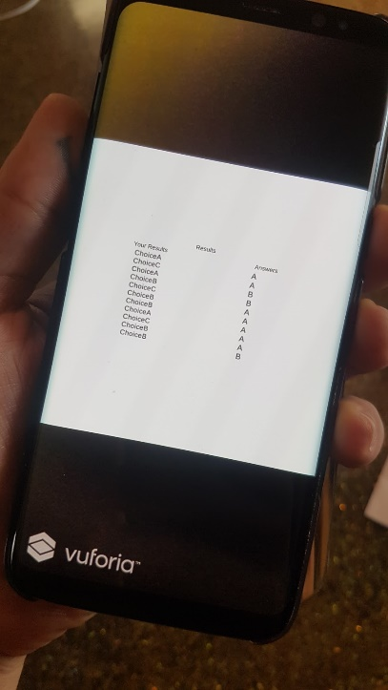

(Prototype *Results Screen*)

# Difficulties & Limitations (Pre-Testing)

Among the problems encountered during the research process the largest that occurred was also the most valuable. For instance, creating a test that produces the most accurate results took learning to limit all outside factors that may hinder the results and effectively leave the study irrelevant. This was done by creating a set of rules of how the test should be conducted for each instance.

Another prominent problem that occurred was locating the appropriate research to prove the points highlighted within the paper. For instance, many of the articles found during research were not open sourced and required payment for access. The way I hope to resolve this during the next part of this process and the future is to take full advantage of the public libraries and other community based open source libraries.

# Artefact

# The final artefact has been changed to create an easily understood test using the information gathered during initial testing. This includes an update to colour scheme, incorporating in-test instructions & the final addition of replacing the cube with a coffee mug. Although the mug was not used during testing to avoid confusion.

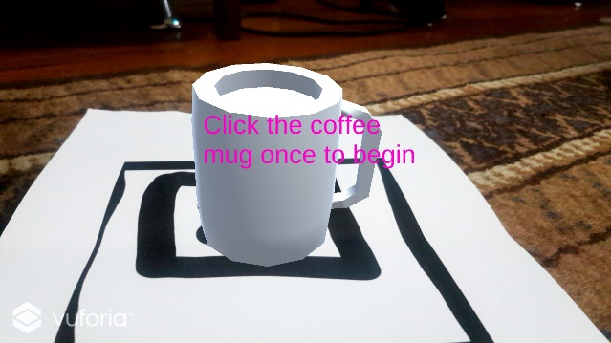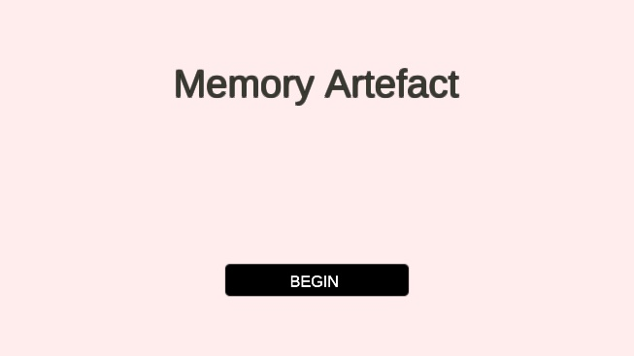

# 

(Entry Screen)

Test Prompt (final cup design not used for testing purposes due to late change).

# 

(test completion)

(Test)

# 

Results

(Select Answer)

# 

# Testing

### Test Subject 1

|  |  |  |  |
| --- | --- | --- | --- |
| Name: Michele Paris  Age: 58  Sex: Female | Food | Mood level time of experiment: | Score: |
| Test 1 (Caffeine Abstinence) | Poached Eggs on toast, Water | 3 | 4 |
| Test 2 (Caffeine Ingested) | Cinnamon Scroll, Cheese & Tomato sandwich | 4 | 6 |
| Test 3 (Caffeine Abstinence) | Steak & eggs. | 4 | 3 |
| Test 4 (Caffeine Ingested) | Espresso, Toast | 5 | 5 |

#### Observations:

In comparison the test results show an improvement once the ingestion of caffeine, the subject did also present improvements of mood and was much more decisive when answering.

#### Difficulties/Future Thoughts

The tests were successful the biggest lesson from the first test subject is that the application testing and debugging period should have been done more thoroughly to present a more fully finished product so not to cause retesting.

### Test Subject 2

|  |  |  |  |
| --- | --- | --- | --- |
| Name: Taran Paris  Age: 31  Sex: Female | Food | Mood level time of experiment: | Score: |
| Test 1 (Caffeine Abstinence) | Bagel with tomatoes | 2 | 4 |
| Test 2 (Caffeine Ingested) | Chicken Salad, Water | 5 | 5 |
| Test 3 (Caffeine Abstinence) | Muesli | 3 | 4 |
| Test 4 (Caffeine Ingestion) | Chicken wrap | 5 | 6 |

#### Observations:

Subject tested well and was affected positively from the ingestion of caffeine. Mood also seemed to be a lot higher.

#### Difficulties/Future Thoughts

The test subject did distress that the first initial test caused slight anxiety. The Solution used so not to affect the test itself was a change to the colour theory of the application.

### Test Subject 3

|  |  |  |  |
| --- | --- | --- | --- |
| Name: Ole Maiava  Age: 60  Sex: Male | Food | Mood level time of experiment: | Score: |
| Test 1 (Caffeine Abstinence) | Steak & Bun | 5 | 5 |
| Test 2 (Caffeine Ingested) | Toast | 5 | 6 |
| Test 3 (Caffeine Abstinent) | Sausage | 4 | 4 |
| Test 4 (Caffeine Ingested) | Pie (Steak & Cheese) | 5 | 6 |

#### Observations:

The subject seemed confident in each set of tests, yet the time taken to answer questions when under the influence of caffeine were shorter. The subject did not show great difference in score in comparison but did score in the higher range when under the influence of caffeine.

#### Difficulties/Future Thoughts:

The biggest difficulties regarding the subject was confirming times for testing due to the subject’s work life. A solution to this in the future would be altering and confirming test times so that it did not conflict with working hours with each subject.

### Test Subject 4

|  |  |  |  |
| --- | --- | --- | --- |
| Name: Klein Siteine  Age: 23  Sex: Male | Food | Mood level time of experiment: | Score: |
| Test 1 (Caffeine Abstinence) | Pork, Chicken wedges | 5 | 8 |
| Test 2 (Caffeine Ingested) | Eggs on Toast | 4 | 6 |
| Test 3 (Caffeine Abstinence) | Bagel | 4 | 5 |
| Test 4 (Caffeine Ingestion) | Peanut Butter on toast | 4 | 7 |

#### Observations:

In terms of results the data gathered seemed somewhat irregular pertaining to the ingestion of caffeine and test results. No major differences observed yet age of subject is lowest in our tests.

#### Difficulties/Future Thoughts

Some aspects of the subject are to be investigated during future research such as either pooling all same age subjects or an extended testing process to acquire more data.

### Test Subject 5

|  |  |  |  |
| --- | --- | --- | --- |
| Name: Isabel Lain  Age: 28  Sex: Female | Food | Mood level time of experiment: | Score: |
| Test 1 (Caffeine Ingested) | Toast, eggs crackers | 5 | 8 |
| Test 2 (Caffeine Abstinence) | Cereal (Special K) | 4 | 7 |
| Test 3 (Caffeine Ingested) | Cereal (Special K) | 5 | 7 |
| Test 4 (Caffeine Abstinence) | Muesli | 4 | 6 |

#### Observations:

High level of mood emitted with only a slight drop during caffeine abstinence as well a smaller average in score while also caffeine abstinent.

#### Difficulties/Future Thoughts

I believe considering the close range between all tests, additional testing may be necessary.

# Conclusion:

# Does caffeine affect short term memory and decision making? Well when looking at the data it appears so, considering four out of 5 subjects did have a positive effect on test scores and decisiveness while under the influence of the caffeine. Also, to be identified one out of five showed the highest results during caffeine abstinence but as observed did become more decisive while caffeinated even if those decisions were not all correct. Other considerations are of the mood each subject were in, since all subjects tested had drops in mood only on caffeine abstinent scheduled testing, it does bring into question on mood and throughput but that is a completely different study.

# Limitations/ Future thoughts

# In this paper I believe a lot of valuable information was gathered and many interesting other topics came into focus. Yet the biggest limit encountered was due to time management. I believe for the future investing the appropriate amount of time to certain tasks will be greatly beneficial. For example, if the application had been tested more thoroughly the catching of bugs before the teste even discovered them may have sped up the process and enabled an increased amount tests since although the information was substantial could have been considerably more but is a good lesson for future projects.

# 

# References

1. Azuma, R. (2006). *A Survey of Augmented Reality*. [ebook] Malibu, p.1. Available at: https://www.mitpressjournals.org/doi/abs/10.1162/pres.1997.6.4.355#authorsTabList [Accessed 7 May 2019].
2. Bealer, B. (2004). *The World of Caffeine*. New York: Taylor & Francis, p.14.
3. Fulgoni, V., Keast, D. and Harris R, L. (2015). *Trends in intake and sources of caffeine in the diets of US adults: 2001–2010*. [ebook] The American Journal of Clinical Nutrition, pp.1081-1087. Available at: https://academic.oup.com/ajcn/article/101/5/1081/4577554 [Accessed 7 May 2019].
4. Hartley, T., Lovallo, W., Whitsett, T., Sung, B. and Wilson, M. (2001). Caffeine and Stress: Implications for Risk, Assessment, and Management of Hypertension. *The Journal of Clinical Hypertension*, [online] 3(6), pp.354-382. Available at: https://doi.org/10.1111/j.1524-6175.2001.00478.x [Accessed 8 May 2019].
5. McLellan, T., Caldwell, J. and Lieberman, H. (2016). A review of caffeine’s effects on cognitive, physical and occupational performance. *Neuroscience & Biobehavioral Reviews*, [online] 71, pp.294-312. Available at: http://A review of caffeine’s effects on cognitive, physical and occupational performance [Accessed 7 May 2019].
6. Mahoney, C., Giles, G., Marriott, B., Judelson, D., Glickman, E., Geiselman, P. and Lieberman, H. (2019). Intake of caffeine from all sources and reasons for use by college students. *Clinical Nutrition*, [online] 38(2), pp.668-675. Available at: http://www.sciencedirect.com/science/article/pii/S0261561418301341 [Accessed 9 May 2019].
7. Sökmen, B., Armstrong, L., Kraemer, W., Casa, D., Dias, J., Judelson, D. and Maresh, C. (2008). Caffeine Use in Sports: Considerations for the Athlete. *Journal of Strength and Conditioning Research*, [online] 22(3), pp.978-986. Available at: <https://journals.lww.com/nsca-jscr/Fulltext/2008/05000/Caffeine_Use_in_Sports__Considerations_for_the.47.aspx>.
8. Jones, G. and Macken, B. (2015). Questioning short-term memory and its measurement: Why digit span measures long-term associative learning. *Cognition*, [online] 144, pp.1-13. Available at: https://doi.org/10.1016/j.cognition.2015.07.009 [Accessed 15 May 2019].
9. Saaty,’ T. L. (2008). Decision making with the analytic hierarchy process. *International journal of services sciences*, *1*(1), 83-98.