Ex.no:7 | DATA VISUALIZATION USING TABLEAU

Aim:
To perform data analysis, data preparation, and visual exploration on the hotel bookings dataset (hotel_bookings.csv) in Tableau Desktop/Prep to analyze booking patterns, cancellation rates, and customer demographics for actionable hospitality insights.
Algorithm:
- Data Ingestion & Connection
Connect Tableau Desktop to hotel_bookings.csv as a text file source.
Verify field data types (e.g., date formats, integer values for lead time/guests, string values for country and reservation status).

- Data Cleansing & Transformation
Handle missing or null values across critical columns like children, country, and agent.
Create calculated fields for key metrics (e.g., total stay duration, total revenue, cancellation rate).

- Exploratory Visual Analysis

- Booking Dynamics: Plot booking lead times against cancellation rates to identify patterns.

- Demographic & Market Segmentation: Analyze origin countries, guest types, and market segments (e.g., Direct, Corporate, TA/TO).

- Seasonality Trends: Map arrival dates across months and years to highlight peak/off-peak booking trends.

- Dashboard Assembly & Formatting
Combine key worksheets into an interactive executive dashboard.
Apply global interactive filters (e.g., Hotel Type, Year, Market Segment) across all dashboard components.

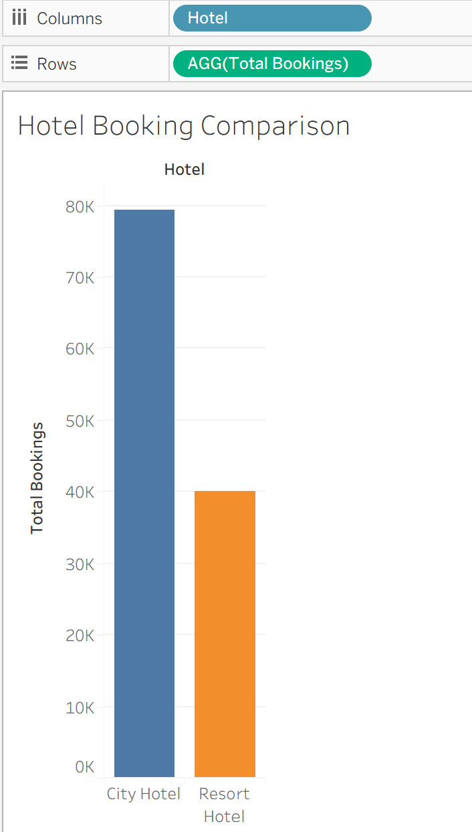
Output:

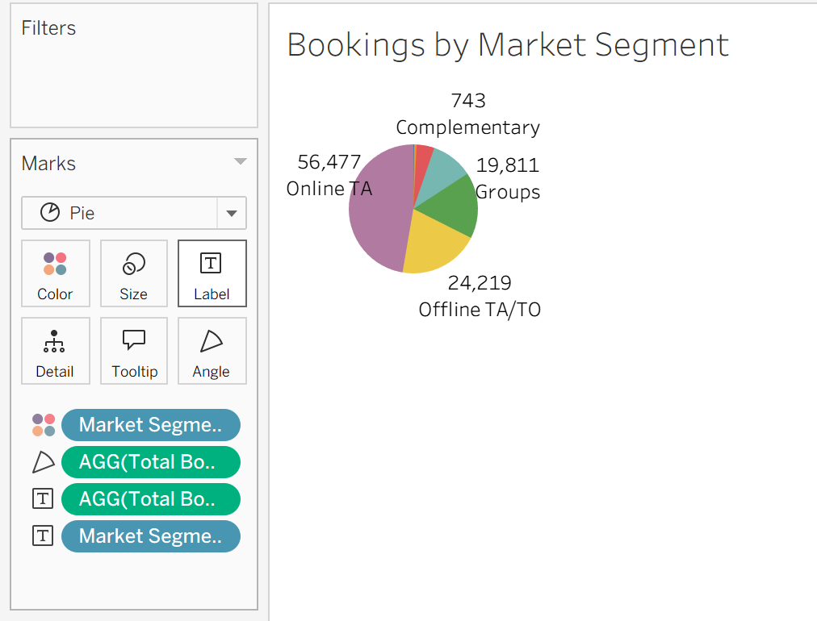

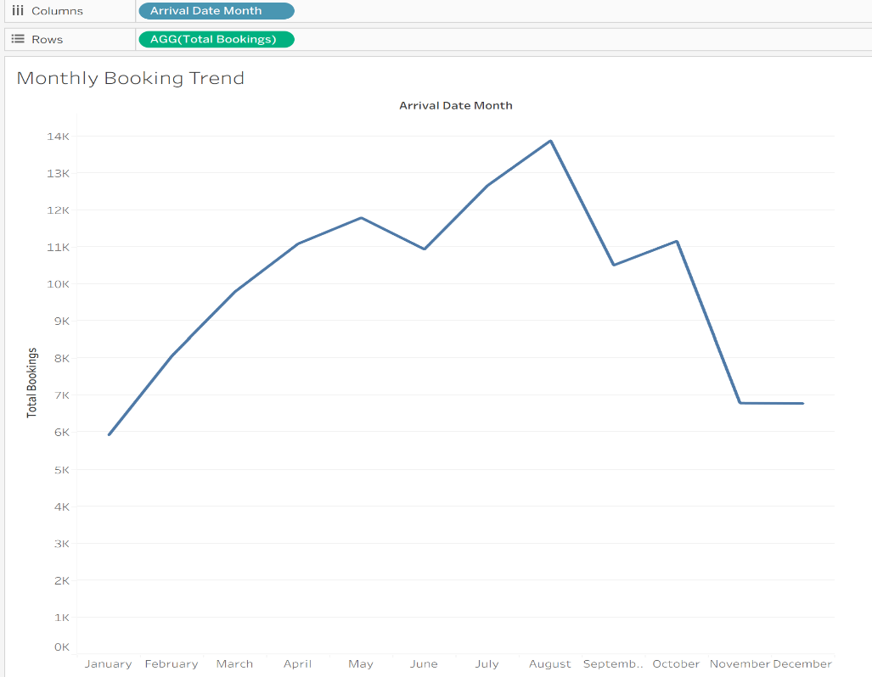

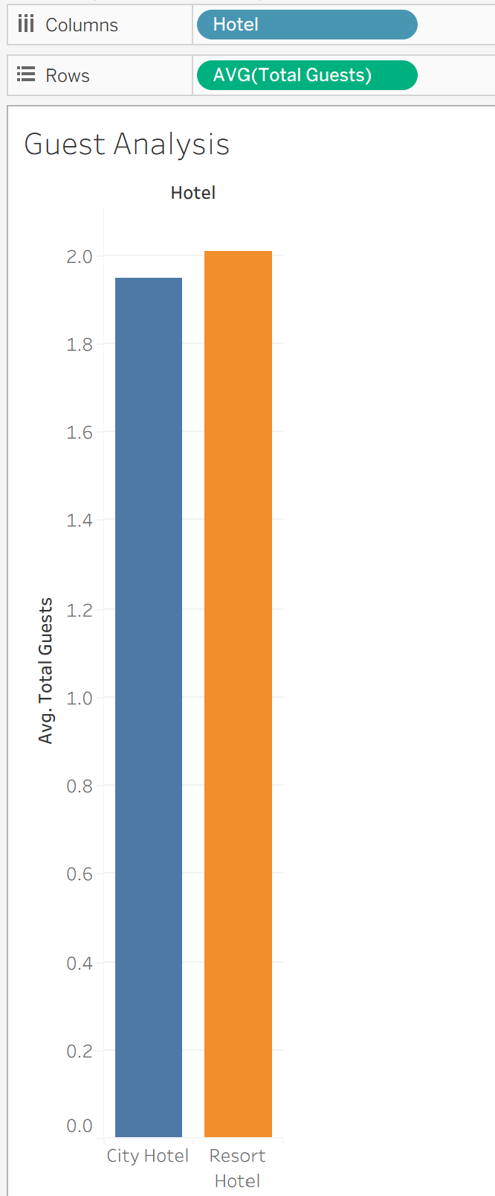
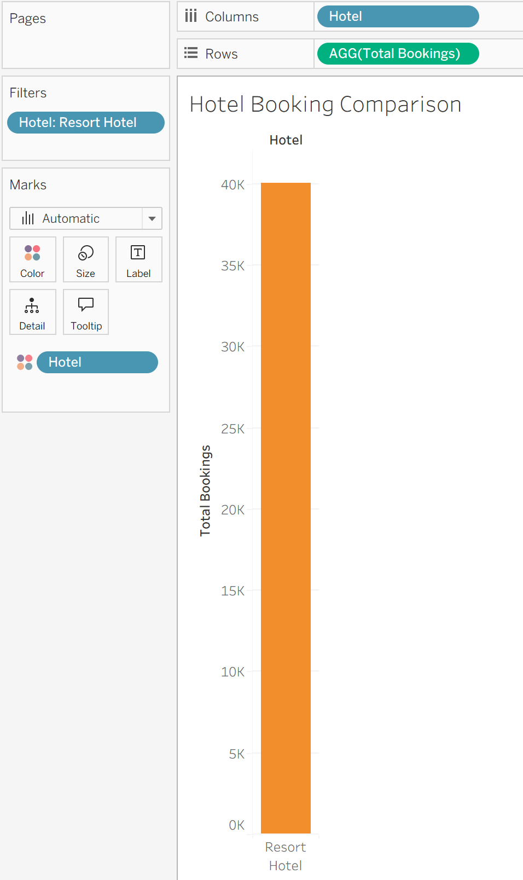

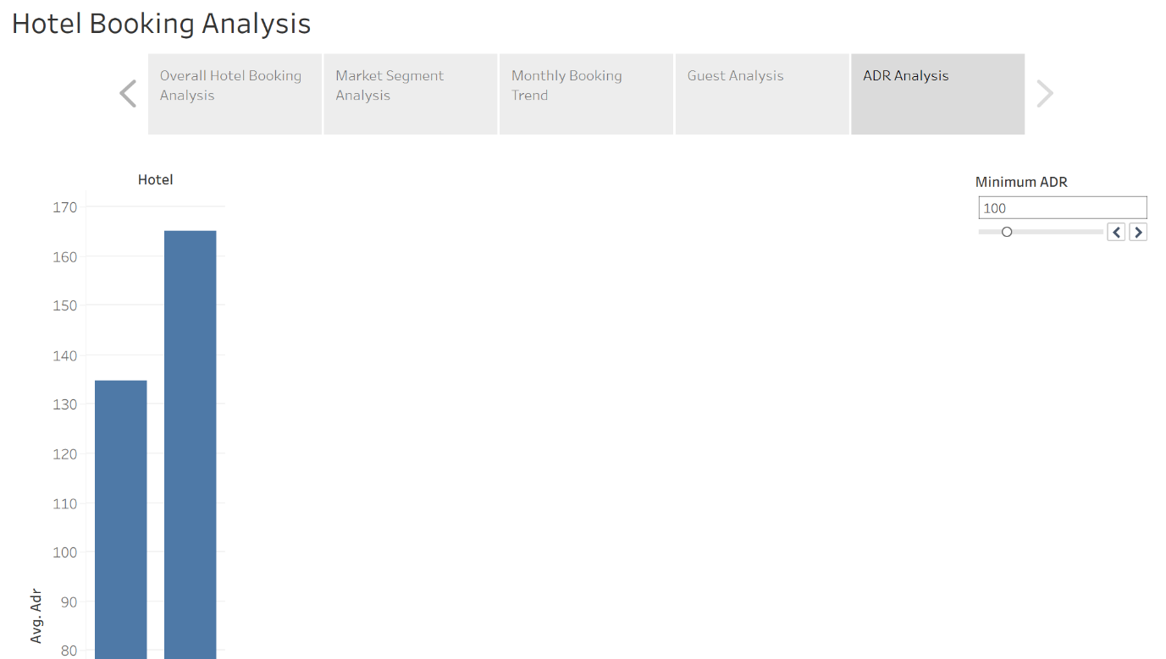

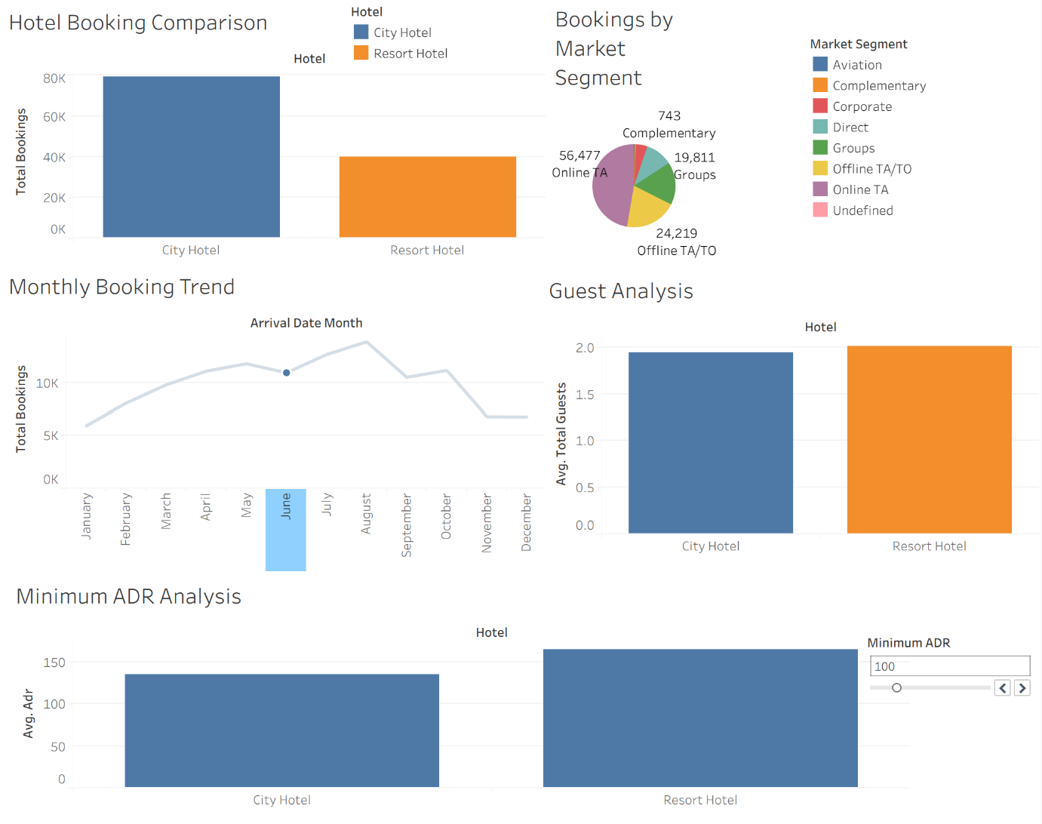

Result:

