**Personal-Webpage**

**Documentation**

Member Names:

Bryan Shebeck

Start Date: September 9th, 2016

End Date: Winter, 2016

Table of Contents

Introduction 3

Goal: 4

Change Log: 4

Background Experience: 5

Software Life-Cycle Model: 5

Application Domain: 5

Client’s Requirements: 5

Client Constraints: 6

Functional Constraints: 6

Nonfunctional Constraints: 6

Business Model: 6

Milestones: 7

Analysis Phase: 7

Task One: Home Page 7

Status: 7

Goal: 7

Mock Ups: Home Page 2.0 8

Task Two: About Me Page 8

Status: 8

Goal: 8

Mock Ups: 8

Task Three: Resume Page 9

Status: 9

Goal: 9

Mock Ups: Resume Page 1.0 10

Task Four: Projects Page 10

Status: 10

Goal: 10

Mock Ups: Projects Page 1.0 11

Task Five: Contact Me Page 11

Status: 11

Goal: 11

Mock Ups: Contact Me Page 1.0 12

Schedule and Budget Summary: 12

Schedule: 12

Budget: 13

Estimate Plan (Cost and Duration): 13

Demand Forecast: 13

Tools: 13

Glossary: 14

Scratch Pad: 14

References 15

# Introduction

This Personal-Webpage documentation is to show my abilities to write software documentation and follow Software Life-Cycle Model. The software life-cycle model approach taken for this project will be a modified Waterfall Life-Cycle method. The modified waterfall method was created in 1970’s, and it is standard waterfall method with modification that allows you to back track and correct errors in previous steps like the Iterative-and-Incremental life-cycle model. This will allow the application to be constructed piece-by-piece rather than through multiple versions, and in addition allows the team members to go back a step and fix an error and then move back to the current step and update before moving on the next step. Under each task will be documentation for that web page as well as model diagram, copy of the code, and the final diagram. The change log will have task number section to direct to which page I worked on that day, and a short explanation of what I did. I am a full time student, therefore the time table set for this project is the winter of 2016, but that is not a definitive date. I will have a scratch pad note section in the back of this document for small notes personally for me, as well as reminders for myself. Also as a disclaimer, I am the client as well as the programmer for this project. I am attempting to make the language very clear and separate without mixing into too much unnecessary personal language into the document.

# Goal:

Main goal of this application is to show off my online resume along with personal skills and abilities that were developed over my time at the University of West Florida. Side goals are continuous development of skills and abilities, learning new functions of HTML5 and CSS, enjoying the process, learning about bootstrap, and Satisfactory feeling of completion when the application is completed.

# Change Log:

|  |  |  |  |  |  |
| --- | --- | --- | --- | --- | --- |
| Change Number | Date | Name | Phase | Explanation | Number of Hours |
| 1 | 9/9/2016 | Bryan Shebeck | Introduction | Creation of Document | 3 |
| 2 | 9/9/2016 | Bryan Shebeck | Analysis | HomePage Mockup 1.0 | 1 |
| 3 | 9/12/16 | Bryan Shebeck | Introduction | Updated Constraints and Life-Cycle Model | 3 |
| 4 | 9/12/16 | Bryan Shebeck | Introduction | Schedule, Budget, and GitHub | 2 |
| 5 | 9/17/16 | Bryan Shebeck | Analysis | Status and goal update, and GitHub update | 2 |
| 6 | 10/2/16 | Bryan Shebeck | Analysis | All of the new Mock Ups | 4 |
| 6 | 10/2/16 | Bryan Shebeck | Coding | 95% of Homepage Code | 4 |

# Background Experience:

* Bryan Shebeck – Proficient in Microsoft Office. Informal experience in MySQL, HTML5, CSS, JS, and Java computing languages. Informal experience as a computer technician, and tutor for MySQL.

# Software Life-Cycle Model:

The software life-cycle model approach taken for this project will be a modified Waterfall Life-Cycle method. This will allow the application to be constructed piece-by-piece rather than through multiple versions, and in addition allows the team members to go back a step and fix an error and then move back to the current step and update before moving on the next step. Also this will allow each stage to be analyzed more than once and so that nothing is missed in decision for less errors to be found later on.

# Application Domain:

The domain for this application is in the personal webpage. The application will be used to promote client’s abilities in the computer science field and show proof of abilities as well.

# Client’s Requirements:

Application Name: Personal-Webpage

Application Overview: Develop a webpage that can display personal resume along with personal skills and abilities.

Data that needs to be tracked: Number of views of the application.

Front End Software: Client requires a complex website that can be used on any of the top five browsers. Using HTML, CSS, JavaScript.

Backend Software: A MySQL database will be created to store addition information. Cold Fusion will also be used for sever side programming in conjunction with the MySQL database.

Hardware: Client would like the application to run on top five browsers. Also the clients want the application to be compatible for smart phones and tablets in addition to desktops and laptops.

Features: Client needs to be able to have clear, crispy and attractive application. Application must be responsive to all 4 different device types. Clients wants to know number of views for the webpage per day, week, and month.

Budget: The budget for this project is $100.00.

File/Folders: - Main Folder

1. Html
2. CSS
3. Js
4. Cold Fusion

# Client Constraints:

## Functional Constraints:

1. Webpages must work for five most popular web browsers
   1. Chrome 50
   2. Firefox 45
   3. Internet Explorer 11 and Edge
   4. Safari 9
   5. Opera 36
2. Responsive Webpage
3. Google Analytics

## Nonfunctional Constraints:

1. Must work on mobile devices.
2. Must not exceed the $100.00 budget.

# Business Model:

Person-Webpage is an online resume to show off skills and abilities that have been developed at the University of West Florida but also through hard work and effort sacrificed at the dispense of personal time. This application will be developed with HTML5, CSS, JS, and with ColdFusion. This application has a budget of one hundred dollars. The applications target audience is recruiting agencies and possible employers.

# Milestones:

|  |  |  |
| --- | --- | --- |
| Millstones: | Estimated Completion Date: | Completion Date: |
| “HomePage” page Completion | 9/30/2016 | 10/2/16 |
| “About Me” page Completion | 10/15/2016 |  |
| “Resume” page Completion | 10/31/2016 |  |
| “Projects” page Completion | 11/16/2016 |  |
| “Contact Me” page Completion | 12/01/2016 |  |
| “Additional Information” page Completion | 12/10/2016 |  |
| End of Test User Cases | 12/20/2016 |  |
| Release of the Project | 12/23/2016 |  |

# Analysis Phase:

## Task One: Home Page

Status: In Progress

### Goal:

Purpose of the Title page is to have inform users of who I am with short, but clear message. As for the header, put your name in the upper right and possibly todays date would be a nice touch, with all links in the upper right. As for center of the page have a nice detailed picture in the back ground and with links to GitHub, LinkedIn and to my homepage. In the three sections under the main photo, have information about Me, and my school and additional links to all of my social media. Image of me and my school in their respective rows, and try to do something fancy with social media links. Also at the bottom of the webpage, have a clear footer with all links just like the header and copy right in bottom right.

### Mock Ups: Home Page 2.0

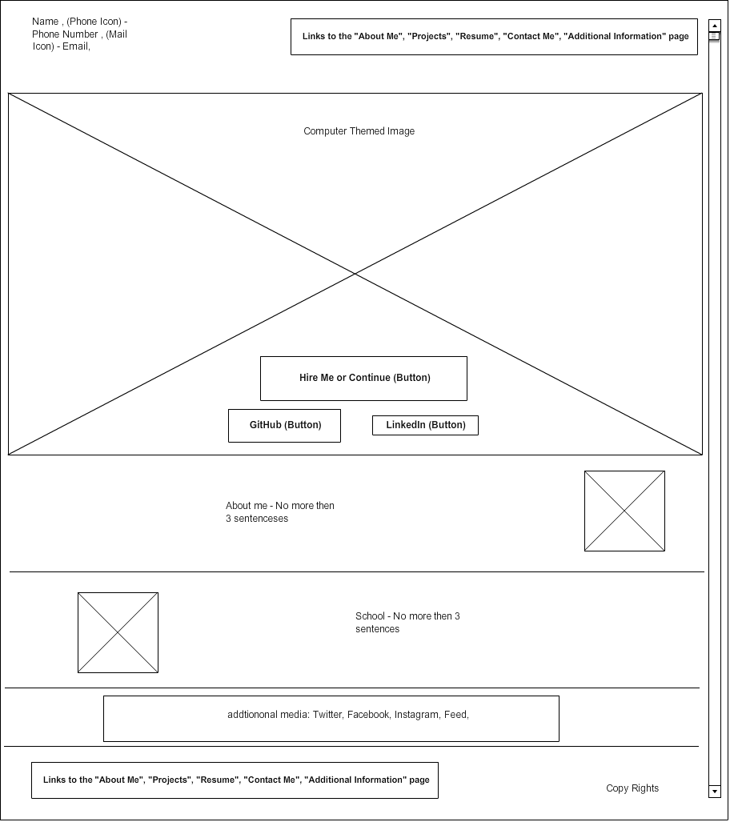

## Task Two: About Me Page

Status: In Progress

## Goal:

Purpose of the About Me page is to display personal information about myself. Timeline of sorts of who I went about deciding my career path and what exactly I want to do with my life. In addition, I want to list personal information beside my profession detail. Some of the personal information can be hobbies and things I like to do in my free time. As well I want to list awards and accomplishments I have been given both on a professional level but as well as personal awards I have received. As for the header and footer, they will be the same as the homage to show consistency across the website.

### Mock Ups:

About Me 1.0

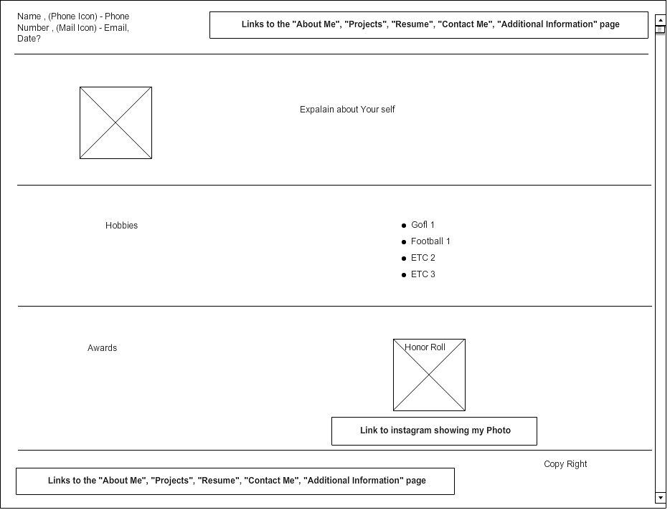

## Task Three: Resume Page

Status: In Progress

### Goal:

Purpose of the Resume page is to show off my resume to future employers and recruiting agencies. I want to look similar to my actual word document resume. At the bottom of my resume, I will have download able links for employers’ ad recruiting agencies to download and save for them. As for right now (10-2-2016) debating on whether to upload a cover letters and reference lists as well to have a complete set up. As for the header and footer, they will be the same as the homage to show consistency across the website.

### Mock Ups: Resume Page 1.0

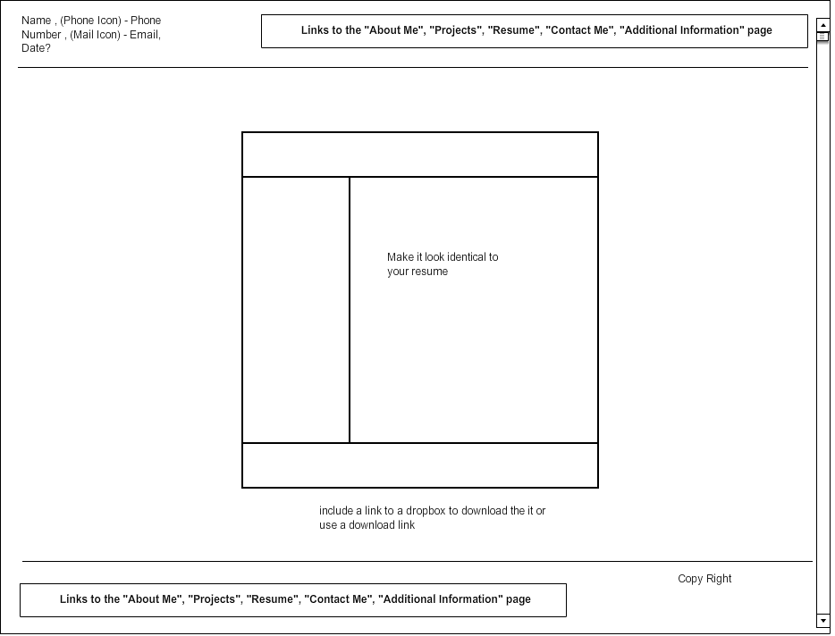

## Task Four: Projects Page

Status: In Progress

### Goal:

Purpose of the Projects page is to explain what projects I have going on and give background information regarding all of the projects. The list on the left side will include links as well as complete projects, current projects and future projects that are in the beginning stages of. Each description for the project should be roughly a paragraph long, in addition to explain what the project is and does, but also include a disclaimer for projects that need it. As for the header and footer, they will be the same as the homage to show consistency across the website.

### Mock Ups: Projects Page 1.0

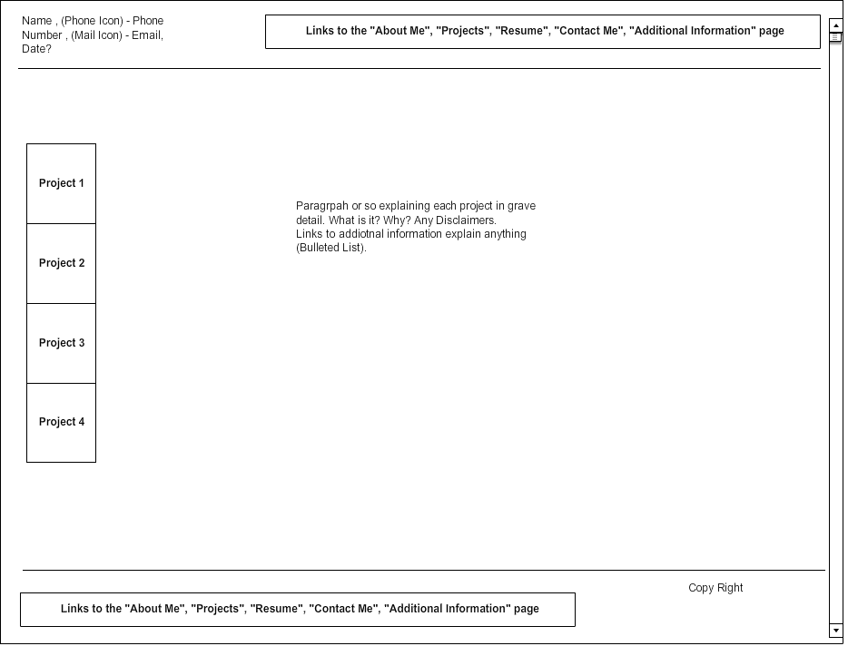

## Task Five: Contact Me Page

Status: In Progress

### Goal:

Purpose of the Contact Me page is to display a reachable phone number, with available times for all 7 days. In additional include LinkedIn URL to provide access to contact me via LinkedIn. At the bottom of the page will be an email diagram box the will allow the user to fill out a full email and click send and it will automatically email me personal. .as for the header and footer, they will be the same as the homage to show consistency across the website.

### Mock Ups: Contact Me Page 1.0

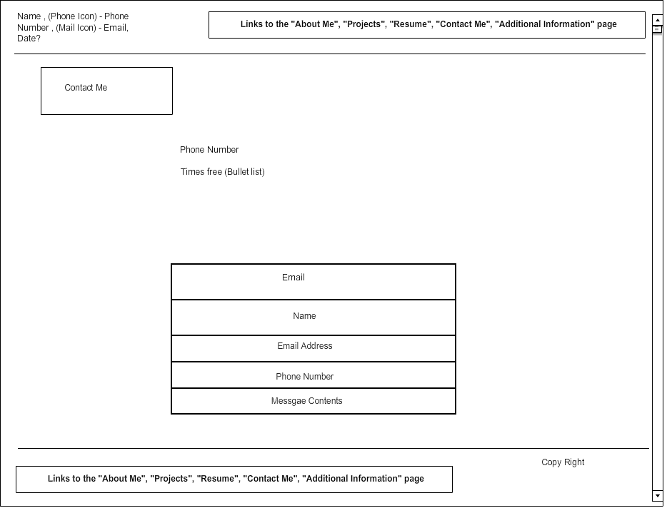

# Coding Phase:

## Task One: Home Page

Status: 95% Complete Waiting State

# Schedule and Budget Summary:

## Schedule:

* “HomePage” Completion - September 30th, 2016
* “About Me” page Completion - October 15th, 2016
* “Resume” page Completion - October 31th, 2016
* “Projects” page Completion – November 1st, 2016
* “Contact Me” page Completion – November 16th, 2016
* “Additional Information” page Completion – December 5th, 2016
* End of Test User Cases – December 20th, 2016
* Release of the Project - December 23rd, 2016

## Budget:

* Domain Name: $20.00
* Hosting: $80.00 Yearly
* Total Budget: $100.00

# Estimate Plan (Cost and Duration):

* Cost: Cost of the entire project should be around $2,000.00. This includes the price of the server and setup and then includes the salaries for developers.
* Duration: This is a very simple project and should take no longer than a couple of weeks to complete.

# Demand Forecast:

* Staffing Level: 1 developers
* Types of Developers: Developers with the knowledge of JS, CSS, and HTML. Along with Cold Fusion knowledge for server side programming.
* Duration: Total of 20 hours a week will be needed to work on this project. Project is fairly difficult to complete by one person and will take several weeks to complete.

# Tools:

Atom

Bootstrap

MockFlow

GitHub

TheNewBoston

Adobe Color

Google Analytics

timeanddate.com

# Glossary:

Modified Waterfall Life-Cycle Method

# Scratch Pad:

9/9/16 - Add the user test cases as you go along, pick out a color scheme soon, Finish building a GitHub repository, think of better name then Personal-Webpage

9/10/16 – GitHub is built, and looking into bootstrap tutorial on TheNewBoston, and Gitter.

9/12/16 –Color scheme is work in progress. Don’t need Gitter as of right now. Documentation still needs work, and so does GitHub page. Once documentation is set up and same for GitHub, then I will start homepage.

9/12/16 – Documentation is complete, but GitHub still needs work. Once GitHub is up and looking good. I will start the homepage. Still learning about bootstrap, and working on color scheme.

9/17/16 – Worked on the GitHub wiki page, and little of the homepage documentation. Color scheme is work in progress, looking for earth tones, with mix of red, gold, and brown. Still looking into bootstrap tutorial videos. Learning lots, and trying not to get over whelmed. Wiki Page is set, and Homepage coding is looking more likely this week.

9/18/16 – I have the color scheme picked out and officially ready to start coding the homepage, and making a temple html file. Continue watching Bootstrap tutorials and start coding later then week.

10/2/16 – Due to school and exams, I had to take a break from this project. I have had time to rethink my design and re did mock ups for the whole analysis phase. Starting Homepage coding today. Finished 95% of the Homepage coding, only thing left for it would be add URLs for other pages when ready. The mock ups will need updated for almost every page because of couple fine points add in the footer and header, but ill wait a day or so before updating those to the 2.0 versions.

# References

[1]"MockFlow - Online Wireframe Tool and Design Cloud", *Mockflow.com*, 2016. [Online]. Available: https://mockflow.com/index.jsp. [Accessed: 09- Sep- 2016].

[2] B. Roberts, "Bootstrap Tutorials for Beginners Playlist - YouTube", Youtube.com, 2016. [Online]. Available: https://www.youtube.com/playlist?list=PL6gx4Cwl9DGBPw1sFodruZUPheWVKchlM. [Accessed: 12- Sep- 2016].

[3]"Free Clocks for Your Website", *Timeanddate.com*, 2016. [Online]. Available: http://www.timeanddate.com/clocks/free.html. [Accessed: 03- Oct- 2016].