EBS develop document
V1.0

版 別 ： 第 1.0 版

總 頁 數 ： 342 頁 （含封面及附件）

文件編號 ： CCMA assign

Copyright© 2011 by ITRI

Cloud Computing Center for Mobile Applications (CCMA)

All Rights Reserved.

This document, may not, in whole or partial, be copied, photocopied, translated or reproduced to any electronic media or any other form without prior written consent from ITRI.

In no circumstance will ITRI be liable for direct, indirect, special, incidental, or consequential damages arising out of the use or inability to use of this product or documentation even if is advised of the possibility of such damages. ITRI shall not be liable for any hardware used with the product, including the costs of repairing, replacing, or recovering such hardware.

CONTENT
Page
1. SVN URL 5
2. System architecture 5
3. Source code hierarchy 7
4. EBS dependency Libraries 7
5. Build EBS 7
6. Deploy EBS 7
7. Configuration files 8
$EBS_SRC_FOLDER/WEB-INF/web.xml 8
$EBS_SRC_FOLDER /WEB-INF/classes/ebs.properties 8
$EBS_SRC_FOLDER /WEB-INF/classes/jets3t.properties 8
8. Web version file 8
9. Webapp initiate stage 9
10. Log files 10
11. Important APIs 10
Account Service(check.jsp) 10
Locking Mechanism 12
Monitoring content of locking queue 13
12. Error Handling 14
13. Fake error response 14
Source code 14
setFakeValue -set fake response of EBS API 14
getFakeValue- get fake setup value 14
True off fake response setup 15
tmp/fakeresponse.cfg 15
14. Unit test 15
Run Unit test 15
Parameterized unit test 15
15. CCMA Maven repository 15
16. EBS port Setting 16
EBS port: 16
Confiuration file: 16
About SSL certification&keys for https to EBS 16
17. Relative document 16
Error handling 16
EBS Fake response 16
Maven 16
Tomcat and Servlet container 17
Jeresy 17
18. Case Study 17
Case 1: add a new EBS API 17
Case2: Manual Build and Deploy EBS 18
Case3: Unit test EBS 18
Case4:change EBS http port 19

- SVN URL
https://10.12.3.41/svn/CSSEBS/branches/alpah_1_1/src/sbx_svr/

- System architecture

EBS is written in the form of J2EE Component(webapp),it run on J2EE Container(ex:tomcat),each weapp comprise many servlets and JSPs,both servlet and jsp are fundamentally java class.

EBS use servlet of jersey libs(JAX-RS compatible、JABX compatible) to build its Restful APIs,as well as servlets are component in Tomcat,we wrote java class(rest.EBSAPI and rest.TESTAPI) and set it as jersey servlet’s compoent(set up by java annotation),then we set all request to url $HOST/rest/* to be processed by jersey servlet(set up in WEB-INF/WEB.xml),then all Restful APIs will work by EBSAPI.java and TESTAPI.java rest on jersey servlet and Tomcat.
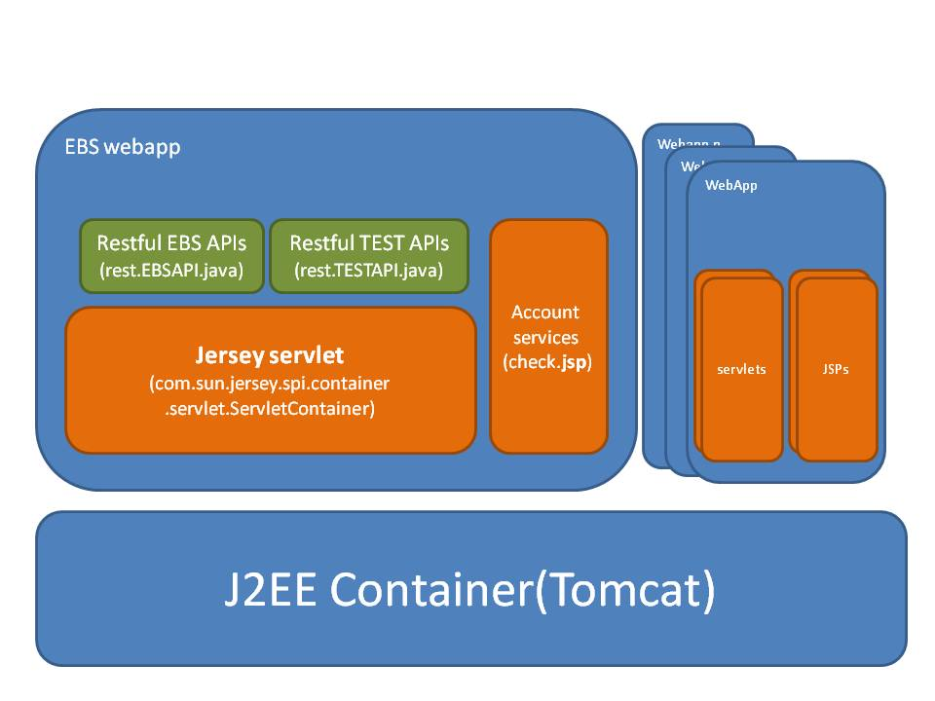
components in EBS

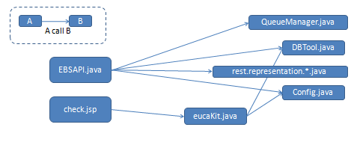
Classes reference in EBS
- Source code hierarchy
./doc/*:EBS documentations.
./maven/*:shell script for installing maven,and repo files.
./pom.xml:EBS project file.

./src/main/java/*:EBS source code.
./src/main/java/rest/exception/*:EBS exception classes.
./src/main/java/rest/representation/*:Representation classes use in EBS response.
./src/main/resources/*:Resources of EBS,all files in this folder will be copy to $EBS_Root/WEB-INF/classes after building.
./src/main/webapp/WEB-INF/lib/*:EBS local java libs

./src/main/test/java/lib/unittest/*: EBS unit test source code.

- EBS dependency Libraries
Jars in source folder:
./src/main/webapp/WEB-INF/lib/*.jar
Jars download by maven:
set in pom.xml.

jersey:for jax-rs based restful api.
jets3t:for communication with walrus
jdbc:EBS does Database operation (CURD) by jdbc.
JUnit libs:EBS uses JUnit(xUnit framework) libs to do unit test.
- Build EBS
Build script:$EBS_SRC_FOLDER/sbx_build.sh
Maunal build:
1.yum install maven
2.mvn clean package -Dmaven.test.skip=true
Target Folder:$EBS_SRC_FOLDER/target/
Build tool:Maven2.0.7

- Deploy EBS
Deploy script:sbx_deploy.sh
Manual deploy: “yes|cp target/sbx_svr.war /opt/apache-tomcat/webapps/”.

Details:
sbx_deploy.sh include installing tomcat by rpm,cp sbx_svr.war to tomcat's webapp folder and create sql schema.
Servlet Container Version: Server version: Apache Tomcat/7.0.26
- Configuration files

$EBS_SRC_FOLDER/WEB-INF/web.xml
tomcat webapp level configuration file.(ex:ldap setup、database ip address、walrus ip address)

$EBS_SRC_FOLDER /WEB-INF/classes/ebs.properties
usage:
ebs level normal configuration file.(ex:max query event limit, unlimited with -1...)

source code to read config:
Config.ebsPorperties=
this.loadEbsConfig(ce.getServletContext()
.getRealPath("WEB-INF/classes/ebs.properties")); //Initator.java line 44

$EBS_SRC_FOLDER /WEB-INF/classes/jets3t.properties
jets3t(ver.9.1)’s configuration file.

- Web version file

Usage:
after building EBS,it create an EBS version file in war package.
File Path:
$EBS_SRC_FOLDER /EBS_version.txt.

Use tool:
“Filter” plug-in in Maven
http://maven.apache.org/plugins/maven-resources-plugin/examples/filter.html

Configureation:
in pom.xml as below:

<resources>
<resource>
<directory>${basedir}/src/main/resources/</directory>
</resource>
<resource>
<directory>${basedir}/src/main/resources/</directory>
<includes>
<include>EBS_Version.txt</include>
</includes>
<filtering>true</filtering>
<targetPath>${basedir}/src/main/webapp/</targetPath>
</resource>
</resources>

Also refer to maven plug-in documentation about filtering:
http://maven.apache.org/plugins/maven-resources-plugin/examples/filter.html

- Webapp initiate stage
Usage:
do initial process of webapp when tomcat start.
Configuration:
In $EBS_SRC_FOLDER/WEB-INF/web.xml:

<listener>
<listener-class>
rest.Initaitor
</listener-class>
</listener>

Initial class and method:
Rest.Initaitor::contextIntaite(…)

See also:
Refer to ServletContextListener
http://docs.oracle.com/javaee/6/api/javax/servlet/ServletContextListener.html

- Log files
Log File path: /opt/apache-tomcat/logs/.

EBS_Initaitor.log:logs about initiate stage of tomcat webapp.
EBS_errorcode.log:each http response with error code will be logged into this file.
EBS_AccountService.log:logs about account service(check.jsp).
ESB_api_error.log:common api error.

catalina.$date.log:
each request and response of ebs and test api will be recorded there.
it's configured in $EBS_SRC_FOLDER/WEB-INF/web.xml:
<init-param>
<param-name>com.sun.jersey.spi.container.ContainerRequestFilters</param-name>
<param-value>com.sun.jersey.api.container.filter.LoggingFilter</param-value>
</init-param>

<init-param>
<param-name>com.sun.jersey.spi.container.ContainerResponseFilters</param-name>
<param-value>com.sun.jersey.api.container.filter.LoggingFilter</param-value>
</init-param>
- Important APIs

Account Service(check.jsp)
Usage:query CSS user’s access key and secret key.

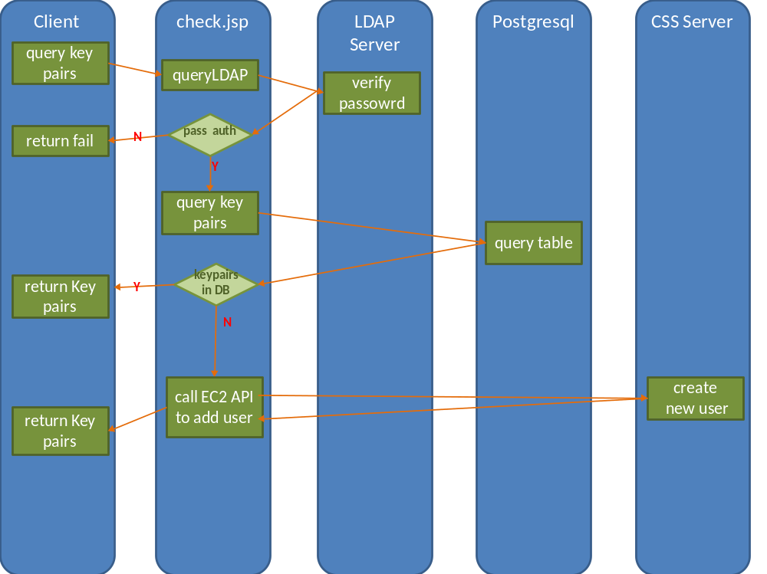
account service query flow

query LDAP in check.jsp:

checkLDAP(user,password); //line 21 in check.jsp

query key pairs in check.jsp:

String key=uk.queryKey(user, hardwareId, instanceName,newEmail);//line 28 in check.jsp

call EC2 API to add user in check.jsp:

uk.AddUser(user); //line
log.info("success to add user");
uk.EnableUser(user);
log.info("success to enable user");
String instanceKey = uk.genInstanceKey(user, "", "");
out.print(uk.queryKey(user,hardwareId, instanceKey,newEmail));
log.info(" success to query key");

Locking Mechanism
Relative api:
syncRequestV、heartBeat、unlockV

For each account in EBS API,here is a queue,when user call EBS API ”syncrequest(V)” with a specific instance id ,EBS will put this instance id in the queue of this account,if this instanceid is on the head of queue(tail in head out),user can use other sync api with this instance id.

If an user with instance id “a1” get lock in queue,this user must do “heartbeat” periodically, until it call the api “unlock” to remove instance id “a1” from head of queue, otherwise ,this user may be “timeout” after a period of time.
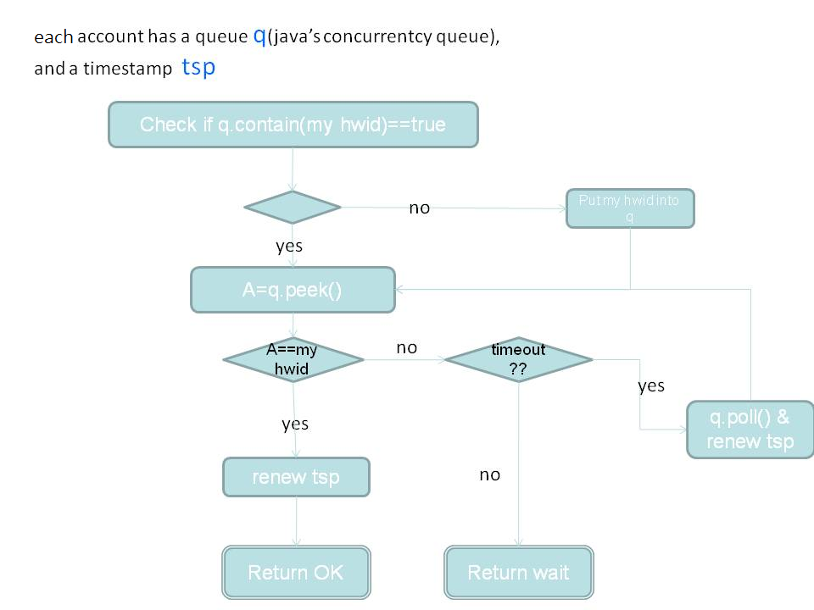
3.locking mechanism in EBS API.

Refer to slide 43~ 45@ https://10.12.3.41/svn/SafeBox/trunk/doc/Design_spec_20120917_EBS.ppt for more detail.

Monitoring content of locking queue
ex:
http://10.201.80.39/sbx_svr/rest/TEST/getQueueContent?account=User1

response:
time stamep:1374748688528
now: 1374748701624

0:a3efad832b3b25bcfe5d16dd9e2de5f07270e368
1:test1
2:test2
It means user1 with instanceid “a3efad…” is now holding lock,and instance id ”test1” and “test2” are waiting in queue.
- Error Handling
Refer to doc about error handling at :
https://10.12.3.41/svn/SafeBox/trunk/doc/Design_spec_EBS_API.docx

- Fake error response

Source code
The source code of all fake error response APIs are
- $sbx_folder/src/main/java/rest/TESTAPI.java
Restful api interface.
- $sbx_folder/src/main/java/rest/FakeTest.java
Write to /read from fake value by /tmp/fakeresponse.cfg
relative APIs are :
- setFakeValue
- getFakeValue

setFakeValue -set fake response of EBS API
http:// $host /sbx_svr/rest/TEST/setFakeValue?key= $api_name &value= $error_code

ex: http://10.218.43.1/sbx_svr/rest/TEST/setFakeValue?key=existingevents&value=0001

effect:
- set ebs api $api_name return fake
- ebs api $api_nem will always return $error_code
- write setup into /tmp/fakeresponse.cfg

getFakeValue- get fake setup value
http://$host/sbx_svr/rest/TEST/getFakeValue?key=$api_name

ex: http://10.218.43.1/sbx_svr/rest/TEST/getFakeValue?key=existingevents
effect: It will return fake error code

True off fake response setup
http:// $host /sbx_svr/rest/TEST/setFakeValue?key= $api_name

effect:
- turn off fake response setting of $api_name
- ebs api $api_name will work as normal.

/tmp/fakeresponse.cfg
When calling setFakeValue,EBS will record fake value of this api both in memory and /tmp/fakeresponse.cfg, /tmp/fakeresponse.cfg then be used by walrus to do walrus fake response.

Format of /tmp/fakeresponse.cfg is $API=$ErrorCode,
ex:
queryevent=0001
abc=test
listobjects=0010
- Unit test
EBS use JUnit libs to do Unit test,all unit test class are in package lib.unittest.

Run Unit test
Deploy CSS(sh sbx_deploy.sh), then run “mvn test” on the source code folder of EBS.

Parameterized unit test
unit test in EBS use JUnit’s parameterized unit test feature,when doing unit test,parameterized test function will read test case from test case files,and use each line as one set of parameter to constructor of unit test class.

Test case files are put in $EBS_SRC_FOLDER\src\test\resources\unittest_$APINAME.txt
- CCMA Maven repository
Maven repository of CCMA is set in pom.xml-

<repository>
<id>CCMA</id>
<name>CCMA Repository</name>
<url>http://140.96.29.153:8080/nexus-2.0.5/content/groups/public/</url>
</repository>

- EBS port Setting

EBS port:
8088:HTTP
8089:HTTPS

Confiuration file:
/opt/apache-tomcat/conf/server.xml:

<Connector port="8088" protocol="HTTP/1.1"
connectionTimeout="20000"
URIEncoding="UTF-8"
redirectPort="8443" />

<Connector port="8089" protocol="HTTP/1.1" SSLEnabled="true"
maxThreads="150" scheme="https" secure="true"
clientAuth="false" sslProtocol="TLS"
keystoreFile="/opt/apache-tomcat/tomcatSSLKey/mycert.p12"
keystorePass="password"
keystoreType="PKCS12"
/>

About SSL certification&keys for https to EBS
In folder:/opt/apache-tomcat/tomcatSSLKey/.
Created tool: openssl
Refro to : http://www.openssl.org/
- Relative document

Error handling
https://10.12.3.41/svn/SafeBox/trunk/doc/ Design_spec_EBS_API.docx

EBS Fake response
https://10.12.3.41/svn/SafeBox/trunk/doc/ ebs_fake_response.pptx

Maven
http://maven.apache.org/

Tomcat and Servlet container
http://tomcat.apache.org/tomcat-5.5-doc/appdev/deployment.html
see “Standard Directory Layout” first, then other parts.

Jeresy
https://jersey.java.net/documentation/latest/index.html
- Case Study

Case 1: add a new EBS API
Case:add a new EBS API ”NewAPI”.

1.add new class “NewAPIResponse.java” in $EBS_SRC_FOLDER/src/main/java/rest/representation/

package rest.representation;

import javax.xml.bind.annotation.XmlRootElement;

@XmlRootElement
public class NewAPIResponse extends BaseResponse{
public String field1,field2;
}

@XmlRootElement is for JABX ,BaseResponse is for EBS error handling.

2.
In $EBS_SRC_FOLDER/src/main/java/rest/EBSAPI.java

Add a function “NewAPI”:

@Path("newAPI")
@GET
@Produces(MediaType.APPLICATION_JSON)
public NewAPIResponse NEWAPI(@QueryParam("param1") String param1){
NewAPIResponse r=new NewAPIResponse();
r.field1=param1;
r.field2=String.valueOf(param1.length());

return r;
}

All of the annotation above ,please see JAX-RS and jersey specification, it’s really intuitive.

3.well,it’s done.

Case2: Manual Build and Deploy EBS
Case: Maunal check out EBS source code,then build it and deploy.
- Make sure you have installed tomcat and maven.

- checkout source code:
svn co https://10.12.3.41/svn/CSSEBS/branches/alpah_1_1/src/sbx_svr

- build EBS:
sh sbx_build.sh

- manual deploy EBS:
yes|cp target/sbx_svr.war /opt/apache-tomcat/webapps/

Case3: Unit test EBS
Case: Unit test EBS after deploy CSS.
- deploy CSS on localhost
- in $EBS_SRC_FOLDER,run “ sh sbx_testAfterDeply.sh”
- It’s done, quite simple.

Case4:change EBS http port
Case:change port of EBS to 1234

- deploy EBS
- modify /opt/apache-tomcat/conf/server.xml(@ line 70):

<Connector port="8088" protocol="HTTP/1.1"

Change 8088 to 1234
- restart tomcat
(/opt/apache-tomcat/bin/shutdown.sh ; /opt/apache-tomcat/bin/startup.sh;)

