ExoSpec Methods & Results

Shea P. Connell

04/10/2019

# Introduction

This is placeholder text for the introduction - depending on journal this may be considered copyrighted.

# Methods

### Patient population and characteristics

### Sample Processing and analysis

### Statistical Analysis

*A priori* filtering of peptides was undertaken by only retaining peptides quantified in at least 30% of either cancer or non-cancer samples.

# Results

**Table 1.** *Characteristics of the ExoSpec development cohort.*

|  |  |  |
| --- | --- | --- |
|  | Biopsy Negative: | Biopsy Positive |
| **Collection Centre:** |  |  |
| NNUH, n (%) | 59 (100) | 133 (100) |
| **Age:** |  |  |
| minimum | 45.00 | 53.00 |
| median (IQR) | 67.00 (59.50, 71.00) | 70.00 (65.00, 76.00) |
| mean (sd) | 66.15 ± 8.30 | 70.23 ± 7.81 |
| maximum | 82.00 | 91.00 |
| **PSA:** |  |  |
| minimum | 0.30 | 4.10 |
| median (IQR) | 5.30 (2.30, 7.95) | 10.40 (6.90, 16.60) |
| mean (sd) | 6.44 ± 5.96 | 16.81 ± 17.36 |
| maximum | 30.30 | 95.90 |
| **Prostate Size (DRE Estimate):** |  |  |
| Small, n (%) | 16 (27) | 12 (9) |
| Medium, n (%) | 25 (42) | 67 (50) |
| Large, n (%) | 14 (24) | 38 (29) |
| Unknown, n (%) | 4 (7) | 16 (12) |
| **Gleason Score:** |  |  |
| 0, n (%) | 59 (100) | 0 (0) |
| 6, n (%) | 0 (0) | 31 (23) |
| 3+4, n (%) | 0 (0) | 48 (36) |
| 4+3, n (%) | 0 (0) | 25 (19) |
| ≥ 8, n (%) | 0 (0) | 29 (22) |
| **Biopsy_Result** |  |  |
| Biopsy Negative | 59 (100) | 0 (0) |
| Biopsy Positive | 0 (0) | 133 (100) |

|  |  |  |  |  |  |  |  |
| --- | --- | --- | --- | --- | --- | --- | --- |
| SoC Variables | SoC Coefficients | MassSpec Variables | MassSpec Coefficients | ExoRNA Variables | ExoRNA Coefficients | ExoSpec Variables | ExoSpec Coefficients |
| PSA | 0.009958 | e01149 | 0.011925 | ERG3 exons 4-5 | 0.006925 | PSA | 0.009169 |
| Age | 0.007041 | e03180 | -0.010655 | PCA3 | 0.072146 | Age | 0.004097 |
|  |  | e03322 | -0.009228 | SERPINB5/Maspin | -0.012714 | e03608 | 0.001122 |
|  |  | e05455 | 0.011084 | SLC12A1 | 0.045846 | e05579 | 0.004501 |
|  |  | e05751 | 0.02384 | SNORA20 | -0.002422 | e05751 | 0.003628 |
|  |  | e07985 | 0.002774 | TMEM45B | 0.02199 | e08713 | -0.001253 |
|  |  | e08713 | -0.012363 |  |  | e12906 | 0.012288 |
|  |  | e09542 | 0.009638 |  |  | e17491 | 0.001549 |
|  |  | e12163 | -0.003992 |  |  | e08713 | -2.4e-05 |
|  |  | e12906 | 0.019524 |  |  | ERG3 exons 4-5 | 0.007908 |
|  |  | e15320 | -0.003608 |  |  | PCA3 | 0.062057 |
|  |  | e16540 | -0.0035 |  |  | SLC12A1 | 0.035865 |
|  |  | e17491 | 0.013475 |  |  |  |  |
|  |  | e01149 | 0.000455 |  |  |  |  |
|  |  | e03180 | -0.00014 |  |  |  |  |
|  |  | e03322 | -1.1e-05 |  |  |  |  |
|  |  | e08713 | -4e-06 |  |  |  |  |

### ExoSpec predictive ability

As ExoSpec Risk Score (range 0-1) increased, the likelihood of high-grade disease being detected on biopsy was significantly greater (Proportional odds ratio = 2.25 per 0.1 ExoSpec increase, 95% CI: 1.9 - 2.69; ordinal logistic regression, **Figure 2**).

**Table 2.** *AUC of all trained models for detecting outcomes of an initial biopsy for varying clinically significant thresholds. Brackets show 95% confidence intervals of the AUC, calculated from 1,000 stratified bootstrap resamples. Input variables for each model are detailed in Table 1.*

|  |  |  |  |  |
| --- | --- | --- | --- | --- |
| Initial biopsy outcome: | SoC | MassSpec | ExoRNA | ExoSpec |
| Gleason ≥4+3: | 0.76 (0.69 - 0.83) | 0.68 (0.60 - 0.76) | 0.67 (0.58 - 0.75) | 0.83 (0.76 - 0.89) |
| Gleason ≥3+4: | 0.71 (0.64 - 0.79) | 0.68 (0.60 - 0.74) | 0.75 (0.68 - 0.82) | 0.83 (0.77 - 0.88) |
| Any Cancer | 0.78 (0.71 - 0.85) | 0.76 (0.67 - 0.83) | 0.84 (0.79 - 0.89) | 0.91 (0.86 - 0.95) |

ExoSpec was superior to the standard of care model for predicting Gleason ≥3+4, returning an AUC of 0.83 (95% CI: 0.77 - 0.88), *p* = 0 but was not significantly better than standards of care in predicting Gleason ≥4+3 disease (0.83 (95% CI: 0.76 - 0.89) *p* = 0.024, **Table 3**).

Resampling of ExoSpec predictions via estimation plots allowed for comparisons of mean ExoSpec signatures between groups by 1,000 bias-corrected and accelerated bootstrap resamples (**Figure 4**). The mean ExoSpec differences between patients with no evidence of cancer on biopsy were: Gleason 6 = 0.4 (95% CI: 0.34 - 0.46), Gleason 3+4 = 0.41 (95% CI: 0.35 - 0.46) and Gleason ≥4+3 = 0.53 (95% CI: 0.47 - 0.57). Interestingly, patients with no evidence of cancer had a lower ExoSpec risk score (mean difference = 0.21 (95% CI: 0.15 - 0.28)) than those men with a raised PSA but negative for cancer on biopsy (**Supplementary Figure 5**).

# Figures

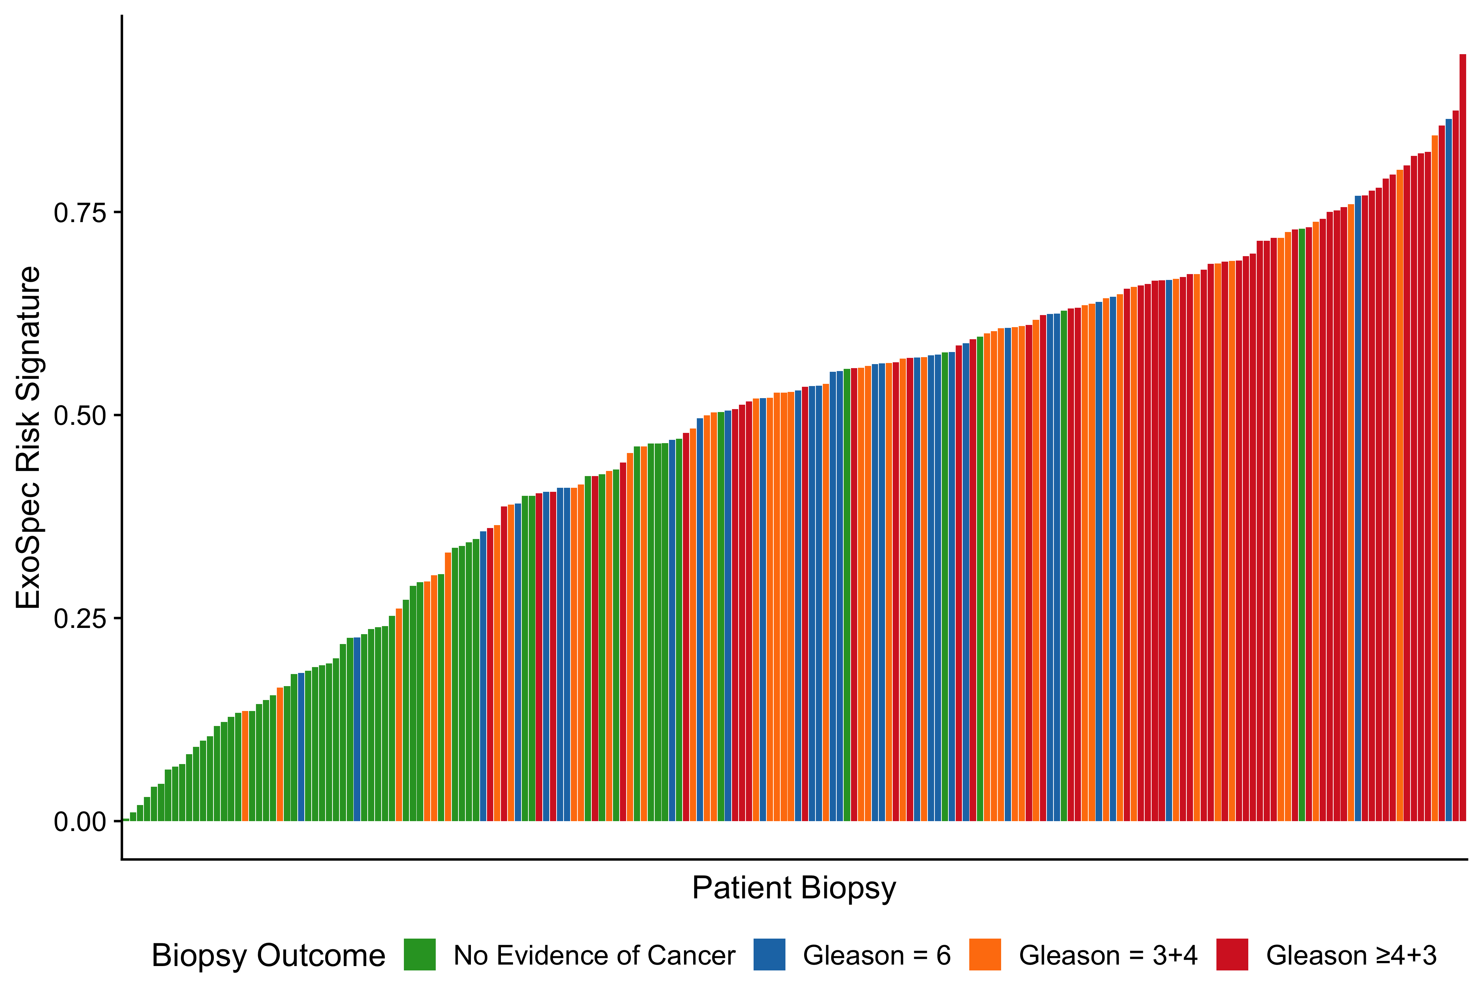

**Figure 1.** *Waterfall plot of the ExoSpec risk score for each patient. Each coloured bar represents an individual patient’s calculated risk score and their true biopsy outcome, coloured according to Gleason score (Gs) . Green - No evidence of cancer, Blue – Gs 6, Orange - Gs 3+4, Red - Gs ≥ 4+3.*

##### 

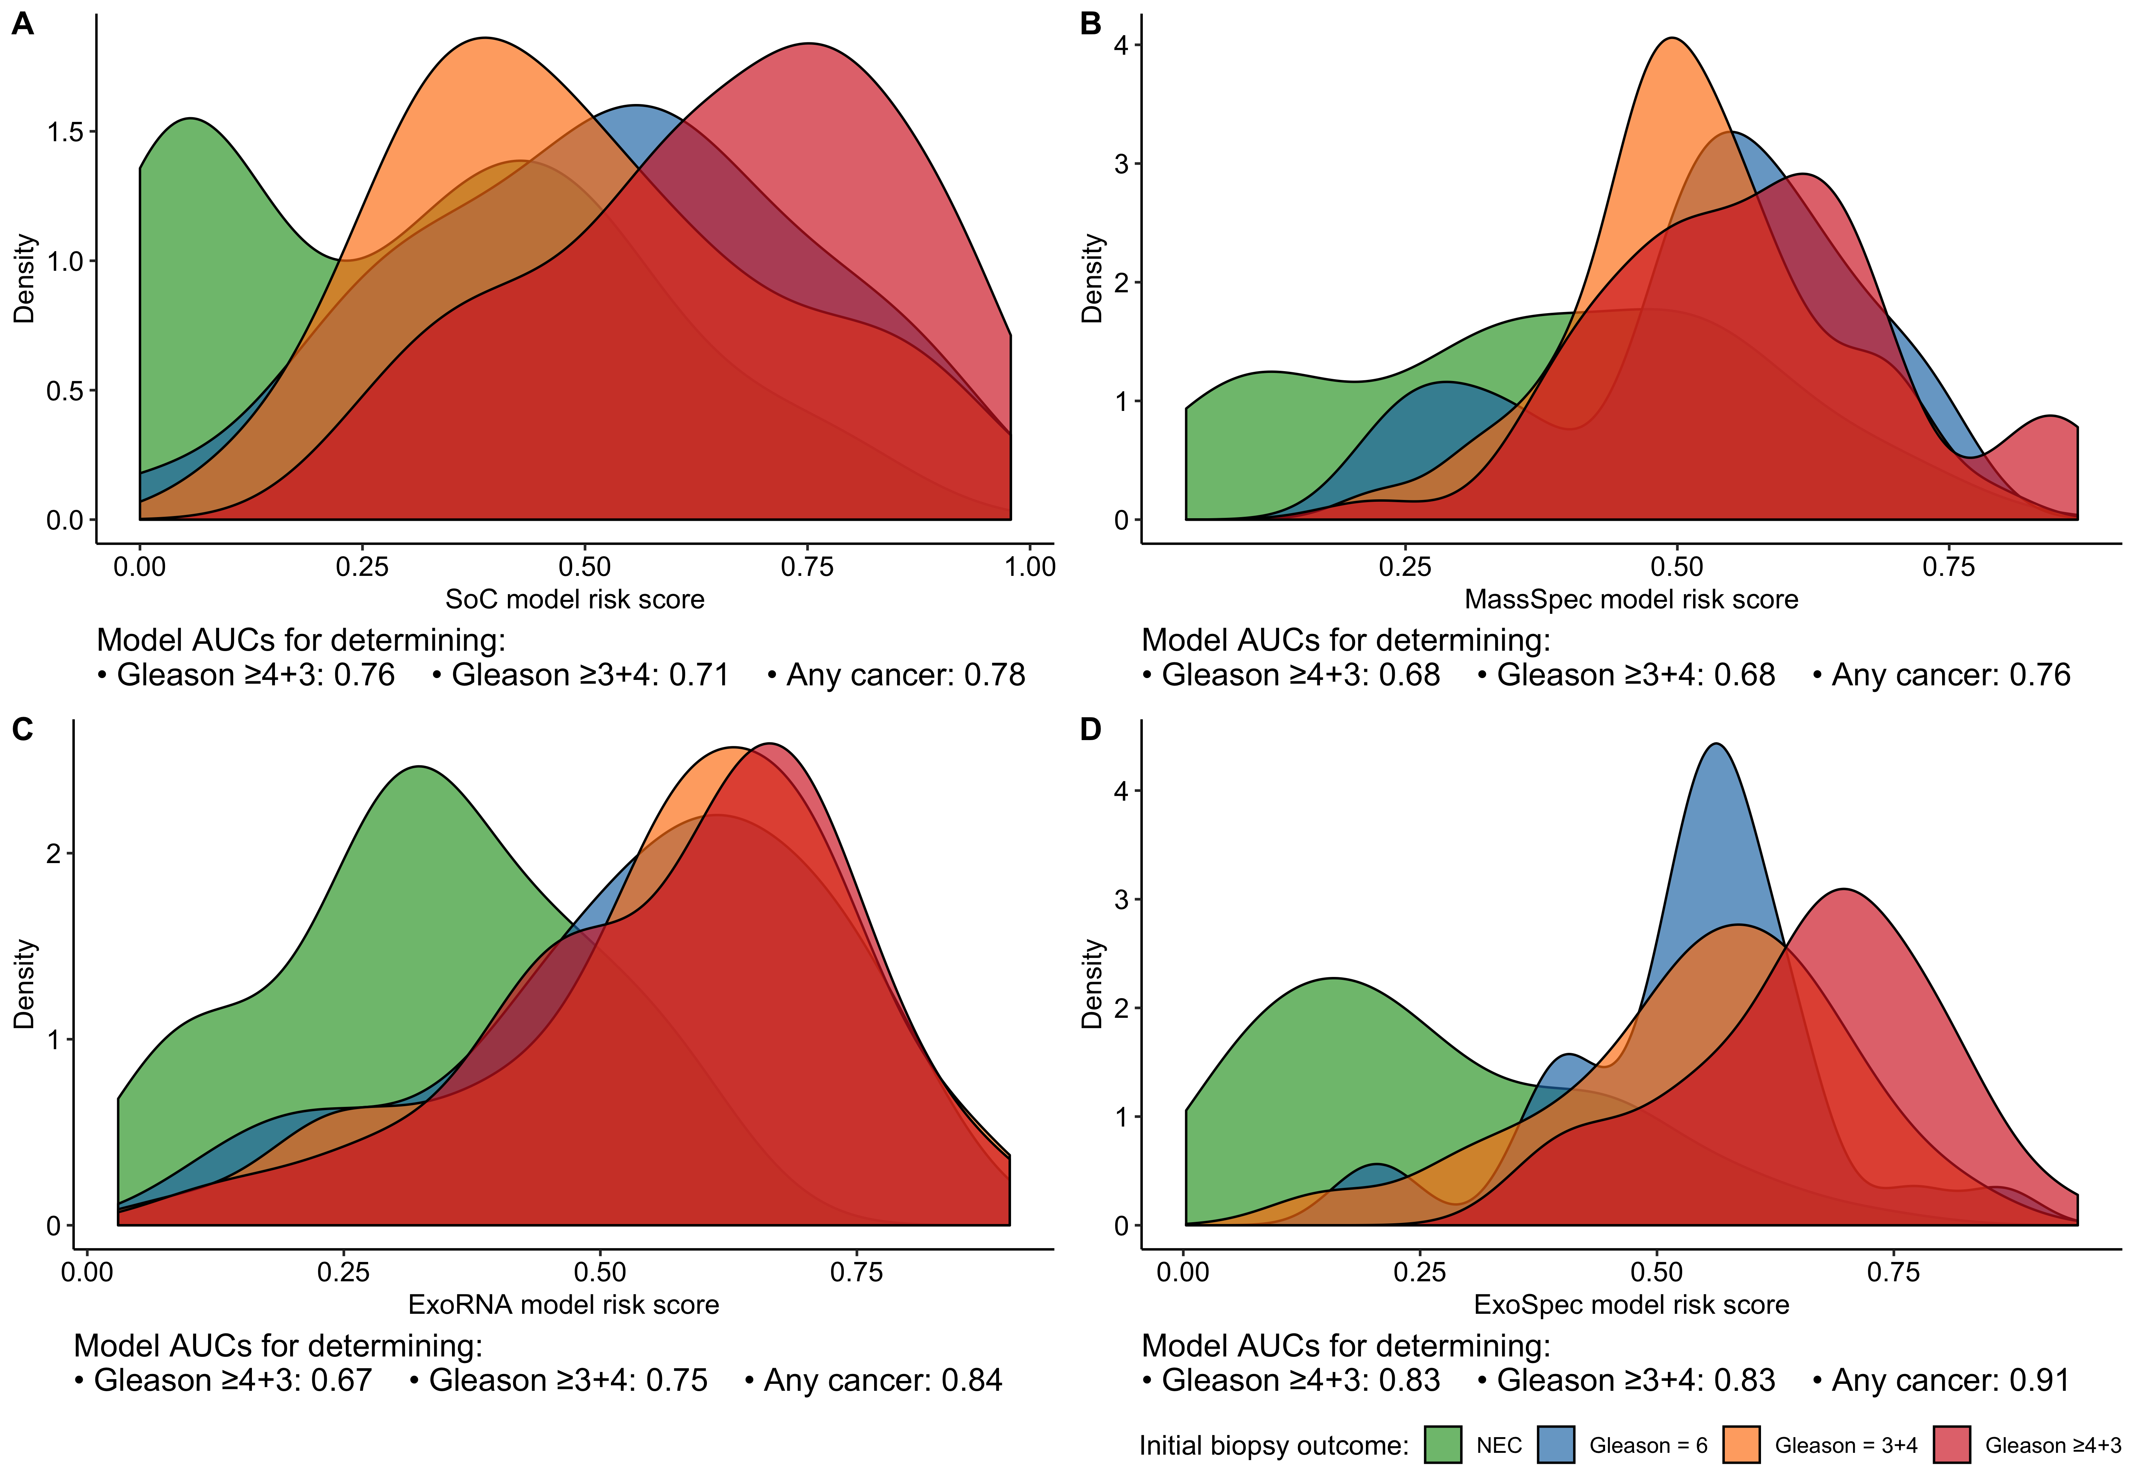

**Figure 2.** *Density plots detailing risk score distributions generated from four trained models. Models A to D were trained with different input variables;* ***A*** *- SoC clinical risk model, including Age and PSA,* ***B*** *- MassSpec model,* ***C*** *-ExoRNA model and* ***D*** *- ExoSpec model, combining the predictors from all three previous models. The full list of variables in each model is available in Table 1. Fill colour shows the risk score distribution of patients with a significant biopsy outcome of Gs ≥ 3+4 (Orange) or Gs ≤ 6 (Blue).*

##### 

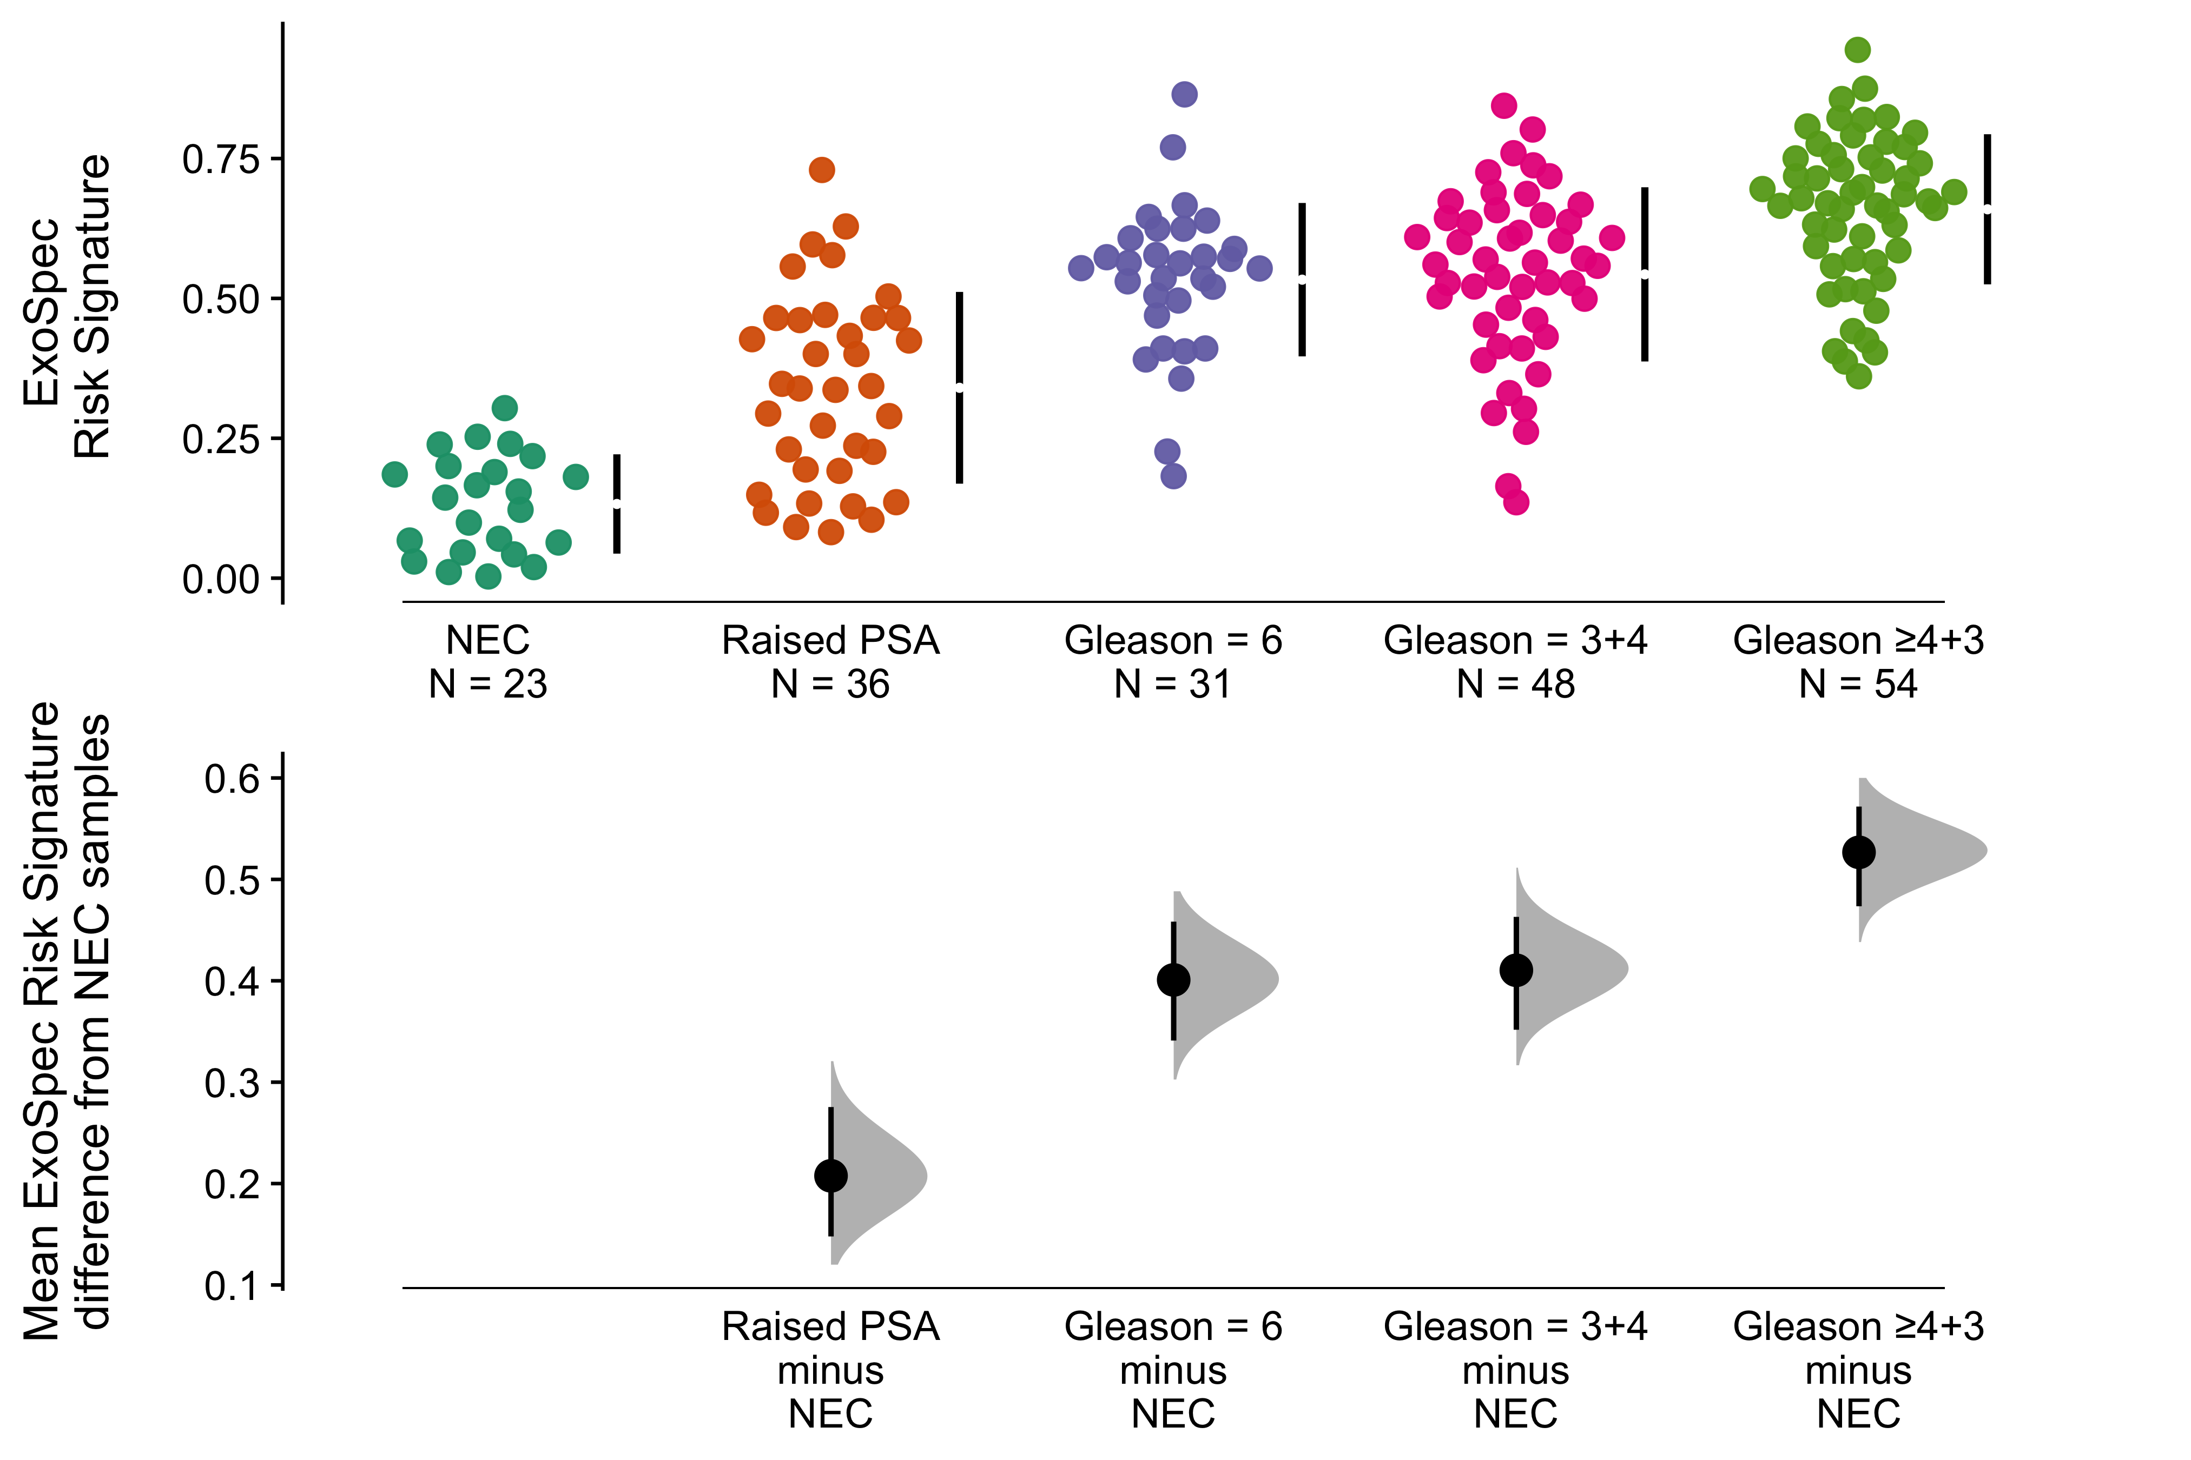

**Figure 3.** *Cumming estimation plot of the ExoSpec risk signature. The top row details individual patients as points, separated according to Gleason score on the x-axis and risk score on the y-axis. Points are coloured according to clinical risk category; NEC - No evidence of cancer, Raised PSA - Raised PSA with negative biopsy, L -D’Amico Low-Risk, I - D’Amico Intermediate Risk, H - D’Amico High-Risk. Gapped vertical lines detail the mean and standard deviation of each group’s risk scores. The lower panel shows the mean differences in risk score of each group, as compared to the NEC samples. Mean differences and 95% confidence interval are displayed as a point estimate and vertical bar respectively, using the sample density distributions calculated from a bias-corrected and accelerated bootstrap analysis from 1,000 resamples.*

##### 

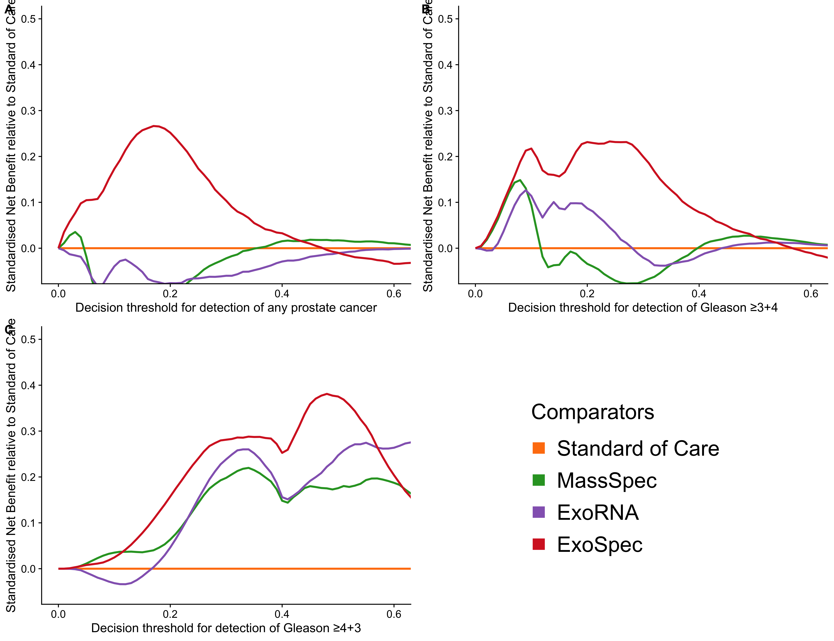

**Figure 4.** *Decision curve analysis (DCA) plots detailing the standardised net benefit (sNB) of adopting different risk models, relative to standard of care The x-axis details the range of risk a clinician, patient or interdisciplinary team may accept before deciding to undertake biopsy. Panels show the relative sNB based upon the detection of varying levels of disease severity:* ***A*** *- detection of any cancer ,* ***B*** *- detection of Gleason ≥ 3+4,* ***C*** *- detection of Gleason ≥ 4+3;* ***Orange*** *- biopsy patients according to current standards of care,* ***Green*** *- biopsy patients based on the MassSpec model,* ***Purple*** *- biopsy patients based on the ExoRNA model,* ***Red*** *- biopsy patients based on a the ExoSpec model. To assess the benefit of adopting these risk models in a non-PSA screened population we used data available from the control arm of the CAP study [@Martin2018]. DCA curves were calculated from 1,000 bootstrap resamples of the available data to match the distribution of disease reported in the CAP trial population. Mean sNB from these resampled DCA results were calculated and the SoC model results used as the baseline benefit. Results are plotted relative to this SoC benefit. See Methods for full details.*

##### 

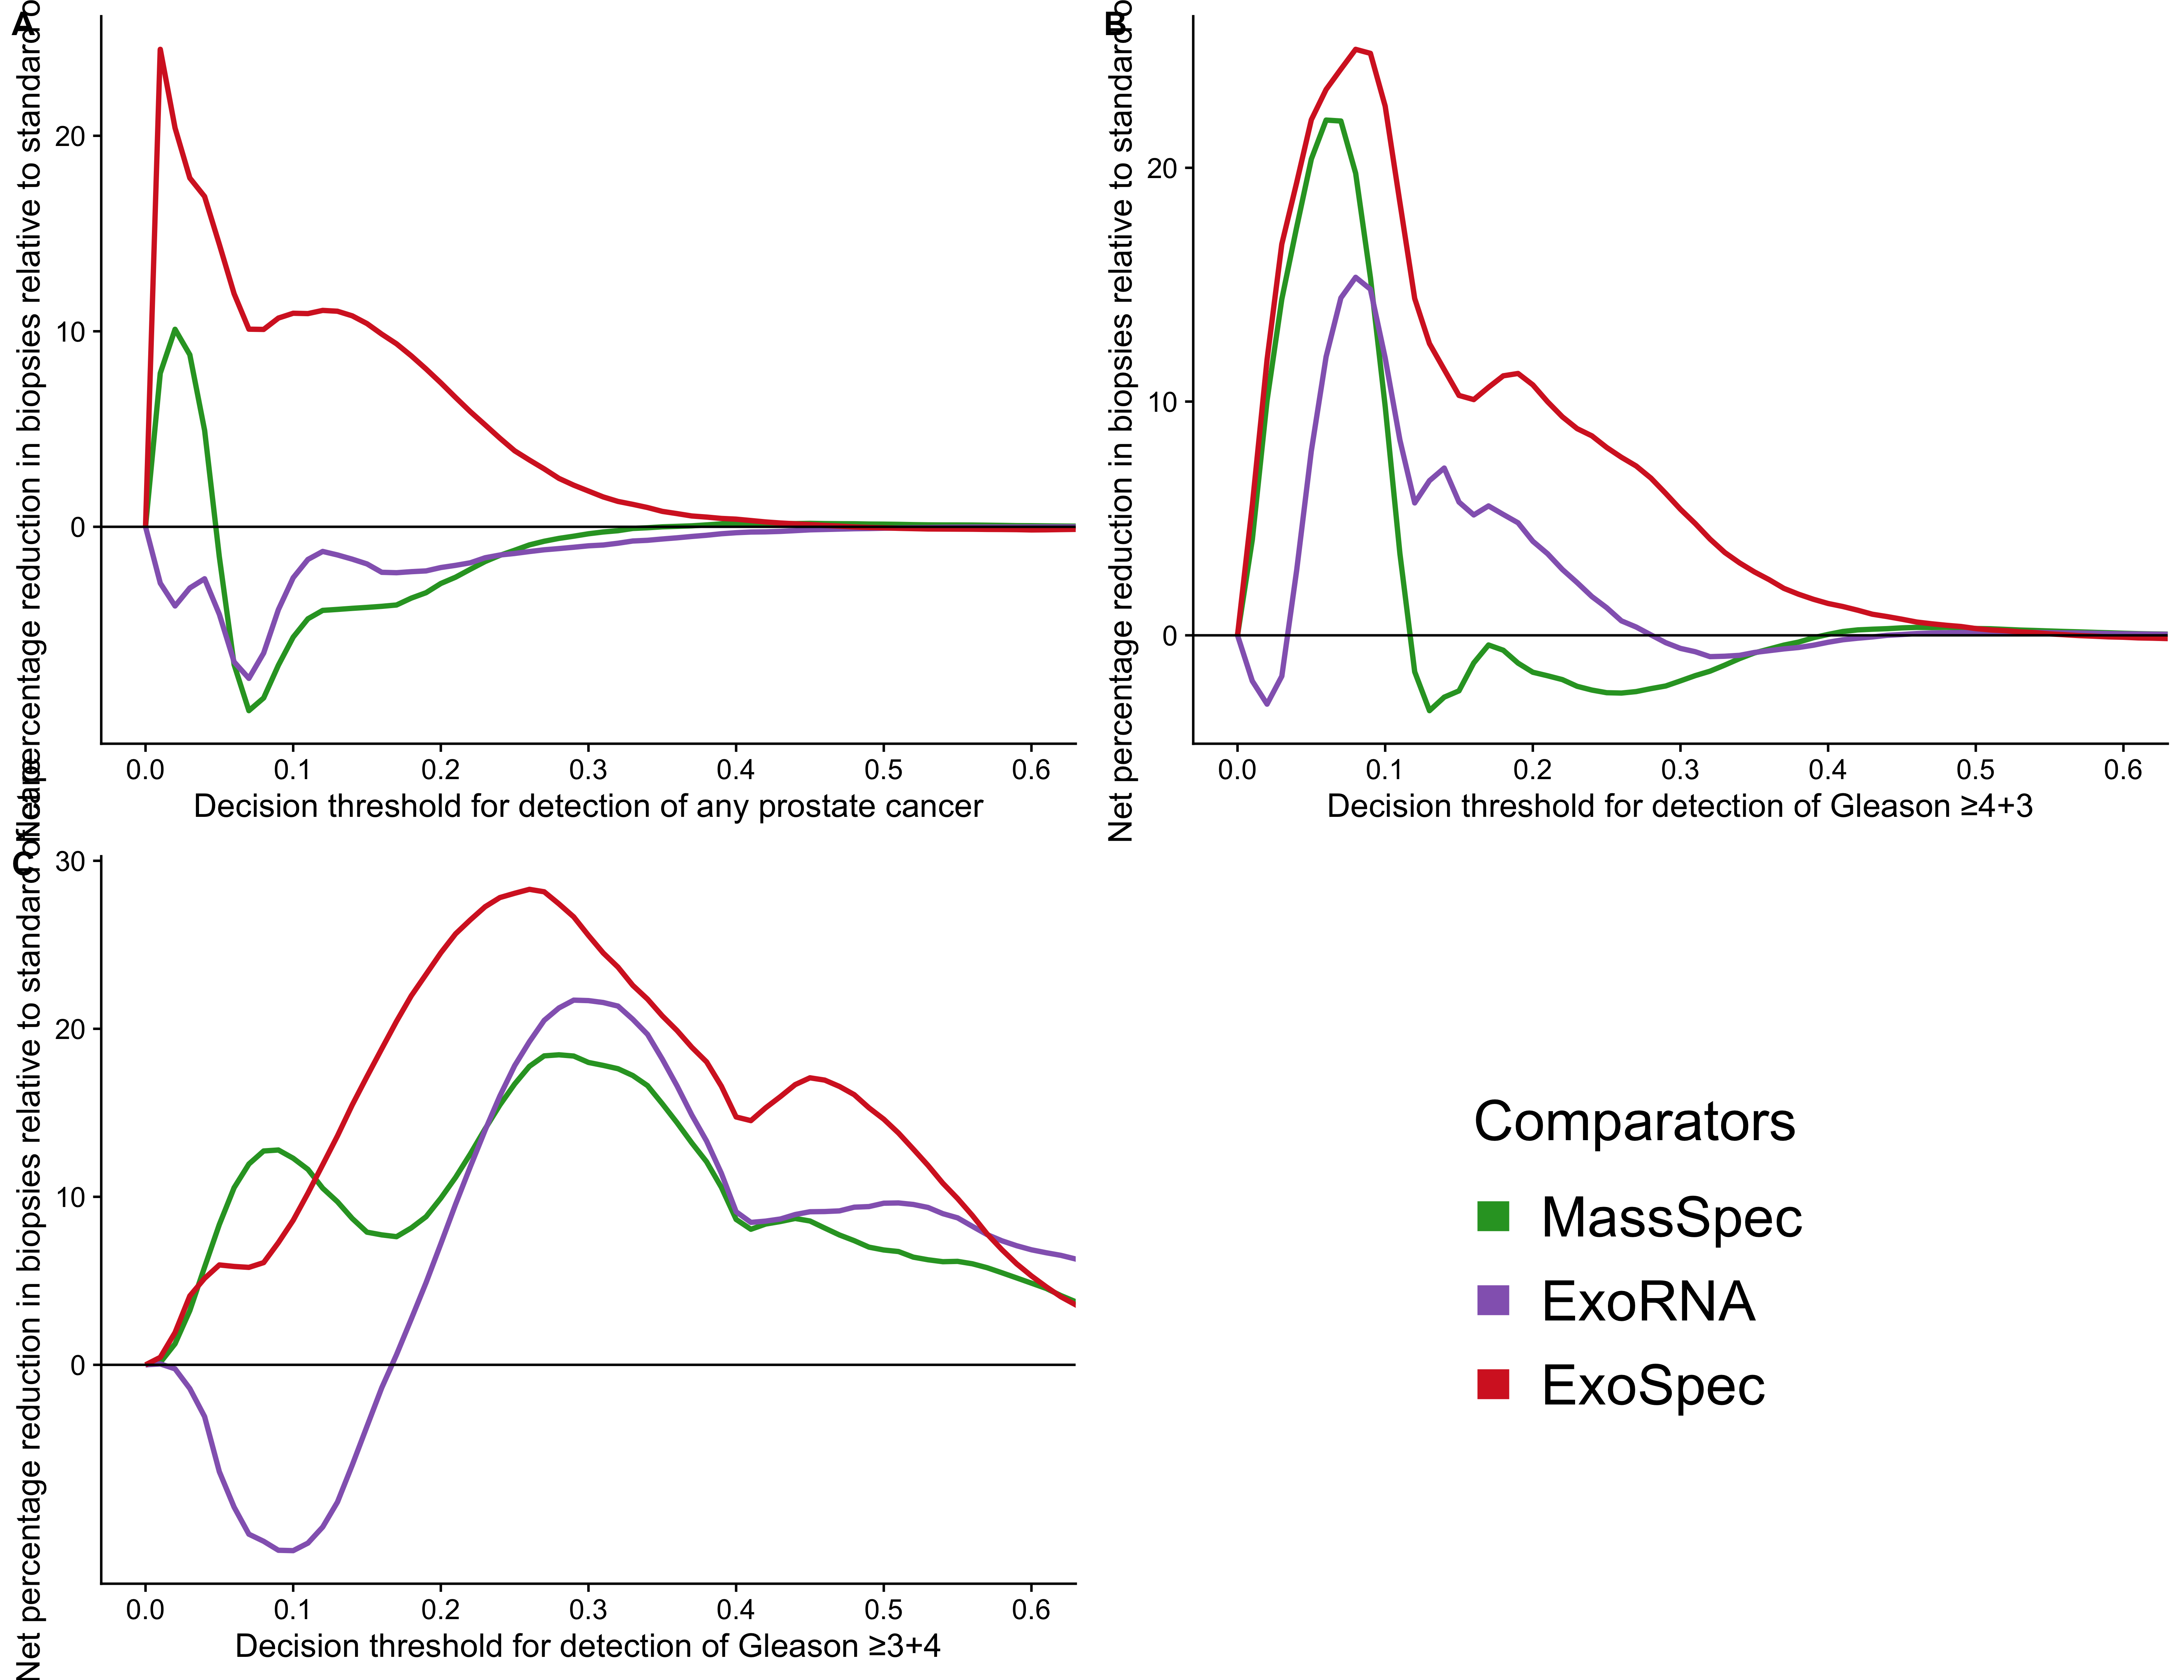

**Figure 5.** *Net percentage reduction in biopsies measured relative to current standards of care, as calculated by DCA measuring the benefit of adopting different risk models for aiding the decision to biopsy patients who would otherwise be biopsied. The x-axis details the range of accepted risk a clinician or patient may accept before deciding to biopsy. Panels show the percentage reduction in biopsies based upon the detection of varying levels of disease severity:* ***A*** *- any cancer ,* ***B*** *- Gleason ≥ 3+4 and* ***C*** *- Gleason ≥ 4+3. Coloured lines show differing comparator models;* ***Blue****- biopsy all patients with a PSA >3 ng/mL,* ***Green*** *- biopsy patients based on the MassSpec model,* ***Purple*** *- biopsy patients based on the ExoRNA model,* ***Red*** *- biopsy patients based on a the ExoSpec model. To assess the benefit of adopting these risk models in a non-PSA screened population we used data available from the control arm of the CAP study [@Martin2018]. DCA curves were calculated from 1,000 bootstrap resamples of the available data to match the distribution of disease reported in the CAP trial population. Mean sNB from these resampled DCA results were calculated and the SoC model results used as the baseline benefit. Results are plotted relative to this SoC benefit. See Methods for full details.*