A
PROJECT ON

SALES PERFORMANCE ANALYSIS

BY PROJECT TEAM A

OF THE COMPUTER OPERATIONS TRACK

IN PARTIAL FULFILLMENT OF THE
REQUIREMENTS FOR THE IDEAS
PROGRAM
2025

PARTICIPANTS:
FULL NAME ADMISSION NUMBER |  | SUBGROUP
IBRAHIM ZAINAB | IBRAHIMZAINAB549@GMAIL.COM | 1
SANI HAFSAT | HAFSATUSANI0814@GMAIL.COM | 2
ABDULSALAM  MAIMUNAH OMENEKE | ABDULSALAMOMENEKE57@GMAIL.COM | 3
NWOSISI VINCENT  CHIAGOZIE | NWOSISI49@ GMAIL.COM | 1
USMAN FATIMA | USMANFATIMA2727@GMAIL.COM | 2
AZUNNA CHRISTIANA  OLUCHI | AZUNNACHRISTIANA@GMAIL.COM | 3
OLORUNSOLA EZEKIEL  GBENGA | EZEKIELOLORUNSOLA@GMAIL.COM | 1
DURU NNEKA MARY | DURUNNEKA7079@GMAIL.COM | 2
SAMAILA SHAMSUDDEEN | SAMAILA6915@GMAIL.COM | 3
SULAIMAN AMINA  HAMISU | SHARYPHASULAIMAN@GMAIL.COM | 1
SAMAILA SHAMSUDDEEN | SHAMSUEES@GMAIL.COM | 2

Digital Skill: COMPUTER OPERATIONS
Contents
1.0 INTRODUCTION 4
1.1 Background 5
1.2 Problem Statement 5
1.3 Project Objectives 5
1.4 Scope of Study 6
1.5 Project Selection 6
2.0 LITERATURE REVIEW 7
2.1 Overview of Sales Analytics & Business Intelligence 7
2.2 Related Works 7
2.3 Research Gap 7
3.0 METHODOLOGY 8
3.1 Tools and Resources 8
3.2 Project Process 8
3.3 Deliverables & Features 8
4.0: RESULTS 12
4.1 Key Findings 12
4.2 Project Outcomes 12
5.0: CONCLUSION AND RECOMMENDATIONS 15
5.1 Summary of Findings 15
5.2 Limitations 15
5.3 Recommendations 15

Table of Figures

Figure 1 ............................................................................................................10

Figure 2 ............................................................................................................10

Figure 3 ............................................................................................................11

Figure 4 ............................................................................................................11

Figure 5 ............................................................................................................12

Figure 6 ............................................................................................................13

Figure 7 ............................................................................................................14

Figure 8 ............................................................................................................15

1.0 INTRODUCTION

1.1 Background
In today's competitive market, data-driven decision-making is crucial for sales departments to optimize performance, maximize revenue, and identify growth opportunities. This project focuses on conducting a comprehensive analysis of the sales data from Growth Enterprise Limited. The goal was to apply data analysis techniques and business intelligence principles to uncover key trends, product performance, regional disparities, and customer return issues. The project employed a structured workflow using Microsoft Excel for data analysis, Word for the strategic report, and PowerPoint to present the findings and actionable insights.
Sales performance analysis plays a critical role in pinpointing top-performing products, underperforming regions, and seasonal patterns. A well-executed analysis provides a clear roadmap for strategic planning, resource allocation, and targeted interventions to boost overall sales and profitability.

1.2 Problem Statement
The Sales Department at Growth Enterprise Limited operates with limited visibility into its performance metrics. Decisions are often based on intuition rather than concrete data, leading to missed opportunities, inefficient resource allocation, and an inability to proactively address issues like high product return rates. The challenge was to systematically analyze historical sales data, quantify performance across key dimensions, and design an actionable strategic report and dashboard to guide future sales strategies.

1.3 Project Objectives
- To conduct a thorough analysis of sales data to identify top and bottom-performing products and regions.
- To uncover seasonal sales trends and their impact on revenue.
- To evaluate product return rates and assess their risk to profitability.
- To develop an interactive Excel dashboard for ongoing performance monitoring.

- To create a comprehensive strategic report in Word with data-driven recommendations.

- To design a compelling PowerPoint presentation to communicate findings and strategies to management.

1.4 Scope of Study
This project focuses on the analysis, visualization, and strategic planning for the Sales Department of Growth Enterprise Limited. The scope includes building a dynamic dashboard in Excel, creating a detailed analytical report in Word, and developing an executive presentation in PowerPoint. The project deliverables are designed to be implemented by the company to achieve immediate improvements in sales strategy and performance tracking.

1.5 Project Selection
This project was executed by 12 trainees, divided into 3 sub-groups, with each group focusing on a core component of the final deliverable:
- Sub-group 1: Excel Data Analysis & Interactive Dashboard
- Sub-group 2: Word Strategic Report
- Sub-group 3: PowerPoint Executive Presentation

2.0 LITERATURE REVIEW

2.1 Overview of Sales Analytics & Business Intelligence
Effective sales management hinges on the ability to transform raw data into actionable insights. Modern sales departments leverage analytics to track Key Performance Indicators (KPIs), understand customer behaviour, and forecast future trends. The use of tools like Microsoft Excel for data modelling and dashboard creation is fundamental for visualizing complex data, enabling managers to quickly grasp performance and make informed, timely decisions.

2.2 Related Works
- Industry Best Practices: Leading sales organizations utilize integrated CRM and Business Intelligence (BI) platforms to track sales pipelines, customer lifetime value, and product performance in real-time, allowing for agile strategy adjustments.
- Academic Research: Studies show that companies employing data-driven sales strategies see a 5-6% higher productivity and profitability than their competitors who do not. Analysing return rates can directly protect profit margins by identifying quality or expectation gaps.
- Case Studies: Businesses that have implemented sales dashboards report faster response times to market changes and a more aligned and focused sales team, driven by clear, visible targets.

2.3 Research Gap
While the importance of sales analytics is universally acknowledged, many small to medium-sized enterprises (SMEs) like Growth Enterprise Limited lack the in-house expertise to conduct foundational analyses and build scalable monitoring tools. This project addresses that gap by providing a specific, actionable, and ready-to-use analysis and strategic package tailored to common sales data challenges.

3.0 METHODOLOGY

3.1 Tools and Resources
The project utilized the core applications of the Microsoft Office Suite, selected for their analytical power and universal accessibility:
- Microsoft Excel: Used for its powerful data manipulation capabilities (PivotTables, SUMIFS, XLOOKUP) and advanced charting to create an interactive sales dashboard.
- Microsoft Word: Employed for its professional formatting tools, including Styles, Table of Contents, and integrated charts, to create a comprehensive and persuasive strategic report.
- Microsoft PowerPoint: Chosen for its visual storytelling features to build a concise, impactful executive presentation for management.

3.2 Project Process
- Data Auditing & Cleaning: Conducted an initial review of the raw sales data to ensure consistency, check for errors, and structure it for analysis.
- Quantitative Analysis in Excel: Used PivotTables and formulas to segment data by Product, Region, and Month. Calculated total revenue, units sold, and return rates to identify key trends and outliers.
- Dashboard Development in Excel: Synthesized the analyzed data into an interactive dashboard with filters, key metric summaries (KPIs), and visual charts (bar graphs, line charts, pie charts) for at-a-glance performance assessment.
- Report and Presentation Development: Transformed the data insights from the Excel dashboard into a narrative-driven strategic report in Word and a visually compelling presentation in PowerPoint for stakeholder communication.

3.3 Deliverables & Features
- Excel Sales Dashboard: An interactive spreadsheet featuring:
  - Key Performance Indicators (KPIs): Total Revenue, Total Units Sold, Total Returns, Overall Return Rate.

  - Dynamic Charts: Sales by Product, Sales by Region, Sales by Month
(seasonality), Returns by Product.
  - Slicers/Filtering: Interactive filters for Region, Product, and Month to allow for deep-dive analysis.
- Word Strategic Report: A comprehensive document including:
  - Executive Summary
  - Detailed Analysis with embedded charts and tables.
  - Conclusion & Data-Driven Recommendations
o Professional layout with a navigable Table of Contents.
- PowerPoint Executive Presentation: A management-facing presentation that includes:
  - Agenda & Introduction
o Key Findings Visualized: Top/Worst performers, seasonal trends, return analysis.
  - Strategic Recommendations & Call to Action
o Interactive Q&A Slide

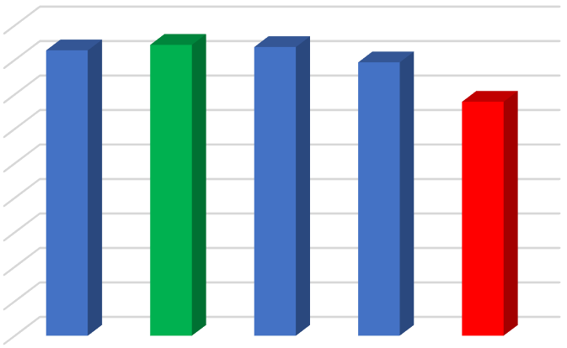

0
100000
200000
300000
400000
500000
600000
700000
800000
900000
Product A
Product B
Product C
Product D
Product E
827624
843711
837344
792856
678618
Best/Worst Products
Product A
Product B
Product C
Product D
Product E
Fig 1. Best/Worst Products by total Sales

0
50000
100000
150000
200000
250000
300000
350000
400000
450000
Jan
Feb
Mar
Apr
May
Jun
Jul
Aug
Sep
Oct
Nov
Dec
Monthly Trends
Total
Fig 2. Sales trends for different months of the year

960365
912462
1027042
1080284
Regional Sales Share
East
North
South
West
Figure 3. Sales revenue for different region regions

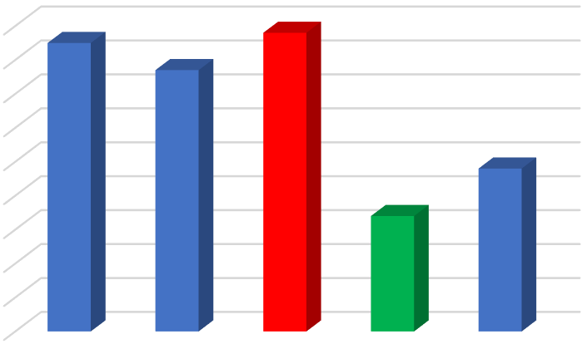

610
620
630
640
650
660
670
680
690
700
Product A
Product B
Product C
Product D
Product E
695
687
698
644
658
Products with High Returns
Product A
Product B
Product C
Product D
Product E
Figure 4. Products with high returns

4.0: RESULTS

4.1 Key Findings
- The analysis of the dataset revealed total revenue of ₦3.98 Million, providing a clear baseline for performance measurement.
- Product B (₦843,711) was the top revenue generator, closely followed by Product C and
A. Product E (₦678,618) was the weakest performer, lagging significantly behind.
- Regionally, the West (₦1.08M) and South (₦1.02M) were the strongest markets, while the East (₦960K) and North (₦912K) underperformed, indicating a need for targeted regional strategies.
- A clear seasonal trend was identified, with peaks in February and September, and troughs in March and October. This presents opportunities for promotional alignment.
- A critical finding was the high return rates for the top-selling products (A, B, and C), indicating that high sales volume is being undermined by potential quality issues or customer dissatisfaction, posing a direct threat to profitability.

4.2 Project Outcomes
The project resulted in a complete Sales Performance & Strategy Pack for Growth Enterprise Limited. The pack provides a clear diagnosis of the sales landscape and a practical path to revenue optimization and risk mitigation.
Key outcomes include:
- A prioritized list of strategic initiatives based on data-driven insights.
- Specific recommendations for product strategy, regional focus, seasonal planning, and return rate reduction.
- A dynamic Excel dashboard that serves as a live tool for ongoing sales performance monitoring.
- An executive-ready presentation designed to secure management buy-in and effectively communicate the strategic roadmap.


Product B
Product C
Product A
Product D
Product E
843711
837344
827624
792856
678618
PRODUCT REVENUE
Total
Figure 5. Product revenue Dashboard

0
50000
100000
150000
200000
250000
300000
350000
400000
450000
Jan
Feb
Mar
Apr
May
Jun
Jul
Aug
Sep
Oct
Nov
Dec
MONTHLY TRENDS
Total

Figure 6. Monthly trends of Total Sales



1080284
1027042
960365
912462
Regional Sales Share
West
South
East
North
Figure 7. Regional Sales Dashboard

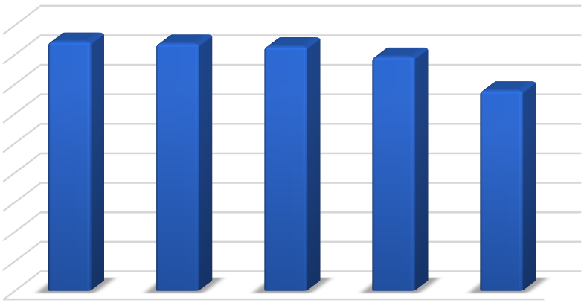

’

0
100000
200000
300000
400000
500000
600000
700000
800000
900000
Product B
Product C
Product A
Product D
Product E
Products with Returns
Total
Figure 8. Product’s returns dashboard

5.0: CONCLUSION AND RECOMMENDATIONS

5.1 Summary of Findings
The sales performance analysis successfully identified and quantified major opportunities and risks within the Sales Department of Growth Enterprise Limited. The project delivered a robust, three-part solution—comprising an interactive dashboard, a strategic report, and an executive presentation—that provides a clear and actionable roadmap for revenue growth and operational improvement.

5.2 Limitations
- The analysis is based on historical data; incorporating real-time data feeds would enhance the dashboard's utility for proactive decision-making.
- The successful implementation of recommendations depends on Growth Enterprise Limited's commitment to acting on the insights, which may require shifts in strategy and budget allocation.
- The depth of analysis is constrained by the fields available in the provided dataset; additional data on customer demographics or marketing spend could yield further insights.

5.3 Recommendations
- Address Product E: Launch a targeted campaign to revitalize Product E or consider its strategic phase-out. Conduct market research to understand its underperformance.
- Boost Lagging Regions: Develop localized sales and marketing strategies for the East and North regions. Investigate the root causes of their underperformance compared to the West and South.
- Leverage Seasonality: Align marketing promotions and inventory planning with the identified seasonal peaks (Feb, Sep) and develop initiatives to stimulate demand during troughs (Mar, Oct).
- Investigate Returns: Immediately conduct a root-cause analysis of the high return rates for Products A, B, and C. This is critical for protecting profit margins and brand reputation.

- Adopt the Dashboard: Implement the Excel dashboard as a standard tool for monthly sales reviews to foster a culture of continuous, data-driven performance management.

