**EEI3346 Web application development.**

**Electrical and computer engineering department.**

**The open university of Srilanka.**

**Mini project Submission**

**Documentation.**

**Student Number- S20001208**

**Name- P.S.R Wijerathne**

Mini project defined to make a website for Srilanka tourism industry. That named *Pearl of the Indian ocean.*

Tourism needs more interactive and updateable site. And provide more information about the srilanka’s places.

The users are this web site is who decided to spend their vacation in Srilanka. So, they need know how facilities which providing srilanka for foreign people and hospitality.

Users expect through the website to find locations and services. Such as tour guides, hotels, transportation, and flight capabilities.

The to do list given by question sheet is also great service.

Entering information categorized is most useful to find information throughout the topic.

If every information is with relative links such as maps also respective.

I focused about the resolution about the web site, it is fit any device screen resolution respectively.

Respective interface is user interactive. It helps for user to stay on site and find more.

I tried to develop the web site for future improvements. And it was succeeded nearly.

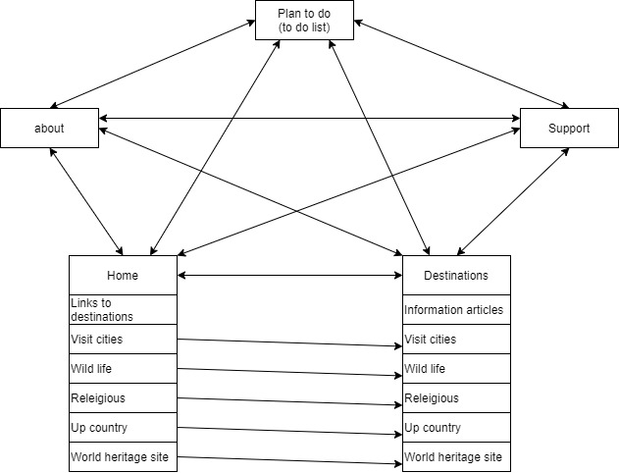

Architectural diagram of website

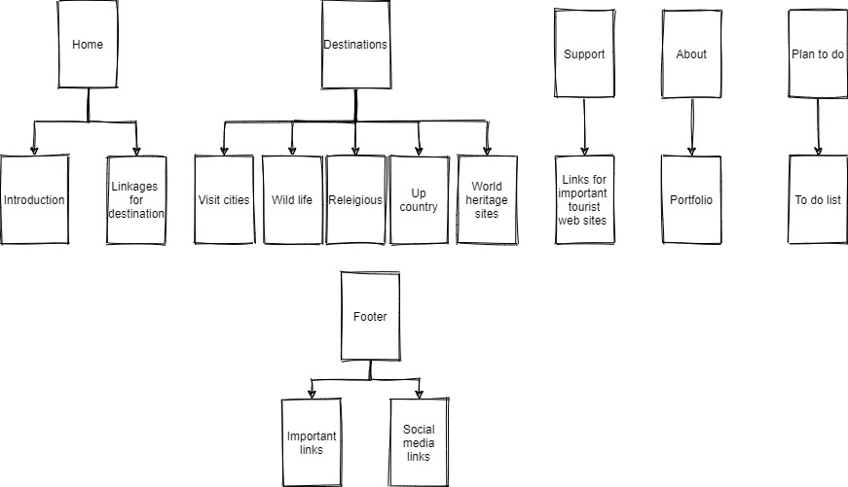

Site map

I used basic web developing tools

HTML

CSS

Javascript

vueJS framework

VS code

Edge browser

The navigation bar of the site is needed to all the pages and in same position fixed. As the solution I make it in separate division and liked its styles separately.

Also, the footer needed same action and I entered its styles in same style sheet.

Some common styles stored in separate style sheets. As the priority some styles needed to enter as internal css. High priority styles used as inline css.

Javascript files separated.

Thank you…...!

- End of mini project -