**INTERNSHIP REPORT**

An Summer Internship Technical Report submitted in partial fulfilment of the requirements for the award of the Degree of

**BACHELOR OF TECHNOLOGY**

**IN**

**INFORMATION TECHNOLOGY**

Submitted by

**M.SHEEBA GRACY**

**Reg.No:22B81A1279**

**InternId:XXXXXX**

Under the Esteemed Guidance of

**Dr. Sundar Balakrishna**

Director General

International Institute of Digital Technology

**(Duration:29th May, 2024 to 20th July, 2024)**



**DEPARTMENT OF INFORMATION TECHNOLOGY**

**SIR C.R. REDDY COLLEGE OF ENGINEERING**

**Approved by AICTE**

**Eluru-534007**

**2024-2025**

**SIR C.R.REDDY COLLEGE OF ENGINEERING**

**DEPARTMENT OF INFORMATION TECHNOLOGY**

**( Permanently Affiliated to JNTU-KAKINADA)**

**ELURU-534007**



**BONAFIDE CERTIFICATE**

This is to certify that the “**Internship report”** submitted by **M.SHEEBA GRACY(Regd. No.:**

**22B81A1279 and InternId:XXXXXX)** is work done by her and submitted during 2022 – 2023

academic year, in partial fulfillment of the requirements for the award of the degree of

**BACHELOROF TECHNOLOGY in INFORMATION TECHNOLOGY, JNTU- KAKINADA at**

**BrainOVision Solutions (India) Pvt.Ltd,Hyderabad.**

**Mr. V.GOPINATH, Asst.Professor Dr. A YESUBABU.**

**INTERNSHIP INCHARGE HEAD OF THE DEPARTMENT**

DEPARTMENT OF IT DEPARTMENT OF IT

Sir CRR College of Engineering Sir CRR College of Engineering

# DECLARATION

ICERTIFYTHAT

1. The internshipcontained inthereportisoriginalandhas beendonebymeunderthe guidance of mysupervisor.
2. TheworkhasnotbeensubmittedtoanyotherUniversityfortheawardofanydegree ordiploma.
3. Theguidelinesofthecollegearefollowedinwritingtheinternship report.

**Date: Name:**

**21EM1A0501**

# INDEX

|  |  |  |
| --- | --- | --- |
| **S.no.** | **CONTENTS** | **PAGENo.** |
| **1** | FoundationsandApplicationsofGenerative AI | 1 |
| **2** | FoundationsofPythonProgrammingandData Analysis with NumPy | 2 |
| 3 | GenerativeAI:Concepts,Applications,and Workflow Optimization | 3 |
| 4 | FutureDirectionsandReal-WorldImpactof Generative AI | 4 |
| 5 | AdvancedTechniquesinAIPromptEngineering | 5 |
| 6 | ApplyingPromptEngineeringTechniquestoCreate Unique Content | 6 |
| 7 | AdvancedDataAnalysisandGenerativeAI:Recap and Exploration | 7 |
| 8 | Hands-OnProjectswithChatGPTandDataAnalysis Techniques | 8 |

## Topic Description:

FoundationsandApplicationsofGenerativeAI

## Covered:

ExploringChatGPT:Functionality,Strengths,andLimitations

#### Inweek1,

This comprehensive module provides a foundational understanding of Generative AI and its applications. Students begin with an introduction to deep learning and machine learning, setting the stage for exploring generative AI. The course covers various types of generative models, including Variational Autoencoders (VAEs) and Generative Adversarial Networks (GANs), delving into their architecturesandfunctions. Emphasisisplacedontheroleofgenerative AIinvariousfields, suchas textgenerationandcreativecontentcreation,highlightingitstransformativeimpactacrossindustries.

Additionally, the course introduces ChatGPT, focusingon its functionalities and capabilities. Students learn about ChatGPT's strengths and limitations through a hands-on approach, interacting with the modelandexploringitspotentialfordifferenttasks.Thecurriculumincludesarecapoftheadvantages of deep learning, reinforcing the foundational concepts that underpin ChatGPT's architecture.

The module also compares generative AI with traditional AI, providing a broader context for understanding how these technologies differ and complement each other. Through practical exercises and theoretical insights, students gain a robust understanding of generative AI's core concepts and its practicalapplications,preparingthemtoleveragethesetechnologieseffectivelyinreal-world scenarios.

By the end of this module, students are equipped with a deep understandingof generative AI models, the practical applications of these technologies, and the capabilities and limitations of ChatGPT. This comprehensiveknowledgepreparesthemforadvancedstudyandapplicationinthefieldofgenerative AI and related technologies.

ReferenceVideoURL:<https://www.youtube.com/watch?v=NSkN4TxjSgc>

<https://www.youtube.com/watch?v=Xmo8UvDuJpI>

Exams:<https://taptap.blackbucks.me/hackathon/2118/?testType=13><https://taptap.blackbucks.me/hackathon/2149/?testType=13>



1

FoundationsofPythonProgrammingandDataAnalysiswithNumPy

## Covered:

Functionality,Tools,andPythonSetup

#### InWeek2,

This module provides an in-depth exploration of ChatGPT's functionalities and capabilities. Students beginwithanintroductiontoVariational Autoencoders(VAEs)andexamplesof variousgenerative AI tools, setting the foundation for understanding ChatGPT concepts. The course includes practical sessionsoninstallingAnaconda,settingupJupyterNotebooks,andanintroductiontoPython,ensuring that students are well-equipped to work with these tools effectively.

Thesecondpartofthemodulefocuseson thebasicsofPythonprogramming,coveringessentialsyntax and data structures. Students learn to work with variables, operators, control flow statements, and functions in Python, providing a strong programming foundation. The course emphasizes libraries crucial for data analysis, particularly NumPy. Through hands-on practice, students learn to import and use the NumPy library, explore its various concepts, and apply the correct syntax for effective data analysis.

By integratingthese topics, the module ensures that students not only understand the theoretical aspects of ChatGPT and generative AI tools but also gain practical programming skills essential for data analysisandAIapplicationdevelopment.Thehands-onexperiencewithPython,Anaconda,andJupyter Notebooks prepares students to leverage these technologies in real-world scenarios, enhancing their overall proficiency in AI and data analysis.

ReferenceVideoURL:<https://www.youtube.com/watch?v=uC24lrezJcw>

<https://www.youtube.com/watch?v=DKDHNaVQg0Q>

Exams:<https://taptap.blackbucks.me/hackathon/2184/?testType=13><https://taptap.blackbucks.me/hackathon/2176/?testType=80><https://taptap.blackbucks.me/hackathon/2202/?testType=13>



2

GenerativeAI:Concepts,Applications,andWorkflowOptimization

## Covered:

GenerativeAI:Concepts,Applications,andWorkflowOptimization

#### InWeek3,

This module provides a comprehensive overview of Python programming fundamentals and its applicationsindataanalysis.Thecoursebeginswithessentialprogrammingconceptssuchas syntax, data structures, variables, operators, control flow statements, and functions. Emphasis is placed on hands-on practice with libraries crucial for data analysis, particularly NumPy and Pandas.

Students are introduced to the Pandas library, learning its uses, how to import it, and the syntax necessaryforeffectivedata manipulation.PracticalexercisesfocusondataanalysistasksusingPandas, providing a solid foundation for handling real-world data scenarios.

The module then transitions to exploringthe realmof Generative AI. Students delve into core concepts and real-world applications of generative AI, examining how these technologies can be leveraged to enhancevariousworkflows.Thecoursecovers innovativeideasingenerativeAI,suchasbuildingmore efficient workflows for knowledge workers, automatingengineeringand data processes, democratizing data access, scaling customer support, and supporting translation and language services.

Throughout the module, students engage with AIconcepts and explore practical applications of generativeAI.Theylearnhowtheseadvanced technologiescanbeusedtooptimizeworkflows, enhance productivity, and solve complex problems across different industries.

ReferenceVideoURL:<https://www.youtube.com/watch?v=czNlHXway3A>

<https://www.youtube.com/watch?v=Ih1mjzIB-e8>

Exams: <https://taptap.blackbucks.me/hackathon/2225/?testType=13><https://taptap.blackbucks.me/hackathon/2278/?testType=13>

3

FutureDirectionsandReal-WorldImpactofGenerativeAI

## Covered:

GenerativeAIinAction:CaseStudiesandEthicalConsiderations

Inweek4,

This moduleprovidesanin-depthexplorationofGenerativeAIthroughreal-worldcasestudies, highlightingitsapplicationsacrossvariousindustries.Studentsbeginbyexaminingkeyconceptsof GenerativeAI,includinginnovativeideasandpracticalimplementations.Thecoursecovershow Generative AIcanbuild moreefficientworkflowsforknowledgeworkers,automateengineeringanddata processes,democratizedataaccess,scalecustomersupport,andsupporttranslationandlanguage services.

PracticalexamplesandcasestudiesshowcasetheimmediateapplicationsofGenerativeAI,suchasingame developmentandvirtualworlds.Studentsexploretheadvantagesofthesetechnologiesandtheirpotentialto revolutionizevarioussectors.Detaileddiscussionsfocusontheethicalconsiderationsandpotentialbiasesin Generative AI,includingissuesrelatedtodatabias, misinformation,andprivacyconcerns.

The moduleemphasizesthefutureofGenerative AIanditsimpactonindustries,discussingemerging applicationsandresearchareas.Studentslearnaboutthechallengesandconsiderationsinvolvedin implementingthesetechnologieseffectivelyandresponsibly.Practicalsessions includecreatingagenerator andadiscriminatorinJupyterNotebook,experiencewiththeseadvancedAI models.

Bytheendofthis module,studentsarewell-versedinthepracticalapplications,ethicalimplications,and futuredirectionsofGenerativeAI.Theygainacomprehensiveunderstandingofhowtoleveragethese technologiestosolvereal-worldproblemswhilebeingmindfulofethicalconsiderationsandpotential biases. This knowledge prepares themtocontributeeffectivelytothe ongoingdevelopmentandresponsible implementationofGenerativeAIinvariousfields.

ReferenceVideoURL:<https://www.youtube.com/watch?v=5zH6tBK7_5E>

<https://www.youtube.com/watch?v=WlyZykVCuck>

Exams: <https://taptap.blackbucks.me/hackathon/2283/?testType=13><https://taptap.blackbucks.me/hackathon/2260/?testType=80><https://taptap.blackbucks.me/hackathon/2368/?testType=13>

4

AdvancedTechniquesinAIPromptEngineering

## Covered:

ExploringSpecificTasksandEffectivenessofPromptStrategies

#### InWeek5,

This module dives deep into advanced prompt engineering techniques, focusing on strategies such as temperaturecontrolandfine-tuning. Studentsexplorepromptengineeringforspecifictasks,including storytelling and translation. The course involves group discussions and presentations to analyze the effectiveness of different prompt strategies, fostering a collaborative learning environment.

ThemodulestartswithanintroductiontoAIpromptengineering,explainingitsimportanceandtherole of an AI prompt engineer. Students learn various techniques for effective prompt engineering and participate in a live Jupyter coding session to apply these techniques in real-time.

Additionally, the module recaps the fundamentals of AI prompt engineering and delves into what happensduringthepromptengineeringprocess.Itcoversessentialparametersofpromptengineering andintroducesadvancedtechniquesforfine-tuningprompts. Studentslearnaboutpromptevaluation, safety measures, and jailbreak prevention, ensuring they can create secure and effective prompts.

Practical tools for prompt engineering are also highlighted, providing students with a robust toolkit for their projects. By understanding these tools and techniques, students can enhance the quality and effectiveness of their AI-driven solutions.Through hands-on experience and theoretical insights, this module equips students with advanced skills in prompt engineering. They gain the ability to craft preciseandeffectivepromptsforvariousapplications,ensuringoptimalperformanceofAImodels.The course prepares students to leverage prompt engineering techniques to solve complex problems and create innovative AI-driven solutions.

ReferenceVideoURL:<https://www.youtube.com/watch?v=PQRmAAcv7Yc>

<https://www.youtube.com/live/6v1xRnfJF1E>

Exams:<https://taptap.blackbucks.me/hackathon/2373/?testType=13><https://taptap.blackbucks.me/hackathon/2382/?testType=13>

5

ApplyingPromptEngineeringTechniquestoCreateUniqueContent

## Covered:

ApplyingPromptEngineeringTechniquestoCreateUniqueContent

#### InWeek6,

This module focuses on hands-on projects using ChatGPT and advanced prompt engineering techniques,enablingstudentstoapplylearnedconceptstocreateuniquetextformats,generatecreative content, and experiment with various applications.

StudentsbeginbycreatinganOpenAIprofileandinstallingthenecessaryOpenAI software. Theylearn to import essential libraries required for their projects. The module emphasizes practical experience, where students give prompts for various cases and handle the corresponding responses. This practice allows them to understand how different prompt strategies affect the output and learn effective error handling techniques.

ThecoursealsoincludesarevisionsessiononOpenAItools,reinforcingfoundational knowledgeand ensuring students are confident in using the platform. Students work on giving prompts to different cases, refining their skills in crafting precise and effective prompts.

By engaging in these hands-on projects, students gain a deep understanding of how to leverage ChatGPT and prompt engineering techniques to create high-quality, creative content. They learn to experimentwithdifferentapplications,understandingthenuancesofpromptengineeringanditsimpact on AI-generated responses.

This module equips students with the practical skills necessary to utilize ChatGPT for various real- worldapplications,ensuringtheycaneffectivelyimplementpromptengineeringtechniquestoachieve desired outcomes. The comprehensive hands-on approach prepares students to tackle complex AI- driven projects and create innovative solutions using ChatGPT.

ReferenceVideoURL:<https://www.youtube.com/live/DoooapGibKk>

<https://www.youtube.com/live/x7h1CQtN0EE>

Exams: <https://taptap.blackbucks.me/hackathon/2417/?testType=13><https://taptap.blackbucks.me/hackathon/2561/?testType=13>

6

AdvancedDataAnalysisandGenerativeAI:RecapandExploration

## Content:

RecapSession

#### Inweek7,

This module provides practical experience through hands-on projects using ChatGPT and advanced promptengineeringtechniques. Studentsapply learnedconceptstocreateuniquetextformats, generate creative content, and experiment with different applications.The course begins with the setup of essential tools, including the importation of important libraries such as NumPy, Seaborn, Pandas, and handling warnings. Students learn to import tables, analyze data types, understand null values, and convertdatatypes.Theseskillsarefundamentalforeffectivedataanalysisandmanipulation,whichare crucial when working with AI models.

As the module progresses, students recap key concepts learned throughout the course. They delve into advancedGenerativeAImodelsandpromptengineeringtools,ensuringtheystayupdatedonthelatest developments in the field. The course covers practical aspects of data handling, including removing symbols, converting data types, handling missing and duplicate data, and performing statistical analysis.

Students engage in creating visual representations of data usingbar plots, heatmaps, and scatter plots. This visualization helps in understanding data patterns and making informed decisions based on data insights.Thepracticalapproachofthemoduleensuresthatstudentscanapplytheirknowledgetoreal- world scenarios effectively.

Bytheendofthismodule,studentsareproficientinusingChatGPTandpromptengineeringforvarious applications. They possess strong data analysis skills, including data cleaning, statistical analysis, and visualization. The course prepares students to leverage advanced Generative AI models and tools, ensuring they can contribute to cutting-edge developments in AI and data science fields.

ReferenceVideoURL:<https://www.youtube.com/live/0YZt1wm4a4c>

<https://www.youtube.com/watch?v=5w9980cJm98&t=865s>

Exams:<https://taptap.blackbucks.me/hackathon/2429/?testType=13><https://taptap.blackbucks.me/hackathon/2557/?testType=13><https://taptap.blackbucks.me/hackathon/2879/?testType=81>

7

Hands-OnDataProjectswithChatGPTandPromptEngineering

## Covered:

ProjectExplanation

#### InWeek8,

This module provides practical experience through hands-on projects using ChatGPT and advanced promptengineeringtechniques.Studentsapplylearnedconceptsto createuniquetextformats,generate creative content, and experiment with different applications.

Thecoursebeginswiththesetupofessentialtools,includingtheimportationofimportantlibrariessuch asNumPy,Seaborn,Pandas,andhandlingwarnings. Studentslearntoimporttables,analyzedatatypes, understand null values, and convert data types. These skills are fundamental for effective data analysis and manipulation, which are crucial when working with AI models.

As the module progresses, students recap key concepts learned throughout the course. They delve into advancedGenerativeAImodelsandpromptengineeringtools,ensuringtheystayupdatedonthelatest developments in the field. The course covers practical aspects of data handling, including removing symbols, converting data types, handling missing and duplicate data, and performing statistical analysis.

Students engage in creating visual representations of data usingbar plots, heatmaps, and scatter plots. This visualization helps in understanding data patterns and making informed decisions based on data insights.Thepracticalapproachofthemoduleensuresthatstudentscanapplytheirknowledgetoreal- world scenarios effectively.

Bytheendofthismodule,studentsareproficientinusingChatGPTandpromptengineeringforvarious applications. They possess strong data analysis skills, including data cleaning, statistical analysis, and visualization. The course prepares students to leverage advanced Generative AI models and tools, ensuring they can contribute to cutting-edge developments in AI and data science fields.

ReferenceVideoURL:<https://www.youtube.com/live/ombrMEZtWis>

Exams: <https://taptap.blackbucks.me/hackathon/2900/?testType=13><https://taptap.blackbucks.me/hackathon/2909/?testType=81>

8

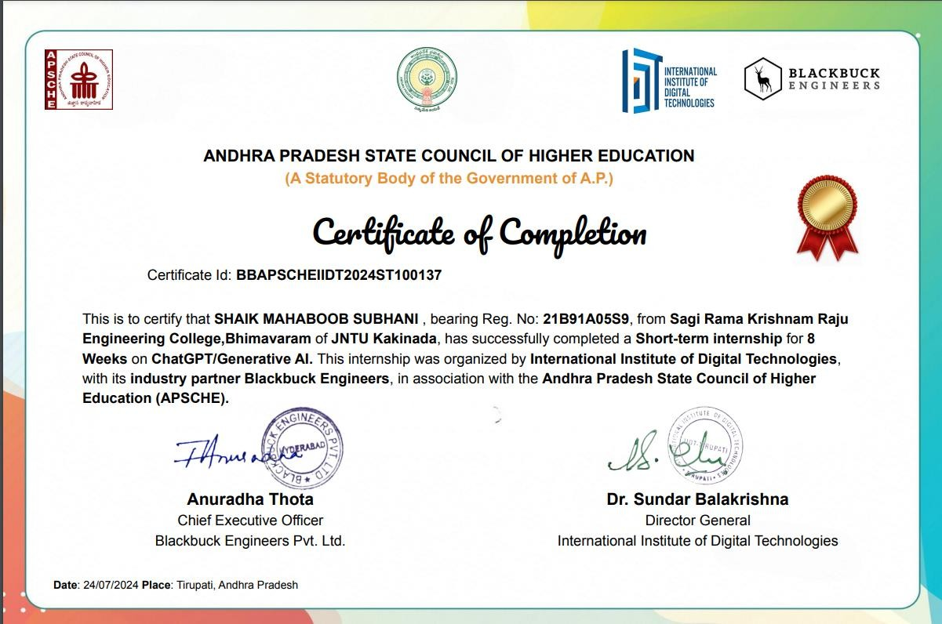

**SDST-28699 1-Jul-2024**