
Department of Artificial Intelligence & Data Science

AUTOMATIC ANSWER SHEET EVALUATION USING DEEP LEARNING

Submitted in partial fulfilment of the requirements for the degree of

BACHELOR OF TECHNOLOGY
In
ARTIFICIAL INTELLIGENCE & DATA SCIENCE
Submitted By

Team Members

Sheeba Princy D - 814724243140

Saranya K - 814724243132

Vaishnavi S - 814724243164

Vaishnavi P - 814724243163
Under the Guidance of

Mrs.R.Kalaiyarasi

SRM TRP ENGINEERING COLLEGE
Academic Year: 2026-27 (ODD)

TABLE OF CONTENTS

Sr. No | Title | Page No.
1 | Abstract ………………………………………………......... | 3
2 | Introduction…...……………………………………………... | 4
3 | System Requirements ………………………………………. | 5
4 | Methodology………………………………………………… | 6
5 | Implementation……………………………………………… | 12
6 | Conclusion…….……………………………………………. | 13
7 | References……………………………………………………. | 13

ABSTRACT

Evaluating handwritten answer sheets is one of the most time-consuming and error-prone tasks in the education system. Manual evaluation demands significant effort from teachers, is influenced by fatigue and subjective judgement, and often leads to inconsistent marking and delayed results. This project presents a deep learning based system that automatically evaluates scanned handwritten answer sheets by converting them into digital text and comparing the student's answers with a reference answer key. The proposed system first applies image preprocessing techniques such as grayscale conversion, noise removal, binarization, and skew correction to improve the quality of the scanned sheets. The pages are then segmented into question-wise answer regions and individual text lines. A convolutional recurrent neural network (CRNN), consisting of convolutional layers for feature extraction, bidirectional LSTM layers for sequence modelling, and a Connectionist Temporal Classification (CTC) decoder, is used to recognize the handwritten text. The recognized answer is cleaned and passed to a transformer based sentence encoder such as Sentence-BERT, which converts the student answer and the model answer into semantic embeddings. The cosine similarity between these embeddings, combined with keyword coverage, is mapped to the marks allotted for the question. Datasets such as the IAM Handwriting Database for handwriting recognition and the ASAP-SAS short answer scoring dataset for answer grading are used for training and evaluation. The handwriting recognition module is evaluated using Character Error Rate (CER) and Word Error Rate (WER), while the scoring module is evaluated using Quadratic Weighted Kappa (QWK), Pearson correlation, and Mean Absolute Error (MAE) against human-awarded marks. The system reduces evaluation time, ensures consistent and unbiased marking, and provides question-wise feedback. However, factors such as poor handwriting, scan quality, diagrams, and answers that are correct but phrased very differently can influence accuracy and must be handled carefully.

INTRODUCTION

Introduction: Automatic Answer Sheet Evaluation using Deep Learning
Assessment is a core part of education, and written examinations remain the most widely used method of measuring a student's understanding. In most institutions, thousands of handwritten answer sheets must be evaluated within a short time after every examination. Manual evaluation is slow, repetitive, and tiring for teachers, and it is affected by factors such as fatigue, mood, and personal bias. As a result, two evaluators may award different marks for the same answer, and the publication of results is often delayed. An automatic answer sheet evaluation system aims to overcome these problems by using artificial intelligence to read, understand, and grade answers with speed and consistency.
Early approaches to automatic grading were limited mainly to objective questions such as multiple choice questions, where an answer is simply matched against a key. Subjective and descriptive answers are much harder to evaluate because the same idea can be written in many different ways. Traditional methods relied on keyword matching, bag-of-words models, and hand-crafted features, which could not capture the meaning of a sentence. Similarly, classical optical character recognition (OCR) tools performed poorly on handwritten text because of variations in writing style, slant, spacing, and ink quality. Deep learning has changed this situation by allowing models to learn features directly from the data.
In this project, the problem is divided into two connected sub-problems: handwritten text recognition and answer scoring. Handwritten text recognition converts the scanned answer sheet into machine-readable text using a convolutional recurrent neural network trained with CTC loss. Answer scoring compares the recognized text with the model answer using transformer based sentence embeddings, so that the meaning of the answer is compared instead of only its words. The similarity score is then converted into marks according to the marking scheme defined by the teacher.
The effectiveness of such a system depends heavily on the quality and diversity of the data used for training. The IAM Handwriting Database provides a large collection of handwritten English text lines written by many different writers, while datasets such as ASAP-SAS and the Mohler short answer grading dataset provide student answers along with human-awarded scores. Preprocessing steps such as binarization, noise removal, skew correction, and data augmentation are applied to make the system robust to real-world scanned answer sheets.
One of the major challenges in automatic answer sheet evaluation is the variability of handwriting, including cursive writing, overwriting, strike-offs, and poor scan quality. In addition, the evaluation of descriptive answers is inherently subjective, since partially correct answers must be awarded partial marks. Diagrams, mathematical expressions, and tables are also difficult to interpret automatically. Therefore, designing an effective system requires careful consideration of the preprocessing pipeline, model architecture, and scoring strategy, and the output should be treated as an aid that supports the teacher rather than a complete replacement.

SYSTEM REQUIREMENTS

Category | Requirement | Description
Operating System | Windows / Linux / macOS | A compatible OS that supports deep learning frameworks. Linux is preferred for better performance and  GPU support.
Processor (CPU) | Intel i5/i7 or AMD Ryzen 5/7 (or higher) | Multi-core processors help in faster  data preprocessing and model execution.
GPU  (Recommended) | NVIDIA GPU (e.g., GTX 1650 / RTX 2060 / RTX  3060 or higher) | Required for accelerating deep learning training using CUDA. Significantly reduces training time  compared to CPU.
RAM | Minimum 8 GB (Recommended: 16 GB or  more) | Required to handle large image datasets and batch processing during  training.
Storage | Minimum 20–50 GB free  space | Needed for storing datasets (images),  trained models, and project files.
Programming Language | Python | Widely used for deep learning due to  simplicity and extensive library support.
Deep Learning Framework | TensorFlow / PyTorch | Used to build, train, and evaluate the CRNN and transformer based models for handwriting recognition and answer scoring.
Computer Vision Library | OpenCV | Used for image processing tasks such as grayscale conversion, noise removal, thresholding, deskewing, and segmentation.
NLP Libraries | Hugging Face Transformers, Sentence-Transformers, NLTK | Used for tokenization, text cleaning, and generating sentence embeddings for answer scoring.
Data Handling  Libraries | NumPy, Pandas | Used for efficient data manipulation  and preprocessing.
Visualization Tools | Matplotlib, Seaborn | Used for plotting training graphs, accuracy, loss curves, and result  visualization.
Development Environment | Jupyter Notebook / Visual  Studio Code | Used for writing, testing, and  debugging code.
Dataset | IAM Handwriting Database / ASAP-SAS Dataset | Contain handwritten text with transcriptions and student answers with human-awarded scores required for training and evaluation.

METHODOLOGY

Methodology: Automatic Answer Sheet Evaluation using Deep Learning
The methodology of this project focuses on designing and implementing a deep learning based system that can read handwritten answer sheets and assign marks automatically. The approach follows a structured pipeline that includes data collection, image preprocessing, answer segmentation, handwriting recognition, semantic answer scoring, evaluation, and deployment. Convolutional and recurrent neural networks are used to convert handwriting into text, and transformer based language models are used to judge how closely the answer matches the reference answer. The methodology ensures that each stage is trained and validated carefully so that the final marks are accurate, consistent, and explainable.
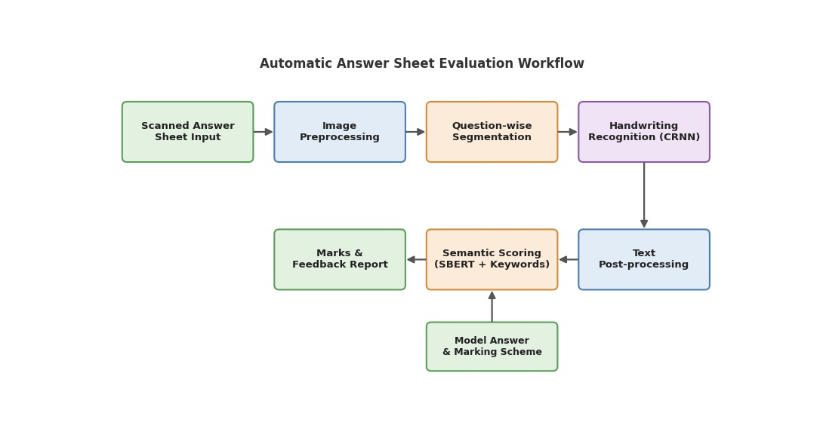

Overall System Workflow
The workflow begins with scanning the answer sheet and preprocessing the images, followed by segmenting the sheet into question-wise answer regions. The segmented text lines are recognized by the CRNN model, and the recognized answers are compared with the answer key using semantic similarity. Finally, the marks are calculated for each question and compiled into a report. Each stage plays a critical role in ensuring the accuracy and reliability of the evaluation.

Data Collection and Dataset Selection
The first step involves selecting suitable datasets for the two tasks. For handwriting recognition, the IAM Handwriting Database is commonly used because it contains thousands of handwritten English text lines with transcriptions. For answer scoring, datasets such as ASAP-SAS and the Mohler short answer grading dataset provide student answers along with scores given by human evaluators. Scanned answer sheets collected from classroom tests, along with teacher-provided answer keys, can be added for fine-tuning the system to the target domain.
Key dataset characteristics:
- Large number of handwritten text lines with ground-truth transcriptions
- Diversity in writers, writing styles, and ink or paper quality
- Student answers with human-awarded marks for supervised scoring
- Coverage of different subjects and question types
A well-balanced and diverse dataset is essential to avoid bias and improve model performance.

Data Preprocessing
Before feeding the data into the models, preprocessing is performed to ensure consistency and improve recognition accuracy. Scanned answer sheets often contain shadows, noise, and tilted pages, so all images must be cleaned and standardized.
Key preprocessing steps include:
- Image Enhancement: Converting to grayscale and removing noise using OpenCV filters
- Binarization and Deskewing: Applying adaptive thresholding and correcting the tilt of the page
- Segmentation: Splitting the sheet into question-wise answer regions and individual text lines
- Resizing and Augmentation: Scaling line images to a fixed height, normalizing pixel values, and applying rotation, shear, and brightness changes
These steps help improve model robustness and prevent overfitting.

Model Architecture Design

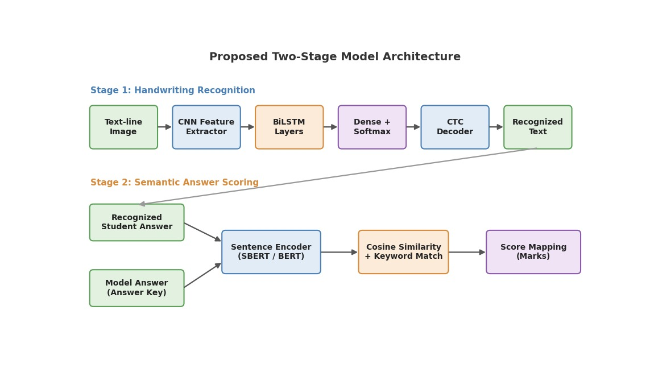

The core of the system consists of two deep learning models. The first is a convolutional recurrent neural network (CRNN) for handwriting recognition. Convolutional layers extract visual features from each text-line image, bidirectional LSTM layers model the sequence of characters, and a CTC decoder produces the final text without requiring character-level alignment. The second is a transformer based sentence encoder, which converts the recognized answer and the model answer into semantic embeddings that are compared using cosine similarity. Together, these models form a two-stage, end-to-end evaluation approach.
Model components:
- Convolutional Layers: Extract spatial features such as strokes, curves, and character shapes
- Recurrent Layers (BiLSTM): Capture the sequence and context of characters in a line of text
- Sentence Encoder (SBERT): Learn semantic representations of the student answer and the model answer

Output Layers:
  - Recognition → Text transcript obtained using CTC decoding
  - Scoring → Similarity score converted into marks for each question
This design allows the system to read the handwriting and judge the meaning of the answer in a single automated pipeline.

Model Training
The recognition model is trained on the preprocessed text-line images and their transcriptions, while the scoring model is fine-tuned on pairs of student answers and reference answers with human-awarded scores. Each dataset is divided into training, validation, and testing sets to ensure proper evaluation and avoid overfitting.
Key training components:

Loss Functions:
  - CTC Loss for handwriting recognition
  - Mean Squared Error (MSE) or cosine similarity loss for answer scoring
- Optimizer: Adam optimizer for efficient gradient descent

- Batch Size & Epochs: Tuned based on dataset size and performance
- Regularization: Dropout layers and early stopping to prevent overfitting
During training, the models update their weights through backpropagation to minimize prediction error.

Model Evaluation

After training, the models are evaluated using the test datasets to measure their performance.
Different metrics are used for recognition and scoring:
- Handwriting Recognition: Character Error Rate (CER) and Word Error Rate (WER)
- Answer Scoring: Quadratic Weighted Kappa (QWK), Pearson correlation, and Mean Absolute Error (MAE) against human marks
The marks given by the system are also compared with those of human evaluators, and error analysis is used to identify weak areas for further improvement.

Prediction and Deployment
Once the models are trained and evaluated, they can be used for real-time evaluation. Given a scanned answer sheet and an answer key, the system performs preprocessing, recognizes the handwritten text, compares each answer with the reference answer, and outputs the marks along with question-wise feedback.
Steps involved:
- Upload scanned answer sheet and answer key
- Preprocessing and answer segmentation
- Handwriting recognition and semantic scoring
- Display question-wise marks and total score

The system can be integrated into applications such as university examination portals, school assessment tools, or web-based platforms built using Flask or Streamlit.

Challenges and Optimization
Some challenges encountered in this project include:
- Variability in handwriting styles, cursive writing, and overwriting
- Poor scan quality, shadows, and noise
- Subjective nature of descriptive answers and partial marking
- Handling diagrams, tables, and mathematical expressions
To overcome these challenges, techniques such as data augmentation, transfer learning with pre-trained models such as TrOCR and BERT, and hyperparameter tuning can be applied.

Summary of Methodology
In summary, the methodology involves a complete pipeline starting from scanning and preprocessing of answer sheets to handwriting recognition, semantic scoring, evaluation, and deployment. By utilizing CNN, BiLSTM, and transformer based deep learning techniques, the system effectively reads handwritten answers and awards marks that are consistent with the marking scheme. The structured approach ensures speed, fairness, scalability, and real-world applicability, making it a robust solution for automating answer sheet evaluation.

IMPLEMENTATION

Output as expected is as follows
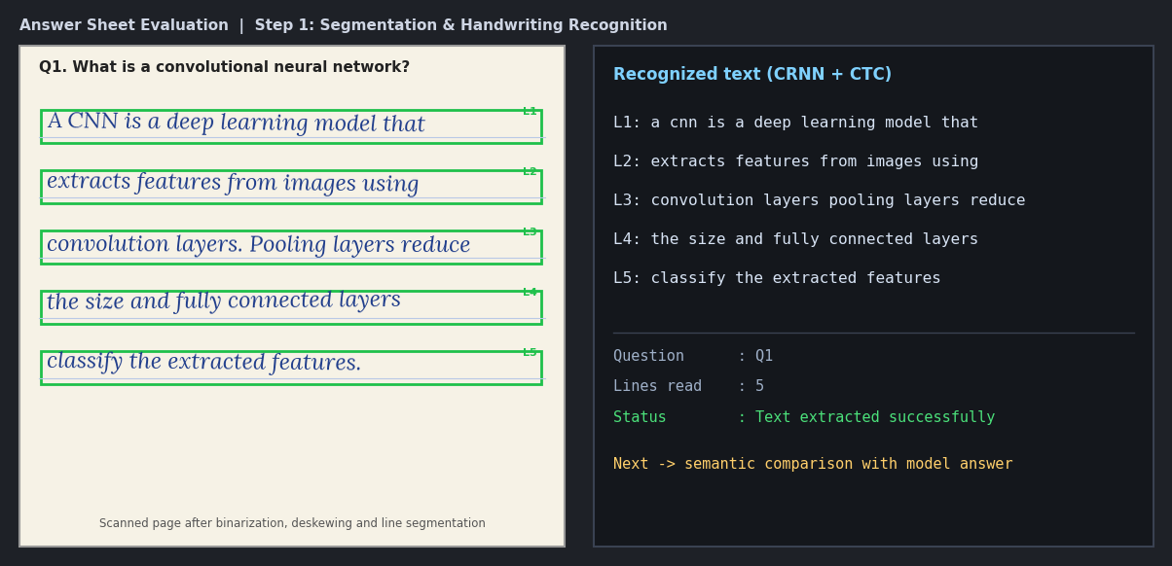

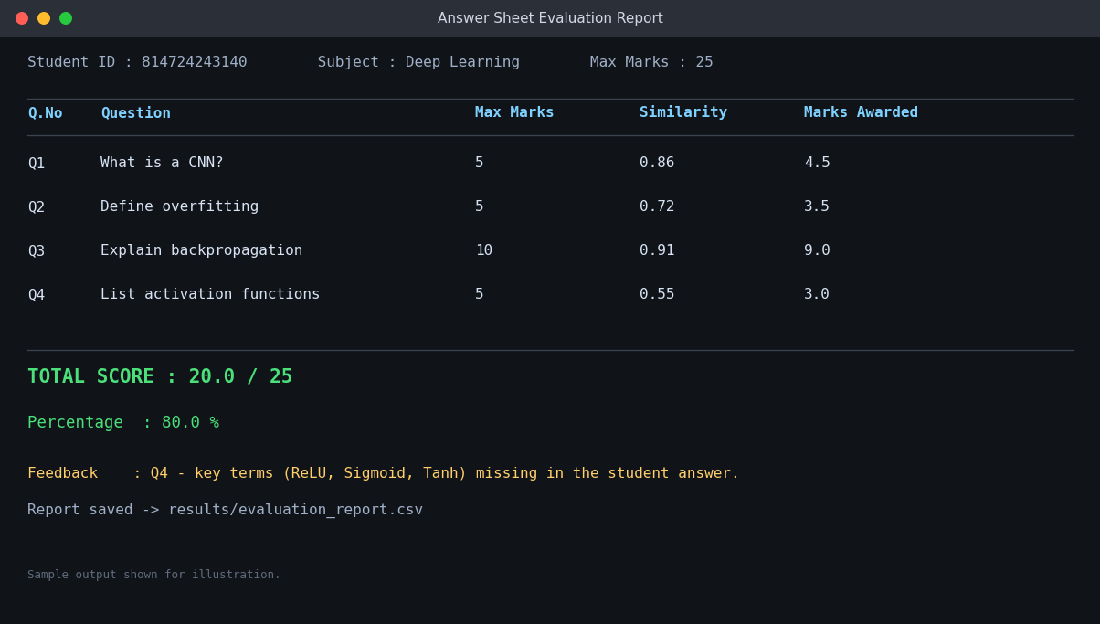

CONCLUSION

The successful implementation of the automatic answer sheet evaluation system demonstrates the effectiveness of deep learning techniques in reducing the effort and subjectivity involved in manual evaluation. By combining a convolutional recurrent neural network for handwriting recognition with transformer based sentence embeddings for semantic scoring, the system is able to read handwritten answers and award marks that closely follow the teacher's reference answer. This project highlights how deep learning reduces the need for hand-crafted rules and keyword-only matching and improves the fairness and speed of evaluation compared with traditional approaches. Throughout the project, a structured methodology was followed, beginning with dataset selection and preprocessing, followed by model design, training, and evaluation. The use of diverse handwriting and answer-scoring datasets helps the models generalize across different writing styles and answer formulations. The two-stage design, in which recognition and scoring are handled by separate specialized models, is flexible and easy to improve. In future, the system can be extended to handle diagrams and mathematical expressions, support multiple languages, and provide detailed feedback to students.

REFERENCES

- IAM Handwriting Database – https://fki.tic.heia-fr.ch/databases/iam-handwriting-database
- ASAP-SAS: Short Answer Scoring Dataset (Kaggle) – https://www.kaggle.com/c/asap-sas
- Mohler et al.: Learning to Grade Short Answer Questions (ACL 2011) – https://aclanthology.org/P11-1076/
- CRNN: End-to-End Trainable Network for Image-based Sequence Recognition – https://arxiv.org/abs/1507.05717
- TrOCR: Transformer-based Optical Character Recognition – https://arxiv.org/abs/2109.10282
- Sentence-BERT: Sentence Embeddings using Siamese BERT-Networks – https://arxiv.org/abs/1908.10084
- BERT: Pre-training of Deep Bidirectional Transformers – https://arxiv.org/abs/1810.04805
- Hugging Face Transformers Documentation – https://huggingface.co/docs/transformers
- TensorFlow Official Documentation – https://www.tensorflow.org
- PyTorch Official Documentation – https://pytorch.org
- OpenCV Documentation – https://docs.opencv.org
- Deep Learning Book, Ian Goodfellow, Yoshua Bengio, Aaron Courville – https://www.deeplearningbook.org

