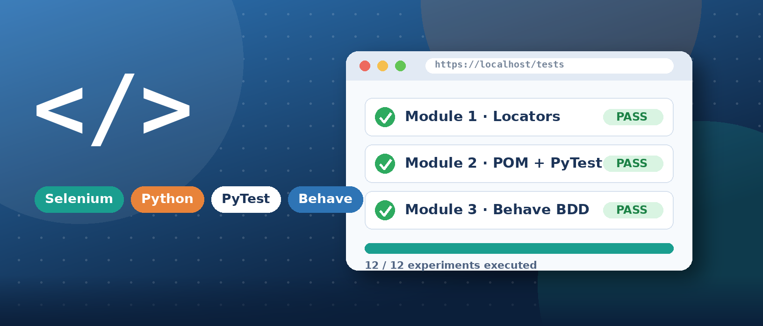
SELENIUM PYTHON AUTOMATION
MODULE-WISE LAB WORKBOOK
Modules 1, 2 & 3 — Locators • Page Object Model • PyTest • Behave BDD

3  MODULES | 12  EXPERIMENTS | 1  GITHUB REPOSITORY

MODULE 1  Locators & Interactions  ▸ Locators: ID, NAME, XPATH  ▸ Explicit waits  ▸ Alerts, tables, iframes |  | MODULE 2  POM, DDT & PyTest  ▸ Page Object Model  ▸ CSV data-driven tests  ▸ PyTest + HTML report |  | MODULE 3  BDD with Behave  ▸ Gherkin scenarios  ▸ Scenario Outline data  ▸ Behave + Page Objects

Student Name | Sheefa Hussain
Batch | Computer Engineering and Information Technology
Date | 25/09/2026
GitHub Repository | https://github.com/Sheefhuss/Selenium_Automation

Coursera Course Completion | Module Examinations | Capstone Project | GitHub Submission

Module 1: Core Fundamentals, Locators & Advanced Interactions
This module covers foundational Selenium automation concepts, moving from basic element locators and explicit waits to advanced browser interactions like alerts, web tables, and frames.

Video Demonstration: https://drive.google.com/file/d/1Hc-3GKYIXKfSCKTEQqbLd7NVYQbQJt2B/view?usp=drivesdk
Module folder: https://github.com/Sheefhuss/Selenium_Automation/tree/main/Modules/module1

Experiment 1: The Multi-Locator Challenge
Problem Statement | A login page must be automated using more than one locator strategy for different elements, then the outcome of a successful login must be verified.
Objective | Interact with the username field using By.ID, the password field using By.NAME, and the login button using By.XPATH, then assert that the final URL contains /inventory.html.
Tools / Software / Concepts | - Python  - Selenium WebDriver  - By.ID / By.NAME / By.XPATH locator strategies  - URL assertion
Implementation Steps | - Launch Chrome and navigate to https://www.saucedemo.com/.  - Locate the username field using By.ID ('user-name') and enter 'standard_user'.  - Locate the password field using By.NAME ('password') and enter 'secret_sauce'.  - Locate the login button using By.XPATH and click it.  - Assert that driver.current_url contains '/inventory.html', then save a screenshot.
Source Code | View on GitHub: Modules/module1/code_session/assignment1.py  Modules/module1/code_session/assignment1.py  from selenium import webdriver  from selenium.webdriver.common.by import By  import time  driver = webdriver.Chrome()  driver.maximize_window()  try:  driver.get("https://www.saucedemo.com/")  # Locate the username field by its id attribute  username_field = driver.find_element(By.ID, "user-name")  username_field.send_keys("standard_user")  # Locate the password field by its name attribute  password_field = driver.find_element(By.NAME, "password")  password_field.send_keys("secret_sauce")  # Locate the login button by an XPath expression  login_button = driver.find_element(By.XPATH, "//input[@id='login-button']")  login_button.click()  time.sleep(1)  current_url = driver.current_url  assert "/inventory.html" in current_url, f"Login failed, landed on: {current_url}"  print("PASS: Login successful, redirected to:", current_url)  driver.save_screenshot("assignment1.png")  finally:  driver.quit()
Output (Screenshots) | 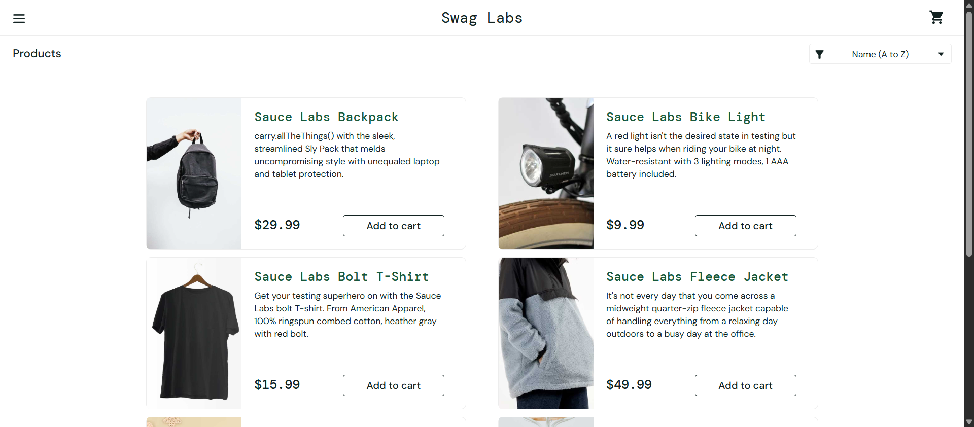  Fig 1.1 — Successful login redirect to the inventory page (saucedemo.com).
Result / Observation / Conclusion | The objective was met: all three locator strategies (ID, NAME, XPATH) located their elements correctly, and the URL assertion confirmed a successful redirect to /inventory.html.

Experiment 2: Synchronization & Explicit Waits
Problem Statement | Dynamic content on a page may not be available the instant a script tries to interact with it, and fixed delays (time.sleep()) are unreliable and slow.
Objective | Handle dynamic content correctly using WebDriverWait combined with expected_conditions instead of time.sleep().
Tools / Software / Concepts | - Python  - Selenium WebDriverWait  - expected_conditions (EC)  - the-internet.herokuapp.com/dynamic_loading
Implementation Steps | - Navigate to the-internet.herokuapp.com/dynamic_loading/1.  - Wait for the Start button to be clickable using EC.element_to_be_clickable, then click it.  - Wait for the revealed text element to become visible using EC.visibility_of_element_located.  - Print the revealed text and save a screenshot.
Source Code | View on GitHub: Modules/module1/code_session/assignment2.py  Modules/module1/code_session/assignment2.py  from selenium import webdriver  from selenium.webdriver.common.by import By  from selenium.webdriver.support.ui import WebDriverWait  from selenium.webdriver.support import expected_conditions as EC  driver = webdriver.Chrome()  driver.maximize_window()  try:  driver.get("https://the-internet.herokuapp.com/dynamic_loading/1")  start_button = WebDriverWait(driver, 10).until(  EC.element_to_be_clickable((By.CSS_SELECTOR, "#start button"))  )  start_button.click()  # Wait until the hidden text box is visible and loaded  revealed_text = WebDriverWait(driver, 10).until(  EC.visibility_of_element_located((By.ID, "finish"))  )  print("Revealed text:", revealed_text.text)  driver.save_screenshot("assignment2.png")  finally:  driver.quit()
Output (Screenshots) | 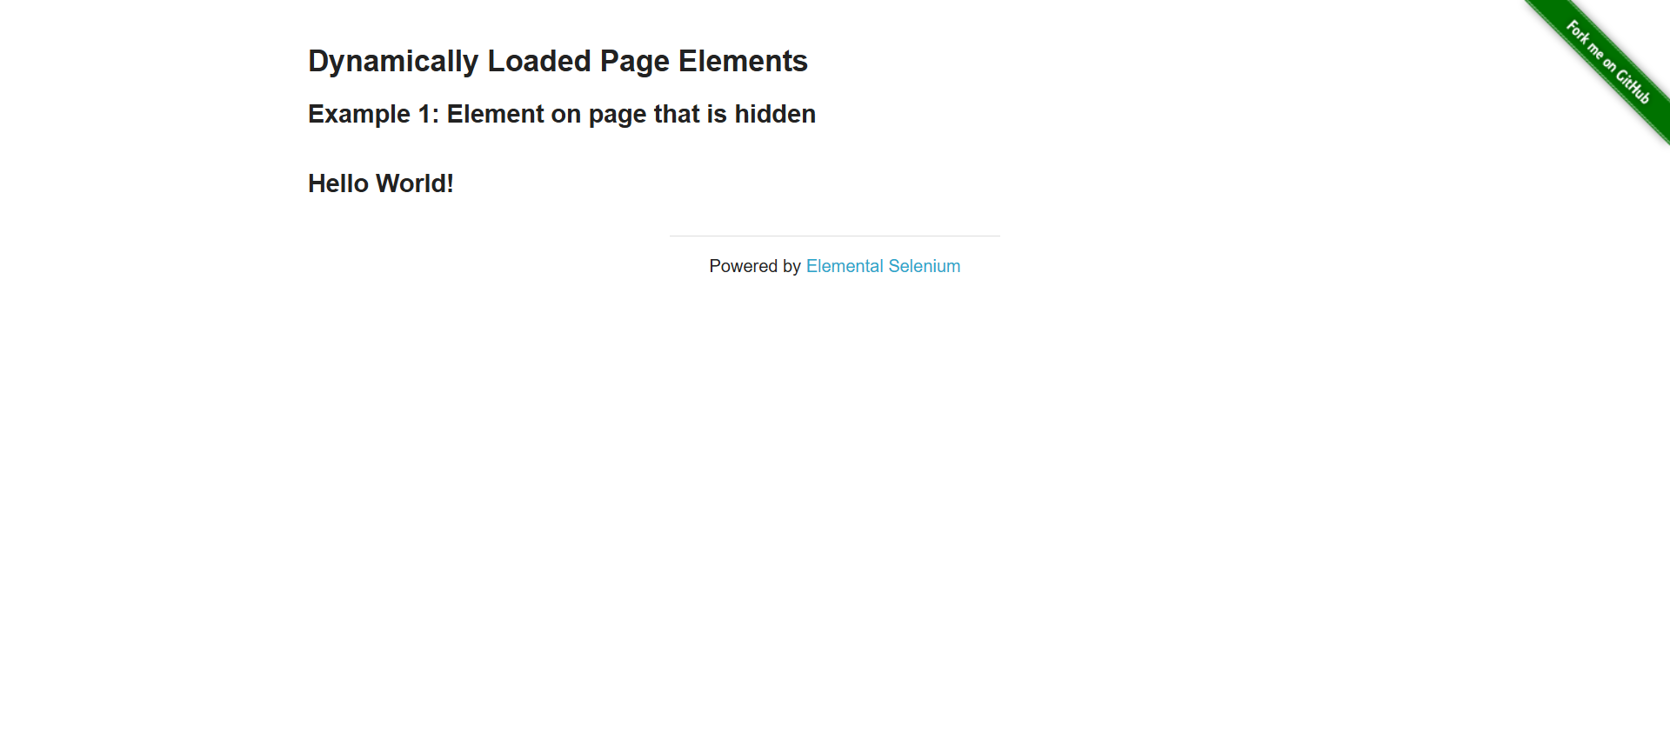  Fig 1.2 — Hidden text revealed after the explicit wait condition is satisfied.
Result / Observation / Conclusion | No time.sleep() was used. Both WebDriverWait conditions (element_to_be_clickable, visibility_of_element_located) worked reliably, confirming synchronization was handled correctly instead of using a fixed delay.

Experiment 3: Checkbox Toggling & Autocomplete Dropdown Selection
Problem Statement | A set of checkboxes needs their state read and toggled, and a separate autocomplete widget needs a specific suggestion selected from a dynamically-appearing list — an internal practice exercise combining element lists with explicit waits.
Objective | Iterate through all checkboxes on a page and ensure each is selected, then type into an autocomplete field and select the exact suggestion 'Java' once the suggestion list becomes visible.
Tools / Software / Concepts | - Python  - Selenium find_elements  - WebDriverWait / expected_conditions  - By.CSS_SELECTOR
Implementation Steps | - Part A: Open the-internet.herokuapp.com/checkboxes, get all checkbox elements, click any that are not already selected, and print each one's selected state.  - Save a screenshot of the checkbox state (screenshot_checkbox.png).  - Part B: Open jqueryui.com's autocomplete demo, wait for the search box, and type 'Ja'.  - Wait for the suggestion list to become visible, loop through the suggestions, and click the one matching 'Java'.  - Save a screenshot of the completed selection (assignment3.png).
Source Code | View on GitHub: Modules/module1/code_session/assignment3.py  Modules/module1/code_session/assignment3.py  from selenium import webdriver  from selenium.webdriver.common.by import By  from selenium.webdriver.support.ui import WebDriverWait  from selenium.webdriver.support import expected_conditions as EC  driver = webdriver.Chrome()  driver.maximize_window()  try:  # --- Part A: Checkboxes ---  driver.get("https://the-internet.herokuapp.com/checkboxes")  checkboxes = driver.find_elements(By.CSS_SELECTOR, "#checkboxes input[type='checkbox']")  for i, box in enumerate(checkboxes):  if not box.is_selected():  box.click()  print(f"Checkbox {i + 1} selected state: {box.is_selected()}")  driver.save_screenshot("screenshot_checkbox.png")  # --- Part B: Autocomplete dropdown ---  driver.get("https://jqueryui.com/resources/demos/autocomplete/default.html")  wait = WebDriverWait(driver, 10)  # Directly wait for the search box to be present  search_box = wait.until(EC.presence_of_element_located((By.ID, "tags")))  search_box.send_keys("Ja")  # Wait for suggestions list to appear  suggestions = wait.until(  EC.visibility_of_all_elements_located((By.CSS_SELECTOR, "ul.ui-autocomplete li"))  )  target = "Java"  for suggestion in suggestions:  if suggestion.text.strip() == target:  suggestion.click()  print(f"Selected suggestion: {target}")  break  driver.save_screenshot("assignment3.png")  finally:  driver.quit()
Output (Screenshots) | 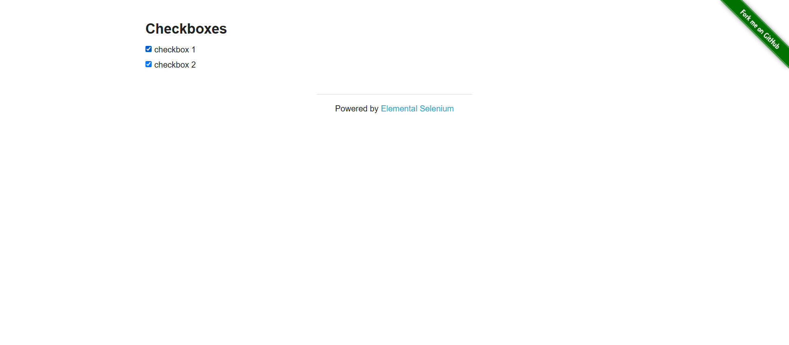  Fig 1.3a — All checkboxes toggled to the selected state.  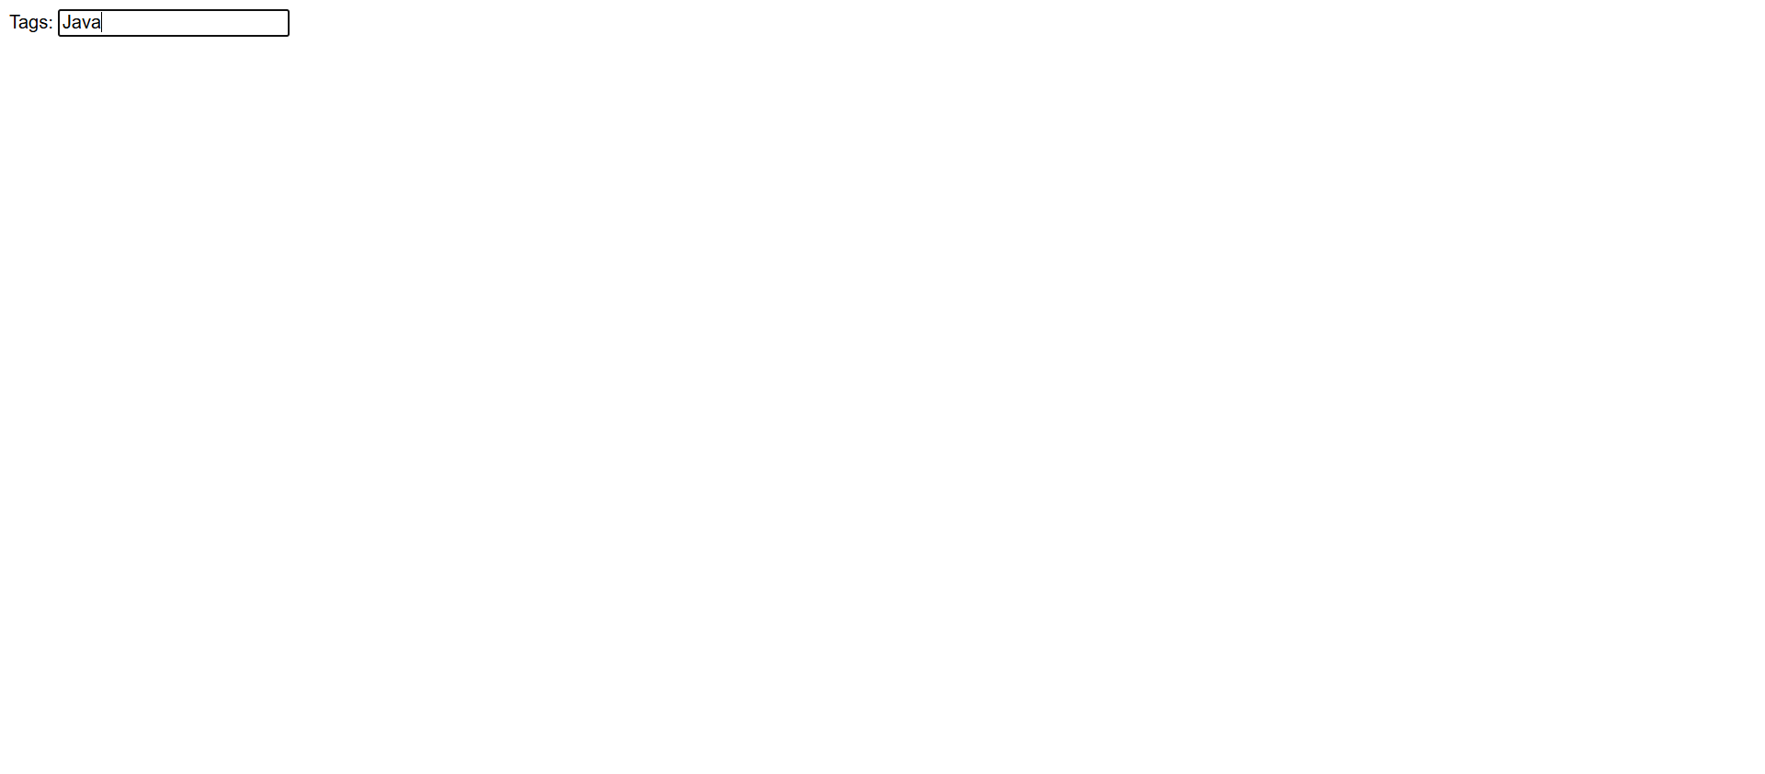  Fig 1.3b — 'Java' suggestion selected from the autocomplete dropdown.
Result / Observation / Conclusion | Both parts completed successfully: all checkboxes reached the selected state, and the autocomplete suggestion matching 'Java' was correctly identified and clicked after the explicit wait for suggestion visibility.

Experiment 4: JavaScript Alerts and Confirms
Problem Statement | Native JavaScript Alert, Confirm, and Prompt dialogs sit outside the normal DOM and cannot be interacted with using standard element locators.
Objective | Trigger, accept, dismiss, and enter text into JavaScript Alert, Confirm, and Prompt boxes using driver.switch_to.alert.
Tools / Software / Concepts | - Selenium Alert API  - driver.switch_to.alert  - WebDriverWait + EC.alert_is_present()
Implementation Steps | - Navigate to the-internet.herokuapp.com/javascript_alerts.  - Click 'Click for JS Alert', wait for the alert, print its text, and accept it.  - Click 'Click for JS Confirm', wait for the alert, print its text, and dismiss it.  - Click 'Click for JS Prompt', send text 'Selenium Automation', and accept it.  - Save a screenshot after all three dialogs are handled.
Source Code | View on GitHub: Modules/module1/code_session/assignment4.py  Modules/module1/code_session/assignment4.py  from selenium import webdriver  from selenium.webdriver.common.by import By  from selenium.webdriver.support.ui import WebDriverWait  from selenium.webdriver.support import expected_conditions as EC  driver = webdriver.Chrome()  driver.maximize_window()  try:  driver.get("https://the-internet.herokuapp.com/javascript_alerts")  # 1. Accept JS Alert  driver.find_element(By.XPATH, "//button[text()='Click for JS Alert']").click()  alert = WebDriverWait(driver, 5).until(EC.alert_is_present())  print("Alert text:", alert.text)  alert.accept()  # 2. Dismiss JS Confirm Box  driver.find_element(By.XPATH, "//button[text()='Click for JS Confirm']").click()  confirm = WebDriverWait(driver, 5).until(EC.alert_is_present())  print("Confirm text:", confirm.text)  confirm.dismiss()  # 3. Input Text into JS Prompt Box & Accept  driver.find_element(By.XPATH, "//button[text()='Click for JS Prompt']").click()  prompt = WebDriverWait(driver, 5).until(EC.alert_is_present())  prompt.send_keys("Selenium Automation")  prompt.accept()  # Save screenshot  driver.save_screenshot("assignment4_screenshot_js_alerts.png")  finally:  driver.quit()
Output (Screenshots) | 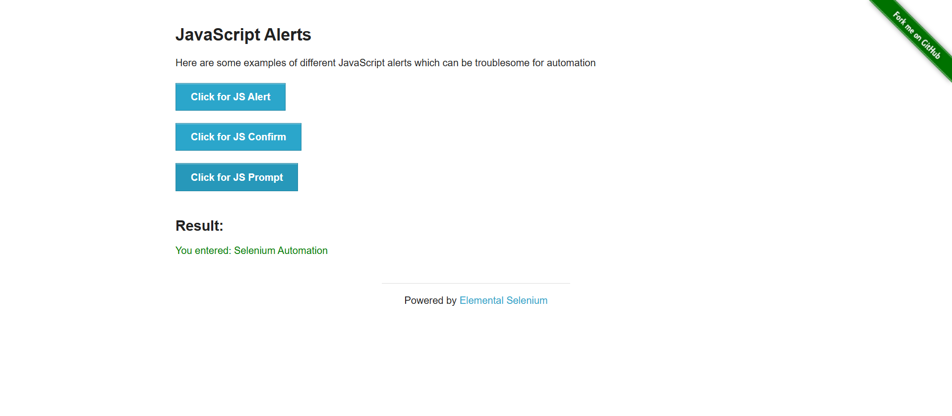  Fig 1.4 — Page state after the Alert, Confirm, and Prompt dialogs were handled.
Result / Observation / Conclusion | All three dialog types were triggered and handled without exception: the Alert was accepted, the Confirm was dismissed, and text was successfully entered into the Prompt before accepting it.

Experiment 5: The HTML Web Table Extractor
Problem Statement | Specific values (such as a status or price) must be retrieved from a dynamic, multi-column HTML table without hardcoding row positions.
Objective | Iterate through the rows and columns of a course-listing web table, match the row named 'Master Selenium Automation in simple Python Language', and extract its price.
Tools / Software / Concepts | - Selenium find_element(s)  - By.XPATH / By.TAG_NAME  - Row/column iteration
Implementation Steps | - Navigate to rahulshettyacademy.com/AutomationPractice and locate the courses table.  - Scroll the table into view.  - Loop through every <tr>, and within each row every <td>.  - Compare the course-name cell against the target course name.  - On a match, print the course name and extracted price, then save a screenshot.
Source Code | View on GitHub: Modules/module1/code_session/assignment5.py  Modules/module1/code_session/assignment5.py  from selenium import webdriver  from selenium.webdriver.common.by import By  import time  driver = webdriver.Chrome()  driver.maximize_window()  try:  driver.get("https://rahulshettyacademy.com/AutomationPractice/")  table = driver.find_element(By.XPATH, "//table[@name='courses']")  driver.execute_script("arguments[0].scrollIntoView(true);", table)  time.sleep(5)  target_course = "Master Selenium Automation in simple Python Language"  rows = table.find_elements(By.TAG_NAME, "tr")  for row in rows:  cols = row.find_elements(By.TAG_NAME, "td")  if cols:  course_name = cols[1].text.strip()  price = cols[2].text.strip()  if course_name == target_course:  print(f"Matched Course: '{course_name}'")  print(f"Extracted Price: {price}")  break  driver.save_screenshot("assignment5_web_tables.png")  finally:  driver.quit()
Output (Screenshots) | 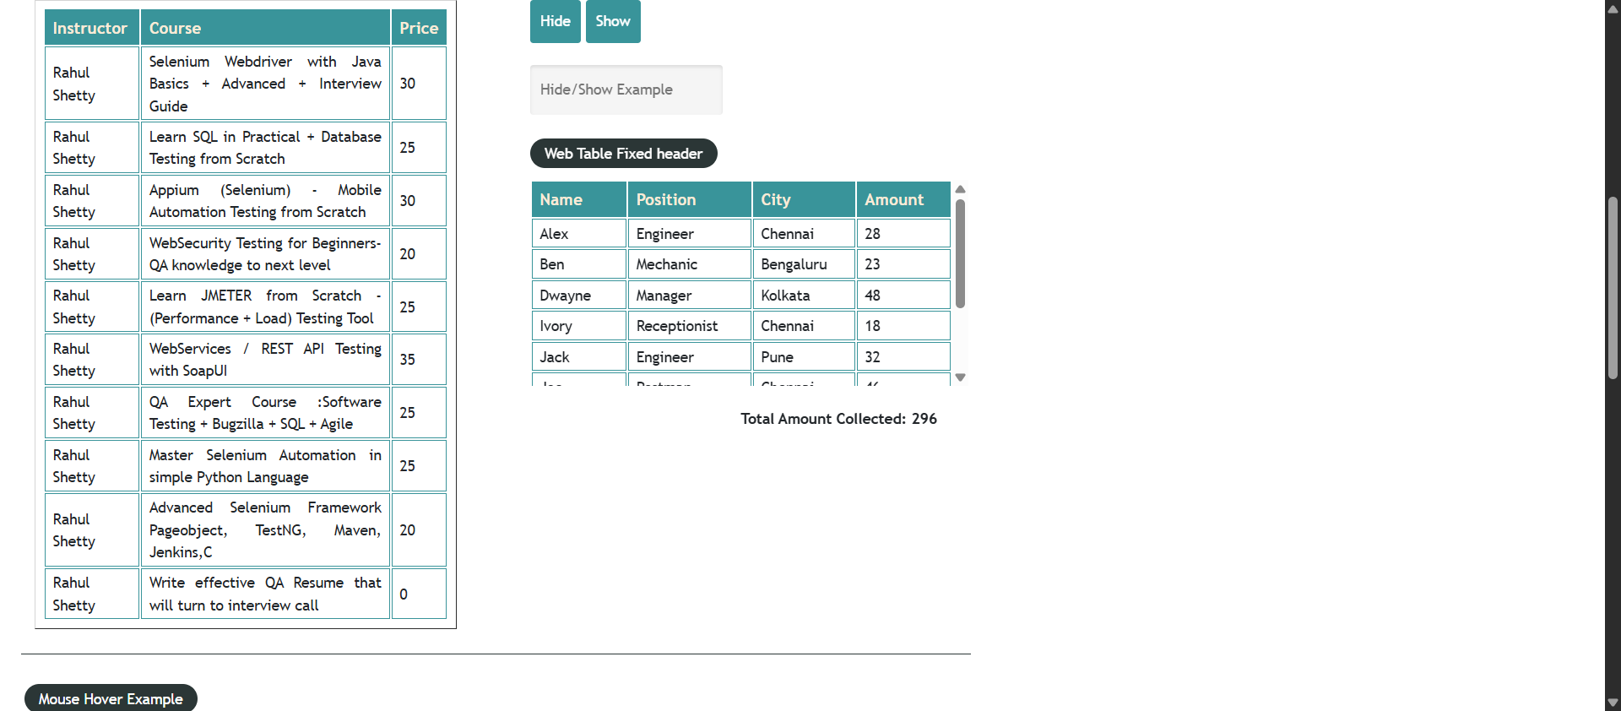  Fig 1.5 — Course table scrolled into view before row-matching.
Result / Observation / Conclusion | The target row was correctly matched by course name, and its price cell was extracted and printed, confirming reliable row/column iteration over a dynamic table.

Experiment 6: Windows, Tabs, and Iframes
Problem Statement | A single script may need to interact with content embedded in an iframe and also with content that opens in a separate browser tab.
Objective | Switch context correctly between an embedded iframe and a newly opened browser tab using window_handles and switch_to.frame(), confirming each context switch with a JS alert.
Tools / Software / Concepts | - driver.window_handles  - driver.switch_to.window()  - driver.switch_to.frame()  - driver.switch_to.default_content()
Implementation Steps | - Open rahulshettyacademy.com/AutomationPractice and record the main window handle.  - Scroll to and switch into the courses iframe using switch_to.frame(), confirming with an injected alert.  - Switch back to the main page with switch_to.default_content().  - Click the 'Open Tab' button, wait for a second window handle to appear, and switch to it.  - Read the new tab's title, save a screenshot, close the tab, and switch back to the original window handle.
Source Code | View on GitHub: Modules/module1/code_session/assignment6.py  Modules/module1/code_session/assignment6.py  from selenium import webdriver  from selenium.webdriver.common.by import By  from selenium.webdriver.support.ui import WebDriverWait  from selenium.webdriver.support import expected_conditions as EC  import time  def show_and_accept_alert(driver, message):  """Triggers an alert safely, pauses so you can read it, then accepts it."""  driver.execute_script("alert(arguments[0]);", message)  time.sleep(1)  driver.switch_to.alert.accept()  time.sleep(1)  driver = webdriver.Chrome()  driver.maximize_window()  try:  driver.get("https://rahulshettyacademy.com/AutomationPractice/")  main_window_handle = driver.current_window_handle  show_and_accept_alert(driver, "TASK 1 START: Main page loaded. Next, scrolling down to the Iframe.")  # HANDLE IFRAME  iframe_element = WebDriverWait(driver, 10).until(  EC.presence_of_element_located((By.ID, "courses-iframe"))  )  driver.execute_script("arguments[0].scrollIntoView(true);", iframe_element)  time.sleep(3)  driver.switch_to.frame(iframe_element)  show_and_accept_alert(driver, "INSIDE IFRAME: Driver focus is now inside the embedded frame!")  driver.switch_to.default_content()  show_and_accept_alert(driver, "BACK TO MAIN PAGE: Exited iframe. Scroll back to top for tab test.")  driver.execute_script("window.scrollTo(0, 0);")  time.sleep(3)  show_and_accept_alert(driver, "TASK 2 START: Clicking the 'Open Tab' button now.")  driver.find_element(By.ID, "opentab").click()  WebDriverWait(driver, 5).until(lambda d: len(d.window_handles) > 1)  all_handles = driver.window_handles  for handle in all_handles:  if handle != main_window_handle:  driver.switch_to.window(handle)  break  time.sleep(3)  new_tab_title = driver.title  show_and_accept_alert(driver, f"NEW TAB DETECTED! Context switched. Title: '{new_tab_title}'")  time.sleep(3)  # Take screenshot  driver.save_screenshot("assignment6_screenshot_windows_iframes.png")  driver.close()  # RETURN TO ORIGINAL TAB  driver.switch_to.window(main_window_handle)  show_and_accept_alert(driver, "EXPERIMENT 6 COMPLETE: Successfully returned to original main layout!")  finally:  driver.quit()
Output (Screenshots) | 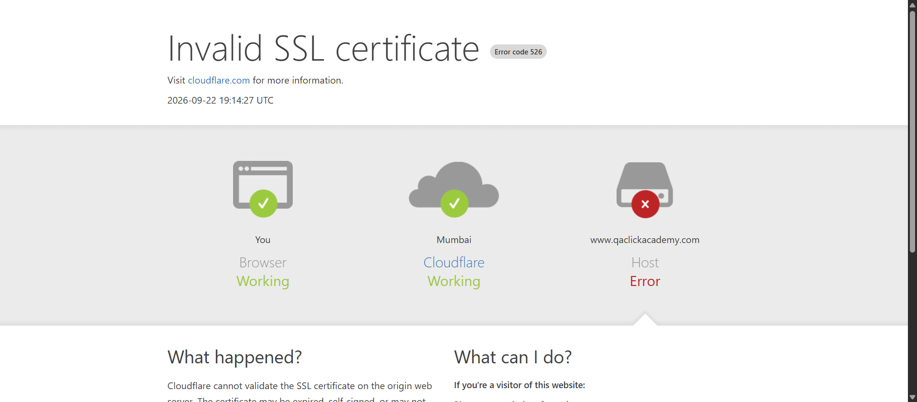  Fig 1.6 — New tab detected and its title read after the context switch.
Result / Observation / Conclusion | Context switching worked in both directions: iframe -> default content, and main window -> new tab -> back to the main window, with the new tab's title correctly retrieved before it was closed.

Module 2: Page Object Model, Data-Driven Testing & PyTest
This module advances automation architecture by implementing the Page Object Model (POM), data-driven testing (DDT) using external files, and scalable test execution using PyTest with HTML reporting.

Video Demonstration: https://drive.google.com/file/d/1wvSgMq75kBy-l2QaSVnMi0MIKBuMpG9j/view?usp=drivesdk
Module folder: https://github.com/Sheefhuss/Selenium_Automation/tree/main/Modules/module2

Experiment 7: Page Object Model (POM) Restructure
Problem Statement | Working scripts that mix locators, actions, and assertions in one file are hard to maintain and reuse.
Objective | Restructure a login script into a Page Object Model: a LoginPage class holding only locators and UI actions, with the test itself performing only the assertion.
Tools / Software / Concepts | - Python  - Selenium WebDriver  - Page Object Model (POM) design pattern
Implementation Steps | - Create login_page.py defining a LoginPage class with username/password/login_button locators.  - Add enter_username(), enter_password(), and click_login() methods to LoginPage.  - Create test_login.py, which imports LoginPage, drives the three actions, and performs the assertion.  - Assert that '/secure' is present in driver.current_url after login.
Source Code | View on GitHub: Modules/module2/assignment7  Modules/module2/assignment7/login_page.py  from selenium.webdriver.common.by import By  class LoginPage:  def __init__(self, driver):  self.driver = driver  username = (By.ID, "username")  password = (By.ID, "password")  login_button = (By.CSS_SELECTOR, "button[type='submit']")  def enter_username(self, username):  self.driver.find_element(*self.username).send_keys(username)  """self.username is:  By.ID, "username" The * unpacks the tuple."""  def enter_password(self, password):  self.driver.find_element(*self.password).send_keys(password)  def click_login(self):  self.driver.find_element(*self.login_button).click()  Modules/module2/assignment7/test_login.py  from selenium import webdriver  from login_page import LoginPage  def test_login():  driver = webdriver.Chrome()  driver.get("https://the-internet.herokuapp.com/login")  login = LoginPage(driver)#login is an object of LoginPage  login.enter_username("tomsmith")  login.enter_password("SuperSecretPassword!")  login.click_login()  assert "/secure" in driver.current_url  driver.quit()  test_login()
Output (Screenshots)
Result / Observation / Conclusion | The locators and UI actions live entirely in LoginPage, and test_login.py contains only the assertion, meeting the POM separation objective. Note: test_login() is called directly as a plain function rather than run through pytest — Experiment 9 introduces pytest-based execution.

Experiment 8: Data-Driven Automation (DDT)
Problem Statement | Testing multiple username/password combinations by hardcoding each case is repetitive and does not scale.
Objective | Read login test cases from an external CSV file using csv.DictReader and loop through them, asserting the expected outcome (success or invalid) for each row.
Tools / Software / Concepts | - csv.DictReader  - Selenium WebDriver  - login_data.csv (4 rows)
Implementation Steps | - Read modules/module2/login_data.csv, with columns username, password, expected.  - For each row, navigate to the login page, enter the given username/password, and submit.  - Save a screenshot named after the row's username and expected result.  - Assert '/secure' in the URL when expected == 'success', otherwise assert '/login' in the URL.
Source Code | View on GitHub: Modules/module2/assignment8.py  Modules/module2/assignment8.py  import csv  from selenium import webdriver  from selenium.webdriver.common.by import By  driver = webdriver.Chrome()  driver.maximize_window()  with open("modules/module2/login_data.csv", "r") as file:  data = csv.DictReader(file)  for row in data:  driver.get("https://the-internet.herokuapp.com/login")  driver.find_element(By.ID, "username").send_keys(row["username"])  driver.find_element(By.ID, "password").send_keys(row["password"])  driver.find_element(By.CSS_SELECTOR, "button[type='submit']").click()  driver.save_screenshot(  "Assignment_8_row_" + row["username"] + "_" + row["expected"] + ".png"  )  if row["expected"] == "success":  assert "/secure" in driver.current_url  print(row["username"], "LOGIN SUCCESS")  else:  assert "/login" in driver.current_url  print(row["username"], "LOGIN FAILED - VALIDATION CORRECT")  driver.quit()
Output (Screenshots) | 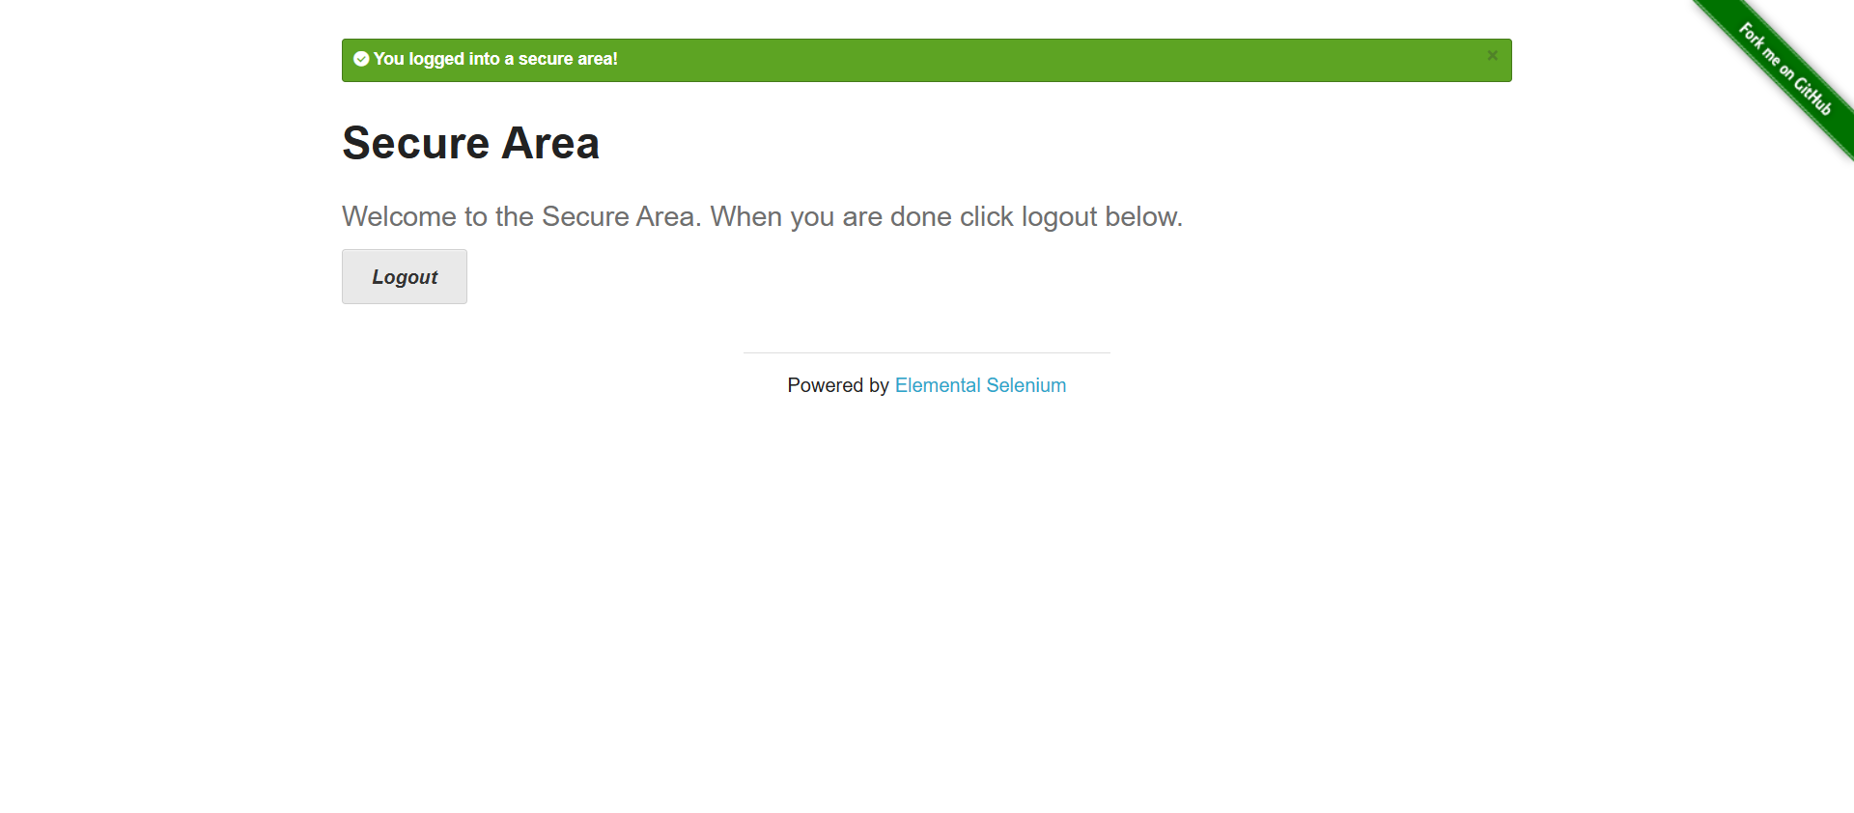  Fig 2.1 — Row 1 (tomsmith / correct password): successful login.  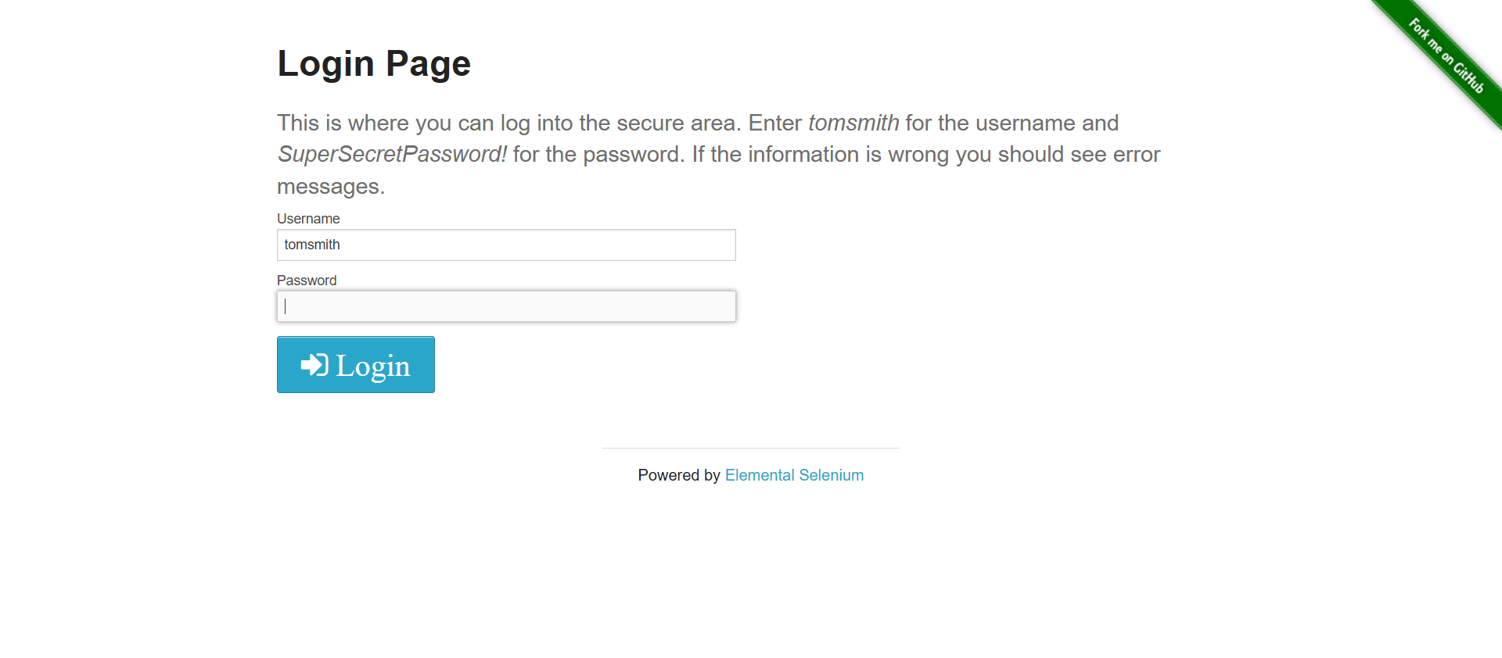  Fig 2.2 — Row 3 (tomsmith / wrong password): validation error shown.  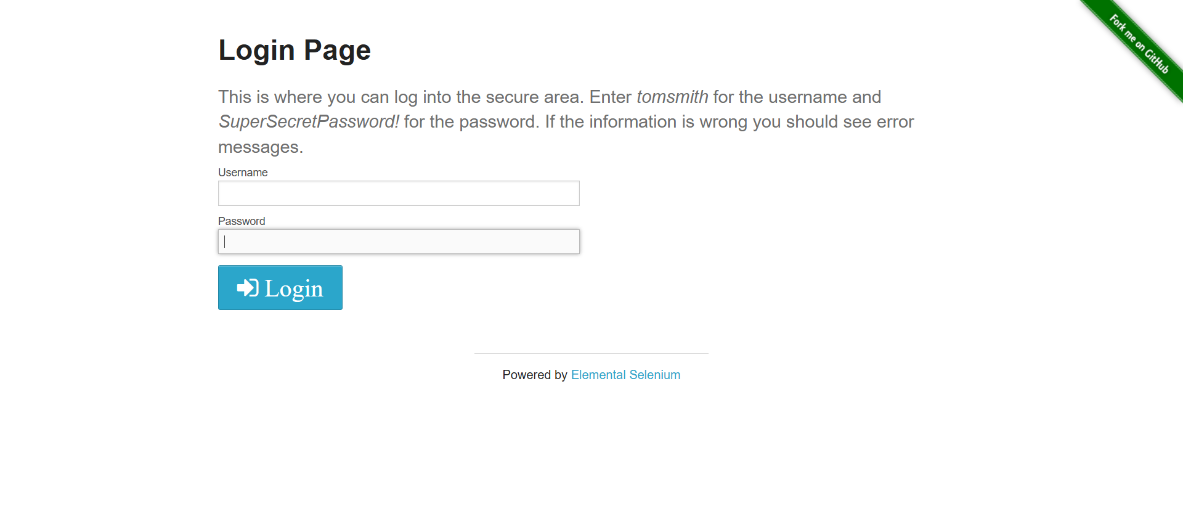  Fig 2.3 — Row 2 or 4 (wronguser): validation error shown.
Result / Observation / Conclusion | All 4 CSV rows executed and asserted the correct outcome. Observation: the screenshot filename is built from username + expected result only, so the two 'wronguser' rows (rows 2 and 4) both save to the same filename and the second run overwrites the first — only 3 distinct screenshot files exist for 4 test rows. This does not affect the assertions, only the retained screenshot evidence.

Experiment 9: PyTest Integration with HTML Reporting
Problem Statement | Running scripts directly and manually inspecting results does not scale, and there is no persistent, shareable record of results across multiple data-driven cases.
Objective | Convert the DDT login test to run via PyTest, using a fixture for browser setup/teardown and @pytest.mark.parametrize to drive it from the same CSV data, then generate an HTML report.
Tools / Software / Concepts | - pytest  - pytest.fixture  - pytest.mark.parametrize  - pytest-html
Implementation Steps | - Define a driver fixture that opens Chrome, navigates to the login URL, yields the driver, then quits it.  - Read the same login_data.csv used in Assignment 8 via read_test_data().  - Parametrize test_login(driver, data) over every CSV row.  - Assert '/secure' for success rows and '/login' for invalid rows.  - Run: pytest test_assignment9.py --html=report.html --self-contained-html
Source Code | View on GitHub: Modules/module2/test_assignment9.py  Modules/module2/test_assignment9.py  import csv  import pytest  from selenium import webdriver  from selenium.webdriver.common.by import By  URL = "https://the-internet.herokuapp.com/login"  @pytest.fixture  def driver():  driver = webdriver.Chrome()  driver.maximize_window()  driver.get(URL)  yield driver  driver.quit()  def read_test_data():  with open("modules/module2/login_data.csv", "r") as file:  return list(csv.DictReader(file))  @pytest.mark.parametrize("data", read_test_data())  def test_login(driver, data):  driver.find_element(  By.ID, "username"  ).send_keys(data["username"])  driver.find_element(  By.ID, "password"  ).send_keys(data["password"])  driver.find_element(  By.CSS_SELECTOR, "button[type='submit']"  ).click()  if data["expected"] == "success":  assert "/secure" in driver.current_url  else:  assert "/login" in driver.current_url
Output (Screenshots) | 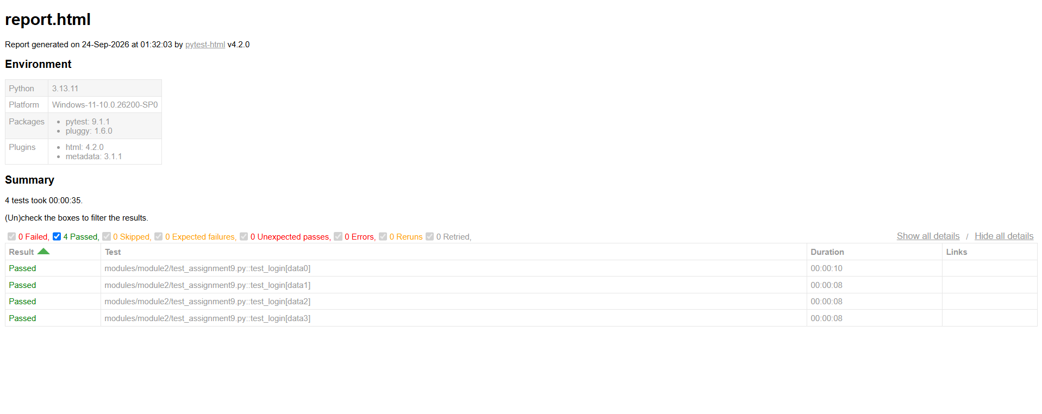  Fig 2.4 — PyTest run / generated HTML report for the parametrized login tests.
Result / Observation / Conclusion | All parametrized cases ran under pytest and produced a single HTML report (report.html) alongside the console output. Observation: the current script does not include a screenshot-on-failure hook (e.g. a pytest_runtest_makereport hook) as described in the module brief — the HTML report itself is generated, but failure screenshots are not yet automatically embedded in it.

Module 3: Behavior-Driven Development (BDD) with Behave
This module focuses on implementing Behavior-Driven Development (BDD) using the Python Behave framework, integrating Gherkin language scenarios, data-driven structures, and combining Behave with the Selenium Page Object Model.

Video Demonstration: https://drive.google.com/file/d/1WiptF2DALU4c3YVSAf-zMXh4zJPH6Fhp/view?usp=drivesdk
Module folder: https://github.com/Sheefhuss/Selenium_Automation/tree/main/Modules/module3

Experiment 1: Implementation of Selenium Python and Behave BDD
Problem Statement | End-to-end scenarios need to be described and executed in a business-readable format rather than as raw Python test functions.
Objective | Set up the Python BDD framework and run an end-to-end login scenario written in Gherkin, with Selenium step definitions.
Tools / Software / Concepts | - Behave (BDD framework for Python)  - Gherkin syntax (Given / When / Then)  - Selenium WebDriver  - PyCharm / VS Code
Implementation Steps | - Write features/login.feature describing a 'Successful login' scenario in Gherkin.  - Implement features/steps/login_steps.py: open the login page, enter username and password, click login.  - In the Then step, assert '/secure' is in the URL and quit the driver.  - Run the feature from the assignment1 folder with the behave command.
Source Code | View on GitHub: Modules/module3/assignment1  assignment1/features/login.feature  Feature: Login functionality  Scenario: Successful login  Given I open the login page  When I enter username "tomsmith"  And I enter password "SuperSecretPassword!"  And I click the login button  Then I should be successfully logged in  assignment1/features/steps/login_steps.py  from behave import given, when, then  from selenium import webdriver  from selenium.webdriver.common.by import By  @given("I open the login page")  def open_login_page(context):  context.driver = webdriver.Chrome()  context.driver.get("https://the-internet.herokuapp.com/login")  @when('I enter username "tomsmith"')  def enter_username(context):  context.driver.find_element(By.ID, "username").send_keys("tomsmith")  @when('I enter password "SuperSecretPassword!"')  def enter_password(context):  context.driver.find_element(By.ID, "password").send_keys("SuperSecretPassword!")  @when("I click the login button")  def click_login(context):  context.driver.find_element(By.CSS_SELECTOR, "button[type='submit']").click()  @then("I should be successfully logged in")  def verify_login(context):  assert "/secure" in context.driver.current_url  context.driver.quit()
Output (Screenshots) | 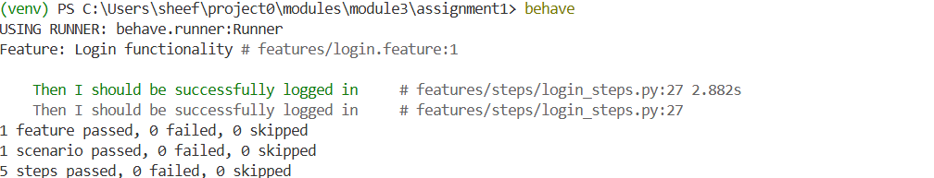  Fig 3.1 — behave run: 1 feature, 1 scenario, 5 steps passed.
Result / Observation / Conclusion | The Gherkin scenario ran end to end: 1 feature, 1 scenario and all 5 steps passed with 0 failures, confirming the Behave + Selenium setup works.

Experiment 2: Test Data-Driven Automation in Python Behave Framework
Problem Statement | A single Gherkin scenario needs to be executed against multiple sets of input data without duplicating the scenario text.
Objective | Adapt the BDD framework to handle multiple test cases using a Scenario Outline with an Examples table.
Tools / Software / Concepts | - Behave  - Gherkin Scenario Outline / Examples table  - Parameterised step definitions  - Python
Implementation Steps | - Convert the scenario into a Scenario Outline with <username>, <password> and expected-result placeholders.  - Add an Examples table with 4 rows of valid and invalid credentials.  - Use parameterised steps ({username}, {password}, {result}) in login_steps.py.  - In the Then step, assert '/secure' for success and '/login' for failure, then run behave.
Source Code | View on GitHub: Modules/module3/assignment2  assignment2/features/login.feature  Feature: Login functionality  Scenario Outline: Login with different test data  Given I open the login page  When I enter username "<username>"  And I enter password "<password>"  And I click the login button  Then I should get "<result>"  Examples:  | username | password | result |  | tomsmith | SuperSecretPassword | success |  | wronguser | SuperSecretPassword! | failure |  | tomsmith | wrongpassword | failure |  | wronguser | wrongpassword | failure |  assignment2/features/steps/login_steps.py  from behave import given, when, then  from selenium import webdriver  from selenium.webdriver.common.by import By  @given("I open the login page")  def open_login_page(context):  context.driver = webdriver.Chrome()  context.driver.get("https://the-internet.herokuapp.com/login")  @when('I enter username "{username}"')  def enter_username(context, username):  context.driver.find_element(By.ID, "username").send_keys(username)  @when('I enter password "{password}"')  def enter_password(context, password):  context.driver.find_element(By.ID, "password").send_keys(password)  @when("I click the login button")  def click_login(context):  context.driver.find_element(By.CSS_SELECTOR, "button[type='submit']").click()  @then('I should get "{result}"')  def verify_login(context, result):  if result == "success":  assert "/secure" in context.driver.current_url  else:  assert "/login" in context.driver.current_url  context.driver.quit()
Output (Screenshots) | 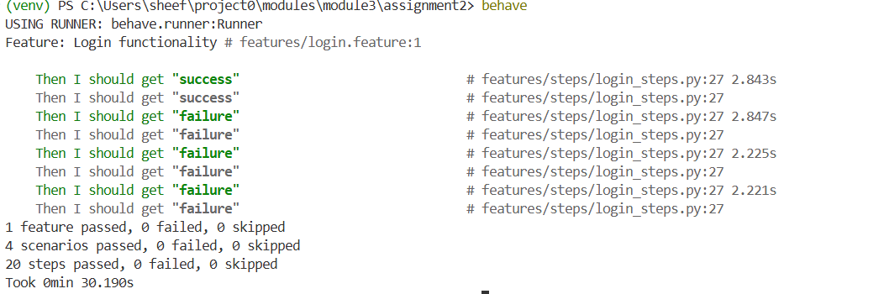  Fig 3.2 — behave run: 4 scenarios (one per Examples row), 20 steps passed.
Result / Observation / Conclusion | Each Examples row ran as its own scenario: 4 scenarios and 20 steps passed, 0 failed (about 30 s). Observation: in the pushed feature file the first row's password is 'SuperSecretPassword' without the trailing '!' while the expected result is 'success' — the passing run above implies the correct password was used, so please re-check that row of the committed file.

Experiment 3: Selenium Page Object Model in the Python Behave Framework
Problem Statement | Step definitions written directly against locators are hard to maintain and do not reuse the POM structure built in Module 2; environment settings are also hard-coded.
Objective | Combine Behave with the Page Object Model, and drive the base URL and browser from a config.ini file, with browser setup/teardown handled by Behave hooks.
Tools / Software / Concepts | - Behave  - Gherkin  - Page Object Model (LoginPage)  - configparser + config.ini  - environment.py hooks
Implementation Steps | - Create pages/login_page.py holding the locators and enter_username / enter_password / click_login methods.  - Store environment, base_url and browser in config.ini.  - In environment.py, read config.ini in before_all, start Chrome in before_scenario and quit it in after_scenario.  - Write steps that call LoginPage methods only, and verify the login with WebDriverWait + EC.url_contains('/secure').  - Run behave from the assignment3 folder.
Source Code | View on GitHub: Modules/module3/assignment3  assignment3/features/login.feature  Feature: Login functionality  Scenario: Successful login  Given I open the login page  When I enter username "tomsmith"  And I enter password "SuperSecretPassword!"  And I click the login button  Then I should be successfully logged in  assignment3/features/pages/login_page.py  from selenium.webdriver.common.by import By  class LoginPage:  def __init__(self, driver):  self.driver = driver  #Locators  self.username_field = (By.ID, "username")  self.password_field = (By.ID, "password")  self.login_button = (By.CSS_SELECTOR, "button[type='submit']")  def enter_username(self, username):  self.driver.find_element(*self.username_field).send_keys(username)  def enter_password(self, password):  self.driver.find_element(*self.password_field).send_keys(password)  def click_login(self):  self.driver.find_element(*self.login_button).click()  assignment3/features/steps/login_steps.py  from behave import given, when, then  from selenium.webdriver.support.ui import WebDriverWait  from selenium.webdriver.support import expected_conditions as EC  from pages.login_page import LoginPage  @given("I open the login page")  def open_login_page(context):  # Uses the dynamic URL loaded from config.ini via environment.py  context.driver.get(context.base_url)  context.login = LoginPage(context.driver)  @when('I enter username "{username}"')  def enter_username(context, username):  context.login.enter_username(username)  @when('I enter password "{password}"')  def enter_password(context, password):  context.login.enter_password(password)  @when("I click the login button")  def click_login(context):  context.login.click_login()  @then("I should be successfully logged in")  def verify_login(context):  WebDriverWait(context.driver, 10).until(  EC.url_contains("/secure")  )  assert "/secure" in context.driver.current_url  assignment3/features/environment.py  import configparser  from selenium import webdriver  def before_all(context):  config = configparser.ConfigParser()  config.read('config.ini')  env = config.get('DEFAULT', 'environment')  context.base_url = config.get(env, 'base_url')  context.browser_type = config.get(env, 'browser')  def before_scenario(context, scenario):  if context.browser_type == 'chrome':  context.driver = webdriver.Chrome()  context.driver.maximize_window()  def after_scenario(context, scenario):  if hasattr(context, 'driver'):  context.driver.quit()  assignment3/config.ini  [DEFAULT]  environment = staging  timeout = 10  [staging]  base_url = https://the-internet.herokuapp.com/login  browser = chrome
Output (Screenshots) | 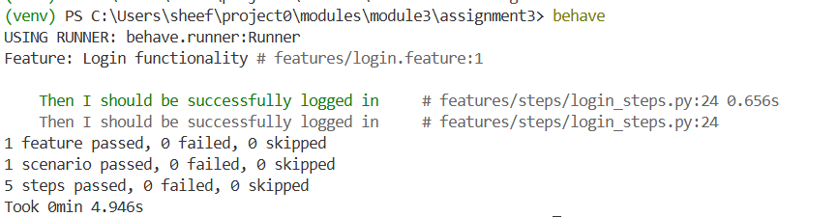  Fig 3.3 — behave run using Page Objects and config.ini: 1 scenario, 5 steps passed (about 5 s).
Result / Observation / Conclusion | The scenario passed (5 steps, 0 failed). Locators live only in LoginPage, the URL and browser come from config.ini, and driver setup/teardown is centralised in environment.py, so step definitions stay short and reusable.

Overall Summary
All three modules are implemented, pushed to the GitHub repository and documented above with real source code and screenshots from actual runs. Module 1 covers locators, explicit waits, alerts, tables and frames;
Module 2 restructures the work into Page Objects, drives it from CSV data and runs it under PyTest with an HTML report;
Module 3 expresses the same login flow as Gherkin scenarios in Behave, then adds data-driven examples and Page Objects. Two follow-ups are noted in the experiment rows: Experiment 9 has no screenshot-on-failure hook, and the Module 3 Assignment 2 data row should be re-checked.
Full repository: https://github.com/Sheefhuss/Selenium_Automation

