* **Create_Terrains_to_Verify_D.py**: Starts with initial DEM, takes values of K and D, and runs to near steady state. Dt = 1E6, tmax = 1E9. I discovered that K = 5E-7 works best (see below). Preliminary experiments showed that best-fit D* values were somewhere between 100-400. Therefore, I created terrains with D* values between 100-400 at increments of 25 (n = 13).
* **Created_Terrains folder**: Contains the final DEMs created using the Create_Terrains_to_Verify_D.py script. The final DEMs were exported as asv files. I then imported them into QGIS, translated them into tif files, and saved them in this folder with a name equivalent to their D* value. The “TerrainSandbox” output folders for each run were subsequently deleted; only the exported DEMs (translated as tifs) were preserved. Asv files were also deleted.
* **D_Calib.m**: Loops through all DEMs in the Created_Terrains folder and compares their slope-area relationships relative to the real DEM. The value of K used in the Create_Terrains_to_Verify_D.py script translates the slope area relationship along the Y-axis. Preliminary experiments showed that a K value of 5E-7 best fits the Y-positions of the real DEM. Therefore, all terrains in the Created_Terains folder were created using K = 5E-7.
* **Output**: Output folder for the D_Calib.m script.

I compared the slope-area relationship of the real Chestatee DEM with the slope-area relationships of terrains with D* values ranging from 100-400 (increments of 25, n = 13). Terrains were considered valid matches when the slope-area relationship rollover occurred between a drainage area of 1 and 2 pixels (i.e. maximum slope occurs at 2 pixels, second highest slope occurs at 1 pixel, third highest slope occurs at 3 pixels). Valid matches occurred at D* values between 200-325 (n = 6). Therefore, the following values will be used:

**D* Values**

* **D*_mean = 262.5**
* **D*_min = 200**
* **D*_max = 325**

Some thoughts:

* Since the rollover occurs at a drainage area between 1-2 pixels, this means that hillslope processes are only important at a spatial scale close to or only slightly larger than the DEM resolution. In other words, at the resolution of this DEM, fluvial processes are by far the dominant process, and hillslope processes probably play a negligible role in shaping the landscape at this scale. This is handy, because after setting a value of D*, we can probably ignore the effects of variable D* values on the model outcomes.

DEM_Comparison_200.tif

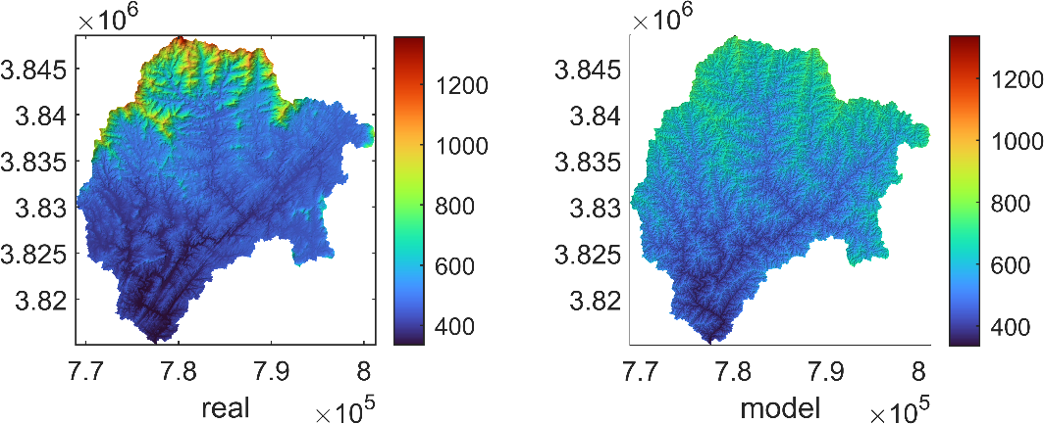

SA_Comparison_clean_200.tif

