* **K0_Validate.py**: Starts with initial DEM, takes values of K and D*, and runs to near steady state. Dt = 1E6, tmax = 1E9. D* value of 262.5 (mean value calculated in the “D” folder) used for all runs. Purpose is to export 3 terrains: one for each of the three K values calculated in the “K0_Empirical” folder (Mean value, Min value, Max value).
* **Created_Terrains folder**: Contains the final DEMs created using the K0_Validate.py script. The final DEMs were exported as asv files. I then imported them into QGIS, translated them into tif files, and saved them in this folder with a name equivalent to their K value. The “TerrainSandbox” output folders for each run were subsequently deleted; only the exported DEMs (translated as tifs) were preserved. Asv files were also deleted.
* **K0_Validation.m**: Loops through the three terrains in the “Created_Terrains” folder, calculates statistics concerning the distribution of topographic elevations in each terrain, and compares with the real DEM.
* **Output**: Output folder for the K0_Validation.m script.

Some thoughts:

* This exercise demonstrates that the K0 values constrained in the last step reasonably produce the elevational distributions of the Chestatee Watershed, assuming the watershed is in steady-state. Of course, there is the issue with the higher terrain in the north, but we have good explanations for this. An important point to note though is that this landscape likely requires millions of years to evolve, and the 10Be rate is only representative of the last few 104ish years or so. This implies that the mean catchment erosion rate of the last few 104ish years is comparable to the mean rate over the last several million years as well. Is this reasonable for this part of North America? I’m not sure. Possibly. For now, we will roll with it.

DEM_comparison_6.4475882661810545e-07.tif (Min)

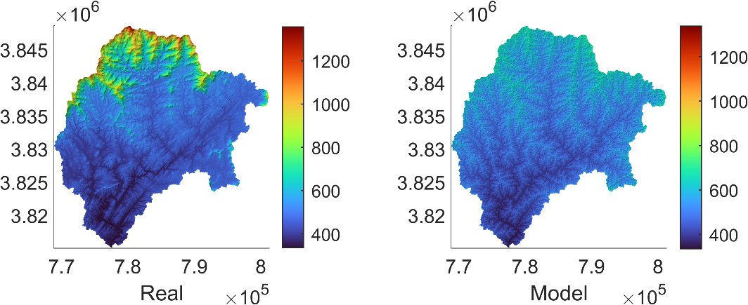

DEM_comparison_8.2912443616803223e-07.tif (Mean)

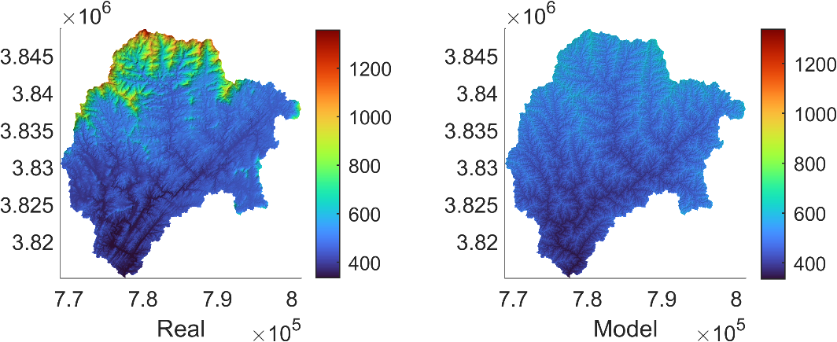

DEM_comparison_1.013490045717959e-06.tif (Max)

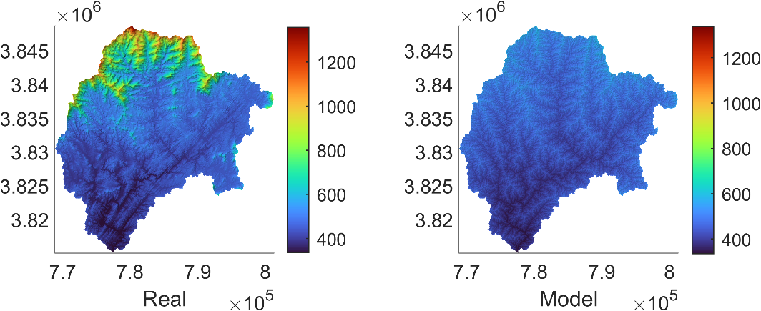

pdf_combined.tif

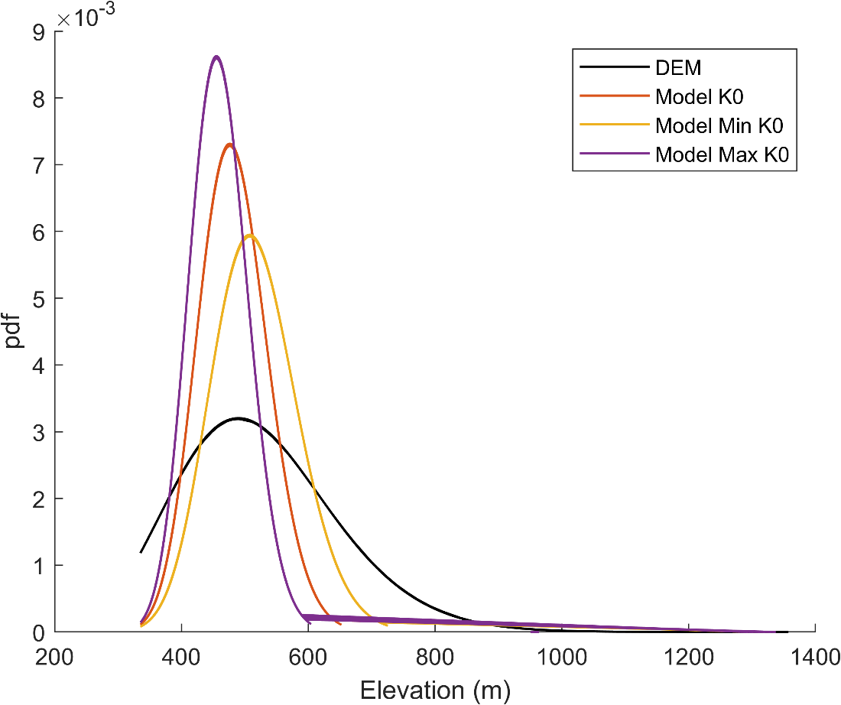

Boxplot.tif

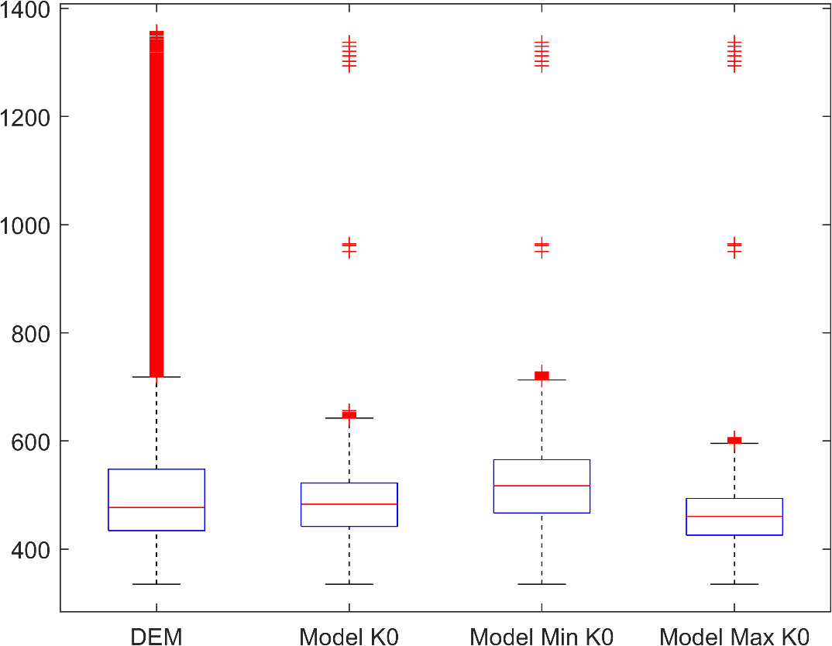

Boxchart.tif

