* **02333500_Large.csv**: USGS daily water discharge data from gauge 2333500. Column “36255_00060_00003” is daily average discharge in cfs.
* **02333500_USE.csv**: USGS water quality data from gauge 2333500.
* **Klc_Validate.py**: The purpose of this script is to estimate a “modern” (i.e. 20th / early 21st century) mean sediment flux (Qs, m3 yr-1) and mean catchment erosion rate (E1rc, m yr-1) using a rating curve. E1rc will serve as an independent estimate of the mean catchment erosion rate that can be compared / contrasted with the value (E1) suggested by the K1lc array. The script:
  + 1. Constructs a sediment rating curve ( log(SSC) = m log(Qw) + b ) using data from 02333500_USE.csv. Separate rating curves are constructed for each discreate decade of data, but the rating curve that is ultimately used for this analysis is created using data from all decades.
  + 2. Uses the rating curve to estimate a daily sediment flux for each day in the 02333500_Large.csv record [ Dates : {19300101 - 19320131}, {19400401 - 20211231} ].
  + 3. Calculates a total sediment flux for each year [ {1930 - 1932}, {1940 - 2021} ] in the 02333500_Large.csv record. This produces the Qs_annual array.
  + 4. Calculates an array of annual mean catchment erosion rates (mcer array) by dividing the Qs_annual array by catchment area.
  + 5. Calculates the mean of the Qs_annual array (Qs_annual_mean) and the mcer array (E1rc_mean).
  + 6. Calculates a minimum and maximum constraint on Qs and E1rc (Qs_annual_min, Qs_annual_max, E1rc_min, E1rc_max) using the interquartile range of the Qs_annual and mcer arrays.
* **Output**: Folder created by the Klc_Validate.py script that also stores relevant exported figures.

**Qs, Rating curve implied sediment export values (m3 yr-1)**

* **Qs_annual_mean = 13199.80563**
* **Qs_annual_min = 3899.409751**
* **Qs_annual_max = 14802.56747**

**E1rc, Rating curve implied mean catchment erosion rate values (m yr-1)**

* **E1rc_mean = 3.33102841064183E-05**
* **E1rc_min = 9.84033024739712E-06**
* **E1rc_max = 3.73549233781876E-05**

Rating_Curve.png

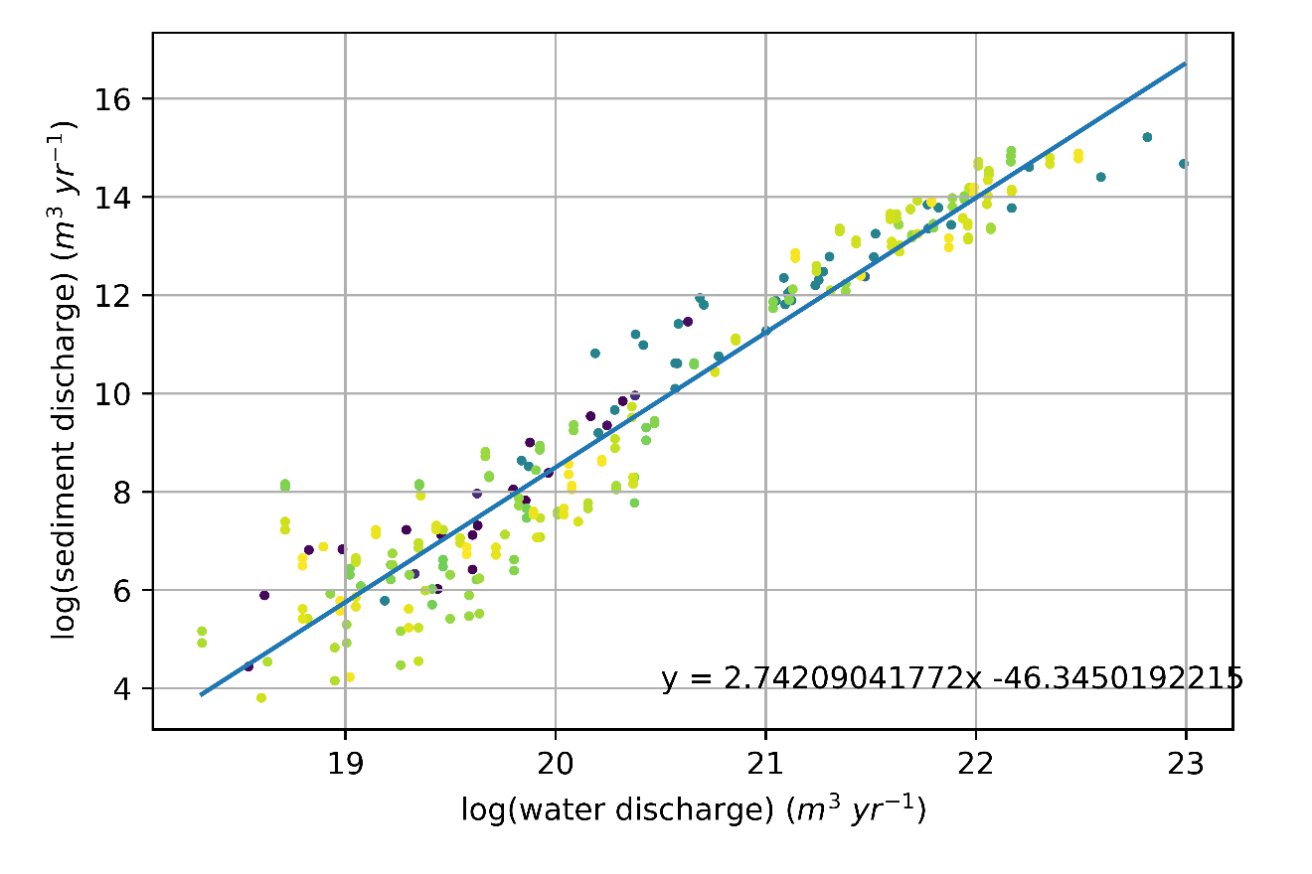

Estimated_Annual_Exported_Sediment.png

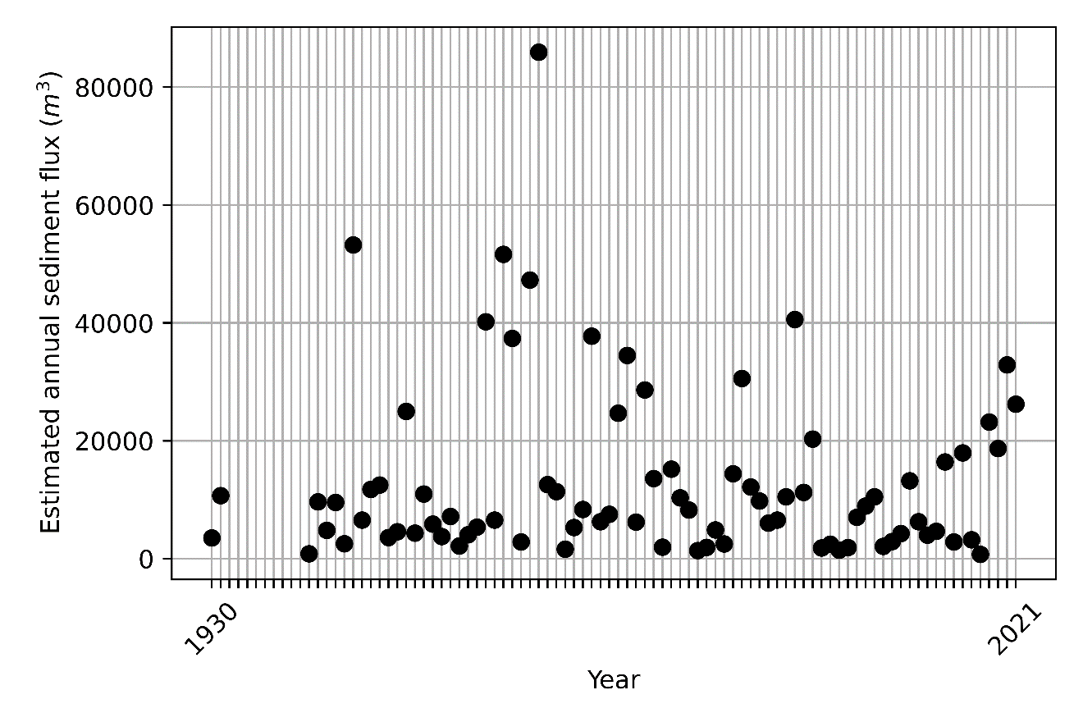

Combined.png

