**TRAFFIC MANAGEMENT**

* **Introduction:**

The Internet of Things (IoT) has revolutionized the way we collect and analyze data in various domains, and one area where it holds immense potential is in traffic monitoring and management. An IoT traffic monitoring system leverages a network of sensors, cameras, and data processing tools to collect real-time traffic data, monitor traffic conditions, and enable authorities to make informed decisions for congestion management, safety improvement, and urban planning. This system integrates hardware and software components to create a comprehensive solution that addresses the complexities of modern urban traffic. In this module, we provide an abstract that outlines the key objectives, components, and benefits of an IoT traffic monitoring system.

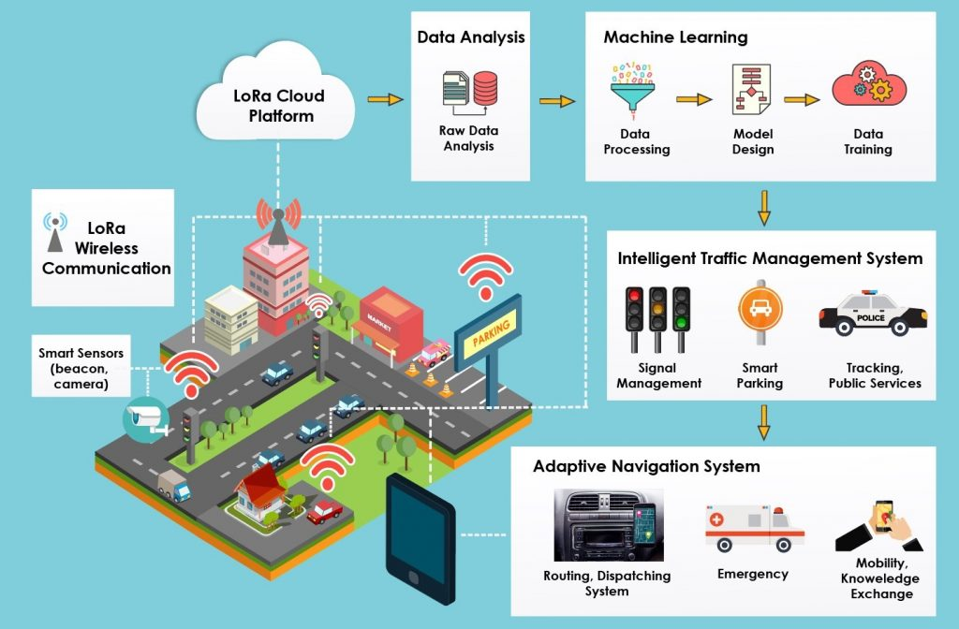

**Traffic Management**

* **Abstract:**

The Internet of Things (IoT) traffic monitoring system is a sophisticated and data-driven solution designed to address the challenges of modern urban traffic management. In an era of growing urbanization and increased vehicular density, the need for efficient traffic monitoring has never been more critical. This system combines cutting-edge technologies, including sensors, cameras, communication devices, and data processing tools, to capture, analyze, and visualize traffic-related data.

Building an IoT traffic monitoring system involves a combination of hardware and software components. This system can help in collecting and analyzing data related to traffic conditions.

**Key objectives of the IoT traffic monitoring system include:**

* **Real-time Data Collection:**
* The system collects data on traffic flow, vehicle counts, speed, and other relevant parameters in real-time. This data serves as the foundation for informed decision-making.
* **Define the Project Scope:**
* Determine the specific goals and objectives of your traffic monitoring system. Consider factors such as the type of data you want to collect, the area you want to monitor, and the devices you plan to use.
* **Hardware Selection:**
* Choose the hardware components for your system, including sensors, cameras, and communication devices. Here are some key components to consider:
* **Traffic Sensors:**
* These can include ultrasonic, infrared, or radar sensors to detect vehicle presence and count.
* **Cameras:**

* IP cameras can capture images and video footage of traffic.
* **Communication Devices:**
* You'll need cellular modems or Wi-Fi modules to transmit data to your central system.
* **Microcontrollers or Single-Board Computers:**
* Use devices like Arduino, Raspberry Pi, or specialized microcontrollers for data processing and communication.
* **Data Collection:**
  + Install sensors and cameras at strategic locations to capture data on traffic flow, vehicle counts, and other relevant information.
  + Ensure that the hardware is powered and connected to a network for data transmission.
* **Data Transmission:**
* Choose a suitable communication protocol (e.g., MQTT, HTTP, CoAP) to send data from the sensors to a central server or cloud-based platform.
  + Implement security measures to protect the data during transmission.
* **Data Storage:**
  + Set up a database or cloud storage to store the collected data. Consider using databases like MySQL, PostgreSQL, or cloud-based solutions like AWS S3 or Azure Blob Storage.
* **Data Processing and Analysis:**
  + Develop software or use IoT platforms to process and analyze the incoming data. You can use tools like Python, Node.js, or dedicated IoT platforms like AWS IoT, Azure IoT, or Google Cloud IoT.
* **Visualization:**
  + Create a user-friendly dashboard or interface to display real-time traffic data and historical trends. Tools like Grafana, Tableau, or custom web applications can be used for this purpose.
* **Alerts and Notifications:**
  + Implement alerting systems to notify relevant authorities or users in the event of traffic anomalies or incidents.
* **Data Insights:**
  + Use machine learning or statistical analysis to derive insights from the collected data, such as traffic patterns, congestion prediction, and vehicle classification.
* **Maintenance and Scalability:**
  + Regularly maintain the system to ensure hardware and software components are functioning correctly.
  + Plan for scalability to add more sensors or expand the system as needed.
* **Compliance and Privacy:**
  + Ensure that your system complies with local regulations, especially regarding data privacy and public surveillance.
* **Testing and Deployment:**
  + Thoroughly test the system in a controlled environment before deploying it in the field. Make necessary adjustments to optimize performance.
* **Data Sharing and Integration:**
  + Consider sharing the collected data with relevant authorities or integrating your system with existing traffic management systems.
* **Documentation and Training:**
  + Document the system's architecture, components, and maintenance procedures. Train the personnel responsible for system operation and maintenance.
* **Continuous Improvement:**
  + Continuously monitor the system's performance and gather feedback from users to make improvements and add new features.
* **Location Assessment:**
  + Identify strategic locations where the IoT devices will be deployed. These locations should be chosen based on traffic patterns, congestion points, accident-prone areas, and the overall goals of your monitoring system.
* **Network Connectivity:**
  + Establish a reliable network connection for the IoT devices. This may involve using wired connections (Ethernet), Wi-Fi, or cellular connectivity, depending on the location's infrastructure.
* **Installation:**
  + Carefully install the traffic flow sensors and cameras at the chosen locations. Follow the manufacturer's installation guidelines and ensure that they are securely mounted.
* **Power Backup (if necessary):**
  + Provide backup power solutions, such as uninterruptible power supplies (UPS) or secondary power sources like batteries, to ensure continuous operation during power outages.
* **Remote Monitoring:**
  + Implement remote monitoring capabilities to allow for real-time status checks and troubleshooting, reducing the need for physical inspections.
  + To develop a Python script on IoT devices for sending real-time traffic data to a traffic information platform, you'll need to choose an appropriate communication protocol (e.g., MQTT, HTTP) and ensure that your device has network connectivity. Below is a basic Python script using the MQTT protocol as an example. Make sure you have the necessary libraries installed, such as paho-mqtt for MQTT communication.
* **Flow Chart:**

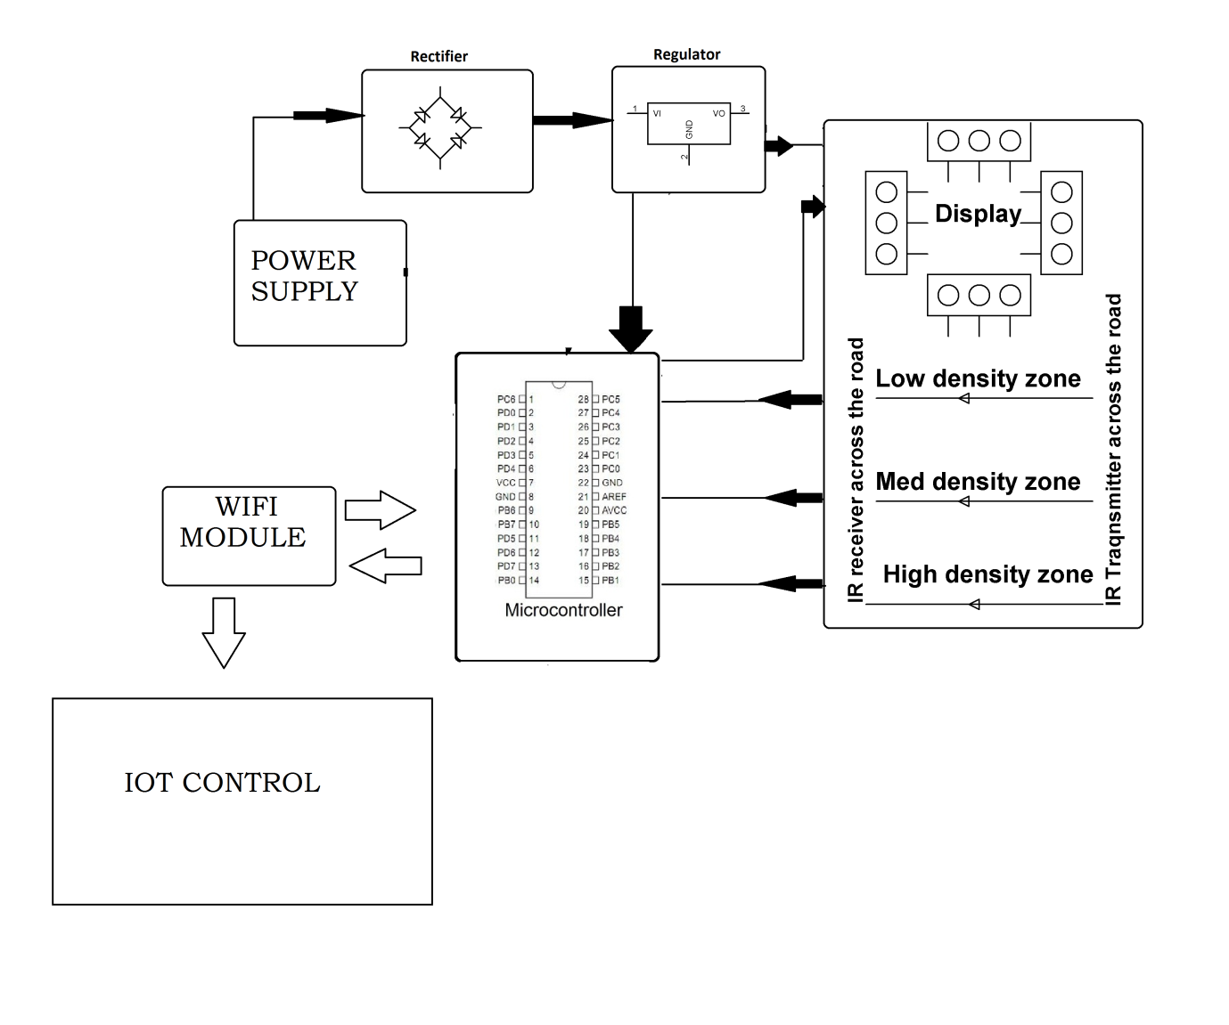

**Program:**

import paho.mqtt.client as mqtt

import json

import random

import time

# Define your IoT device's unique ID and topic

device_id = "your_device_id"

mqtt_topic = "traffic_data"

# Define the MQTT broker address and port

mqtt_broker = "mqtt.example.com" # Replace with your MQTT broker's address

mqtt_port = 1883

# Function to simulate traffic data (replace this with actual data acquisition)

def generate_traffic_data():

traffic_data = {

"timestamp": int(time.time()),

"vehicle_count": random.randint(0, 100),

"average_speed": random.uniform(0, 100),

# Add more data fields as needed

}

return json.dumps(traffic_data)

# Callback when the device connects to the MQTT broker

def on_connect(client, userdata, flags, rc):

print(f"Connected with result code {rc}")

client.subscribe(mqtt_topic)

# Main function to publish traffic data to the MQTT topic

def publish_traffic_data():

client = mqtt.Client(client_id=device_id)

client.on_connect = on_connect

client.connect(mqtt_broker, mqtt_port, 60)

while True:

traffic_data = generate_traffic_data()

client.publish(mqtt_topic, traffic_data)

print(f"Published: {traffic_data}")

time.sleep(5) # Adjust the interval as needed

if __name__ == "__main__":

publish_traffic_data()

* **In this script:**
* Replace "your_device_id", "mqtt.example.com", and other placeholders with your specific device ID and MQTT broker details.
* The generate_traffic_data function generates simulated traffic data. You should replace this function with code to gather real-time traffic data from your sensors or cameras

.

* The script uses the MQTT protocol to connect to the broker and publish traffic data to the specified topic at a specified interval (5 seconds in this example).
* Make sure to install the paho-mqtt library (you can use pip) and any other necessary libraries for data acquisition. Additionally, consider adding error handling and data validation in your production script for reliability and security.
* **Conclusion:**
* In conclusion, the development of an IoT traffic monitoring system offers a promising solution to the challenges of modern urban traffic management. By combining cutting-edge sensor technology with robust data processing and visualization tools, this system empowers traffic authorities and commuters alike. Real-time data insights enable efficient decision-making, reducing congestion and improving road safety. As we move forward, it is crucial to continue enhancing the system's capabilities, expanding its reach, and ensuring compliance with data privacy regulations. The IoT traffic monitoring system is a significant step towards achieving smarter and safer urban transportation systems, with the potential to transform the way we navigate our cities.