AGRICULTURE FARM
MANAGEMENT SYSTEM
Project Documentation
Java • Spring Boot • Spring Data JPA • MySQL

S. Sheela Reddy

1. Project Overview
Agriculture Farm Management System is a backend REST API application developed using Java and Spring Boot. It organizes farm operations through seven modules: Farmer, Farm, Field, Crop, Activity, Expense and Harvest. MySQL stores application data, while Spring Data JPA and Hibernate provide persistence and object-relational mapping.
The application uses separate controllers, DTOs, entities, mappers, repositories, service interfaces and service implementations. It includes request validation, centralized exception handling, auditing, optimistic locking, pagination, sorting, filtering, reporting, scheduled tasks, HTTP Basic security, Swagger/OpenAPI and Actuator monitoring.

2. Objectives
- Manage farmer and farm information.
- Maintain fields, soil types, irrigation methods and crop records.
- Record agricultural activities and related expenses.
- Track harvest dates, quantities, status, buyers and revenue.
- Provide REST APIs for CRUD operations, searching and filtering.
- Support pagination, sorting and summary reports.
- Improve data consistency using validation, auditing, transactions and optimistic locking.
- Generate periodic reports using scheduled tasks.
- Document and test APIs through Swagger UI.

3. Technologies
Technology | Purpose
Java 25 | Application development
Spring Boot 4.1.1 | Backend application and configuration
Spring Web | REST API endpoints
Spring Data JPA / Hibernate | Persistence and ORM
MySQL | Relational database
Maven | Build and dependency management
Jakarta Bean Validation | Request validation
MapStruct 1.6.3 | DTO and entity mapping
Lombok | Reduces boilerplate code where used
Spring Security | HTTP Basic authentication
Springdoc OpenAPI / Swagger UI | API documentation and testing
Spring Boot Actuator | Health and metrics
Spring Scheduling | Scheduled module reports
Spring Cache | Caching support configured in the project

4. System Architecture
The application follows a layered architecture that separates API handling, business logic and database access.
Client (Swagger UI / Postman)
↓
Controller Layer
↓
Service Interface and Service Implementation
↓
Repository Layer (Spring Data JPA)
↓
MySQL Database

5. Project Structure
Package / Layer | Responsibility
controller | Receives HTTP requests and returns responses
dto | Request and response data objects
entity | JPA entities mapped to database tables
mapper | Converts DTOs and entities using MapStruct
repository | Database operations
service | Service interfaces
serviceimpl | Business logic implementations
config | Security, auditing, scheduling and OpenAPI configuration
exception | Custom exceptions and global exception handling
scheduler | Scheduled trigger classes

6. Main Modules
Module | Main responsibility
Farmer Management | Farmer contact details, email uniqueness and phone validation
Farm Management | Farm records, farmer relationship, status and farm report
Field Management | Field records, soil type, irrigation type and farm relationship
Crop Management | Crop records, season, status and field relationship
Activity Management | Agricultural activities linked to crops
Expense Management | Expense records, expense types, totals and reports
Harvest Management | Harvest date, quantity, status, buyer and revenue

7. Entity Relationships
The main relationship flow is shown below. Harvest records form a separate branch from Crop.
Farmer
↓
Farm
↓
Field
↓
Crop
↓
Activity
↓
Expense
Crop
↓
Harvest

8. Enumerations
Enum | Values
FarmStatus | ACTIVE, INACTIVE
SoilType | BLACK, RED, ALLUVIAL, LOAMY, SANDY
IrrigationType | DRIP, SPRINKLER, FLOOD, CANAL, RAINFED
CropSeason | KHARIF, RABI, ZAID
CropStatus | PLANNED, GROWING, READY_FOR_HARVEST, HARVESTED
ActivityType | PLOWING, SEEDING, IRRIGATION, FERTILIZER, PEST_CONTROL, WEEDING, HARVESTING
ExpenseType | SEEDS, FERTILIZER, PESTICIDE, LABOUR, IRRIGATION, MACHINERY, TRANSPORT, OTHER
HarvestStatus | PLANNED, HARVESTED, SOLD

9. DTOs and Mapping
DTOs separate the API request and response structure from database entities. MapStruct performs mapping between DTOs and entities, keeping conversion logic separate from controllers.

10. Validation and Exception Handling
- Required farmer fields are validated before saving.
- Phone number validation requires exactly 10 digits.
- Email format and duplicate email values are checked.
- Enum fields accept only supported values.
- Missing related records are rejected.
- Global exception handling provides consistent error responses for validation, missing records, conflicts and unexpected errors.
Exception / condition | Typical HTTP response
Invalid request / validation error | 400 Bad Request
Record not found | 404 Not Found
Duplicate or database constraint conflict | 409 Conflict
Optimistic locking conflict | 409 Conflict
Unexpected server or data-access error | 500 Internal Server Error

11. Auditing, Optimistic Locking and Transactions
- Auditing records creation and modification details for configured entities.
- Optimistic locking uses a version field to detect concurrent updates.
- Transactional service methods group database operations and support rollback when configured.

12. Security and Monitoring
- Spring Security is configured with HTTP Basic authentication.
- Application endpoints require authentication under the supplied security configuration.
- Actuator provides health and metrics endpoints.
- HikariCP manages database connections.
- Application logs are written to application.log.
Production note: use secure secret management and restrict Actuator endpoint exposure before deploying outside a development environment.

13. REST API Documentation
The API tables below are grouped by business module. The endpoint paths are extracted from the supplied controller source. Use Swagger UI to check each endpoint's parameters and full request/response details.

13.1 Farmer Module
HTTP Method | Endpoint | Purpose
POST | /api/farmers | Post operation
GET | /api/farmers | Get operation
GET | /api/farmers/{id} | Get operation
PUT | /api/farmers/{id} | Put operation
PATCH | /api/farmers/{id} | Patch operation
DELETE | /api/farmers/{id} | Delete operation
GET | /api/farmers/page | Get operation
GET | /api/farmers/sort | Get operation
GET | /api/farmers/search | Get operation
GET | /api/farmers/count | Get operation
GET | /api/farmers/jpql | Get operation
GET | /api/farmers/native | Get operation

13.2 Farm Module
HTTP Method | Endpoint | Purpose
POST | /api/farms | Post operation
GET | /api/farms | Get operation
GET | /api/farms/{id} | Get operation
PUT | /api/farms/{id} | Put operation
PATCH | /api/farms/{id} | Patch operation
DELETE | /api/farms/{id} | Delete operation
GET | /api/farms/page | Get operation
GET | /api/farms/sorted | Get operation
GET | /api/farms/search/name | Get operation
GET | /api/farms/search/location | Get operation
GET | /api/farms/status | Get operation
GET | /api/farms/farmer/{farmerId} | Get operation
GET | /api/farms/count | Get operation
GET | /api/farms/report | Get operation

13.3 Field Module
HTTP Method | Endpoint | Purpose
POST | /api/fields | Post operation
GET | /api/fields | Get operation
GET | /api/fields/{id} | Get operation
PUT | /api/fields/{id} | Put operation
PATCH | /api/fields/{id} | Patch operation
DELETE | /api/fields/{id} | Delete operation
GET | /api/fields/page | Get operation
GET | /api/fields/sorted | Get operation
GET | /api/fields/search/name | Get operation
GET | /api/fields/soil-type | Get operation
GET | /api/fields/irrigation-type | Get operation
GET | /api/fields/farm/{farmId} | Get operation
GET | /api/fields/count | Get operation

13.4 Crop Module
HTTP Method | Endpoint | Purpose
POST | /api/crops | Post operation
GET | /api/crops | Get operation
GET | /api/crops/{id} | Get operation
PUT | /api/crops/{id} | Put operation
PATCH | /api/crops/{id} | Patch operation
DELETE | /api/crops/{id} | Delete operation
GET | /api/crops/page | Get operation
GET | /api/crops/sorted | Get operation
GET | /api/crops/search/name | Get operation
GET | /api/crops/season | Get operation
GET | /api/crops/status | Get operation
GET | /api/crops/field/{fieldId} | Get operation
GET | /api/crops/harvest-date | Get operation
GET | /api/crops/count | Get operation

13.5 Activity Module
HTTP Method | Endpoint | Purpose
POST | /api/activities | Post operation
GET | /api/activities | Get operation
GET | /api/activities/{id} | Get operation
PUT | /api/activities/{id} | Put operation
PATCH | /api/activities/{id} | Patch operation
DELETE | /api/activities/{id} | Delete operation
GET | /api/activities/page | Get operation
GET | /api/activities/sorted | Get operation
GET | /api/activities/search/name | Get operation
GET | /api/activities/type | Get operation
GET | /api/activities/crop/{cropId} | Get operation
GET | /api/activities/date | Get operation
GET | /api/activities/count | Get operation

13.6 Expense Module
HTTP Method | Endpoint | Purpose
POST | /api/expenses | Post operation
GET | /api/expenses | Get operation
GET | /api/expenses/{id} | Get operation
PUT | /api/expenses/{id} | Put operation
PATCH | /api/expenses/{id} | Patch operation
DELETE | /api/expenses/{id} | Delete operation
GET | /api/expenses/page | Get operation
GET | /api/expenses/sorted | Get operation
GET | /api/expenses/search/name | Get operation
GET | /api/expenses/type | Get operation
GET | /api/expenses/activity/{activityId} | Get operation
GET | /api/expenses/date | Get operation
GET | /api/expenses/count | Get operation
GET | /api/expenses/total | Get operation

13.7 Harvest Module
HTTP Method | Endpoint | Purpose
POST | /api/harvests | Post operation
GET | /api/harvests | Get operation
GET | /api/harvests/{id} | Get operation
PUT | /api/harvests/{id} | Put operation
PATCH | /api/harvests/{id} | Patch operation
DELETE | /api/harvests/{id} | Delete operation
GET | /api/harvests/page | Get operation
GET | /api/harvests/sorted | Get operation
GET | /api/harvests/status | Get operation
GET | /api/harvests/crop/{cropId} | Get operation
GET | /api/harvests/date | Get operation
GET | /api/harvests/search/buyer | Get operation
GET | /api/harvests/count | Get operation
GET | /api/harvests/revenue | Get operation

Swagger UI: http://localhost:8080/swagger-ui/index.html
OpenAPI JSON: http://localhost:8080/v3/api-docs

14. Scheduled Reports
The application has seven scheduled trigger classes. Each trigger calls a scheduler service in its corresponding business module. The configured development interval is 60,000 milliseconds (one minute).
Scheduler | Purpose
FarmerReportScheduler | Farmer report
FarmReportScheduler | Farm report
FieldMonitoringScheduler | Field monitoring
CropMonitoringScheduler | Crop monitoring
ActivityReminderScheduler | Activity reminders
ExpenseReportScheduler | Expense report
HarvestReminderScheduler | Harvest reminders

Scheduler Trigger
↓
Module Scheduler Service
↓
Collect and log module report

15. Testing Workflow
Start MySQL
↓
Run AgricultureFarmManagementApplication
↓
Open Swagger UI and authenticate
↓
Create Farmer → Farm → Field → Crop
↓
Create Activity → Expense and Harvest
↓
Test CRUD, search, validation, pagination and sorting
↓
Check reports and application.log

16. Common Errors
Error | What to check
401 Unauthorized | Provide valid HTTP Basic credentials.
400 Bad Request | Check required fields, formats and enum values.
404 Not Found | Check the URL, HTTP method and record ID.
409 Conflict | Check duplicate data, database constraints or version conflicts.
MySQL connection error | Verify MySQL is running and datasource settings are correct.
Port 8080 already in use | Stop the other process or change server.port.
Related record not found | Create the parent record and use a valid related ID.
Scheduler logs missing | Check scheduler configuration and application.log.

17. Build and Test Status
The latest Maven output supplied during project preparation reported BUILD SUCCESS with seven tests run, zero failures, zero errors and zero skipped tests. This status applies to that recorded build run.

18. Screenshots
- Swagger UI displaying the available APIs.

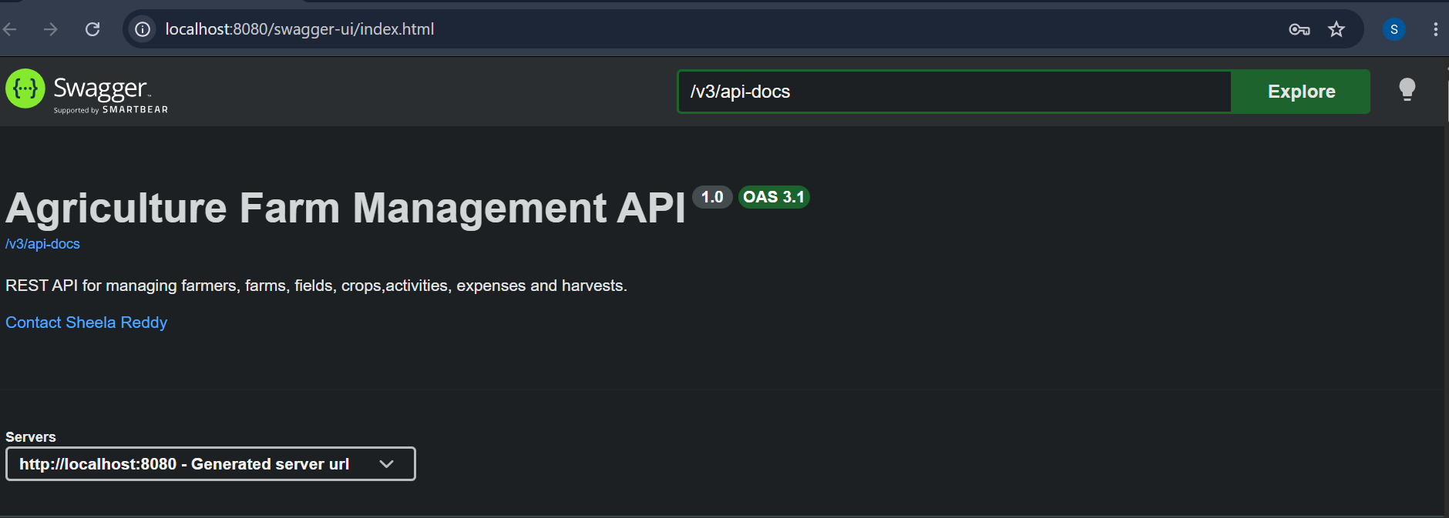

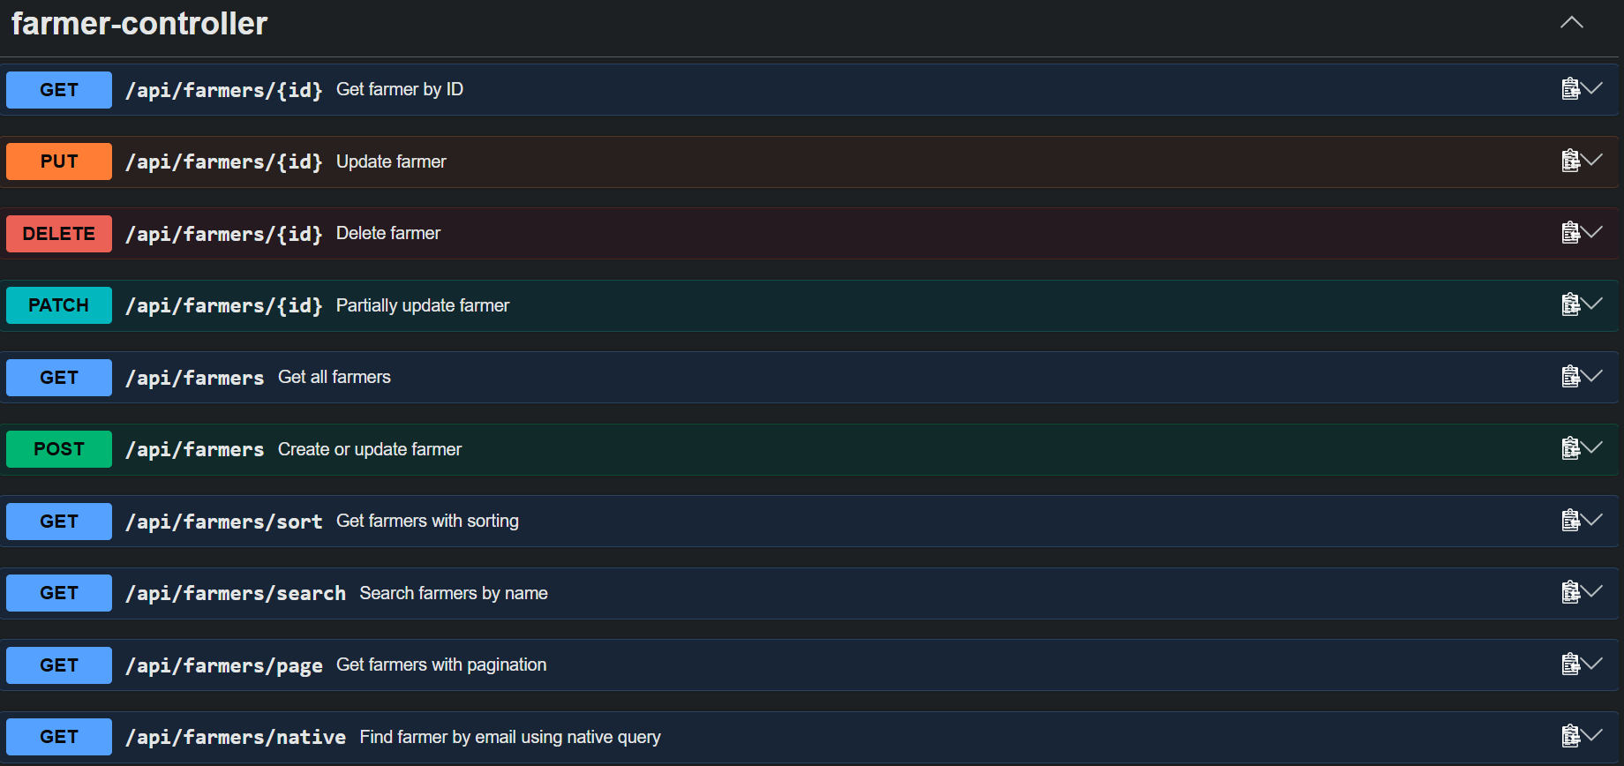

Farmer creation request and response.

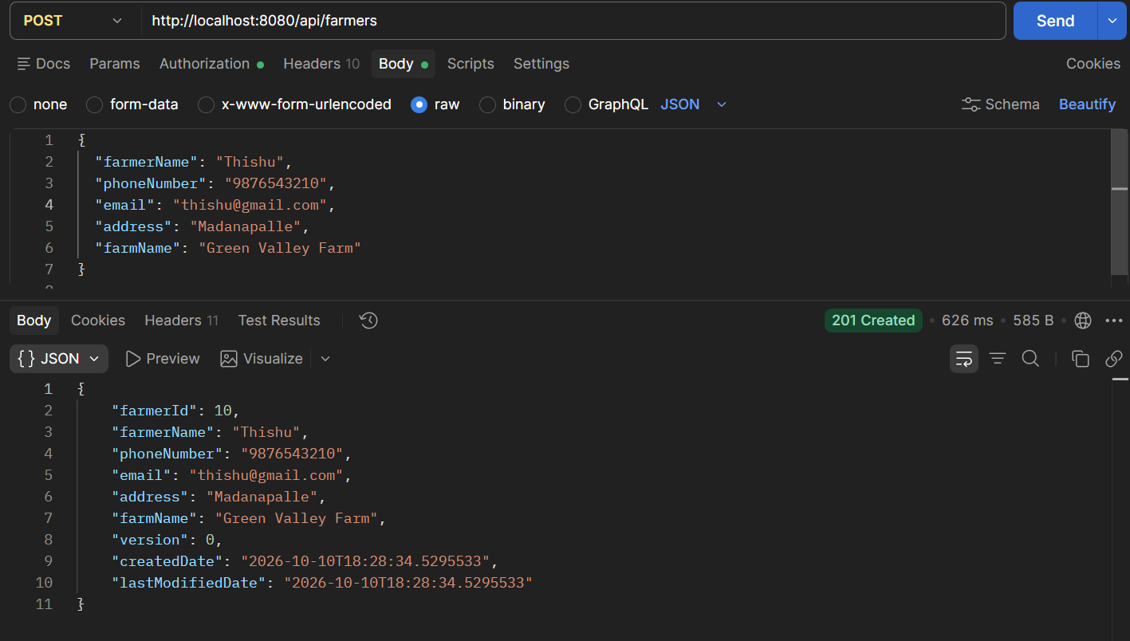

Farm, Field and Crop records showing relationships.

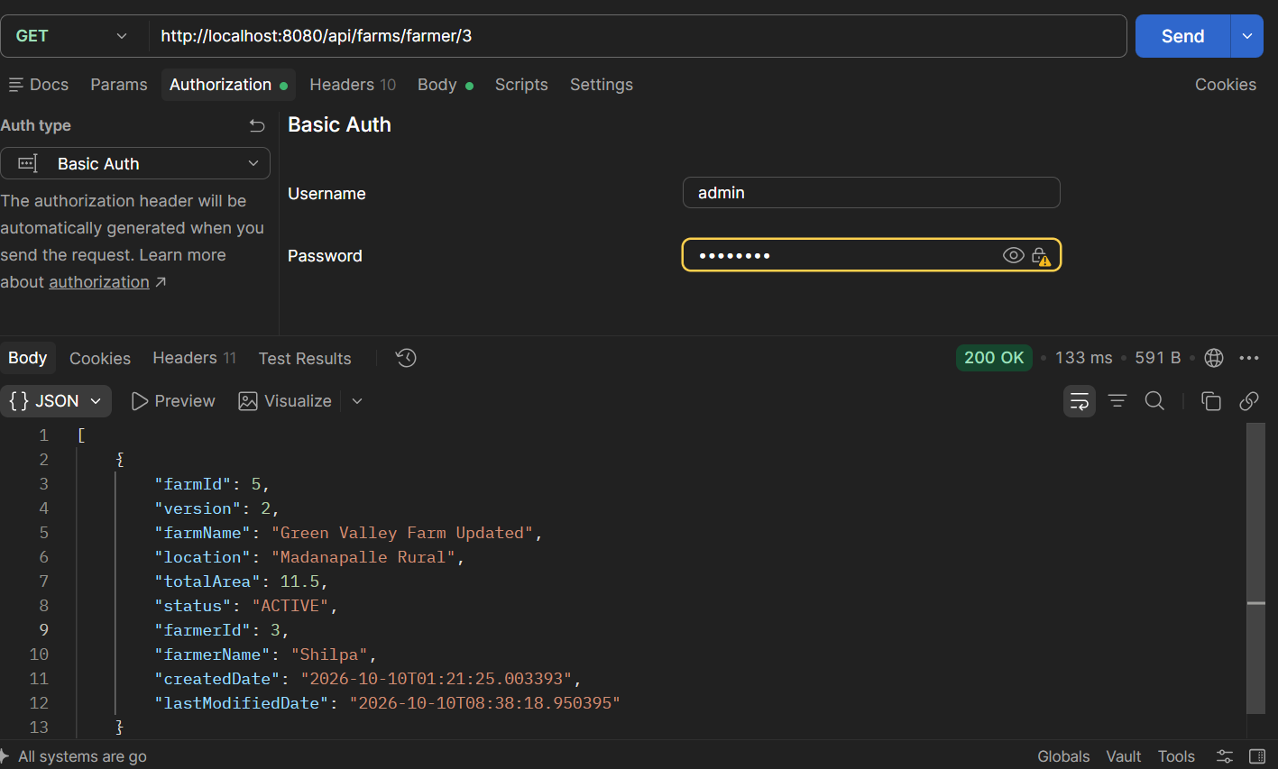

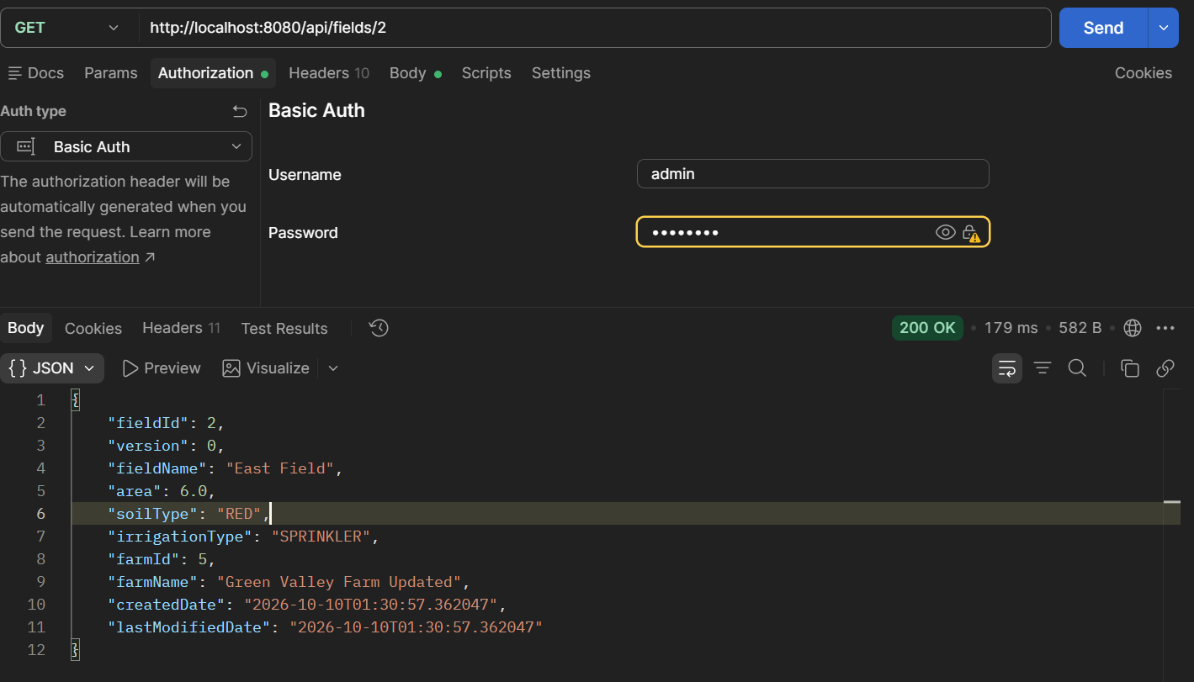

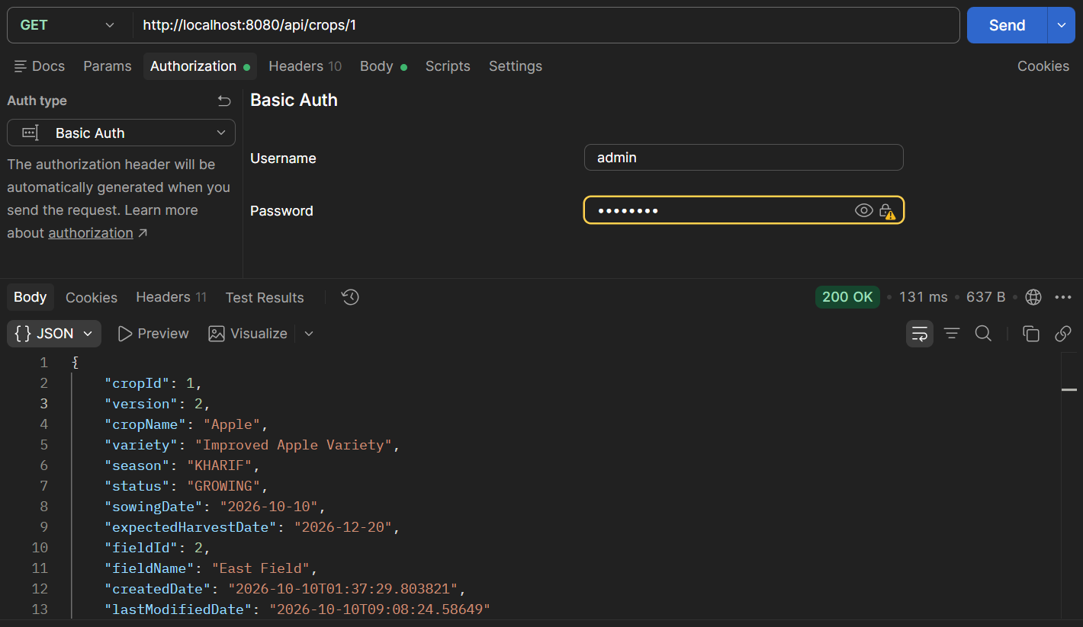

Expense total

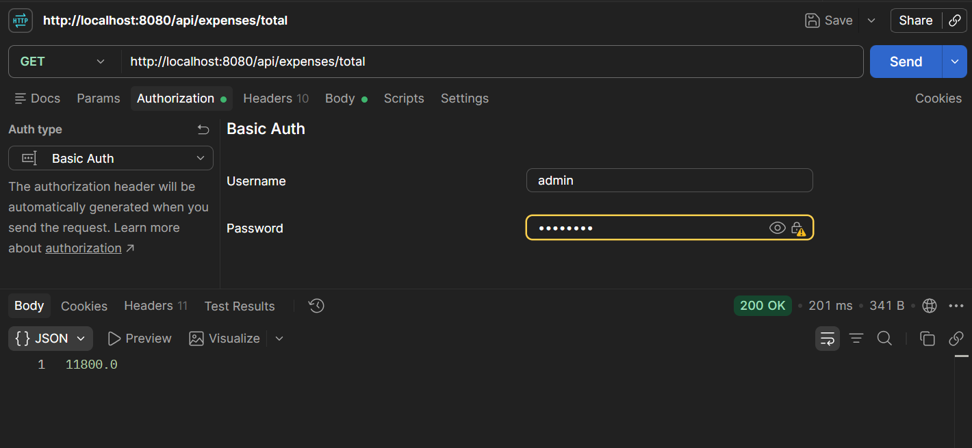

Harvest revenue report.

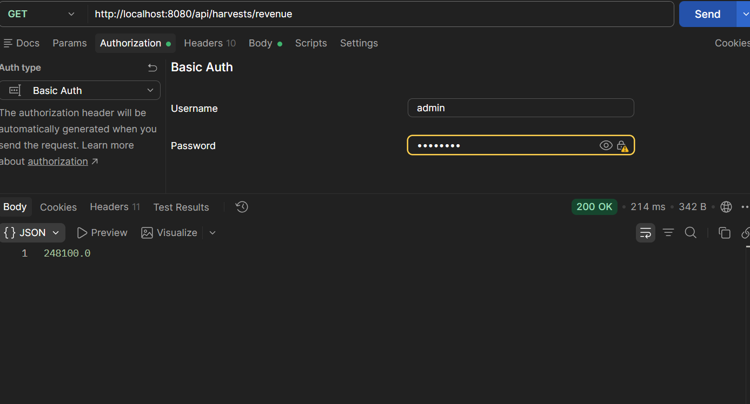

Application log showing scheduled reports.

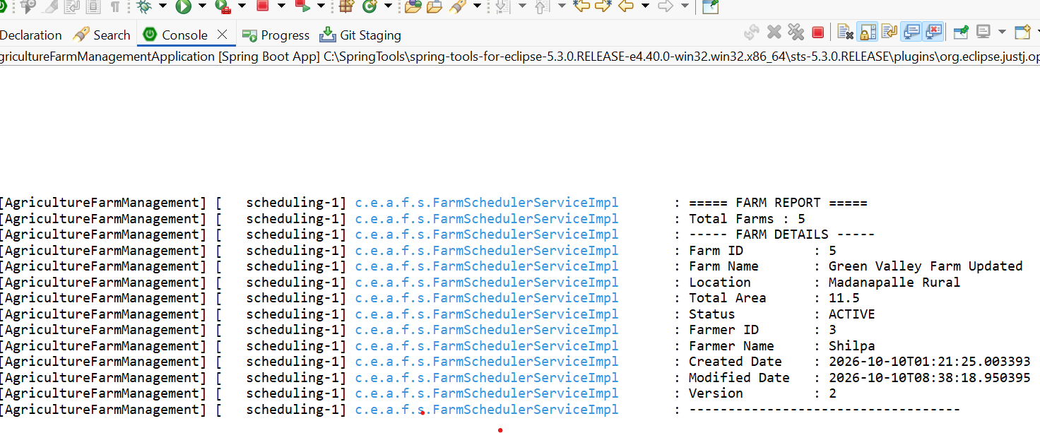

19. Project Summary
Agriculture Farm Management System is a modular Spring Boot REST API for managing farmer details and agricultural operations. It combines MySQL persistence, DTO mapping, validation, exception handling, auditing, optimistic locking, reports, scheduled tasks, security and API documentation. Its layered design separates responsibilities and supports maintainability.

— End of Project Documentation —

