RESTAPI WITH POSTMAN

**Postman** is a popular API client tool that makes it easier for developers to create, share, test, and document APIs. It provides a user-friendly interface for building and testing HTTP requests, making it a valuable tool for API development and testing.

1. **CREATE MOCKAPI:**

* Search mockapi in browser and click on the link.
* Login
* Create project as Rest_api_project
* Click on the project
* Set how many json data needed. Eg: 6 json data
* Click on the mockapi link. It has 6 json data in that link.

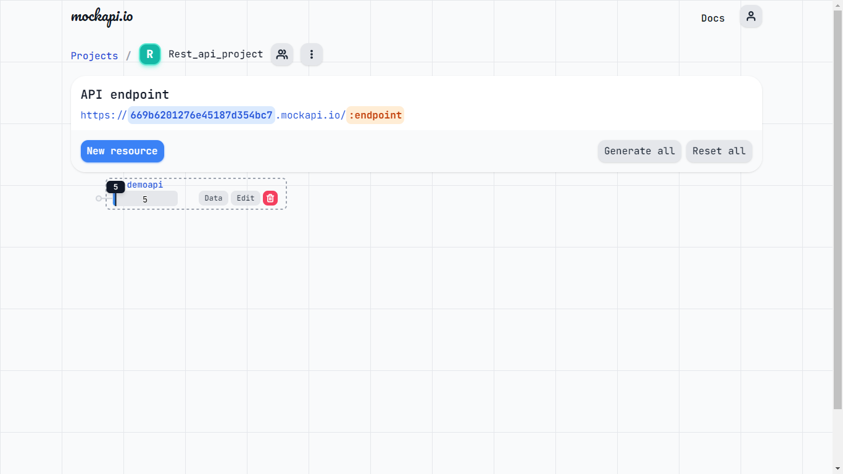

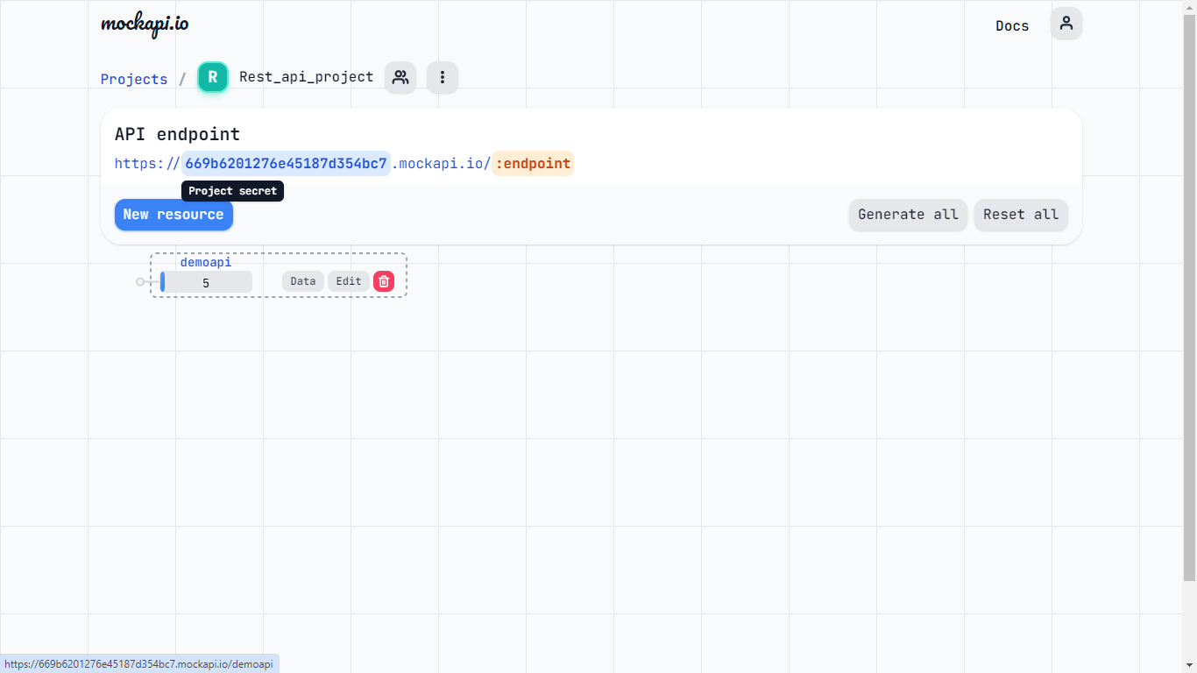

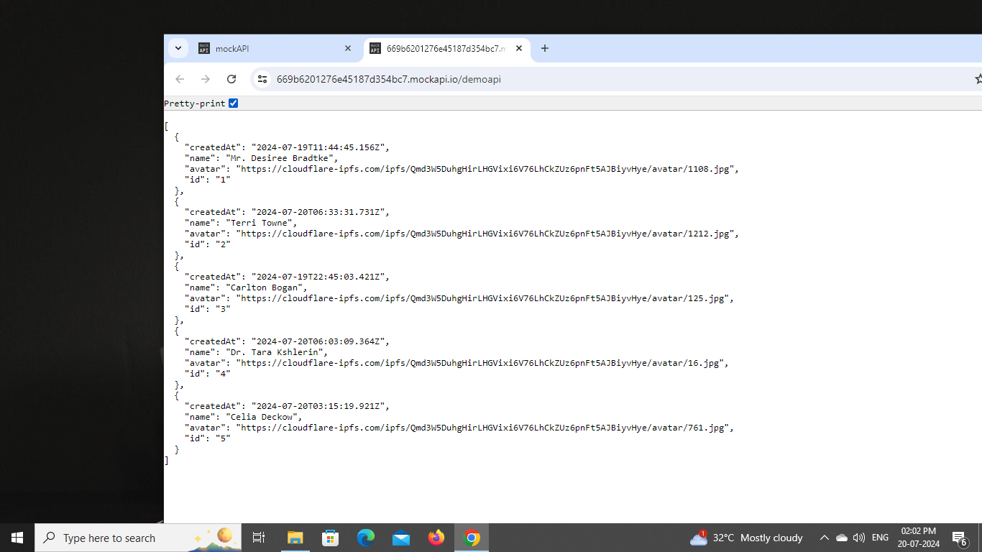

1. **WEB POSTMAN:**
   * + Search web postman in browser and click Web link
     + Login
     + Click workspace drop down and create my workspace
     + Click + button to create new collection
     + Provide name to the collection
     + Click + in tab for doing CRUD operation

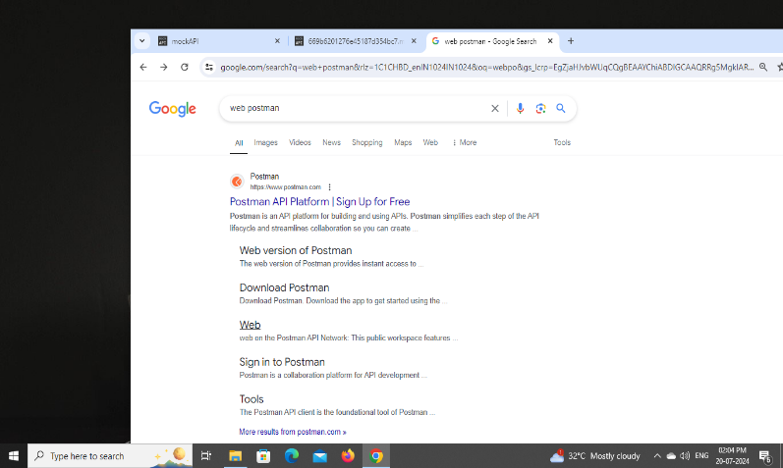

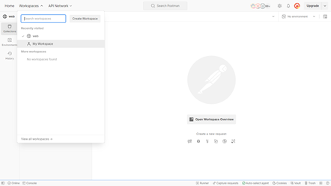

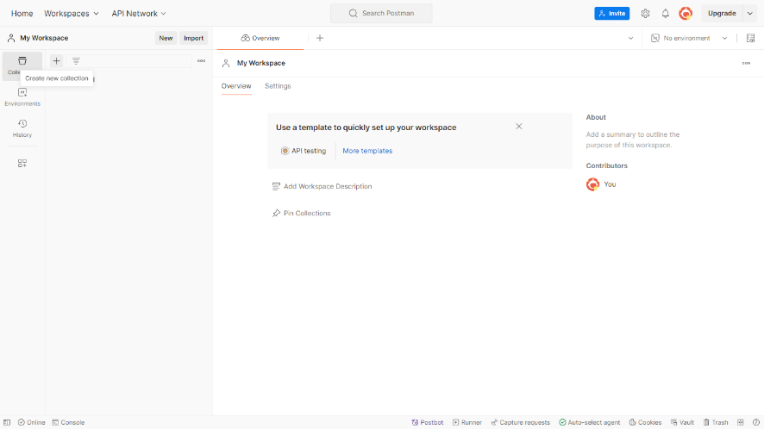

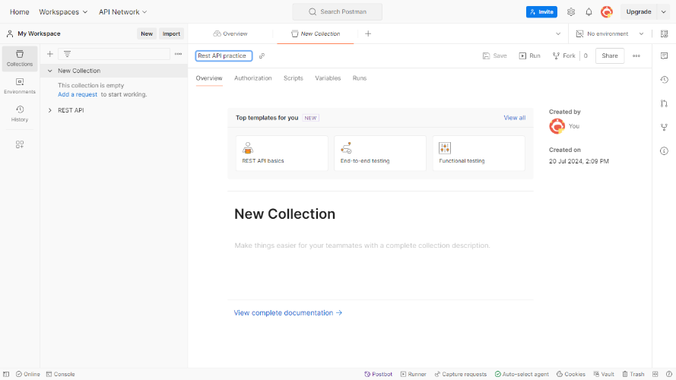

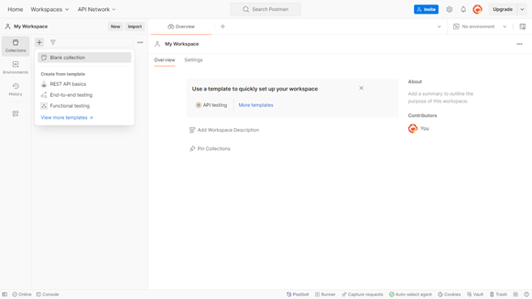

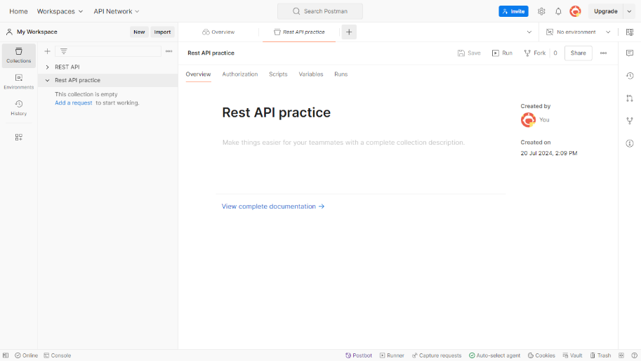

**GET, POST, PUT, DELETE in Postman**

Postman is a versatile tool that allows you to easily send various types of HTTP requests to interact with APIs.

Below, we'll walk through how to perform GET, POST, PUT, and DELETE requests in Postman.

**1. GET Request**

A GET request is used to retrieve data from a server.

**Steps to make a GET request:**

1. Select GET from the dropdown list next to the URL field.
2. Enter the request URL.
3. Save as GET
4. Click Send.
5. View the response in the lower pane

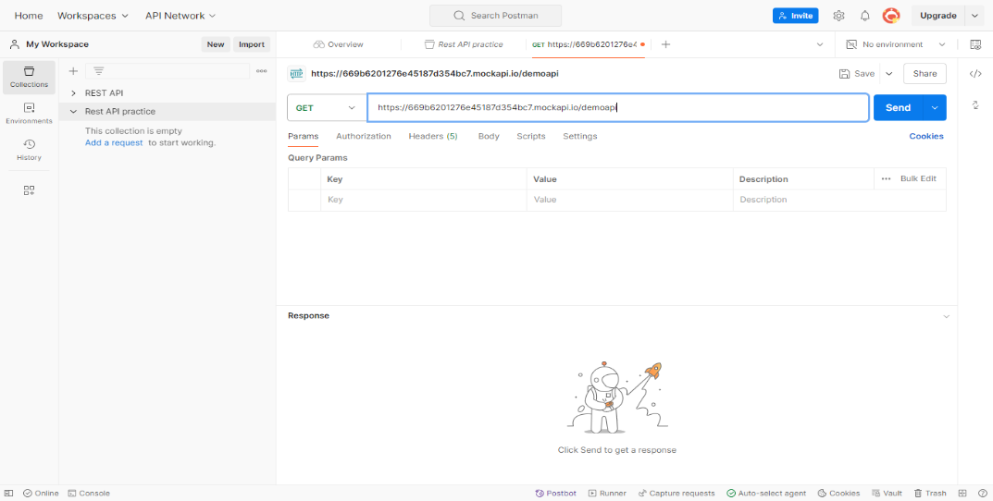

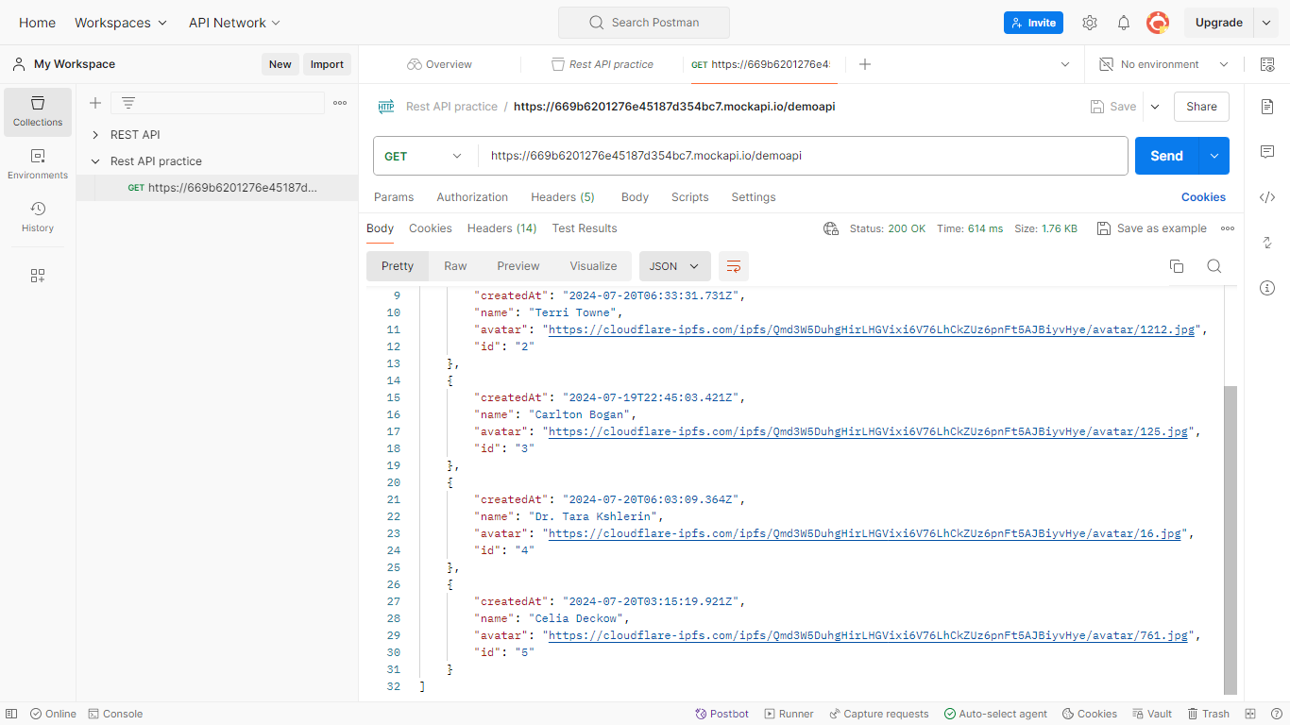

**2. POST Request**

A POST request is used to send data to a server to create a resource.

**Steps to make a POST request**

1. Select POST from the dropdown list.
2. Enter the request URL.
3. Go to the Body tab and select raw.
4. Choose JSON from the dropdown.
5. Enter the JSON data you want to send in the body.
6. Save as POST
7. Click Send.
8. View the response in the lower pane.

**Example:**

JSON DATA: {"name":"keni lisa","avatar":"https://cloudflare-ipfs.com/ipfs/Qmd3W5DuhgHirLHGVixi6V76LhCkZUz6pnFt5AJBiyvHye/avatar/761}

This will **create ID 7** with **{"name":"keni lisa"**,"avatar":"https://cloudflare-ipfs.com/ipfs/Qmd3W5DuhgHirLHGVixi6V76LhCkZUz6pnFt5AJBiyvHye/avatar/761}

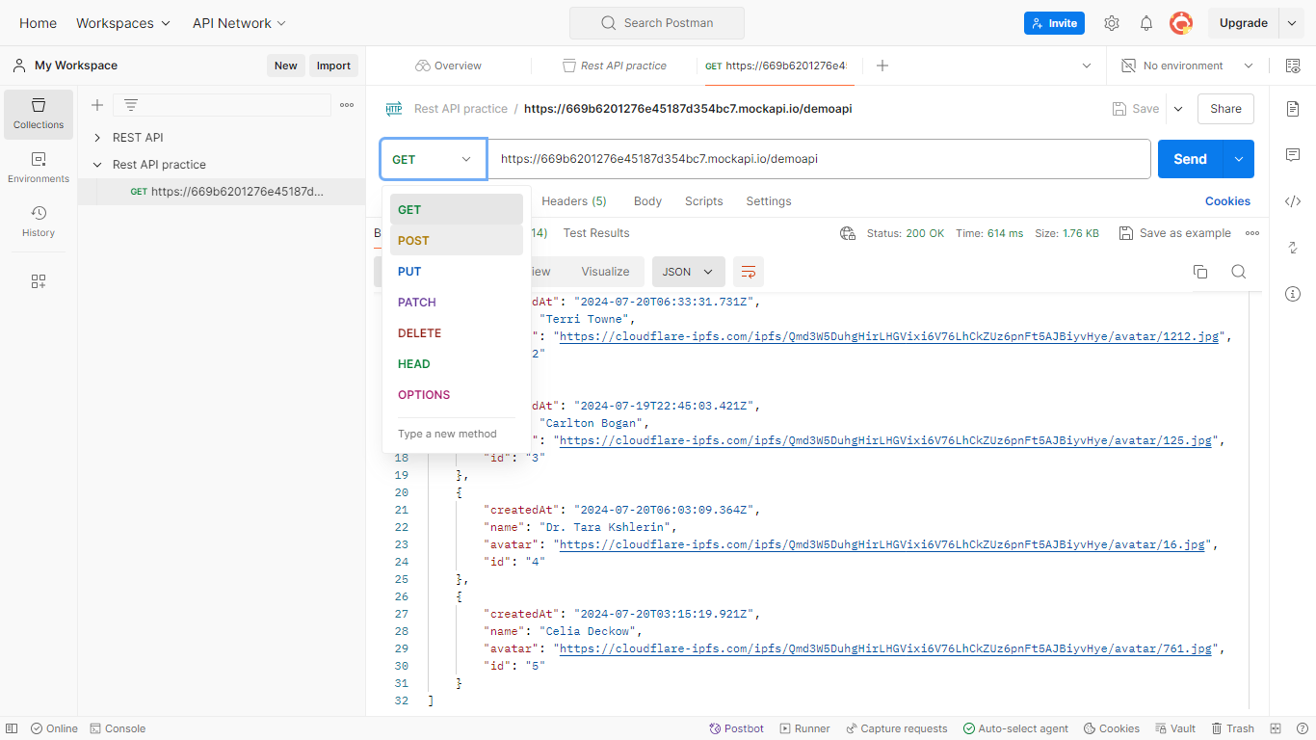

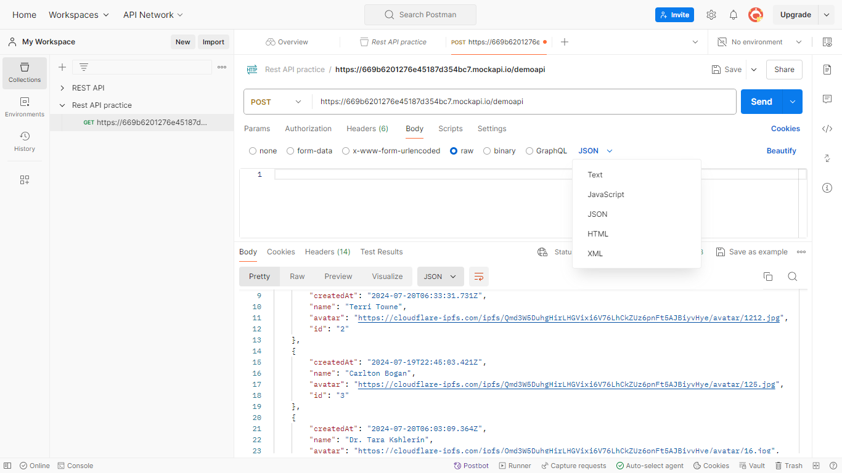

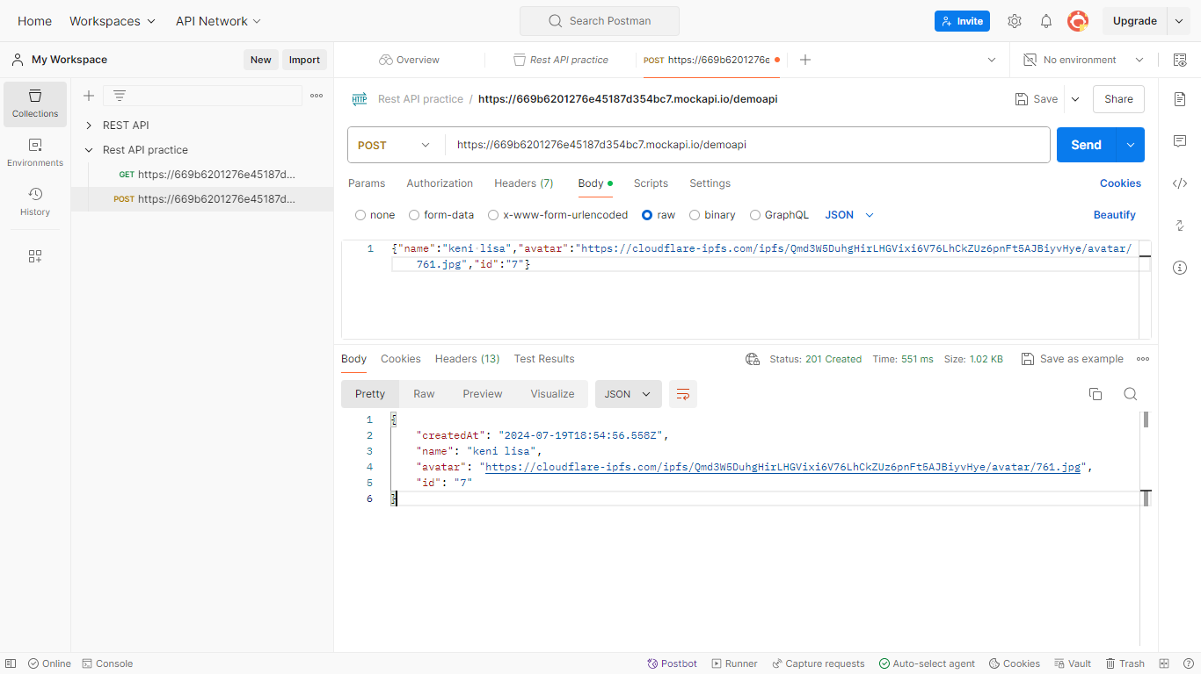

**3. PUT Request**

A PUT request is used to update an existing resource on the server.

**Steps to make a PUT request:**

1. Select PUT from the dropdown list.
2. Enter the request URL.
3. Go to the Body tab and select raw.
4. Choose JSON from the dropdown.
5. Enter the JSON data you want to update in the body.

7. Save as PUT

8. Click Send.

1. View the response in the lower pane.

**Example:**

URL: https://669b6201276e45187d354b7.mockapi.io/demoapi**/7**

This will **update ID 7** with **{“name”:keni joe**, "avatar":"https://cloudflare-ipfs.com/ipfs/Qmd3W5DuhgHirLHGVixi6V76LhCkZUz6pnFt5AJBiyvHye/avatar/761}

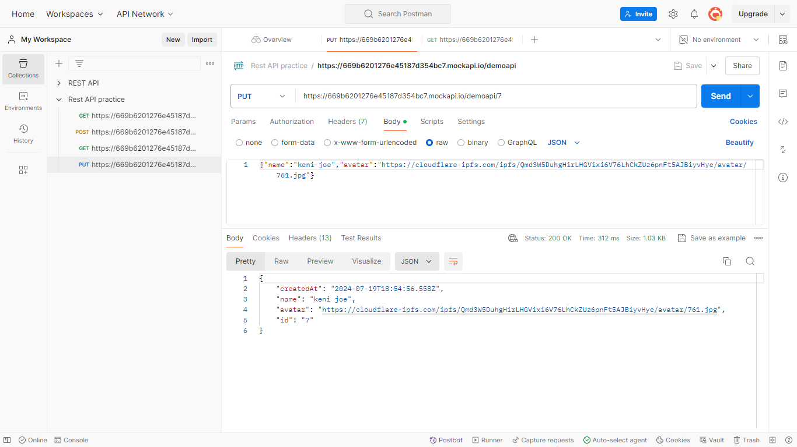

**4. DELETE Request**

A DELETE request is used to delete a resource from the server.

**Steps to make a DELETE request:**

1. Select DELETE from the dropdown list.
2. Enter the request URL.
3. Click Send.
4. Save as DELETE
5. View the response in the lower pane.

**Example:**

* URL: https://669b6201276e45187d354b7.mockapi.io/demoapi**/7**
* This will **delete the post with ID 7**.

