
Kenya National Commission on Human Rights
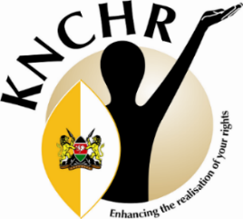

TEMPLATE FOR SUBMISSION OF MEMORANDA, COMMENTS, AND INPUT ON THE DRAFT REPARATIONS GUIDELINES, 2026
In accordance with Article 10(2) (a) of the Constitution, stakeholders and members of the public are hereby invited to submit memoranda, comments and/or input in the format hereunder:

DRAFT REPARATION GUIDELINES, 2026

Name or Institution: ……….
Contact ……….
Date……….

Page No/Guideline | Copy and paste here the specific sentence or paragraph you wish to commend about | Proposed amendment  (Provide the exact wording of how your proposed amendment should read) | Explain your reason for the proposed amendment

Kindly submit your Memoranda, comments or input through the following email address reparations@knchr.org; Postal address P.O Box 74359-00200 Nairobi or by hand delivery to the KNCHR Head Office (CVS Plaza, 1st Floor, Lenana Road) and Regional Offices.

KNCHR Regional Offices:
Central Regional Office, Nyahururu: AFC Building, Next to Nyahururu Law Courts ; 0710974302 / 0705982617
Coast Regional Office, Mombasa: 10th Floor Imaara Building, Dedan Kimathi Avenue , 0757 292932
Western Regional Office, Kisumu: 3 rd Floor-Reinsurance Plaza, Oginga Odinga Street ; 0746415714
North Rift Regional Office, Kitale: AFC Building, Opposite Mega Plaza ; 0708 271216 / 0786 236683
North Eastern Regional Office, Wajir: I-Mall Building, Airport Road; 0794 376 259 / 0794 375 288
Isiolo Office: Ground Floor Shune Suites, County Area ; 0101500161
Garissa Office: IPOA House, Off Kismayu Road ; 0111517725
Kajiado Satellite Office: Huduma Center ; 0800 720 627

The memoranda, comments and/or input should be submitted not later than Monday, 27th April, 2026.

