

XENONAUTS

QUICKSTART GUIDE

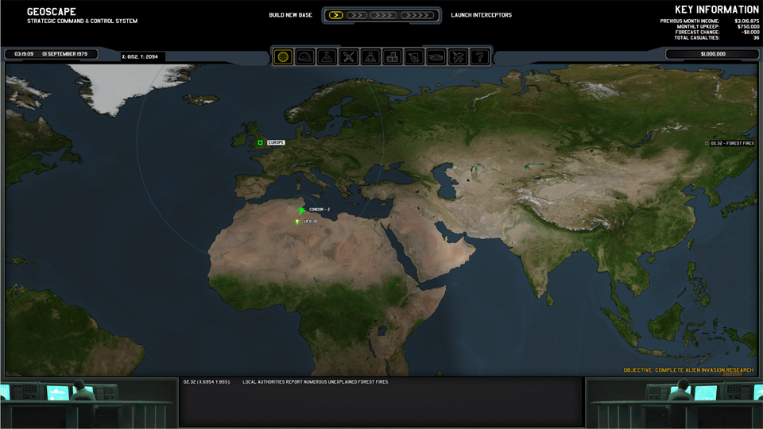

**GEOSCAPE BASICS:**

* The Geoscape is made up of ten funding regions that provide your monthly income. Protect them from the aliens and they will increase funding, but fail to do so and they will reduce your funding and eventually be lost to the aliens entirely.
* The flow of time on the Geoscape is controlled using the arrows at the top of the screen. Using the maximum setting allows you to quickly advance to the next actionable event.
* A “wave” of UFOs will appear on the map every few days.
  + If left alone, they will generate events on the Geoscape that cause funding damage.
  + If shot down, they will boost local funding.
  + If shot down over land, they will either generate a Crash Site or provide resources.
* Players can send a dropship full of troops to a Crash Site to start a ground mission. Victory will recover alien technology for research and grant your soldiers combat experience.
* You are not expected to do every crash site – you can airstrike them for cash instead. Once you have recovered a couple of examples of a particular UFO, it is often advisable to airstrike future Crash Sites of that type.

**BASES / INTERCEPTORS:**

* Bases provide radar coverage that automatically detects UFOs entering radar range and also house your aircraft, soldiers, scientists and engineers.
* The radar range of a base can be expanded by building additional Radar Arrays (max: 3).
* Additional bases can be built using the links at the top of the Geoscape.
* Your interceptors are used to shoot down UFOs.
* You can group up to three interceptors in a squadron. This is essential for tackling some of the larger UFOs.
* You will generally need multiple interceptors at each base, but be careful of their high maintenance costs.

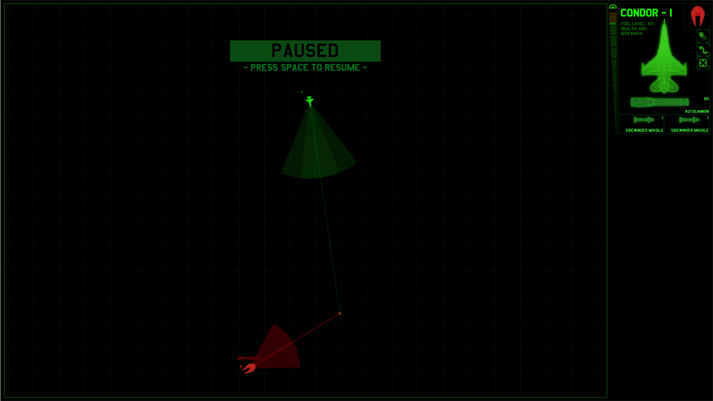

**AIR COMBAT:**

* You can pause / unpause the air combat at any time by pressing Space.
* You can order individual aircraft around by selecting them and:
  + Clicking on the map to give them a move destination.
  + Using the throttle bar beside their UI panel to control their speed.
  + Pressing the Evasive Roll button (or using Q or E) to make the aircraft roll sideways to avoid incoming projectiles.
  + Use the Afterburner button to increase speed at the cost of vastly increased fuel consumption.
  + Order them to Retreat by pressing the retreat button.
* Cannon weapons will automatically fire at any enemy in their shaded fire arc.
* Missiles will automatically fire at the targeted enemy once they are within range and locked on target (target lock is achieved simply by keeping the target in front of the interceptor).
* Autofire can be disabled by clicking on the weapon tile, turning it from green to red. This can be particularly with missiles, as you can draw an Evasive Roll from the enemy with a single missile and then hit them with another immediately afterwards.

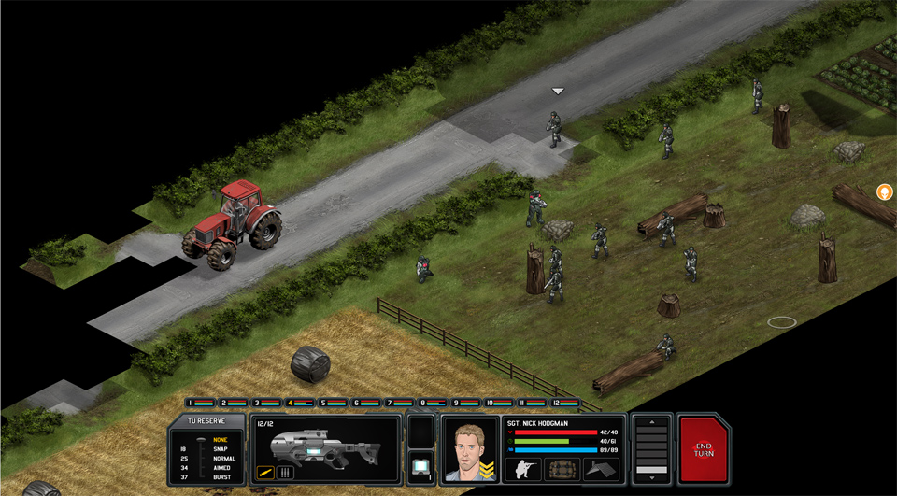

**GROUND COMBAT BASICS:**

* The objective of a ground mission is usually to eliminate all of the alien units on the map.
* Xenonaut and alien forces take turns to move and shoot with their forces.
* Each unit has a set number of Time Units (TU) to spend on their actions per turn.
* Unspent time units can be saved for reaction fire / overwatch during the enemy turn.

**MOVEMENT:**

* You can preview movement with a single click. This shows the move path, as well as the number of **remaining** TU when the unit arrives at the destination tile.
* Crouching costs 3 TU, but increases accuracy by 25% and makes the soldier 20% harder to hit. However, be aware that standing up also costs 3 TU!
* Doors can be opened or closed with a right-click from any adjacent tile.
* Spacebar is an “emergency stop” button that will immediately halt a unit’s movement.

**VISION:**

* Units are able to see up to eighteen tiles, generally with a 90-degree vision cone.
* You can rotate units on the spot using right-click, allowing you to visually sweep an area for enemies.
* Line of sight updates in real-time. If a unit turns away (or is killed) vision will be lost on the tiles they had been looking at.
* On a night mission, tiles require line of sight AND light to be “visible”. As soldiers only project light for twelve tiles in front of them, flares or environmental light sources must be used to reach full vision range.

(continued overleaf)

**SHOOTING:**

* If an alien is visible, the fire cursor will appear if you mouseover them.
* You can force fire on an object, tile or friendly unit by holding Ctrl or clicking the GUI weapon image.
* You may right-click to add “zoom” to the fire cursor. This increases the accuracy of the shot but costs additional TU; higher levels of zoom are more TU-efficient than lower levels.
* There is an accuracy bonus of 12% per tile, capped at 60%, if the shooter is within five tiles of the target. Close range combat highly effective and highly dangerous.
* Objects between the shooter and the target will reduce accuracy. However, any cover in an adjacent tile to the shooter is disregarded. This allows you to fire over an object you are hiding behind (this includes crouched friendly units).
* You can also use it to deal with units in cover. If an enemy is hiding behind an object, simply running up to the other side will negate the cover it provides.
* Some weapons can burst fire: this inflicts extra suppression damage, but has less killing power per TU spent than single shots (unless the target is within five tiles of the shooter).
* Most terrain is destructible, but this only becomes relevant when using explosives (which do quadruple damage to terrain) or when you possess more advanced weapons.

**REACTION FIRE:**

* If a unit has enough unspent TU to fire their weapon, they may take a Reaction Fire check when a hostile unit performs an action in the line of sight during the enemy turn.
* Aliens will use reaction fire to defend UFOs. There are several ways to deal with this:
  + Suppressing the target will prevent the Reaction Fire, plus reduce the TU the enemy unit will receive in the following turn;
  + Smoke grenades will make the incoming shots less accurate;
  + Using a Combat Shield to soak up the reaction fire;
  + Triggering the reaction fire with an expendable soldier will keep your veterans alive;
  + Killing the alien before it has a chance to reaction fire;
* Weapons have a Reaction Fire modifier. Soldiers with close combat weapons like shotguns are less likely to sustain reaction fire and more likely to perform it, whereas the reverse is true for sniper rifles and heavy weapons.
* The remaining TU % of the unit also affects the calculation. Units with high TU% remaining and much less likely to sustain reaction fire than those with low TU%.
* For the mathematicians amongst you, this is the Reaction Fire formula:
  + Initiative = (unit Reactions stat) x (% of remaining TU) x (weapon modifier)
  + Thus a soldier with 60 Reactions, 30/60 TU and a shotgun with a 1.5 weapon modifier has an Initiative of 45.
  + When two units sight one another, they compare Initiative. The unit with the higher Initiative may spend TU until their Initiative drops below that of the hostile unit, at which point the other unit may act until it no longer has the higher Initiative.