2.

- A Boolean value is either true or false. In Python, the two Boolean values are True and False. A Boolean expression is an expression that evaluates to produce a result which is a Boolean value.

* Exp:
  + 1 + 1 == 2 🡪 True
  + 2 % 2 == 0 🡪 True
  + Type(1.6) == int 🡪 False

3.

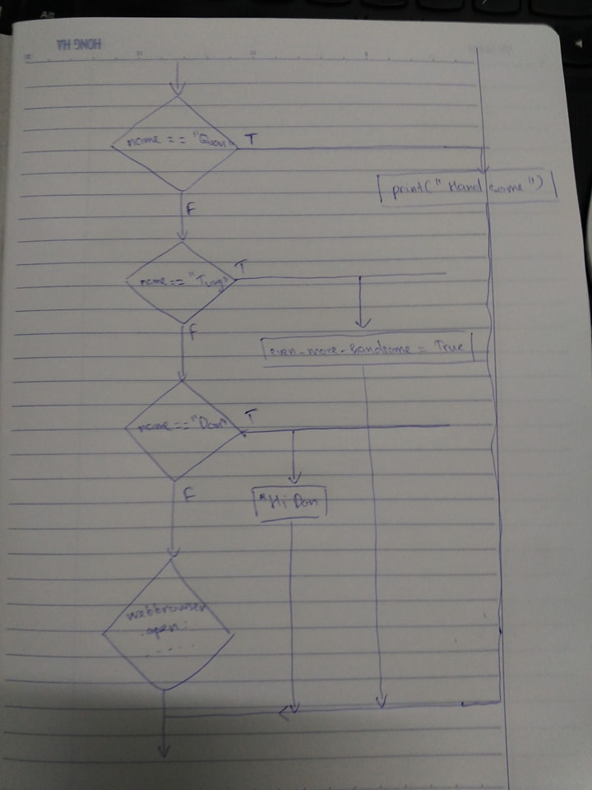

4.

- Nested conditionals happen when one condition is nested within another – when a conditional statement is inside a branch of another conditional statement.

* Exp:

n = float(input(“Input your grade: ”))

if n < 5:

print("fail")

else:

if 5 <= n < 8:

print("normal")

else:

print("good")