Ex 1:

Are there any duplicate ids in the record?

* Yes and no

If yes:

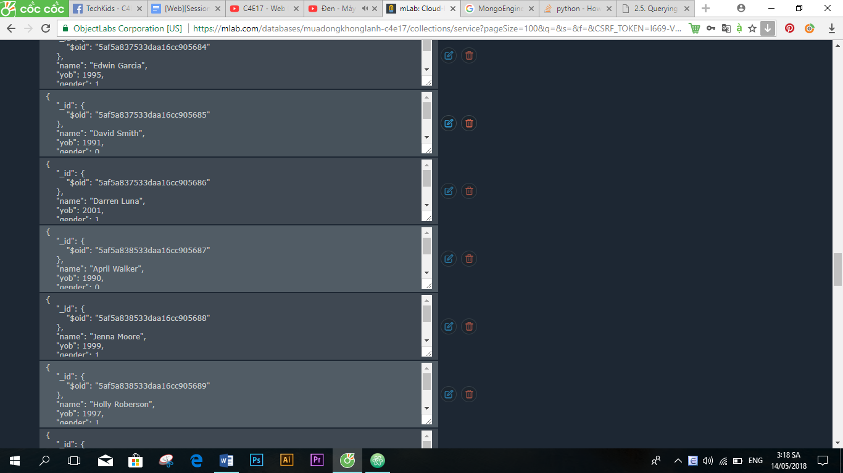

If no:

* Because if u ran it in one time, the ids last number will run from 0 -> 9 and repeat that rules. If not, the ids will be randomed
* It represents ID of objects

Ex 2:

Doc.objects.get(id = ‘5af5a837533daa16cc905686’)

Doc.objects.with_id(‘5af5a837533daa16cc905686’)

Ex 3:

+ Delete a single id

Docs = Doc.objects.get(id = ‘5af5a837533daa16cc905686’)

Docs.delete()

+ Delete all item name Hera

Doc.objects(type = “Hera”).delete()

+ Delete all documents

Doc.objects.delete()