

CODEBOOK

FOR

PMJAY FRAUD DETECTION DASHBOARD

Developed by:

INTRODUCTION:

The PMJAY Fraud Detection Dashboard, Bihar is a powerful yet user-friendly web application designed to streamline the identification and analysis of potentially fraudulent healthcare claims.

The dashboard is now in the testing phase to test according to the standards.

This dashboard visualises the data on daily basis by processing the fraud flagged data. The dashboard provides an at-a-glance overview of critical metrics—such as daily detected cases, 30-day trends presented through intuitive visualizations and interactive cards.

This facility can only be used by Administrative Officer of Ayushman Bharat office. With secure login access and scheduled data processing, the system ensures that up-to-date insights are always available. A login page is created with his credentials to access the dashboard.

**VARIABLE DESCRIPTIONS:**

There are various variables on the basis of which the dashboard has been developed. The dashboard currently displays the following cards:

* Patient Admitted in Watchlist Hospitals
* High Value Claims
* Hospital Bed Cases
* Family ID Cases
* Geographic Anomalies
* Ophthalmology (Cataract)

1. **Patient Admitted in Watchlist Hospitals**: This variable is about flagging all the cases that are in the pre-auth data and also are from Suspicious Hospitals list.
2. **High Value Claims**: This variable is about flagging all those cases which have initiated the claim amount of more than Rs. 1,00,000 in SURGICAL case type as well as claim amount of more than Rs. 25,000 in the MEDICAL case type
3. **Hospital Bed Cases**: This variable is about matching the number of daily admissions of the hospital with the bed strength of the hospital. If the number of admissions is greater than the bed strength of that particular hospital in a day, then that hospital is marked as suspicious.
4. **Family ID Cases**: This variable is about flagging all those cases where on a single day same family id have raised more than one case.
5. **Geographic Anomalies**: This variable is about flagging all those cases in which the Patient State is different from the Hospital State Name
6. **Ophthalmology (Cataract)**: This variable is about flagging all the cases which are in the ophthalmology (cataract) department and must have satisfied the following three conditions:

* Age less than 40: All those cases where patient age is less than 40.
* OT Cases: The cases linked with those hospitals where there are more than 30 OT cases recorded per surgeon.
* Pre-auth Time: All the cases where pre-auth time is not falls between 8 am to 6 pm.

Each of the card has three metrics: “Overall, Yesterday, and Last 30 days”. The “Overall” displays the total flagged cases, the “Yesterday” displays the cases captured the day before today, and the “Last 30 days” displays the cases captured in the last 30 days

At initial phase a consideration is made as there are large number of flagged fraud cases highlights in “Cataract”.

All the reports can be downloaded in color-coded excel format by using the download button available at the top-right corner of each card or by using the “Export Excel” button inside each card’s table visual. There is also a “Download PDF Report” button at the top-right inside each card’s analysis page which gives the option to download the analysis data such as tables, bar charts, and pie-charts in properly organised PDF report.

**HOW TO USE IT:**

In order to use this dashboard which is currently in the testing phase, there are some specific steps that are required to follow. The project is available in a folder named: “pmjay_fraud_dashboard”. This folder is the root folder of the project in which there are many sub-folders and files. Most of them are dependencies for the dashboard to run. In order to run the dashboard following steps are needed to be followed:

1. Copy the fraud excel file that is needed to analyse to the New Files folder inside the project folder: “pmjay_fraud_dashboard/data/new_files/”
2. Browse to the Fraud Detection Dashboard Project root folder named: “pmjay_fraud_dashboard” and run the “run.bat” file.
3. After running the run.bat file three command line interfaces will open. Click the “http://127.0.0.1:8000/” from one of the interfaces using “Ctrl + left-mouse-click” to start the dashboard server.

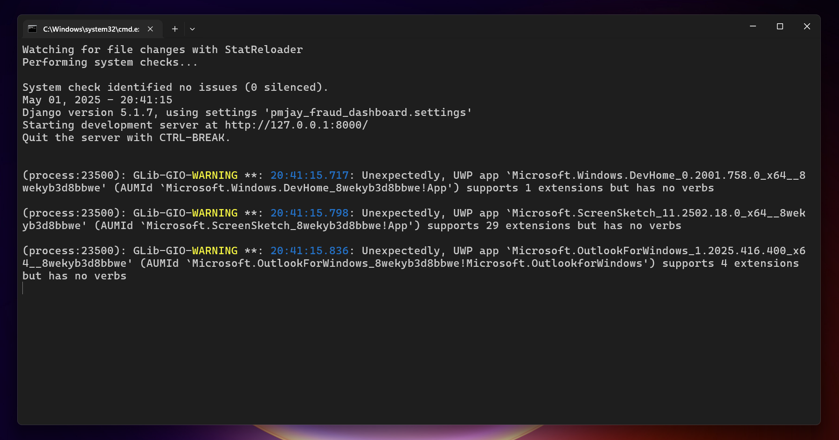



*Fig 1: Command Line interface containing the link to the dashboard*

1. The dashboard will then pop-up in a browser.

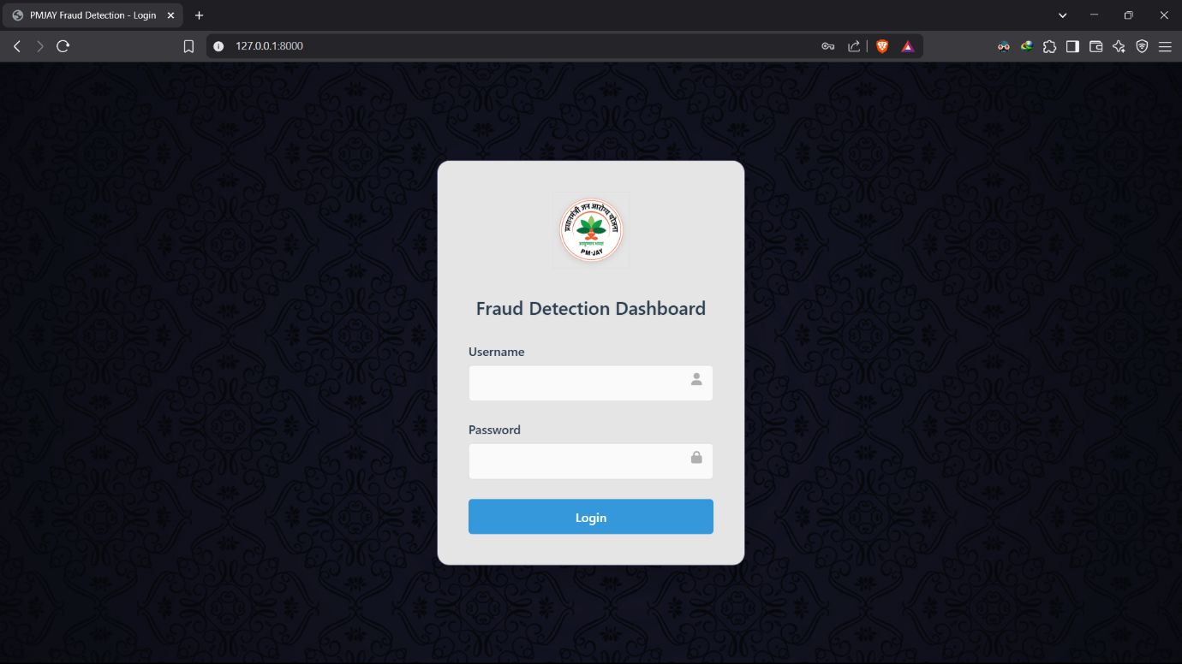

*Fig 2: Login Page after clicking the dashboard link*

1. Login with your credentials provided and the main dashboard page will slide up
2. After which all the fraud cases respective to each card will be visible.

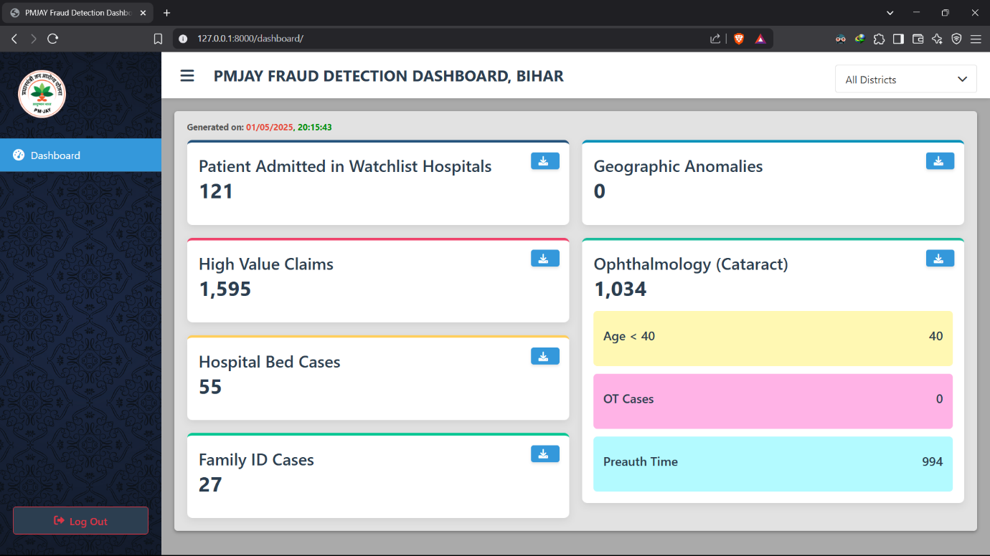

*Fig 3: Main dashboard displaying all the card details*

1. The system will scan the “new_files” every one minute to check if any new excel files is added or not and import the new data to the database.
2. After adding any new file, a one-minute wait is required and then refreshing the dashboard page will update the analysis.
3. All the cards have these three metrics: “Overall, Yesterday, and Last 30 days” which appears on hovering the mouse on card.

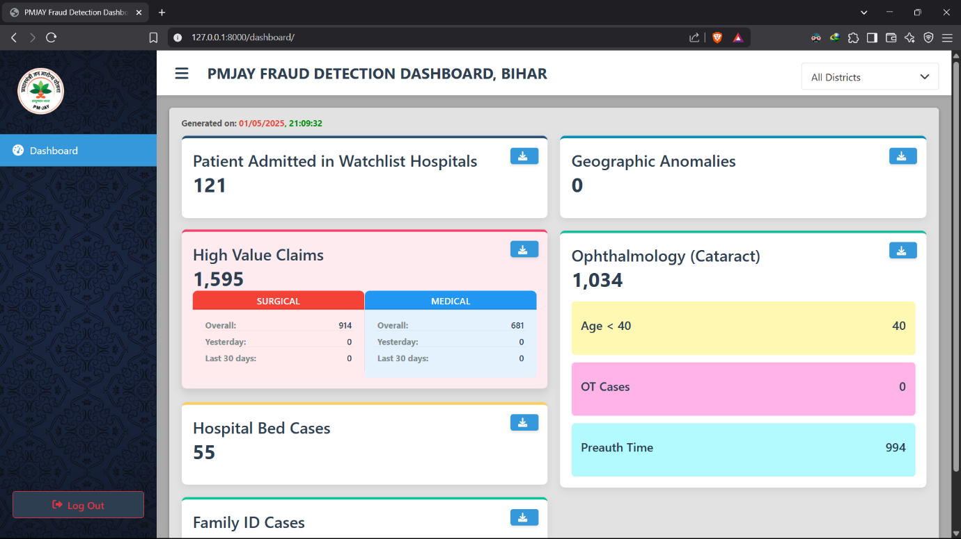

*Fig 4: Card showing its three metrics: “Overall, Yesterday, and Last 30 days”*

1. Each of the card will have a download button at the top-right corner which will allow to download color-coded excel file respective to that card to any specific folder with a specific file name of your choice





*Fig 5: Download button of each card for downloading excel files respective to each card*

1. Each card has an analysis page, which will open on click the card. The analysis page contains a table, a district wise distributed bar chart, and pie-charts (age and gender distribution)

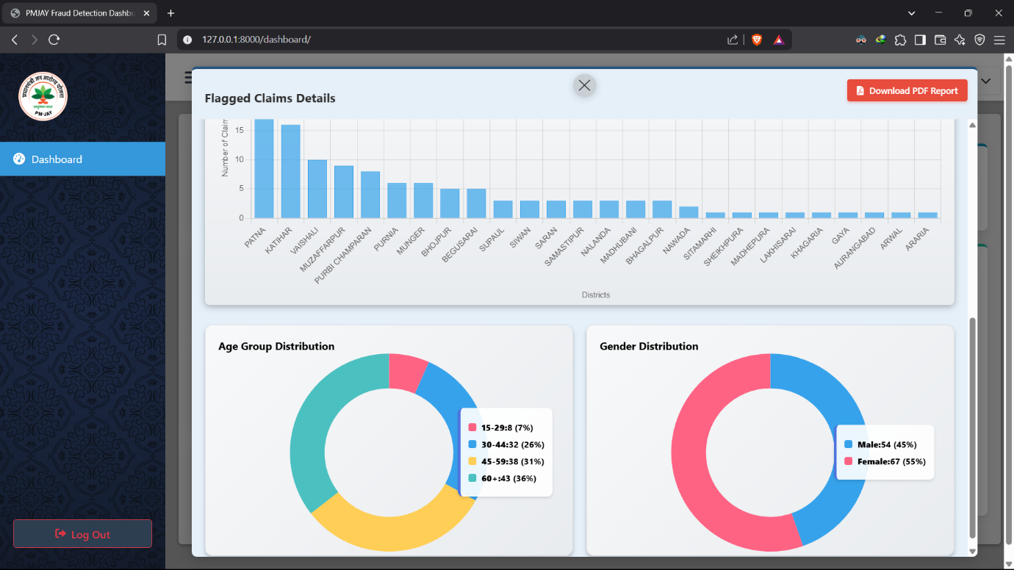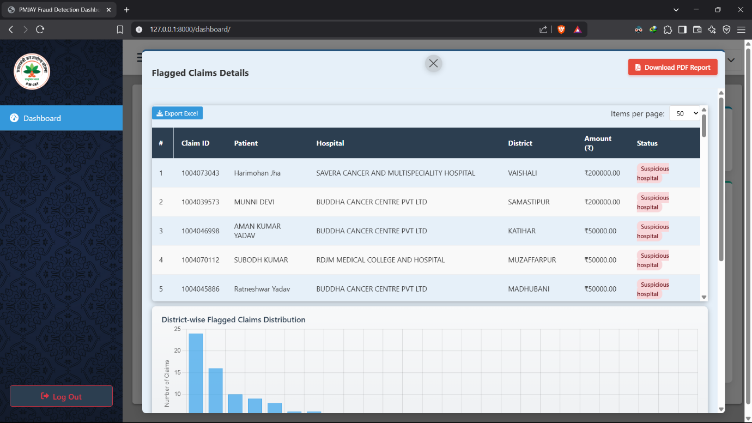

*Fig 6: Analysis page of a card showing the implemented visualizations*

1. The same color-coded excel file can be downloaded from the analysis page as well by clicking the “Export Excel” available at the top-left of the table.





*Fig 7: Export excel button at the top of each card’s table*

1. There is also a “Download PDF Report” which will allow to download a structured pdf report of that particular card. After clicking the button, it will take some time to generate the pdf report after which it can be saved to any specific folder with a specific file name of your choice.





*Fig 8: Download PDF Report button at the top-right corner of analysis page*

1. All the table by default displays 50 cases per table which can be changed by using the drop-down menu to show more or lesser entries. There is a page navigation option available at the bottom of each table to go next or previous in that table

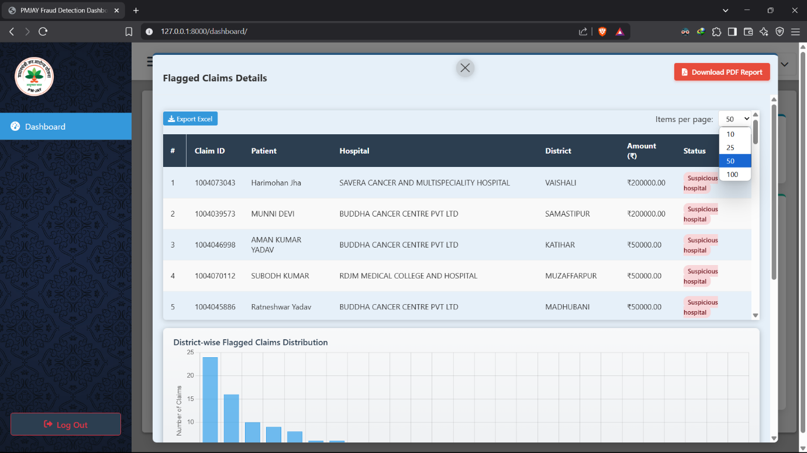



*Fig 9: Drop-down menu to choose number of entries to be displayed in the table*

1. Click the “High Alert” tab below the “Dashboard” tab to move to the High Alert page

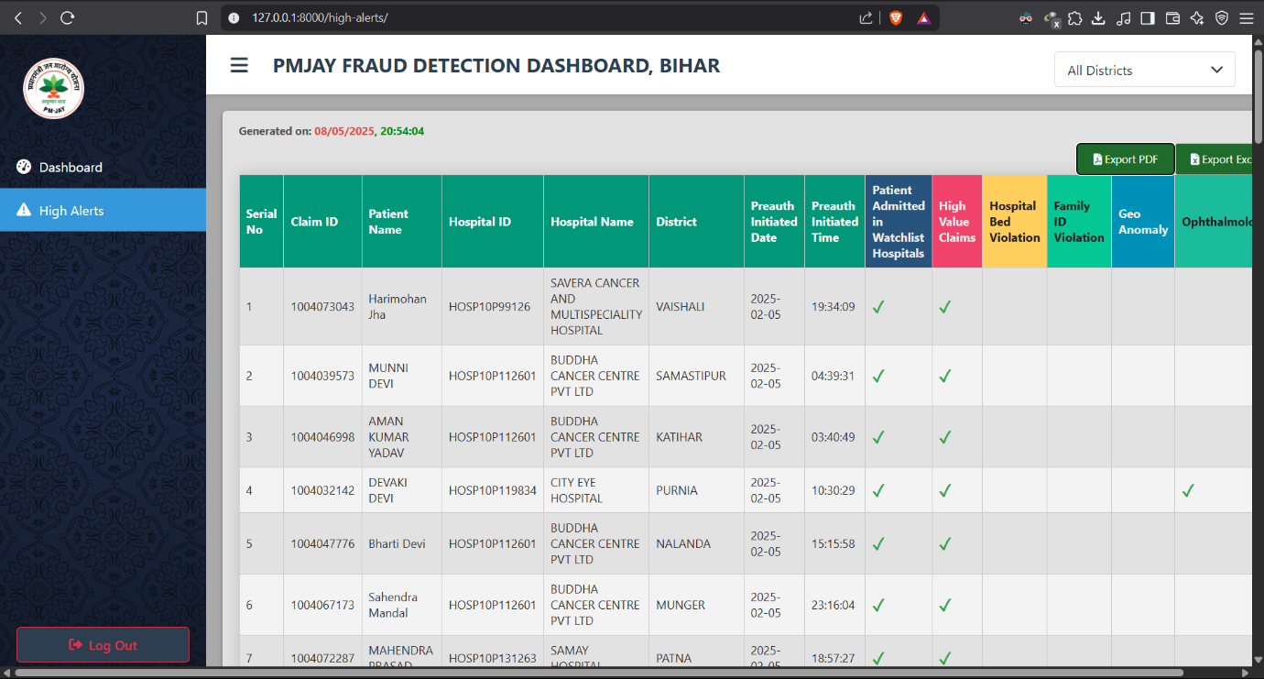

*Fig 10: High Alert Page*

1. Export as PDF or Excel using the buttons at the top-right corner





*Fig 11: Download Buttons*

1. For logging out use the “Log Out” option available at the main dashboard page’s bottom-left.





*Fig 12: Logout button*

1. For closing the dashboard, close the browser tab or the browser itself and also close the three command line interfaces.

**Note: Please do not rename any folder or delete any folder or file from inside the project folder.