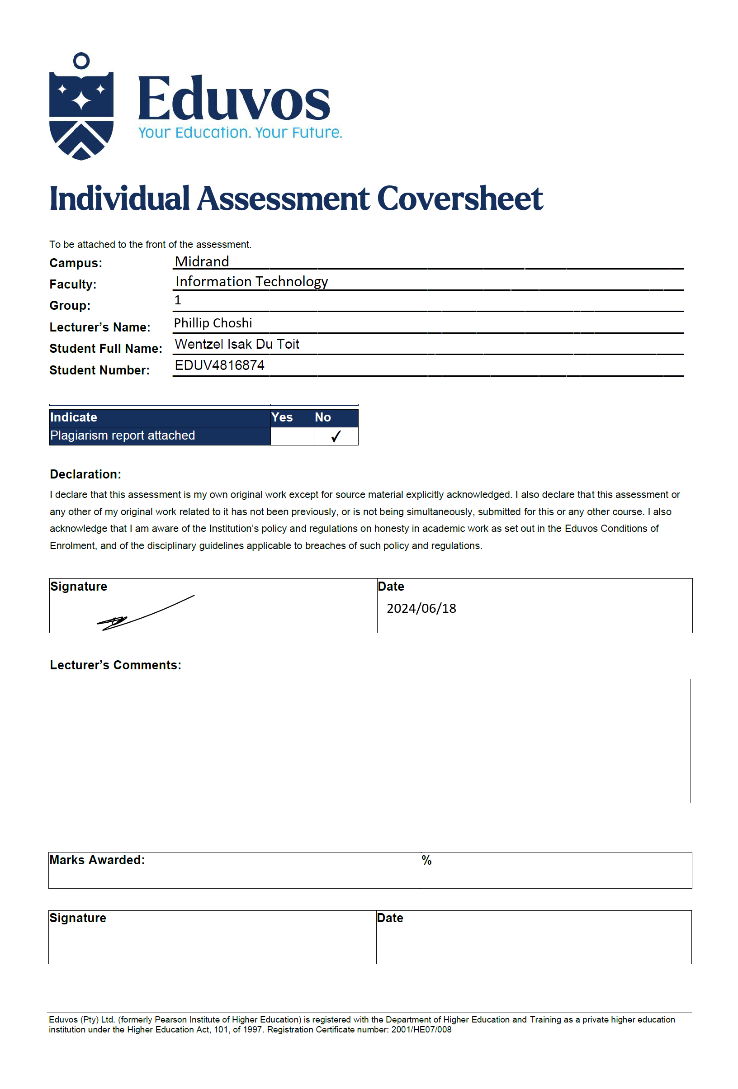

Table of Contents
Question 1 3
1.1.a 3
1.1.b 4
1.2.a 6
1.2.b 6
1.2.c 6
1.3.a 6
1.3.b 6
1.3.c 6
1.3.d 7
1.3.e 7
1.3.f 7
1.3.e 8
Question 2 8
2.1 8
2.2 8
2.3 8
2.4 9
2.5 12
2.6 13
2.7 15
2.8 16
2.9 16
2.10 17
References 18

Question 1

1.1.a
CREATE TABLE TITLE (
TITLE_ID VARCHAR(10) NOT NULL,
TITLE VARCHAR(32) NOT NULL,
DESCRIPTION VARCHAR(256) NOT NULL,
RATING NUMBER(3,1) NOT NULL,
CATEGORY VARCHAR(15) NOT NULL,
RELEASEDATE DATE NOT NULL,
PRICE NUMBER(8,2) NOT NULL,
PRIMARY KEY (TITLE_ID)
);

CREATE TABLE MEMBER (
MEMBER_ID VARCHAR(10) NOT NULL,
LASTNAME VARCHAR(32) NOT NULL,
FIRSTNAME VARCHAR(32) NOT NULL,
ADDRESS VARCHAR(128) NOT NULL,
CITY VARCHAR(32) NOT NULL,
PHONE NUMBER NOT NULL,
JOINDATE DATE NOT NULL,
PRIMARY KEY (MEMBER_ID)
);

CREATE TABLE TITLE_COPY (
COPY_ID VARCHAR(10) NOT NULL,
TITLE_ID VARCHAR(10) NOT NULL,
STATUS VARCHAR(13) NOT NULL,
PRIMARY KEY (COPY_ID),
FOREIGN KEY (TITLE_ID) REFERENCES TITLE(TITLE_ID)
);

CREATE TABLE RENTAL (
BOOKDATE DATE NOT NULL,
ACCTRENTALDATE DATE NOT NULL,
EXPRENTALDATE DATE NOT NULL,
COPY_ID VARCHAR(10) NOT NULL,
MEMBER_ID VARCHAR(10) NOT NULL,
PRIMARY KEY (BOOKDATE),
FOREIGN KEY (COPY_ID) REFERENCES TITLE_COPY (COPY_ID),
FOREIGN KEY (MEMBER_ID) REFERENCES MEMBER (MEMBER_ID)
);

CREATE TABLE RESERVATION (
RESDATE DATE NOT NULL,
TITLE_ID VARCHAR(10) NOT NULL,
MEMBER_ID VARCHAR(10) NOT NULL,
PRIMARY KEY (RESDATE),
FOREIGN KEY (TITLE_ID) REFERENCES TITLE (TITLE_ID),
FOREIGN KEY (MEMBER_ID) REFERENCES MEMBER (MEMBER_ID)
);

1.1.b
INSERT INTO TITLE VALUES ('T001', 'The Shawshank Redemption', 'Two imprisoned men bond over a number of years, finding solace and eventual redemption through acts of common decency.', 9.3, 'Drama', '1994-10-14', 12.99);
INSERT INTO TITLE VALUES ('T002', 'Inception', 'A thief who enters the dreams of others to steal secrets from their subconscious. He is offered a chance to have his criminal history erased as payment for the implantation of another persons idea into a targets subconscious.', 8.8, 'Sci-Fi', DATE '2010-07-16', 14.99);
INSERT INTO TITLE VALUES ('T003', 'The Godfather', 'The aging patriarch of an organized crime dynasty transfers control of his clandestine empire to his reluctant son.', 9.2, 'Crime', DATE '1972-03-24', 11.99);
INSERT INTO TITLE VALUES ('T004', 'The Dark Knight', 'When the menace known as The Joker emerges from his mysterious past, he wreaks havoc and chaos on the people of Gotham. The Dark Knight must accept one of the greatest psychological and physical tests of his ability to fight injustice.', 9.0, 'Action', DATE '2008-07-18', 13.99);
INSERT INTO TITLE VALUES ('T005', 'Forrest Gump', 'The presidencies of Kennedy and Johnson, the events of Vietnam, Watergate, and other historical events unfold from the perspective of an Alabama man with an IQ of 75, whose only desire is to be reunited with his childhood sweetheart.', 8.8, 'Drama', DATE '1994-07-06', 10.99);

INSERT INTO MEMBER VALUES ('M001', 'Smith', 'John', '123 Main Street', 'New York', '0115551234', DATE '2023-05-10');
INSERT INTO MEMBER VALUES ('M002', 'Johnson', 'Emily', '456 Elm Avenue', 'Los Angeles', '0215555678',DATE '2022-11-30');
INSERT INTO MEMBER VALUES ('M003', 'Garcia', 'Carlos', '789 Oak Street', 'Chicago', '0315559012',DATE '2024-01-15');
INSERT INTO MEMBER VALUES ('M004', 'Brown', 'Jessica', '101 Pine Lane', 'Houston', '0415553456',DATE '2023-09-22');
INSERT INTO MEMBER VALUES ('M005', 'Martinez', 'Maria', '222 Cedar Street', 'Miami', '0515557890',DATE '2022-08-05');

INSERT INTO TITLE_COPY VALUES ('C001', 'T001', 'Available');
INSERT INTO TITLE_COPY VALUES ('C002', 'T002', 'Rented');
INSERT INTO TITLE_COPY VALUES ('C003', 'T003', 'Available');
INSERT INTO TITLE_COPY VALUES ('C004', 'T002', 'Available');
INSERT INTO TITLE_COPY VALUES ('C005', 'T004', 'Available');

INSERT INTO RENTAL VALUES (DATE '2023-05-20', DATE '2023-05-20', DATE '2023-06-20', 'C001', 'M001');
INSERT INTO RENTAL VALUES (DATE '2023-06-10', DATE '2023-06-10', DATE '2023-07-10', 'C002', 'M002');
INSERT INTO RENTAL VALUES (DATE '2023-07-05', DATE '2023-07-05', DATE '2023-08-05', 'C003', 'M003');
INSERT INTO RENTAL VALUES (DATE '2023-08-15', DATE '2023-08-15', DATE '2023-09-15', 'C004', 'M004');
INSERT INTO RENTAL VALUES (DATE '2023-09-10', DATE '2023-09-10', DATE '2023-10-10', 'C005', 'M005');

INSERT INTO RESERVATION VALUES (DATE '2023-05-25', 'T001', 'M001');
INSERT INTO RESERVATION VALUES (DATE '2023-06-15', 'T002', 'M002');
INSERT INTO RESERVATION VALUES (DATE '2023-07-10', 'T003', 'M003');
INSERT INTO RESERVATION VALUES (DATE '2023-08-20', 'T004', 'M004');
INSERT INTO RESERVATION VALUES (DATE '2023-09-05', 'T005', 'M005');

1.2.a
UPDATE TITLE
SET TITLE.PRICE = 200
WHERE TITLE.TITLE_ID = 'T001';

1.2.b
SELECT TITLE, PRICE FROM TITLE;

1.2.c
SELECT FIRSTNAME, TITLE, BOOKDATE, (rental.exprentaldate - rental.bookdate) AS DURATION
FROM TITLE, MEMBER, RENTAL, TITLE_COPY
WHERE title_copy.status = 'Rented';

1.3.a
CREATE VIEW MemberInfo
AS
SELECT * FROM MEMBER;

1.3.b
SELECT * FROM memberinfo ORDER BY member_id DESC;

1.3.c
CREATE VIEW MOVIE_VIEW AS SELECT TITLE, STATUS, EXPRENTALDATE FROM TITLE, TITLE_COPY, RENTAL WHERE title_copy.copy_id = rental.copy_id;

1.3.d
SELECT * FROM MOVIE_VIEW ORDER BY title;

1.3.e
CREATE INDEX title_description ON TITLE(Description);

1.3.f

CREATE OR REPLACE FUNCTION MovieTitleDiscount (title_Name IN VARCHAR)
RETURN VARCHAR
IS
MESSAGE VARCHAR(100);
DISCOUNTEDPRICE NUMBER(10,2);
BEGIN
SELECT CASE
WHEN TITLE_COPY.STATUS = 'Rented' THEN '40% Discount applied'
ELSE 'Title is available'
END
INTO MESSAGE
FROM TITLE
JOIN TITLE_COPY ON TITLE.TITLE_ID = TITLE_COPY.TITLE_ID
WHERE TITLE.TITLE = title_Name;

SELECT CASE
WHEN TITLE_COPY.STATUS = 'Rented' THEN TITLE.PRICE * 0.6
ELSE TITLE.PRICE
END
INTO DISCOUNTEDPRICE
FROM TITLE
JOIN TITLE_COPY ON TITLE.TITLE_ID = TITLE_COPY.TITLE_ID
WHERE TITLE.TITLE = title_Name;

RETURN MESSAGE || ' - Title: ' || title_Name || ', Price: ' || TO_CHAR(DISCOUNTEDPRICE, '999.99');
END;

1.3.e
SELECT MovieTitleDiscount('The Godfather') AS Discount_Info FROM dual;

Question 2

2.1
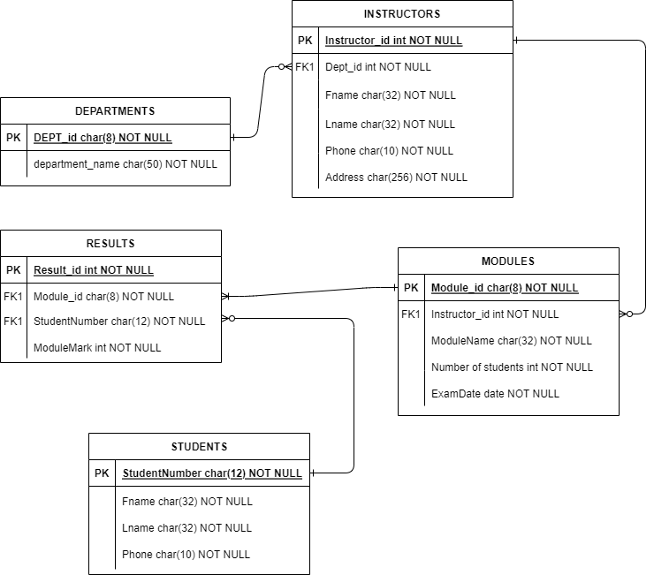

2.2
use EduEnrolment

2.3
db.Department.insertOne({"DepID": 1, "DepName": "IT Department" });
{
acknowledged: true,
insertedId: ObjectId('6666bba8fa307ceca5cdcdfa')
}
db.Students.insertOne({"StudentNumber": "STU001", "FName": "James", "LName": "Wright", "Phone": "0812682323" });
{
acknowledged: true,
insertedId: ObjectId('6666bc76fa307ceca5cdcdfb')
}
db.Instructors.insertOne({"InstructorID": 1, "Department_DepID": 1, "FName": "Wendy", "LName": "Tonga", "Phone": "0825632486", "Address": "17 Bicker Street, Midrand, Gauteng" });
{
acknowledged: true,
insertedId: ObjectId('6666bf6bfa307ceca5cdce00')
}
db.Modules.insertOne({"ModuleID": "CPP1513", "Instructors_InstructorID": 1, "ModuleName": "C++ Programming and development", "NumberOfStudents": 15, "ExamDate": "2024-07-01"});
{
acknowledged: true,
insertedId: ObjectId('6666c905fa307ceca5cdce05')
}
db.Results.insertOne({"ResultID": 1, "Modules_ModuleID": "CPP1513", "Students_StudentNumber ": "STU001", "ModuleMark": 85});
{
acknowledged: true,
insertedId: ObjectId('6666cc3dfa307ceca5cdce0a')
}

2.4
db.Department.insertMany([{"DepID": 2, "DepName": "Law Department"},
{"DepID": 3, "DepName": "Accounting Department"},
{"DepID": 4, "DepName": "Humanities and Art Department"},
{"DepID": 5, "DepName": "Science Department"}]);
{
acknowledged: true,
insertedIds: {
'0': ObjectId('6666bb39fa307ceca5cdcdf6'),
'1': ObjectId('6666bb39fa307ceca5cdcdf7'),
'2': ObjectId('6666bb39fa307ceca5cdcdf8'),
'3': ObjectId('6666bb39fa307ceca5cdcdf9')
}
}

db.Students.insertMany([{"StudentNumber": "STU002", "FName": "Lindsay", "LName": "Coleman", "Phone": "0712682223" }, {"StudentNumber": "STU003", "FName": "Dick", "LName": "Romans", "Phone": "0612612343" }, {"StudentNumber": "STU004", "FName": "Jacob", "LName": "White", "Phone": "0615234123" }, {"StudentNumber": "STU005", "FName": "Isak", "LName": "Pillay", "Phone": "0718543269" }]);
{
acknowledged: true,
insertedIds: {
'0': ObjectId('6666bd8dfa307ceca5cdcdfc'),
'1': ObjectId('6666bd8dfa307ceca5cdcdfd'),
'2': ObjectId('6666bd8dfa307ceca5cdcdfe'),
'3': ObjectId('6666bd8dfa307ceca5cdcdff')
}
}

db.Instructors.insertMany([{"InstructorID": 2, "Department_DepID": 2, "FName": "Jessica", "LName": "Hill", "Phone": "0716542389", "Address": "1 Kobalt Street, Midrand, Gauteng" }, {"InstructorID": 3, "Department_DepID": 3, "FName": "Phillip", "LName": "Setonga", "Phone": "0612354789", "Address": "8 Nice Lane, Sandton, Gauteng" }, {"InstructorID": 4, "Department_DepID": 4, "FName": "Lana", "LName": "Jacobsons", "Phone": "0630253461", "Address": "65 Loner Road, Edenvale, Gauteng" }, {"InstructorID": 5, "Department_DepID": 5, "FName": "Elias", "LName": "Ngwena", "Phone": "0812357896", "Address": "100 CloutMain Avenue, Sandton, Gauteng" }]);
{
acknowledged: true,
insertedIds: {
'0': ObjectId('6666c118fa307ceca5cdce01'),
'1': ObjectId('6666c118fa307ceca5cdce02'),
'2': ObjectId('6666c118fa307ceca5cdce03'),
'3': ObjectId('6666c118fa307ceca5cdce04')
}
}

db.Modules.insertMany([{"ModuleID": "ILW322", "Instructors_InstructorID": 2, "ModuleName": "Introduction to Law", "NumberOfStudents": 20, "ExamDate": "2024-07-11"},
{"ModuleID": "FAC428", "Instructors_InstructorID": 3, "ModuleName": "Financial Accounting", "NumberOfStudents": 28, "ExamDate": "2024-07-05"},
{"ModuleID": "HOA758", "Instructors_InstructorID": 4, "ModuleName": "History of Art", "NumberOfStudents": 17, "ExamDate": "2024-07-08"},
{"ModuleID": "ITB528", "Instructors_InstructorID": 5, "ModuleName": "Introduction in Biology", "NumberOfStudents": 30, "ExamDate": "2024-07-05"},]);
{
acknowledged: true,
insertedIds: {
'0': ObjectId('6666cb02fa307ceca5cdce06'),
'1': ObjectId('6666cb02fa307ceca5cdce07'),
'2': ObjectId('6666cb02fa307ceca5cdce08'),
'3': ObjectId('6666cb02fa307ceca5cdce09')
}
}
db.Results.insertMany([{"ResultID": 2, "Modules_ModuleID": "ILW322", "Students_StudentNumber": "STU002", "ModuleMark": 92},
{"ResultID": 3, "Modules_ModuleID": "FAC428", "Students_StudentNumber": "STU003", "ModuleMark": 71},
{"ResultID": 4, "Modules_ModuleID": "HOA758", "Students_StudentNumber": "STU004", "ModuleMark": 78},
{"ResultID": 5, "Modules_ModuleID": "ITB528", "Students_StudentNumber": "STU005", "ModuleMark": 89}]);
{
acknowledged: true,
insertedIds: {
'0': ObjectId('6666cd29fa307ceca5cdce0b'),
'1': ObjectId('6666cd29fa307ceca5cdce0c'),
'2': ObjectId('6666cd29fa307ceca5cdce0d'),
'3': ObjectId('6666cd29fa307ceca5cdce0e')
}
}

2.5
db.Students.find().sort({"FName": 1})
[
{
_id: ObjectId('6666bd8dfa307ceca5cdcdfd'),
StudentNumber: 'STU003',
FName: 'Dick',
LName: 'Romans',
Phone: '0612612343'
},
{
_id: ObjectId('6666bd8dfa307ceca5cdcdff'),
StudentNumber: 'STU005',
FName: 'Isak',
LName: 'Pillay',
Phone: '0718543269'
},
{
_id: ObjectId('6666bd8dfa307ceca5cdcdfe'),
StudentNumber: 'STU004',
FName: 'Jacob',
LName: 'White',
Phone: '0615234123'
},
{
_id: ObjectId('6666bc76fa307ceca5cdcdfb'),
StudentNumber: 'STU001',
FName: 'James',
LName: 'Wright',
Phone: '0812682323'
},
{
_id: ObjectId('6666bd8dfa307ceca5cdcdfc'),
StudentNumber: 'STU002',
FName: 'Lindsay',
LName: 'Coleman',
Phone: '0712682223'
}
]

2.6
db.Instructors.find().sort({"InstructorID": 1}, {"FName": -1})
[
{
_id: ObjectId('6666bf6bfa307ceca5cdce00'),
InstructorID: 1,
Department_DepID: 1,
FName: 'Wendy',
LName: 'Tonga',
Phone: '0825632486',
Address: '17 Bicker Street, Midrand, Gauteng'
},
{
_id: ObjectId('6666c118fa307ceca5cdce01'),
InstructorID: 2,
Department_DepID: 2,
FName: 'Jessica',
LName: 'Hill',
Phone: '0716542389',
Address: '1 Kobalt Street, Midrand, Gauteng'
},
{
_id: ObjectId('6666c118fa307ceca5cdce02'),
InstructorID: 3,
Department_DepID: 3,
FName: 'Phillip',
LName: 'Setonga',
Phone: '0612354789',
Address: '8 Nice Lane, Sandton, Gauteng'
},
{
_id: ObjectId('6666c118fa307ceca5cdce03'),
InstructorID: 4,
Department_DepID: 4,
FName: 'Lana',
LName: 'Jacobsons',
Phone: '0630253461',
Address: '65 Loner Road, Edenvale, Gauteng'
},
{
_id: ObjectId('6666c118fa307ceca5cdce04'),
InstructorID: 5,
Department_DepID: 5,
FName: 'Elias',
LName: 'Ngwena',
Phone: '0812357896',
Address: '100 CloutMain Avenue, Sandton, Gauteng'
}
]

2.7
db.Students.find( { FName: { $regex: /^A/i } } )
Tested but had no names starting with A so I tested the following for J:

EduEnrolment> db.Students.find( { FName: { $regex: /^J/i } } )
[
{
_id: ObjectId('6666bc76fa307ceca5cdcdfb'),
StudentNumber: 'STU001',
FName: 'James',
LName: 'Wright',
Phone: '0812682323'
},
{
_id: ObjectId('6666bd8dfa307ceca5cdcdfe'),
StudentNumber: 'STU004',
FName: 'Jacob',
LName: 'White',
Phone: '0615234123'
}
]

2.8
db.Modules.updateMany({"Instructors_InstructorID": 1},{$set:{"ModuleName":"Introduction to C++"}})
{
acknowledged: true,
insertedId: null,
matchedCount: 1,
modifiedCount: 1,
upsertedCount: 0
}
db.Modules.find({"Instructors_InstructorID":1})
[
{
_id: ObjectId('6666c905fa307ceca5cdce05'),
ModuleID: 'CPP1513',
Instructors_InstructorID: 1,
ModuleName: 'Introduction to C++',
NumberOfStudents: 15,
ExamDate: '2024-07-01'
}
]

2.9
db.Instructors.deleteOne({"InstructorID": 5})
{ acknowledged: true, deletedCount: 1 }

2.10
The collections of EduEnrolment has been added to the zip file.

References
Coronel, C. & Morris, S., 2022. Database Systems - Design, implementation, and management. 14th ed. Boston: Cengage Learning, Inc..
MongoDB, 2024. https://www.mongodb.com/. [Online]
Available at: https://www.mongodb.com/docs/manual/crud/
[Accessed 18 June 2024].

