USER PERSONAS

**Steven Jacobs**

* 25 years old
* PHD student studying philosophy
* Lives in Glasgow
* Single and doesn’t have many friends

“I can’t be bothered setting up any accounts”

“I love a cheeky Nandos”

Steve’s studies take up a lot of his time so when he has time to eat lunch he will want it to be quick to get and eat.

Having lots of spam emails already filling up his inbox, Steve does not want to give his information away to another website.

Steve generally only eats vegetables on special occasions, and happily eats unhealthy food if it saves him time and money.

Being a student, money can be tight, so being able to find the cheapest places to eat nearby would make his life easier.

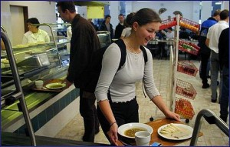**Harriet Cole**

* 23 years old
* Recently graduated into an office job
* In long distance relationship
* Big foodie
* Grew up & studied in Manchester
* Now lives in London
* Loves social media

*“I don’t eat the same cuisine 2 days in a row”*

*“Presentation really makes a good dish great!”*

Harriet recently graduated from Manchester University with a bachelor in Psychology. She now works as a marketing researcher for a large supermarket chain, the job required her to move to London after living in Manchester her whole life. Due to expensive house prices a large portion is spent on rent so she tries to save what money she can, however this doesn’t stop her spending money on nice food once in a while.

Harriet eats out for lunch every day she is working but being in a new city struggles to find the right place for her to eat as she enjoys eating a variety of cuisines.