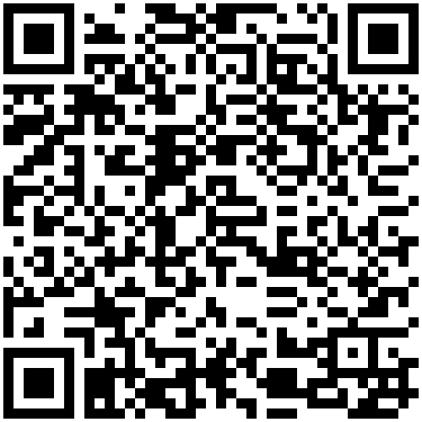

WESTERN MINDANAO STATE UNIVERSITY

CERTIFICATE OF REGISTRATION
Name  MAJID, JASMIN MONSANTO |  |  |  |  | Program  BSCS | Major |  |  |  | Student Number  2023-01224
College  COLLEGE OF COMPUTING STUDIES |  |  |  |  | Sem/SY  1ST 2025-2026 |  | Level  2
 |  |  |  | Particulars |  |  |  |  | Account Summary
BSCS125781  BSCS125781  BSCS125784  BSCS125784  BSCS125789  BSCS125789  BSCS125791  BSCS125791  BSCS125870  BSCS125870  BSCS125882  JEEP125049  TOTAL Units | SE 131  SE 131  ADS 133  ADS 133  CSE 131  CSE 131  CSE 133  CSE 133  OS 137  OS 137  CALC 139  EPIC1  21 | 2.00  0.00  2.00  0.00  2.00  0.00  2.00  0.00  2.00  0.00  3.00  0.00 | 0.00  1.00  0.00  1.00  0.00  1.00  0.00  1.00  0.00  1.00  0.00  3.00 | SOFTWARE 07:00AM-09:00AM S LR 1  ENGINEERING 1  SOFTWARE 11:30AM-02:30PM S LR 7  ENGINEERING 1  ADVANCED 03:00PM-05:00PM TH LAB 2  DATABASE SYSTEMS  ADVANCED 10:00AM-01:00PM TH LR 1  DATABASE SYSTEMS  CS ELECTIVE 1 01:00PM-03:00PM T LAB 2  CS ELECTIVE 1 01:00PM-04:00PM F LR 3  CS ELECTIVE 2 01:00PM-03:00PM M LR 2  CS ELECTIVE 2 08:30AM-11:30AM W LR 5  OPERATING SYSTEMS 09:00AM-11:00AM M LR 3  OPERATING SYSTEMS 01:00PM-04:00PM W LR 1  CALCULUS FOR 10:00AM-11:30AM TF LR 2  COMPUTER SCIENCE  EPIC START 1-A 04:00PM-05:30PM TF EPIC  LAB-A  Date Generated: 28/09/2025 12:49:56 PM |  |  |  |  | Total Charges 3670.00  Amount Paid 3670.00  __________  Total Balance 0
WMSU-REG-FR-021.00 This copy is uncontrolled unless stamped Effective Date: 26-April-2017
controlled by the Registrar

