NOTE:I did this activity on one of Lab computer so that’s why I have just saved screenshots of this activity.

Activity03:

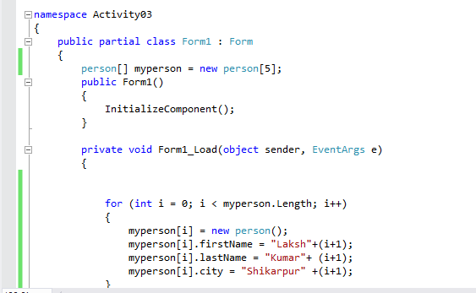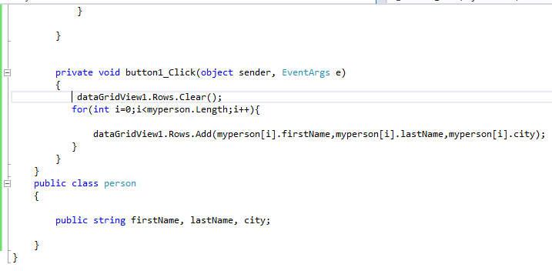

Output:

