Visual Programming

Lab 01

Sheeraz Ahmed

023-18-0014

Activity 01:

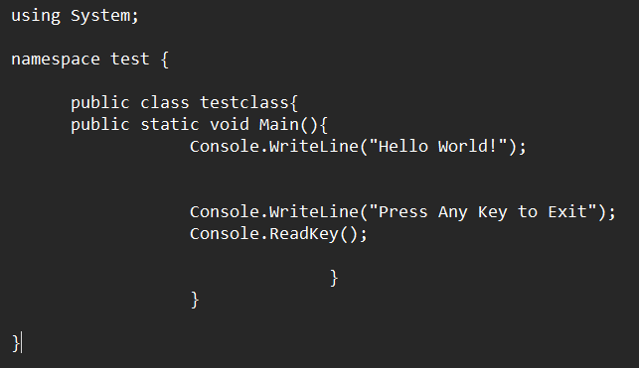

Output:

Activity02:

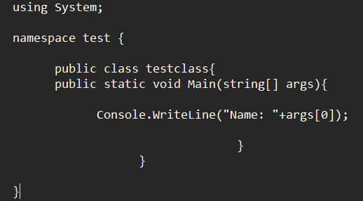

Output:

Activity03:

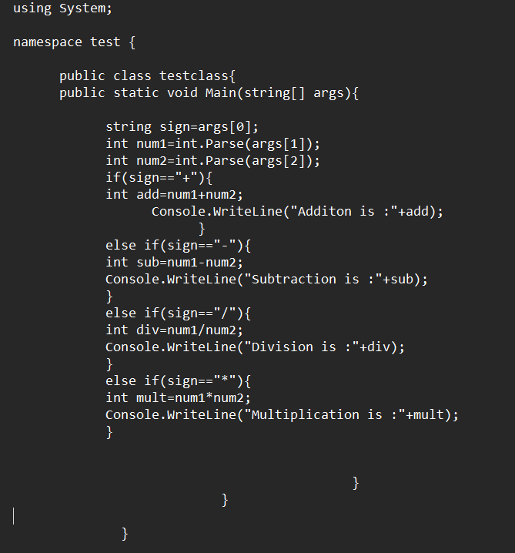

Output:

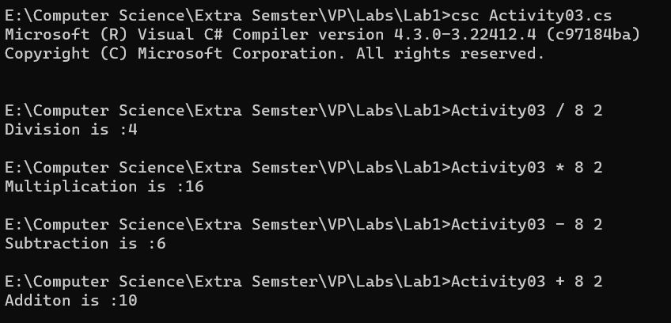

Activity04:

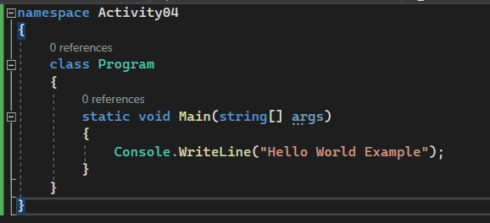

Output:

Activity 05:

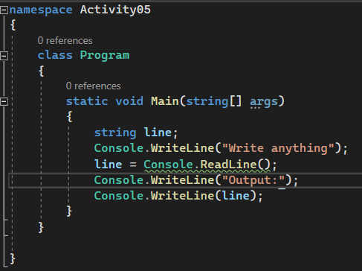

Output:

Activity06:

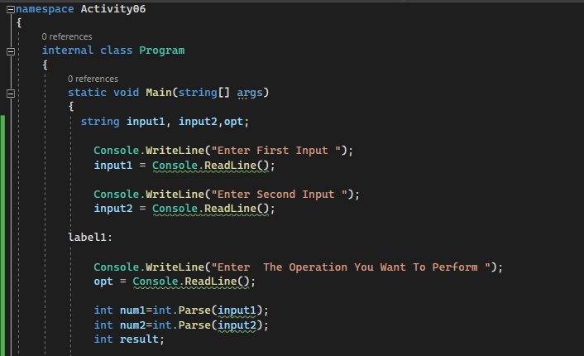

Output:

Activity07:

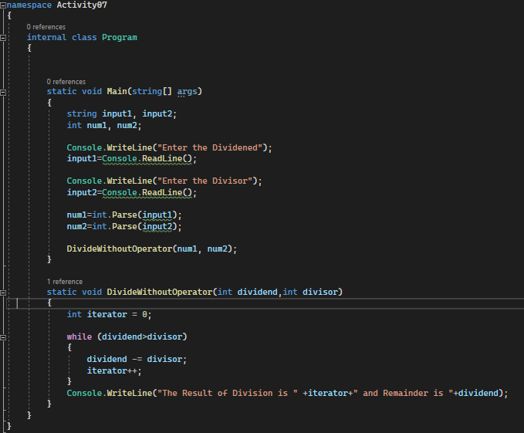

Output:

Activity08

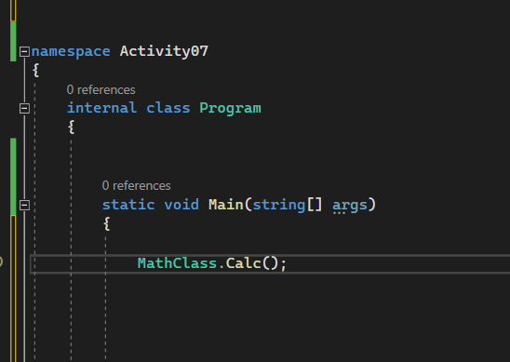

Output:

