**Visual Programming**

**Lab02**

Name: Sheeraz Ahmed

Cms:023-18-0014

Class: BS-V-SE

Activity01:

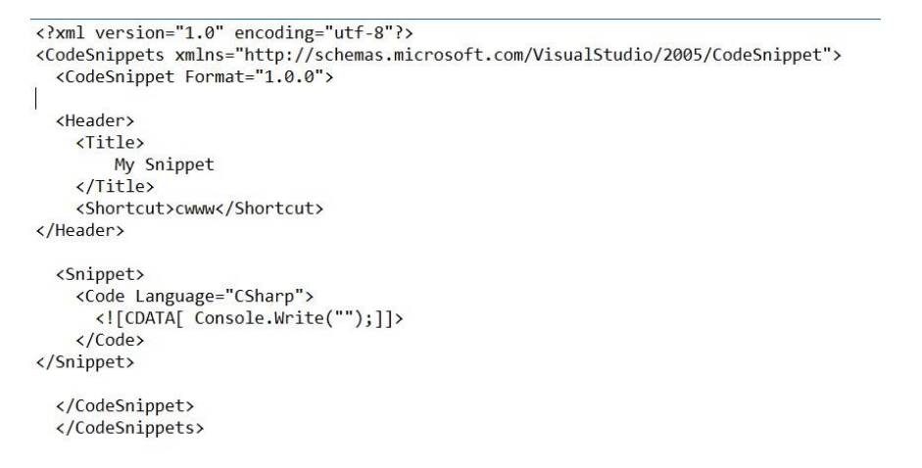

Output:

Write cwww and press tab 2 times.

The result will be that snippet will be Called.

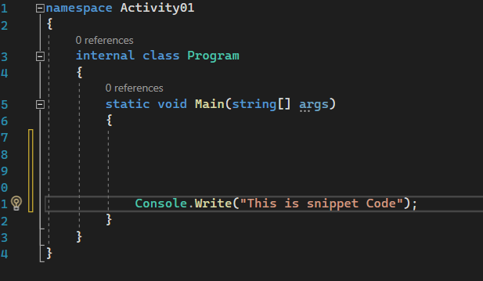

Activity 02:

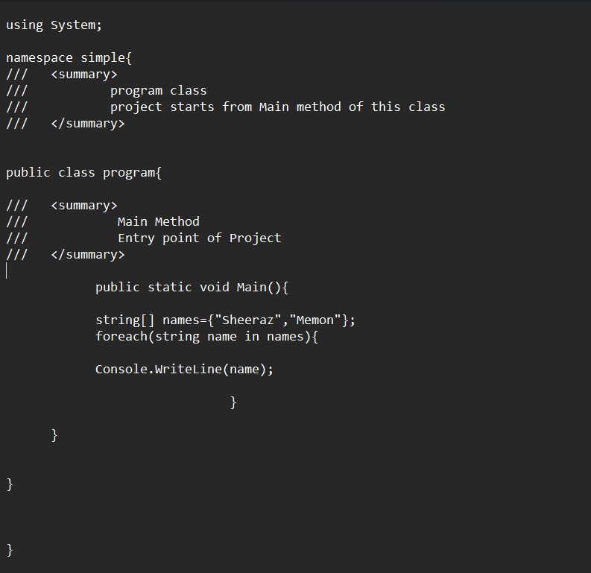

Output:

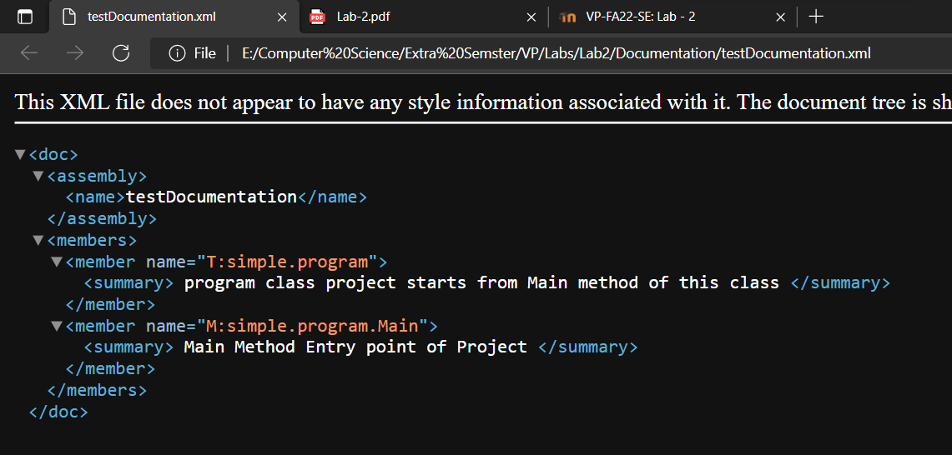

Activity_03:

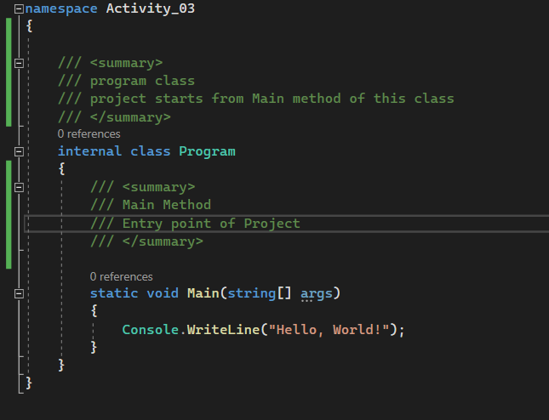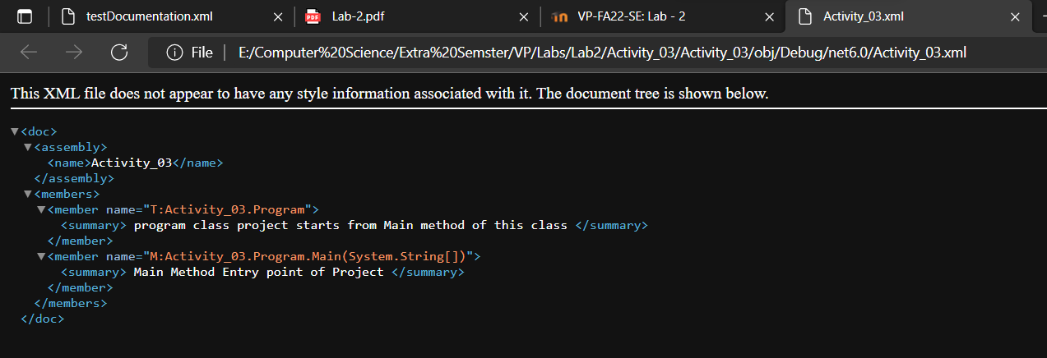

Activity 05:

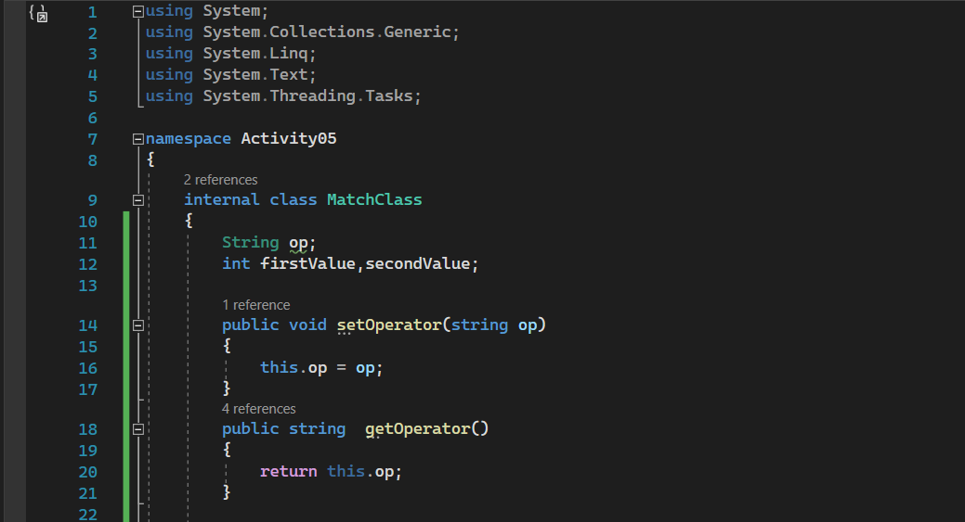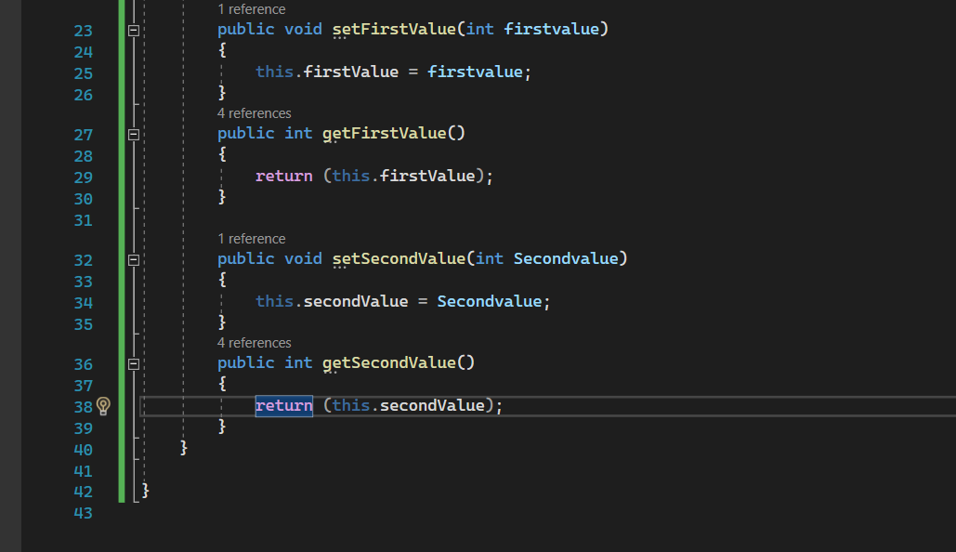

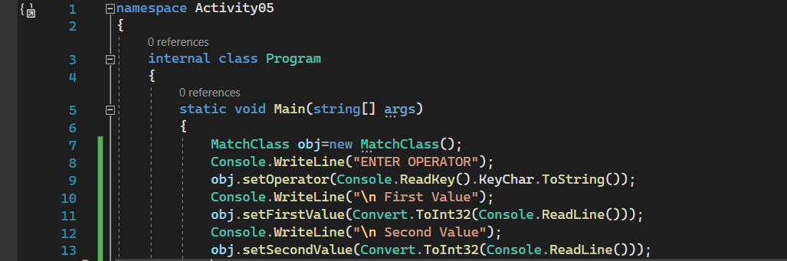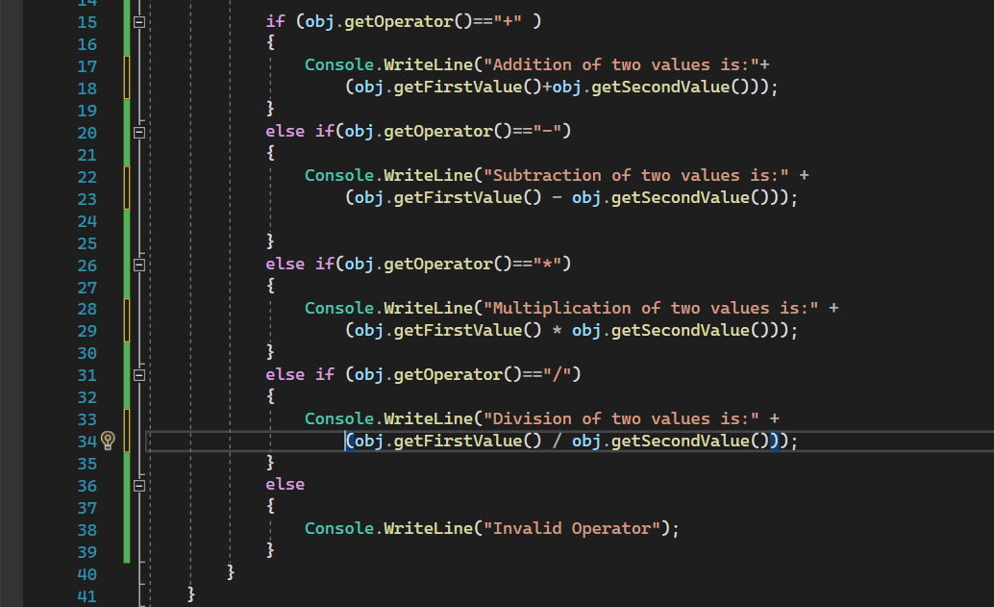

Output:

Activity06:

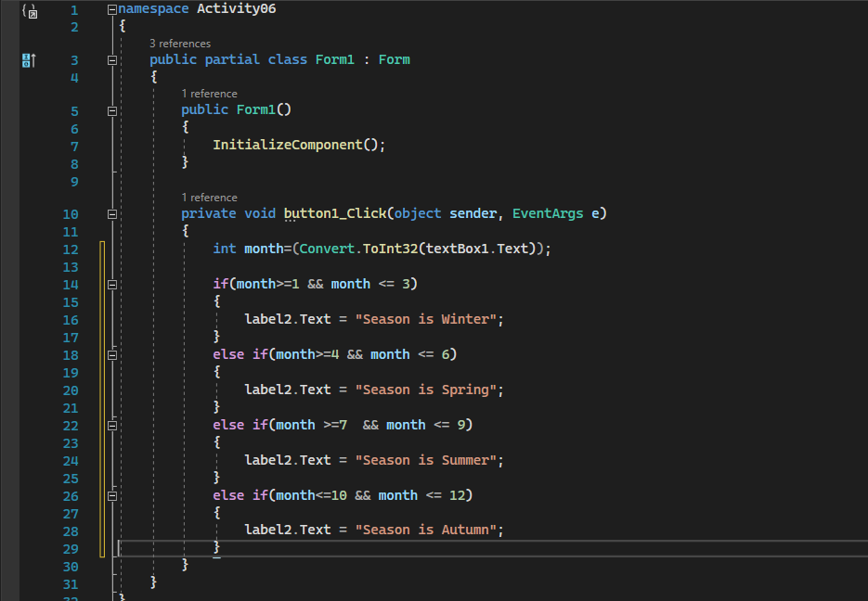

Activity07:

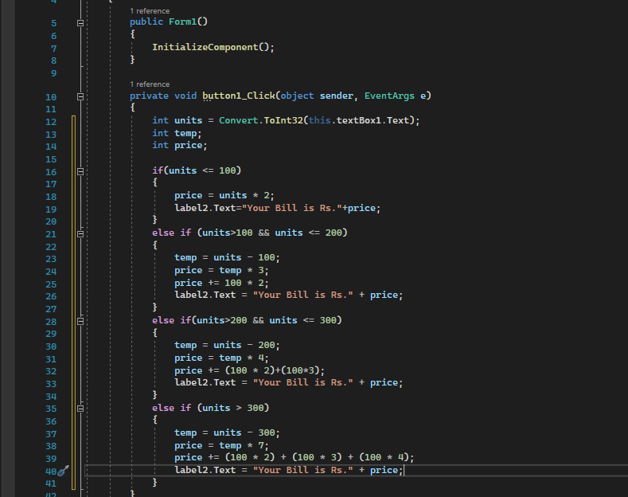

Output:

Activity08:

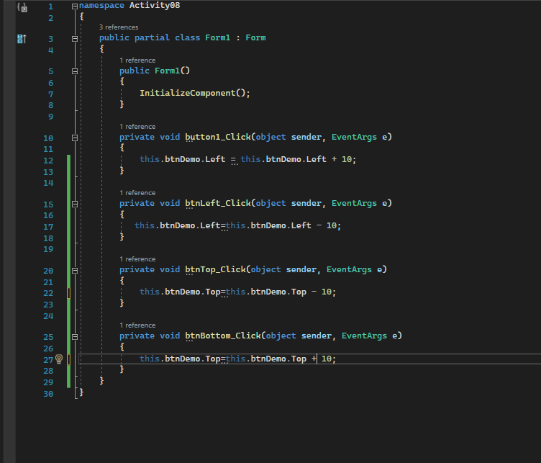

Output:

Activity09:

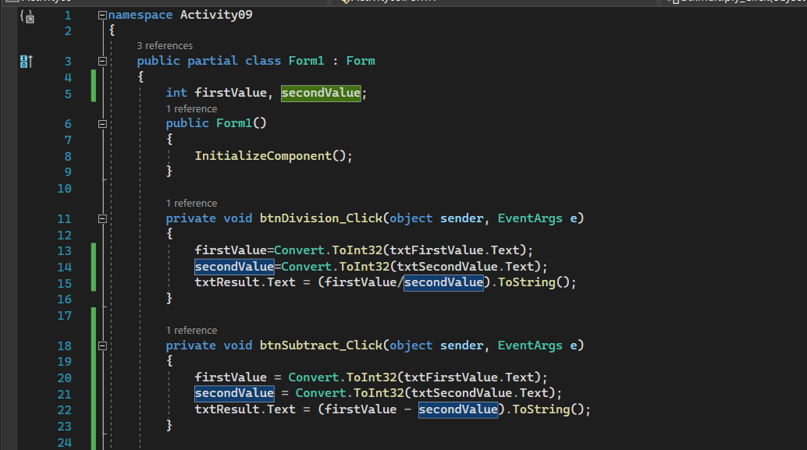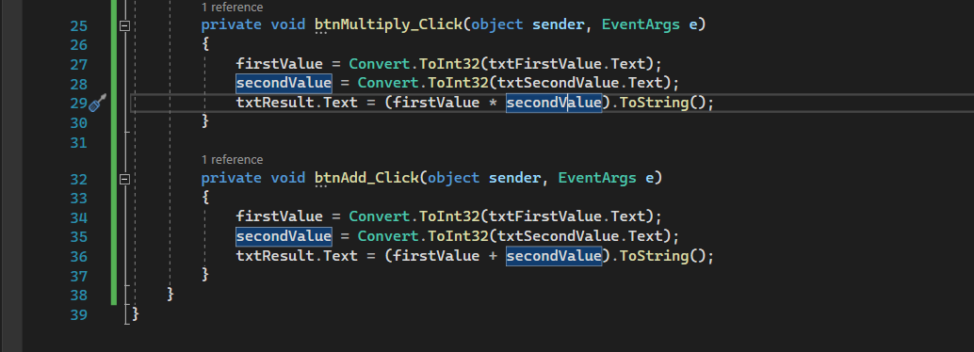

Output:

