|  |
| --- |
| **Visual programming** |
| **Semester V(SE) (Fall 2022)**  **Course Instructor(s): Nisar Ahmed** |
| **Name: Sheeraz Ahmed**  **Cms:023-18-0014** |

LAB 05

Activity01: 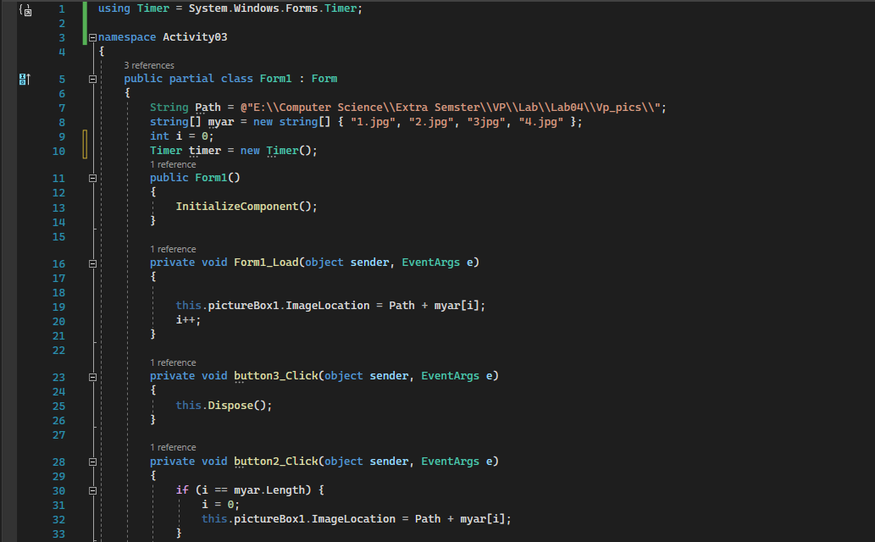

Output:

Activity02:Version1:

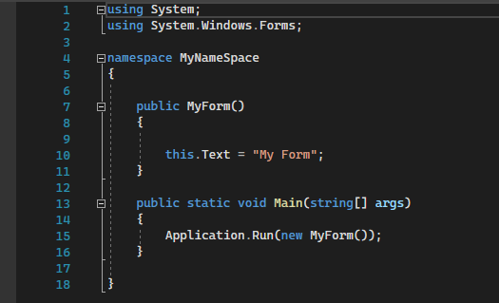

Activity02:version03:

Activity03:

Output:

Activity04:

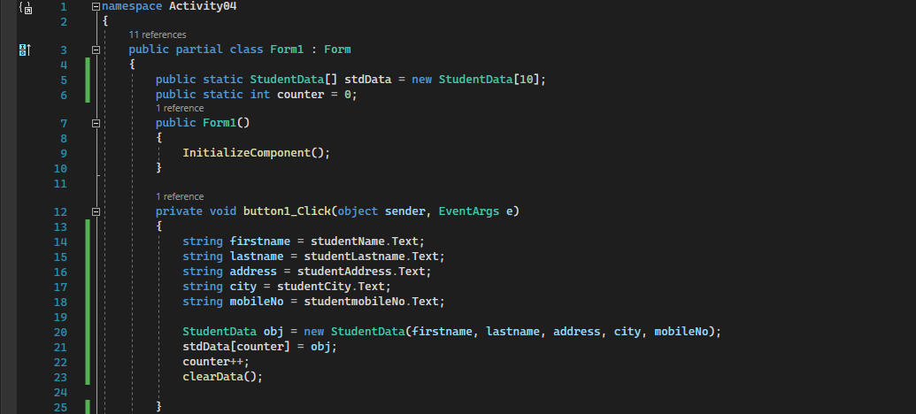

Output:

