**QUAID-I-AZAM UNIVERSITY OF ISLAMABAD**

**SOFTWARE CONSTRUCTION**



**Green Zone Connect**

**GROUP V – BSCS 5TH SEMESTER**

|  |  |
| --- | --- |
| **SYED SHEERAZ ALI SHAH** | **04072212001** |
| **AWAIS ALI** | **04072212045** |
| **KHURRAM SHAHZAD** | **04072212029** |

**SUBMITTED TO : MAM ONAIZA MAQBOOL**

**SUBMISSION DATE: 11th MARCH 2024**

### Use Case Diagram

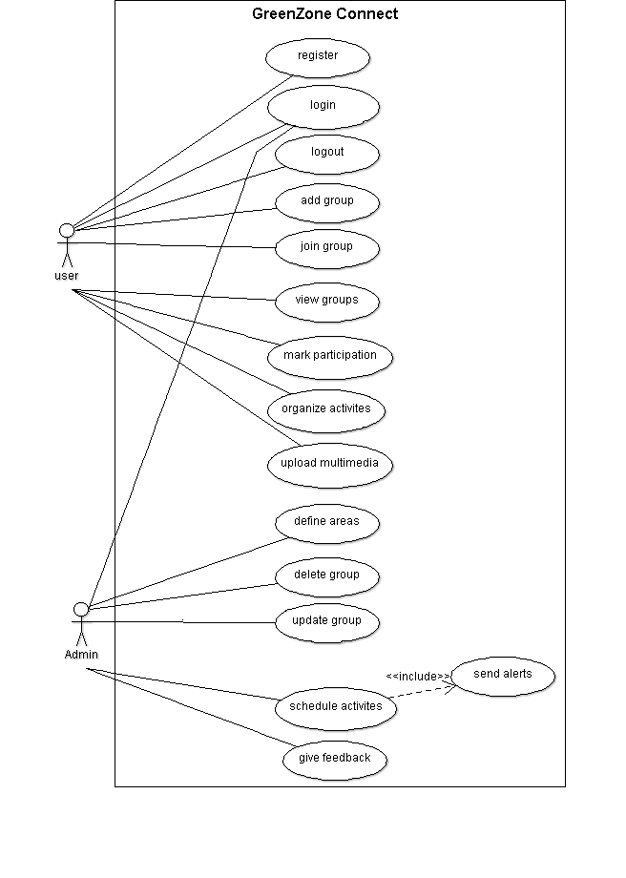Figure : Use Case Diagram

# Use Case Description

### Use case: Define areas

|  |  |
| --- | --- |
| **USE CASE ID** | UC-1 |
| **USE CASE NAME** | Define areas |
| **PRIMARY ACTOR** | Admin |
| **STAKE HOLDER AND INTEREST** | Admin: Interested in defining the area where event may take place. |
| **PRECONDITION** | Admin is logged in to the system |
| **POST CONDITION** | The areas will be saved in the system |
| **MAIN SUCCESS SCENARIO**  **(BASIC FLOW)** | 1. Admin select the option to define areas. 2. The system will display the form to enter the area details. 3. Admin fill area details. 4. Admin presses submit button. 5. The system will display a dialogue box with message “Area added successfully”. |
| **ALTERNATE FLOW**  **(EXTENSION)** | A: Mandatory Field not filled:  If the admin leaves the mandatory fields empty then the process will be as follows:   1. The system will display a dialogue box with message “Mandatory Field is missing”. |
| **SPECIAL REQUIREMENT TECHNOLOGY** | None |
| **FREQUENCY OF USE** | High |
| **SPECIAL ISSUES** | None |

Table : UC-1 Define Area by Sheeraz Ali Shah