EduPredict
Student Dropout Risk Prediction & Academic Analytics Portal
Big Data Course — eProject Report
Aptech Computer Education
Submitted by: Muhammad Shees
Final Semester Project

1. Introduction
EduPredict is a role-based academic analytics portal built to identify students at risk of dropping out and to recommend academic pathways, using real, live academic, attendance, and engagement data. The system was developed to satisfy the Big Data eProject requirements set by Aptech, which call for the use of Hadoop/HDFS for storage, parallel processing for large-scale data handling, machine learning for predictive analytics, and interactive dashboards for stakeholders.
Beyond the core dropout-risk requirement, EduPredict also includes three additional predictive tools — a matric-percentage field/college recommender, an intermediate-percentage university admission recommender, and a CGPA trend predictor — extending the platform from risk detection into broader academic guidance.
The system is used by four types of stakeholders — Administrators, Teachers, Students, and Analysts — each with a tailored view and permission set, and is deployed end-to-end on cloud infrastructure (MongoDB Atlas, Render, Vercel) so it can be accessed from any browser without local setup.

2. Objectives
- Predict student dropout risk using historical academic and behavioural data.
- Recommend likely academic field, college tier, university tier, and CGPA trend from a student's own metrics.
- Store and process large educational datasets using Hadoop (HDFS) and PySpark.
- Provide role-based, secure access to academic data, with self-service registration for every role.
- Visualize key metrics, trends, and anomalies through interactive dashboards.
- Notify stakeholders in real time when a student is flagged as high-risk.
- Provide a feedback/support channel for users.
- Run entirely on real, user-generated data — no demo or placeholder data ships with the application.

3. System Architecture
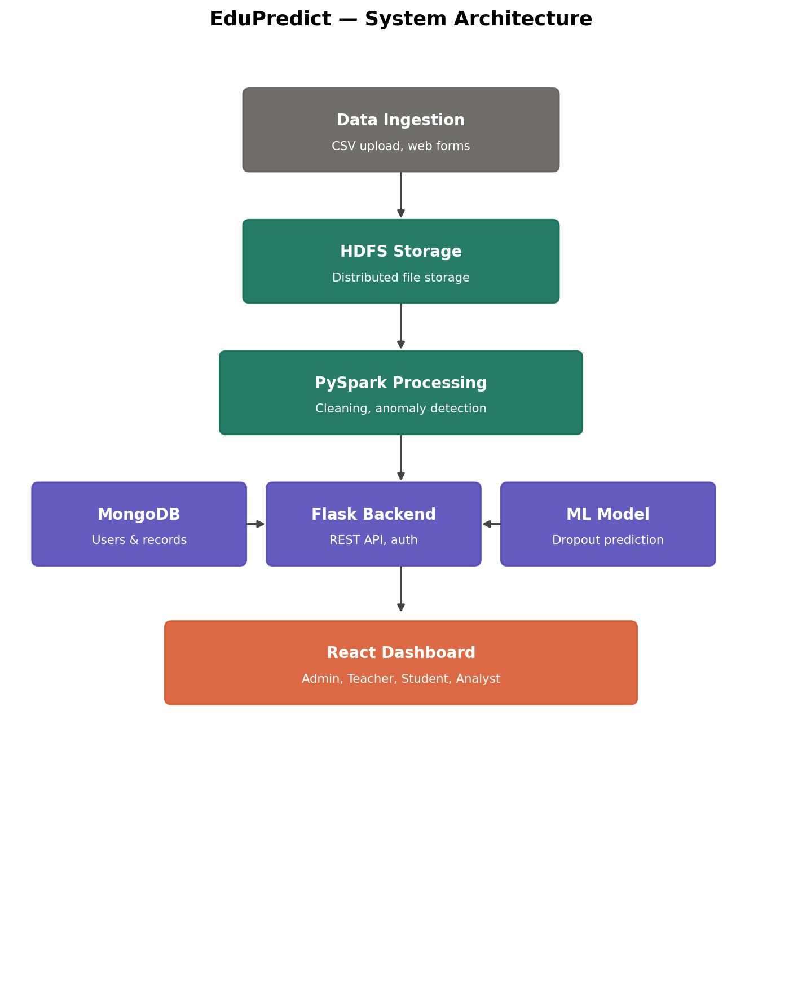
Figure 1: EduPredict system architecture — data flows from ingestion through HDFS and PySpark into the Flask/MongoDB/ML backend, out to the role-based React dashboard.

4. Data Flow Diagrams

4.1 Level 0 — Context Diagram
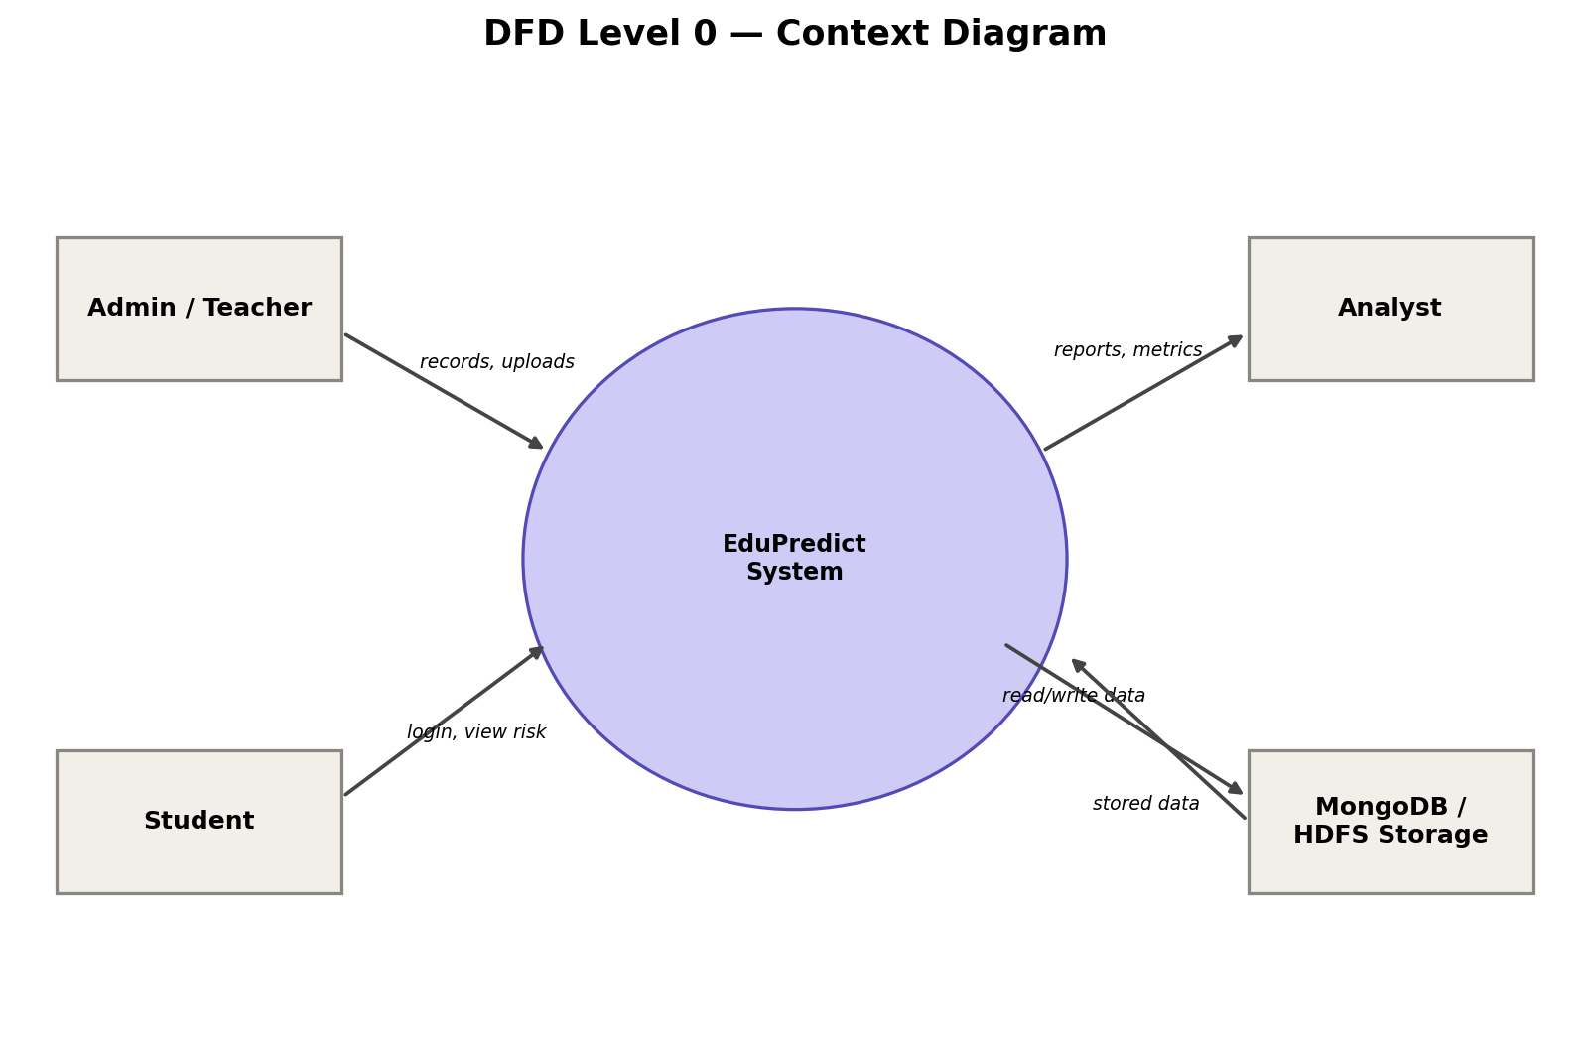
Figure 2: Context-level DFD showing external entities interacting with the EduPredict system.

4.2 Level 1 — Process Breakdown
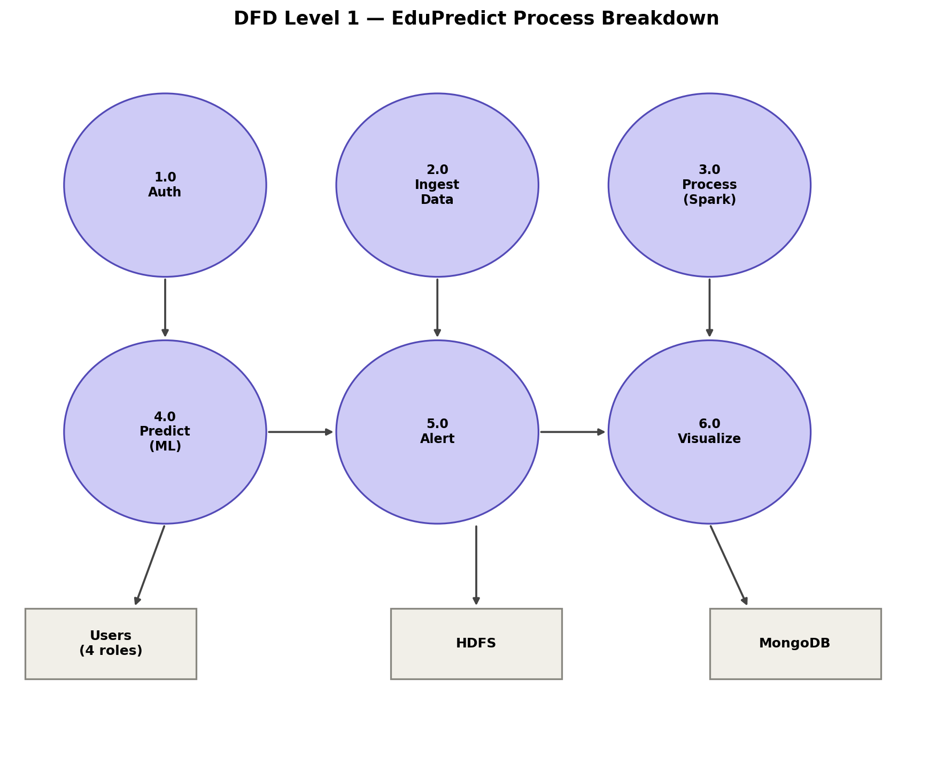
Figure 3: Level 1 DFD decomposing EduPredict into its six core processes.

5. Technology Stack
Layer | Technology | Purpose
Language | Python | Backend, ML, data pipeline
Storage | Hadoop HDFS (pseudo-distributed) | Scalable, fault-tolerant dataset storage
Processing | PySpark | Parallel cleaning, feature engineering, anomaly detection
Database | MongoDB Atlas (cloud) | Users, student records, alerts, feedback
Backend | Flask, hosted on Render | REST API, role-based session auth
ML | scikit-learn (Random Forest) | Dropout, field, university, and CGPA prediction
Frontend | React + Recharts, hosted on Vercel | Role-based interactive dashboards
Dev tools | VS Code, Jupyter Notebook | Development and model prototyping

6. Functional Requirements Coverage
Requirement | Status | Implementation
User authentication & authorization | Done | Flask sessions, 4 roles, self-service registration
Data ingestion | Done | CSV upload API + web forms + self-registration
HDFS storage | Done | Pseudo-distributed HDFS, dataset stored & read
Parallel data processing | Done | PySpark pipeline (cleaning, features)
Anomaly / pattern detection | Done | Spark anomaly flagging + correlation analysis
Real-time processing | Done | Server-Sent Events live alert stream
ML — dropout risk | Done | Random Forest, trained & serving live
ML — course/field demand | Done | Matric % -> field/college predictor
ML — university admission | Done | Intermediate % -> program/university predictor
ML — CGPA trend | Done | Regression model, next-semester GPA
Data visualization | Done | React + Recharts dashboards, 4 role views
Notifications & alerts | Done | Threshold-based, real-time push (no backlog replay)
Feedback & support | Done | In-app widget + admin review queue
No placeholder/demo data | Done | Database starts empty; all data is real, self-registered or uploaded

7. Setup & Installation

7.1 Prerequisites
- Python 3.10+, Node.js, MongoDB Community Server
- WSL2 with Ubuntu (for Hadoop/HDFS on Windows)
- Java 11 (OpenJDK), Hadoop 3.3.6, PySpark

7.2 Backend Setup
cd backend && pip install -r requirements.txt
python app.py

7.3 Frontend Setup
cd dashboard-app && npm install && npm run dev

7.4 HDFS / Spark Setup
- Format the NameNode: hdfs namenode -format
- Start HDFS: start-dfs.sh
- Push dataset: hdfs dfs -put data/students_sample.csv /edupredict/raw/
- Run pipeline: python3 spark/pyspark_pipeline.py

7.5 First-time use — no seeded accounts
The database starts completely empty — there is no demo/seed data. The first user creates an Admin account via the in-app "Create account" flow on the login screen, then all other users (Teacher, Analyst, Student) self-register the same way, or Admin/Teacher can bulk-upload student records via CSV.

8. Model Performance
All four models were trained on realistic synthetic datasets, since real institutional records were not available for this project. The dropout-risk Random Forest classifier was trained on 2,000 synthetic student records with an 80/20 train-test split. Key evaluation metrics:
Metric | Value
Accuracy | 75.8%
Precision | 59.2%
Recall | 61.7%
F1 Score | 60.4%
The two strongest predictors of dropout risk are average test score and attendance rate, consistent with the anomaly patterns flagged in the PySpark processing stage.
Important note on data: the training datasets for all four models (dropout risk, field/college, university admission, CGPA trend) are synthetically generated to mirror realistic patterns (e.g. merit-based admission bands), because real institutional records were not available. The application itself, however, runs on entirely real, live data — the database starts empty and is populated only through genuine user registration, CSV uploads, and live predictions. No demo or placeholder data ships with the application.

9. Future Work
- Retrain all four models on real institutional data once available, replacing the synthetic training sets.
- Move from a single-node HDFS setup to a multi-node cluster for true distributed storage.
- Add data encryption at rest and in transit for production deployment.
- Introduce automated model retraining on a scheduled basis as new data arrives.
- Add admin-side role approval for new registrations, rather than open self-registration.

10. Conclusion
EduPredict successfully demonstrates the application of Big Data technologies — HDFS for scalable storage, PySpark for distributed processing, and machine learning for predictive analytics — within a practical, role-based academic analytics portal. The system meets the functional requirements defined in the project specification, runs entirely on real user-generated data with no demo placeholders, and is deployed end-to-end on free-tier cloud infrastructure (MongoDB Atlas, Render, Vercel) so it can be demonstrated from any browser without local setup.

