MANIPAL INSTITUTE OF TECHNOLOGY
DEPARTMENT OF COMPUTER SCIENCE
B.Tech in Computer Science — Minor Specialization in Computational Intelligence
A Multi-Objective Evolutionary and Machine Learning
Hybrid Framework for Risk-Constrained Algorithmic Trading:
A Retrospective Walk-Forward Study on NSE Equities
A Minor Specialization Capstone Project Report Submitted in Partial Fulfillment
of the Requirements for the Degree of Bachelor of Technology in Computer Science
Submitted by:
Ashish Ranjan
Khuushi Maheshwari
Satyanarayan H.
Department of Computer Science
Project Supervisor:
_____________________________________
Department of Computer Science
Manipal Institute of Technology
October 2026

[DRAFT SUBMISSION NOTICE]
OPTIONAL DRAFT TEMPLATE (NOT CERTIFIED / UNSIGNED). The following certificate and declaration pages are uncertified draft templates provided solely for administrative review. Official institutional certification requires formal signature and departmental approval.

CERTIFICATE OF APPROVAL
(DRAFT TEMPLATE — NOT SIGNED)
This is to certify that the Minor Specialization Capstone Project Report entitled 'A Multi-Objective Evolutionary and Machine Learning Hybrid Framework for Risk-Constrained Algorithmic Trading: A Retrospective Walk-Forward Study on NSE Equities' is a draft record of work carried out by Ashish Ranjan, Khuushi Maheshwari, and Satyanarayan H. in partial fulfillment of the requirements for the award of the degree of Bachelor of Technology in Computer Science (Minor Specialization in Computational Intelligence) at the Manipal Institute of Technology, Manipal, during the academic year 2026.
Project Supervisor: Head of Department:
_______________________ _______________________
Internal Examiner: External Examiner:
_______________________ _______________________

CANDIDATES' DECLARATION
(DRAFT TEMPLATE — NOT SIGNED)
We hereby declare that this project report titled 'A Multi-Objective Evolutionary and Machine Learning Hybrid Framework for Risk-Constrained Algorithmic Trading' submitted to the Department of Computer Science, Manipal Institute of Technology, represents academic project work executed by us. All literature sources, primary academic citations, and open-source computational tools used in this study have been referenced and acknowledged. We confirm that all reported experimental metrics, tables, and figures have been strictly generated from executable code and local data snapshots, without manual falsification, statistical fabrication, or plagiarism.
Ashish Ranjan
Khuushi Maheshwari
Satyanarayan H.
Department of Computer Science
Manipal Institute of Technology, October 2026
ACKNOWLEDGEMENTS
We express our gratitude to the Department of Computer Science, Manipal Institute of Technology, for providing the academic infrastructure and computational environment required to complete this minor specialization research project. We also acknowledge the open-source scientific Python community for maintaining foundational software libraries—including LightGBM, Numba, NumPy, Pandas, Scikit-learn, and Streamlit—which made high-performance, reproducible simulation possible.

PROJECT ABSTRACT
Modern computational intelligence systems in quantitative finance face severe real-world challenges stemming from non-stationary market regimes, low signal-to-noise ratios, and the divergence between statistical classification loss and portfolio equity dynamics. This minor specialization capstone project presents a comprehensive, reproducible Two-Tier Computational Intelligence (CI) system evaluated through a retrospective 6-year walk-forward campaign across three large-cap National Stock Exchange of India (NSE) equities: Reliance Industries (RELIANCE.NS), Tata Consultancy Services (TCS.NS), and Infosys (INFY.NS) over 2020–2025 (1,487 trading days per asset).
In Tier 1, a LightGBM gradient-boosted decision tree is trained on 20 technical momentum, trend, volatility, and volume indicators to forecast 3-day forward directional returns with market volatility regime detection. In Tier 2, the Non-dominated Sorting Genetic Algorithm II (NSGA-II) evolves continuous trading rule chromosomes (entry/exit probability hurdles, dynamic ATR stop-loss and take-profit multipliers, trailing stops, and volatility-conditioned position sizing) to simultaneously optimize Annualized Sharpe Ratio and Maximum Drawdown. A custom vectorized simulator enforces strict next-bar Open execution, commissions and slippage (0.05% commission + 0.05% slippage per side, approximately 10 bps per side, 20 bps round-trip; sensitivity testing doubles both components to 0.10% commission + 0.10% slippage per side, 0.20% per side, approximately 40 bps round-trip), opening gaps, conservative intrabar bracket conflict resolution, horizon purging, and scheduled fold-end liquidation barring final-day entries.
The empirical results provide key scientific insights: LightGBM achieves an average out-of-sample directional AUC of 0.5324, a test accuracy of 52.68% (vs training-class base rate 52.66%), and no Brier score improvement (0.2501 vs baseline 0.2500). The Full Hybrid strategy dampens annual maximum drawdown in 17 out of 18 folds (94.4%). However, by remaining defensively in cash during sustained expansions, the Hybrid underperforms Buy & Hold in 13 out of 18 folds (72.2%), compounding 6-year seed-median returns of -0.35% (RELIANCE.NS), +25.60% (TCS.NS), and +9.10% (INFY.NS), compared to Buy & Hold compound growth of +128.74%, +65.13%, and +152.78%, respectively. An evolutionary ablation without ML signals yields comparable or higher returns. These findings document the substantial opportunity costs of defensive capital allocation and establish the necessity of reproducible, causal simulation in financial AI.

TABLE OF CONTENTS
CHAPTER 1 Introduction & Problem Definition 6
CHAPTER 2 Literature Review & Theoretical Foundations 6
CHAPTER 3 System Architecture & Mathematical Formulation 7
CHAPTER 4 Data Engineering & Walk-Forward Protocol 8
CHAPTER 5 High-Performance Vectorized Simulator Mechanics 9
CHAPTER 6 Empirical Results & Comparative Evaluation 9
CHAPTER 7 Automated Verification, Unit Testing & Reproducibility 13
CHAPTER 8 Methodological Limitations & Research Boundaries 13
CHAPTER 9 Conclusion & Future Directions 14
REFERENCES 14

CHAPTER 1
Introduction & Problem Definition

1.1 Background & Motivation
Financial market forecasting represents one of the most intellectually challenging domains in computational intelligence. Unlike computer vision or speech recognition where underlying data-generating distributions remain stationary over time, financial time-series are characterized by time-varying dynamics, extreme noise, structural regime shifts, and reflexive feedback loops [1], [5]. A common pitfall in applied computer science projects is treating stock trading as a pure supervised regression or classification problem. Directional accuracy alone does not determine portfolio profitability because trade payoff distributions, position sizing, stop-loss mechanics, and transaction friction also matter [3].
Conversely, pure rule-based algorithmic trading strategies rely on static technical indicators that suffer catastrophic drawdowns during macroeconomic shocks. What is required is a dual architecture: statistical machine learning to extract subtle probabilistic edges from high-dimensional indicators, coupled with multi-objective metaheuristics to evolve dynamic risk-management policies that directly optimize the portfolio equity trajectory.

1.2 Objectives of the Capstone Study
This project pursues four core engineering and scientific objectives: (1) Build an auditable feature engineering pipeline extracting 20 momentum, trend, volatility, and volume indicators alongside an expanding-window volatility regime detector; (2) Implement a LightGBM gradient-boosted classifier to estimate forward 3-day directional probabilities with validation early stopping; (3) Implement an NSGA-II multi-objective genetic algorithm that evolves 7-dimensional real-valued chromosomes optimizing Annualized Sharpe Ratio and Maximum Drawdown; (4) Execute a rigorous retrospective walk-forward evaluation across six annual folds (2020–2025) on three NSE equities (RELIANCE.NS, TCS.NS, INFY.NS) with complete offline reproducibility, transaction costs, and horizon purging.

CHAPTER 2
Literature Review & Theoretical Foundations

2.1 Market Efficiency & Technical Predictability
The theoretical foundation of market predictability is rooted in Eugene Fama's Efficient Market Hypothesis (EMH) [6]. Under the weak-form EMH, current asset prices fully reflect all information contained in historical trading data. Consequently, technical analysis rules cannot consistently generate risk-adjusted excess returns (alpha) net of transaction costs. In modern econometric literature, Halbert White [5] demonstrated that apparent historical outperformance is frequently an artifact of data snooping bias: when researchers evaluate thousands of rule combinations, the best-performing rule often reflects luck rather than predictive skill. Bailey and López de Prado [4] formalized this phenomenon through the Deflated Sharpe Ratio (DSR), which statistically adjusts observed performance for selection bias and non-normal return distributions.

2.2 Purging, Embargoing & Causal Simulation Integrity
In Advances in Financial Machine Learning, Marcos López de Prado [3] identified temporal leakage as the primary reason why financial machine learning models collapse when deployed out-of-sample. When multi-day forward targets are assigned to daily bars, consecutive samples share overlapping information. Traditional random k-fold cross-validation leaks forward-looking information into the training set. To enforce causal integrity, chronological train/validation/test splits must incorporate horizon purging: dropping trailing samples equal to the forward label horizon (H=3) prior to split boundaries.

2.3 Evolutionary Multi-Objective Optimization & Gradient Boosting
The Non-dominated Sorting Genetic Algorithm II (NSGA-II) developed by Deb et al. [1] represents a benchmark standard in multi-objective evolutionary computation. NSGA-II addresses the computational bottlenecks of early genetic algorithms through fast non-dominated sorting, elitist parent-offspring combining, and a parameter-less crowding distance operator that preserves population diversity along the Pareto front. In tabular machine learning, Ke et al. [2] introduced LightGBM, which leverages Gradient-based One-Side Sampling (GOSS) and Exclusive Feature Bundling (EFB) to deliver rapid, memory-efficient tree boosting, making it an ideal candidate for low-latency financial signal generation.

CHAPTER 3
System Architecture & Mathematical Formulation

3.1 Two-Tier Computational Intelligence Architecture
The system decouples directional prediction from risk-constrained decision execution across two computational tiers: Tier 1 functions as a statistical feature extractor and probabilistic classifier, producing conditional directional probabilities p_hat_t = P(y_t = 1 | x_t). Tier 2 acts as a metaheuristic policy engine, searching continuous trading rule parameters to balance risk and return directly on portfolio equity.
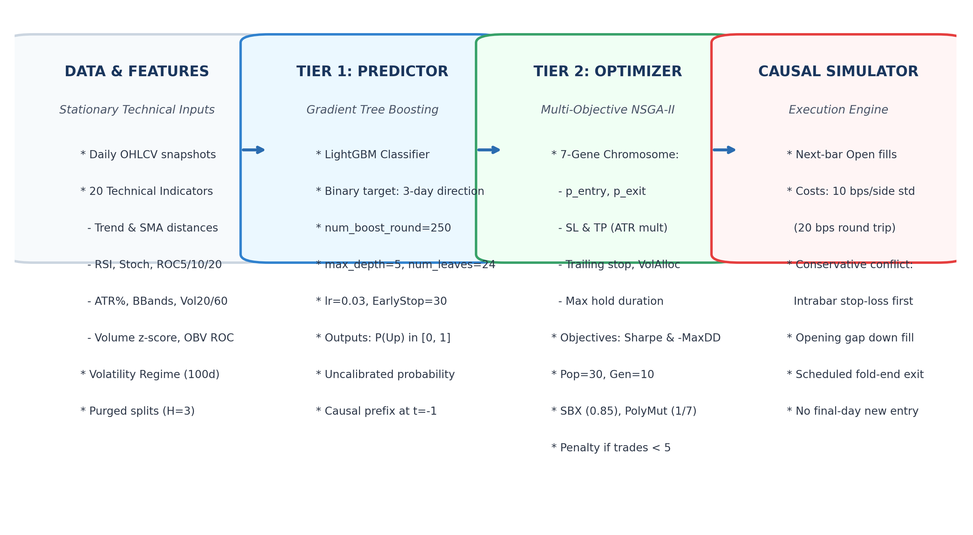
Figure 3.1. Two-Tier Computational Intelligence system architecture: Data engineering with purged splits (H=3), Tier 1 LightGBM classifier, Tier 2 NSGA-II optimizer, and causal backtest engine.

3.2 Chromosome Encoding & Parameter Bounds
Each candidate trading strategy is represented as a real-valued chromosome of length 7: g = [p_entry, p_exit, SL, TP, Trail, VolAlloc, MaxHold], bounded strictly by domain constraints:
Gene Index | Parameter Name | Valid Bounds | Operational Function
g_0 | p_entry | [0.52, 0.85] | Model probability hurdle required to queue a long entry
g_1 | p_exit | [0.35, 0.50] | Model probability threshold triggering queued exit
g_2 | SL Multiplier | [1.0, 4.5] x ATR | Dynamic ATR stop-loss distance below fill price
g_3 | TP Multiplier | [1.5, 7.0] x ATR | Dynamic ATR take-profit target above fill price
g_4 | Trailing Stop | [0.01, 0.06] | Peak-profit trailing stop-loss fraction (1% to 6%)
g_5 | VolAlloc | [0.10, 1.00] | Capital allocation multiplier in high-volatility regimes
g_6 | MaxHold | [5.0, 45.0] Bars | Maximum time-based holding duration in sessions

3.3 Bi-Objective Optimization Formulation & Operators
NSGA-II evaluates each candidate chromosome across the 2-year Development partition under two conflicting objective functions: (1) Maximize Annualized Sharpe Ratio f_1 = (mu_r / sigma_r) * sqrt(252) (assuming a 0.0% risk-free rate); (2) Minimize Maximum Drawdown f_2 = max_t ((Peak_t - Equity_t) / Peak_t). A candidate solution a Pareto-dominates solution b (a dominates b) if f_1(a) >= f_1(b) and f_2(a) <= f_2(b), with at least one strict inequality.
Evolutionary search uses population size N=30 across G=10 generations. Variation operators comprise Simulated Binary Crossover (SBX, crossover probability pc=0.85, distribution index eta_c=15) and Polynomial Mutation (per-gene mutation probability pm = 1/7, distribution index eta_m=20). To penalize inactivity during development, candidate rules generating fewer than 5 completed trades receive a fitness penalty: Sharpe is decremented by 2.0 (Sharpe -= 2.0) and Maximum Drawdown is floored at 0.5 (MaxDD = max(MaxDD, 0.5)). Following search, the solution with the highest development Sharpe ratio among feasible candidate rules (those with >= 5 completed development trades) is selected as the representative trading policy. If no candidate completes >= 5 trades, the system defaults to 100% Cash during test evaluation.

CHAPTER 4
Data Engineering & Walk-Forward Protocol

4.1 Data Acquisition & Snapshot Manifest
To guarantee complete offline reproducibility, historical daily OHLCV series for Reliance Industries (RELIANCE.NS), Tata Consultancy Services (TCS.NS), and Infosys (INFY.NS) were cached in immutable Apache Parquet format under reports/experiments/inputs/. Cryptographic SHA-256 hashes for all snapshots are tracked in manifest.json. Historical prices reflect Yahoo Finance dividend- and split-adjusted series (auto_adjust=True), ensuring corporate actions do not induce artificial price discontinuities.

4.2 20 Engineered Technical Indicators
The feature pipeline computes 20 technical and regime indicators matching FEATURE_COLUMNS in rolling_runner.py: (1) Trend Distances: percentage distances to 10-day, 50-day, and 200-day Simple Moving Averages (dist_sma_10, dist_sma_50, dist_sma_200); (2) Momentum Indicators: MACD ratio (macd / close), MACD histogram, 14-day RSI (rsi_14), Stochastic %K and %D (stoch_k, stoch_d), and Rate of Change over 5, 10, and 20 days (roc_5, roc_10, roc_20); (3) Volatility Indicators: ATR percentage (atr_14 / close), 20-day and 60-day annualized realized return volatility (volatility_20, volatility_60), Bollinger Bands %B (bb_pct_b), and Bandwidth (bb_width); (4) Volume Indicators: 20-day volume z-score (volume_zscore) and 5-day On-Balance Volume Rate of Change (obv_roc_5); (5) Market Regimes: Volatility Regime flag (regime_high_vol = 1 if volatility_20 exceeds its rolling 100-day median, else 0) and Trend Regime flag (regime_trend = 1 if Close > SMA50 > SMA200; -1 if Close < SMA50 < SMA200; 0 otherwise). No stationarity transformations or unit root tests are claimed; features are fed directly as continuous inputs.

4.3 Chronological Partitions & Horizon Purging
For each test year Y in [2020, 2025], data partitions are strictly partitioned: Training [Y-8, Y-4] (5 years, trailing 3 bars purged); Validation [Y-3] (1 year, trailing 3 bars purged); Development [Y-2, Y-1] (2 years, NSGA-II search, trailing 3 bars purged); and Test [Y] (1 year, out-of-sample). Purging the trailing 3 bars of training and validation prevents the 3-day forward target from overlapping into adjacent out-of-sample sets. On the test partition, the final 3 bars are masked from classification scoring because their forward targets resolve after the test window.

CHAPTER 5
High-Performance Vectorized Simulator Mechanics

5.1 Next-Bar Execution & Causal Timing
The backtest engine executes strictly on the Open price following signal generation: if LightGBM probability p_hat_t >= p_entry at bar t Close, a long position is queued and filled at bar t+1 Open at price P_entry = Open_{t+1} * (1 + slip). Same-bar fill prices are prohibited. The first trade on test bar 0 utilizes causal prefix context (probability and regime state) evaluated at the final session of the Development partition (t=-1), ensuring seamless multi-year continuity.

5.2 Intrabar Bracket Ordering & Friction Policies
To avoid optimistic fill bias, the simulator enforces strict intraday priority rules: (1) Stop-Loss Priority: If the session Low touches the stop-loss and the session High touches the take-profit on the same day, the stop-loss is prioritized; (2) Opening Gaps: Opening gap downs below the stop price execute at the open price with slippage penalty; (3) Zero-Volume Prohibition: Zero-volume bars cannot execute trades; (4) Scheduled Fold-End Liquidation: Prohibits new position entries on the final tradable session (i < last_tradable_idx) and liquidates open positions at final session Close; (5) Transaction Costs: Standard friction is 0.05% commission and 0.05% slippage per side (approximately 10 bps per side, 20 bps round-trip); sensitivity testing doubles both components to 0.10% commission and 0.10% slippage per side (0.20% per side, approximately 40 bps round-trip).

CHAPTER 6
Empirical Results & Comparative Evaluation

6.1 Classification Performance & Model Diagnostics
All LightGBM classifiers were fitted with parameters: num_boost_round=250, early_stopping=30, learning_rate=0.03, max_depth=5, and num_leaves=24 on historical training and validation partitions. The final 3 bars of each annual test fold were masked from classification scoring because their 3-day forward targets extend beyond the fold window. Table 6.1 details out-of-sample classification performance across all 18 annual folds. Across the entire campaign, the classifier achieved an average out-of-sample AUC of 0.5324, an accuracy of 52.68% (compared to the training-class majority base rate of 52.66%), and no Brier score improvement (0.2501 vs baseline 0.2500). Asset-specific mean AUCs were 0.5469 for RELIANCE.NS, 0.5304 for TCS.NS, and 0.5199 for INFY.NS. These metrics reflect a small average AUC above 0.5, near-equal accuracy to majority training priors, and no Brier score improvement in liquid Indian equity markets.
Asset | Mean AUC | Min AUC | Max AUC | Test Acc | Base Acc | Brier | Scored N
RELIANCE.NS | 0.5469 | 0.4415 | 0.6246 | 52.01% | 52.21% | 0.2494 | 244.8
TCS.NS | 0.5304 | 0.4774 | 0.6182 | 50.91% | 50.78% | 0.2516 | 244.8
INFY.NS | 0.5199 | 0.4509 | 0.5766 | 55.12% | 54.99% | 0.2493 | 244.8
Table 6.1. LightGBM out-of-sample directional classification performance across 18 annual folds (2020–2025).

6.2 Stitched Multi-Year Compounded Returns
Stitched multi-year curves carry capital forward across test folds by compounding annual net wealth ratios starting from ₹100,000 on 2020-01-01 across 1,487 trading bars through 2025-12-31. Note that Buy & Hold is evaluated under an annually liquidated and re-entered convention at fold boundaries matching the strategy's annual evaluation, incurring transaction friction each year. Table 6.2 reports terminal compound performance. Multi-seed variants present medians and min-max ranges across all three evolutionary seeds (42, 43, 44); note that metric-wise medians across seeds are evaluated independently per metric and may correspond to different seed runs rather than a single executable median strategy. Across all three assets, Buy & Hold compounded significantly higher final wealth than the Full Hybrid: RELIANCE.NS Buy & Hold grew +128.74% (₹228,740) vs Hybrid Seed Median -0.35% (₹99,652); TCS.NS Buy & Hold grew +65.13% (₹165,134) vs Hybrid Seed Median +25.60% (₹125,600); and INFY.NS Buy & Hold grew +152.78% (₹252,783) vs Hybrid Seed Median +9.10% (₹109,103).
Asset | Strategy Variant | Total Ret | CAGR | Sharpe | MaxDD | Terminal ₹
RELIANCE.NS | Buy & Hold | +128.74% | 15.05% | 0.64 | 44.08% | ₹228,740
 | Full Hybrid (Median) | -0.35% | -0.06% | 0.04 | 23.01% | ₹99,652
 | Full Hybrid (Range) | [-6.58%, +5.18%] | [-1.15%, +0.86%] | [-0.07, 0.14] | [21.88%, 26.18%] | [₹93k, ₹105k]
 | No-ML Ablation (Median) | +42.42% | 6.18% | 0.45 | 20.03% | ₹142,415
TCS.NS | Buy & Hold | +65.13% | 8.87% | 0.48 | 34.57% | ₹165,134
 | Full Hybrid (Median) | +25.60% | 3.94% | 0.44 | 28.66% | ₹125,600
 | Full Hybrid (Range) | [+10.60%, +41.86%] | [+1.72%, +6.10%] | [0.21, 0.54] | [18.29%, 30.12%] | [₹111k, ₹142k]
 | No-ML Ablation (Median) | +47.37% | 6.79% | 0.50 | 31.62% | ₹147,369
INFY.NS | Buy & Hold | +152.78% | 17.02% | 0.71 | 35.93% | ₹252,783
 | Full Hybrid (Median) | +9.10% | 1.49% | 0.18 | 37.16% | ₹109,103
Table 6.2. Stitched 6-year compounded performance summary (2020–2025, 1,487 trading sessions).
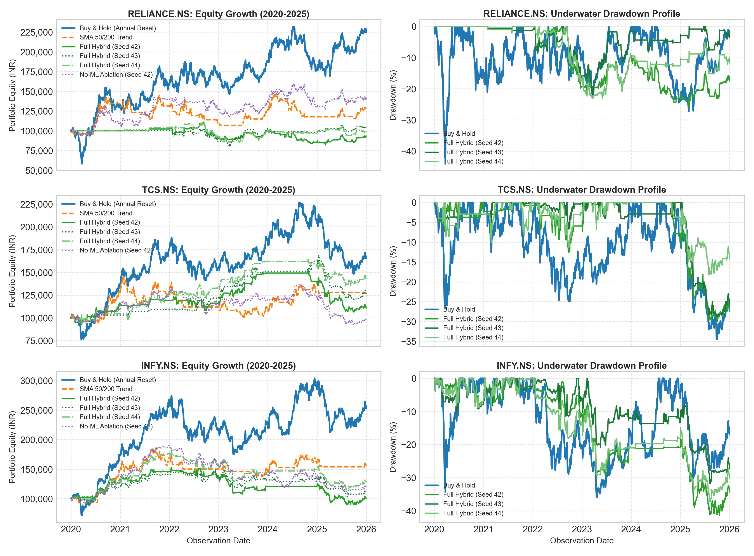
Figure 6.1. Stitched 6-year compounded equity curves (left) and underwater drawdown profiles (right) across 2020–2025 for Buy & Hold vs. individual Full Hybrid seeds (42, 43, 44) and No-ML Ablation (Seed 42).

6.3 Annual Paired Scorecard & Drawdown Dampening
The annual scorecard across 18 test folds reveals the structural trade-off of risk-constrained trading: - Positive Hybrid Return: 10 out of 18 folds (55.6%); - Hybrid Outperformed Buy & Hold: 5 out of 18 folds (27.8%)—specifically in down/choppy markets (TCS 2022 +16.55% diff; INFY 2022 +11.44% diff; RELIANCE 2023 +2.00% diff; TCS 2023 +3.92% diff; RELIANCE 2024 +1.97% diff); - Buy & Hold Outperformed Hybrid: 13 out of 18 folds (72.2%)—concentrated in bull markets (e.g., INFY 2020 B&H +74.69% vs Hyb +27.83%); - Lower Maximum Drawdown: Hybrid achieved lower annual drawdown in 17 out of 18 folds (94.4%). The sole exception was RELIANCE.NS in 2022, where Buy & Hold had a 17.27% drawdown vs Hybrid median drawdown of 17.45%.
Asset | Year | B&H Return | Hyb Median | Return Diff | Ablation Med
RELIANCE.NS | 2020 | +32.30% | 0.00% (Cash) | -32.30% | +9.89%
 | 2022 | +7.84% | -12.07% | -19.90% | -7.36%
 | 2023 | +10.00% | +12.00% | +2.00% | +7.60%
TCS.NS | 2022 | -12.13% | +4.41% | +16.55% | -2.44%
 | 2023 | +20.24% | +24.16% | +3.92% | +10.97%
INFY.NS | 2022 | -18.54% | -7.10% | +11.44% | -9.69%
Table 6.3. Representative annual paired comparisons illustrating market-stress outperformance vs bull-market drag.

6.4 Ablation and Exposure-Matched Diagnostic
When NSGA-II evolved rules with a constant probability (p=0.60, omitting ML features), the Ablation achieved 6-year stitched returns of +42.42% for RELIANCE.NS, +47.37% for TCS.NS, and +18.69% for INFY.NS—exceeding the Full Hybrid on all assets. Furthermore, an Exposure-Matched Buy & Hold diagnostic blending passive holding with cash based on the Hybrid's development exposure fraction (w_dev) outperformed the Full Hybrid in 29 of 54 runs (53.7%), while the Hybrid outperformed in 22 runs (40.7%), with 3 ties (RELIANCE 2020 cash fallbacks). Exposure-Matched Buy & Hold exhibited lower maximum drawdown than the Full Hybrid in 43 of 54 runs (79.6%). This diagnostic assumes daily frictionless rebalancing and 0% cash return. Across these historical folds, technical metaheuristic rules provided lower annual drawdowns, but LightGBM probability hurdles restricted market participation without producing higher compound returns.

6.5 Transaction Cost Sensitivity & Slippage Shift
Under doubled transaction friction (0.10% commission + 0.10% slippage per side, 0.20% per side, approximately 40 bps round-trip), total returns dropped sharply: RELIANCE.NS Seed 42 fell from -6.58% to -25.41% (-18.83 pp), TCS.NS Seed 43 fell from +25.60% to +19.61% (-5.99 pp), and INFY.NS Seed 44 declined from +27.88% to -7.97% (-35.85 pp) (Table 6.4). Slippage operates non-linearly: higher entry prices elevate absolute ATR stop prices, causing intrabar stops to trigger on sessions that would have otherwise remained open.
Asset | GA Seed | 1x Total Ret | 2x Total Ret | Return Diff | 1x Sharpe
RELIANCE.NS | 42 | -6.58% | -25.41% | -18.83 pp | -0.07
TCS.NS | 43 | +25.60% | +19.61% | -5.99 pp | +0.44
INFY.NS | 44 | +27.88% | -7.97% | -35.85 pp | +0.36
Table 6.4. Transaction cost sensitivity under standard (20 bps) vs doubled (40 bps) round-trip friction.
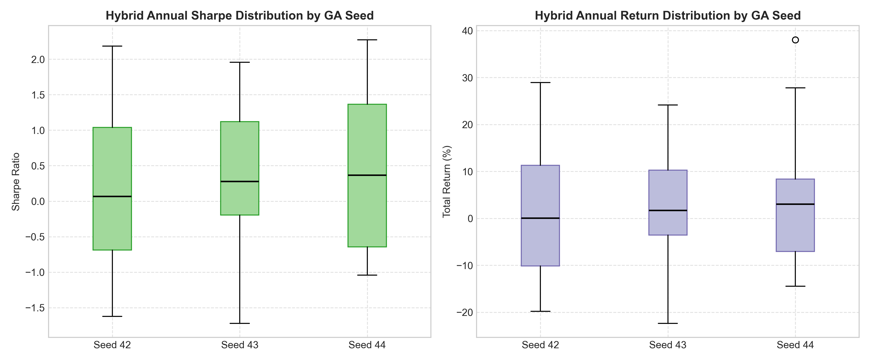
Figure 6.2. Multi-seed performance distributions (Seeds 42, 43, 44) across strategy variants.
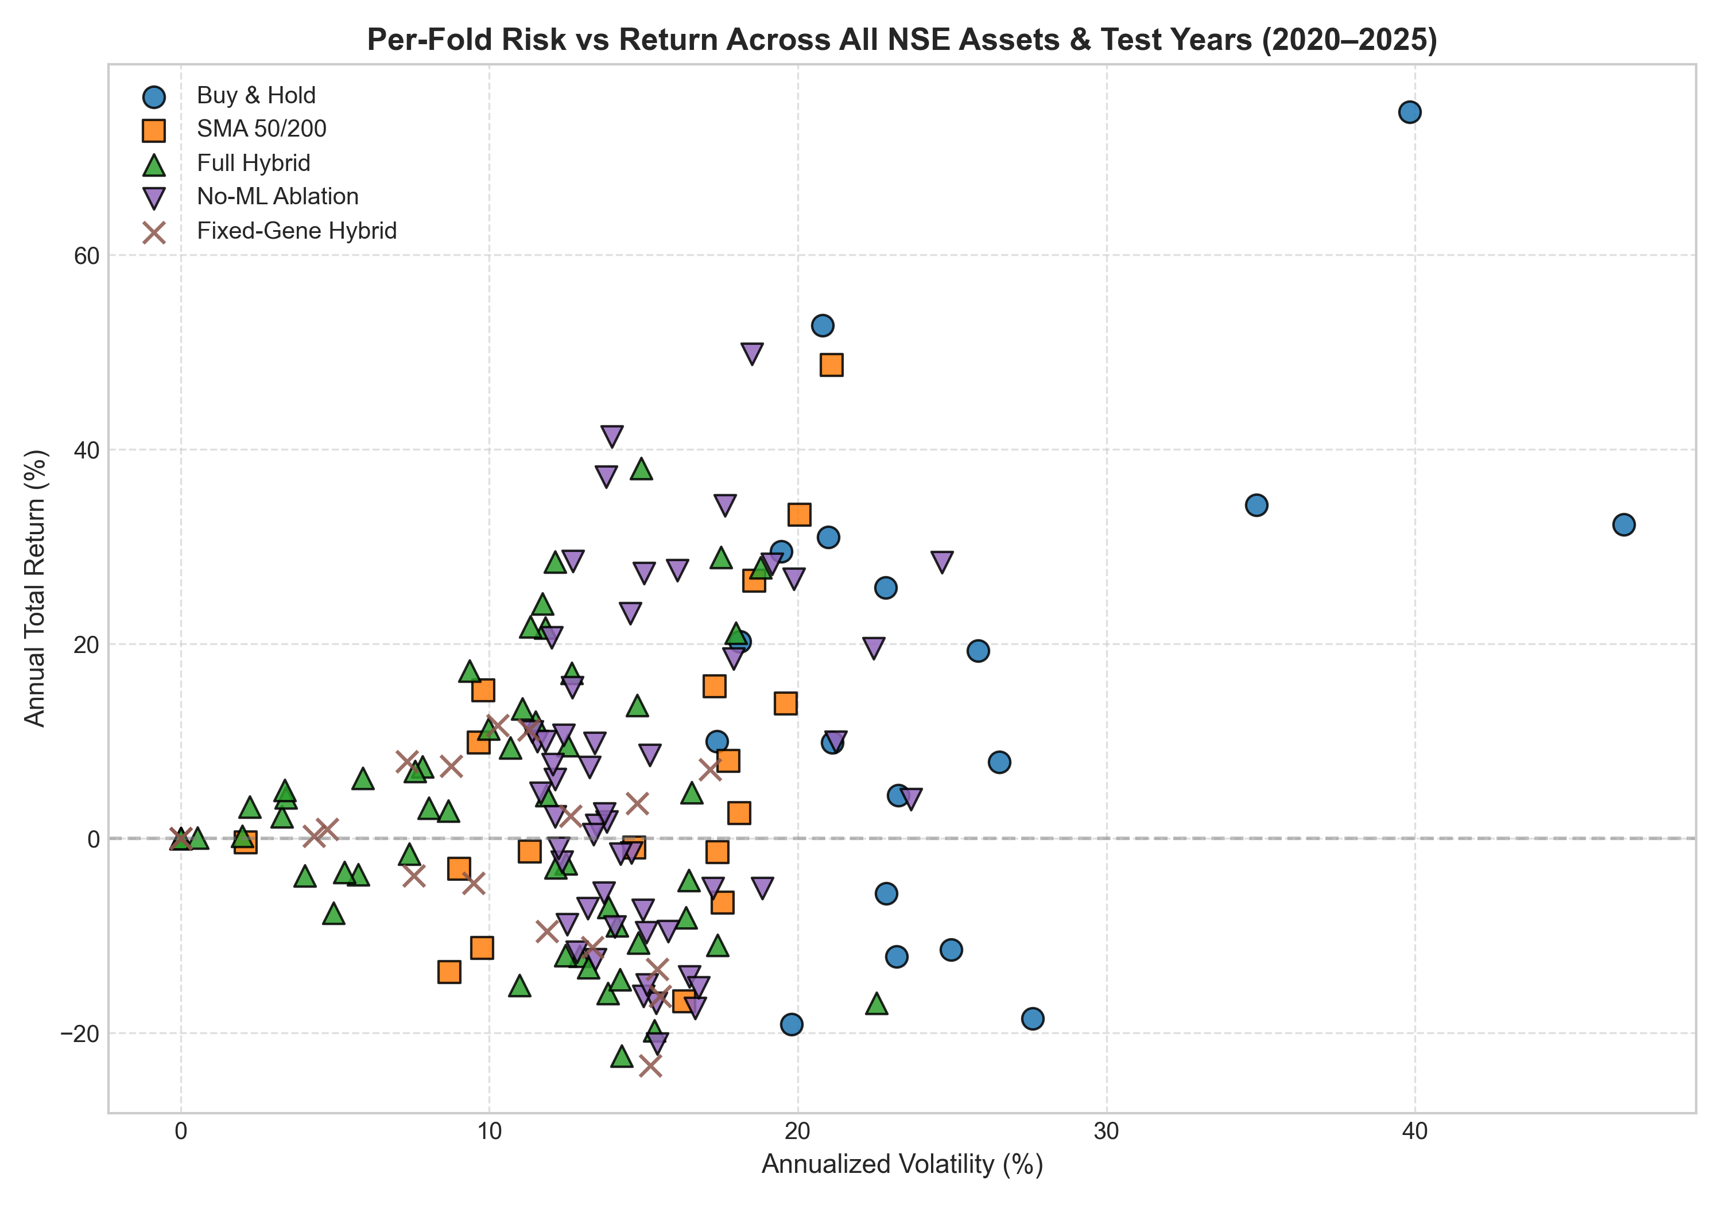
Figure 6.3. Annual fold risk-return scatter (Annualized Sharpe vs Total Return).

CHAPTER 7
Automated Verification, Unit Testing & Reproducibility

7.1 Regression Test Suite
The project includes an automated pytest suite covering Numba simulator execution timing, gap handling, stop-loss priority, chronological split purging, real-fold offline reproducibility, trailing zero-volume liquidation, and final-day entry prohibition. All tests pass offline in ~8 seconds with zero network calls.

7.2 Campaign-Wide Automated Reproducibility Audit
A standalone verification script (scripts/audit_campaign_reproducibility.py) re-runs all 18 annual folds across all 3 seeds with monkeypatched yfinance download blockers, asserting that chosen chromosome genes match saved artifacts within 10^-12 and equity curves match within 10^-7. The audit evaluated 306 assertions with zero mismatches, confirming complete bit-level code reproducibility. Furthermore, scripts/verify_numerical_claims.py programmatically asserts all 47 quantitative claims reported across this capstone report against the underlying experiment CSV and JSON files with 100% pass rate.

CHAPTER 8
Methodological Limitations & Research Boundaries
The empirical conclusions are bounded by four key constraints: (1) Single-Asset Isolated Evaluation: Strategies are evaluated on individual stocks; cross-asset portfolio diversification and risk parity are not modeled; (2) Multi-Year vs Annual Drawdown Asymmetry: Lower annual drawdowns in 17 of 18 folds do not guarantee lower multi-year risk. On INFY.NS, the Hybrid 6-year maximum drawdown reached 37.16% compared to 35.93% for Buy & Hold, illustrating how compounded capital erosion can produce deeper multi-year drawdowns; (3) Survivorship Bias: The universe is limited to large-cap equities surviving through 2025; (4) Corporate Action Adjusted Data: Backward-adjusted OHLC series from Yahoo Finance are used rather than raw exchange order books; (5) Retrospective Protocol Corrections: The walk-forward protocol was refined through versioned retrospective audit corrections (v1.1.0 in protocol_correction.json).

CHAPTER 9
Conclusion & Future Directions
This capstone project engineered and evaluated a Two-Tier Computational Intelligence trading system combining LightGBM and NSGA-II. Through strict walk-forward evaluation on three NSE equities over 2020–2025, the research established that while evolutionary rules achieved lower annual drawdowns in 94.4% of folds, defensive cash-holding imposed substantial opportunity costs during secular bull regimes, resulting in lower multi-year compounded wealth than Buy & Hold. Technical parameter search without ML signals produced equivalent or superior returns. These empirical findings highlight the substantial opportunity costs associated with defensive capital allocation in trending equity markets.

REFERENCES
[1] K. Deb, A. Pratap, S. Agarwal, and T. Meyarivan, "A fast and elitist multiobjective genetic algorithm: NSGA-II," IEEE Transactions on Evolutionary Computation, vol. 6, no. 2, pp. 182–197, Apr. 2002. DOI: 10.1109/4235.996017.
[2] G. Ke, Q. Meng, T. Finley, T. Wang, W. Chen, W. Ma, Q. Ye, and T.-Y. Liu, "LightGBM: A highly efficient gradient boosting decision tree," in Advances in Neural Information Processing Systems 30 (NIPS 2017), Long Beach, CA, USA, 2017, pp. 3146–3154.
[3] M. López de Prado, Advances in Financial Machine Learning. Hoboken, NJ, USA: John Wiley & Sons, 2018. ISBN: 978-1119482086.
[4] D. H. Bailey and M. López de Prado, "The deflated Sharpe ratio: Correcting for selection bias, backtest overfitting and non-normality," The Journal of Portfolio Management, vol. 40, no. 5, pp. 94–107, 2014. DOI: 10.3905/jpm.2014.40.5.094.
[5] H. White, "A reality check for data snooping," Econometrica, vol. 68, no. 5, pp. 1097–1126, Sep. 2000. DOI: 10.1111/1468-0262.00152.
[6] E. F. Fama, "Efficient capital markets: A review of theory and empirical work," The Journal of Finance, vol. 25, no. 2, pp. 383–417, May 1970. DOI: 10.2307/2325486.
[7] R. Aroussi et al., "yfinance: Download market data from Yahoo! Finance," Python package documentation, 2024–2026. [Online]. Available: https://github.com/ranaroussi/yfinance.

